ORDER FOR WORSHIP

Reformation Sunday – October 26, 2025
WE PREPARE FOR WORSHIP - (Silence and Prayer is appropriate)
Prelude
Announcements
Confession/Absolution Page 94
WE SING PRAISES TO GOD
Entrance Hymn – A Mighty Fortress Is Our God #504
Greeting & Kyrie Page 203
Hymn of Praise – Come Let Us Join Page 204
Prayer of the Day
WE HEAR THE WORD

First Lesson – Jeremiah 31:31-34

Choir Anthem – God is Our Refuge

Second Lesson – Romans 3:19-28

Bells & Chimes
Gospel Acclamation – Alleluia Page 205
Gospel – John 8:31-36
Children’s Moment
Sermon – ‘Freedom Begins In The Heart’ Pastor Don
WE RESPOND WITH SONGS AND STATEMENTS
Pulpit Hymn – Who You Say I Am by Hillsong See Screen
The Apostles’ Creed Page 105
Prayers of the Church
WE OFFER GIFTS TO GOD AS WE SAY THANKS
Offering
Offertory – Praise and Thanksgiving (vs.1,2) #689
Offertory Prayer
WE EAT AND DRINK TOGETHER IN CHRIST
Words of Institution Page 108
Lord’s Prayer Page 208
O Lamb of God Page 208
WE LEAVE TO DO OUR WORK ON GOD’S BEHALF
Distribution/Closing Prayer
Benediction
Sending Song – ‘Built On A Rock’ # 652
Postlude


Welcome to Fall Worship! We’re excited to see so many members and visitors here to celebrate together in our church home. God has granted us so many gifts and opportunities to share God’s love with everyone we meet. We have activity bags available near the doors for the young to enjoy and take home.

Today’s Altar Flowers and Facebook Live are given by Tom and Leanna Albrecht in honor of the birth of their great grandson
Wilhelm Schuler Barnes to Greg and Kyla Barnes of Granite Falls.

Today’s Radio Broadcast is sponsored by Dave Gardner and
Jan Olson. Thank you for your gift.


Can you help us out and keep us on
the air and online?

We are always looking to have sponsors for Altar Flowers, Radio Broadcast and Facebook Live. You can sponsor any of these in memory or honor of someone, or in celebration of a special event in your life. Call and check for available dates.

Please contact the church office at 269-8824 to reserve your special date on the calendar.

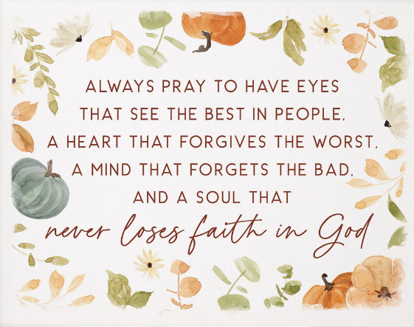

Ministry of Caring
We give thanks to God for God’s healing power. Your prayers have made a big difference in the lives of our people on this list. Please continue to pray for each person by name. As we offer our prayers, God’s love fills us with grace.

Health for Members
Yvonne Ward; Inez Johnson; Pat Freese; Kay Gustafson; Don Haugerud; Sheryl Maus; Bea Hoppe; Dianne Dvergsten; Kyle Haase; Darwin TeBeest; Jenell Dahl; Nancy Dack; Diane & Dennis Loose; Mike Fagen;
Julie Rhode; Lowell Hanson; Darlene Ulven; Tom Albrecht; Pastor Chris; Don Maland; Paul Arends; Lynette Arends; Curt Winters; Lee Kvanli; Kathy Gilkey and Marvin & Gayle Jensen.

Health for Others

Name Requested By
Paul Rice Mary Rice
Janice Lund, Delaine Christenson Lois Christenson
Beckham Trygestad Jennifer Hauge
Emily Evenson Tom Albrecht
Amerie Tell, Mitch Augeson, Terry Hermanson Sally Groothuis
Cathy Teske Pam Haugeud
Tim & Andrea Dreier Mary Ann Nordaune
Jerry Cronen Karen Kepner
Tim Johnson, Mike Halvorson Lois & DeVon Vien
Lyn Bonnema Margit Bonnema
Delores Bursack Deb & Jerry Larson
Neal Dalton Doris Larson
Randy Lee Caren & Duane Johnson
Linda Bendickson, Brenda Ulven Darlene Ulven
Trevor Hansen Pat & Ron Binnebose
Alyson, Joe & Cam Helgeson Rosie Dehli
Gina Jung Thorne Sue Varpness
Willard Arnold Yvonne Ward
Andi Moon Pam & Dave Arneson
Jim & Jody Renbarger Barb Smith

Serving in the Military
Bowen Tesch, grandson of Jim & Deb Bowen; Paul Evenson, son-in-law of Karyn Maass; Dennis DeJong, friend of Lois Christenson;
Sean Prior, grandson of DeVon & Lois Vien; Justin Olsen, grandson of Ken & Janice Olsen; Alan Gronewold, son of Gladys Nelson;
Tyler Meyenburg, son of Rick & Mort Meyenburg;
Kirk Larson & Ross Larson, sons of Jerry & Deb Larson;
Daniel Harter & Shane McDonald, sons-in-law of Susan Marcinkowski.
Reformation Sunday
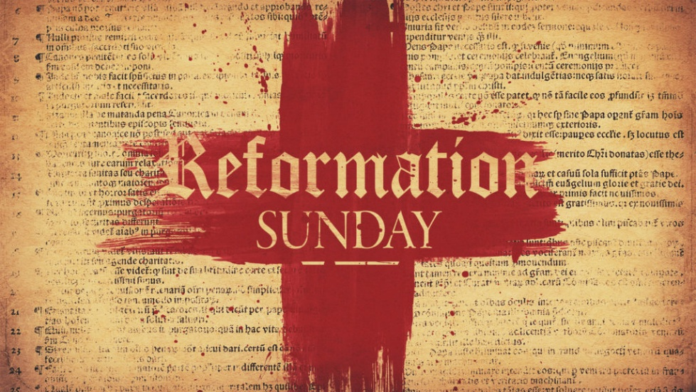
October 26, 2025


OUR SAVIOR’S LUTHERAN
222 NORTH 5TH STREET
MONTEVIDEO, MN
320-269-8824
www.oslcmonte.com

Week of October 27th through November 2nd
Monday
9:00 am Quilting
Tuesday
9:00 am Quilting
10:15 am Staff Meeting
10:30 am Worship on Channel 180
Wednesday
7:00 am Roll with Jesus
1:00 pm Happy Hatters
2:30 pm Worship on Channel 180
5:00 pm Chimes Practice
6:00 pm Handbell Practice
6:30 pm Confirmation
7:00 pm W.O.W
7:00 pm Choir Practice
Thursday
10:30 am Worship on Channel 180
Sunday
9:00 am Worship with Holy Communion
10:15 am Sunday School
10:15 am Coffee Fellowship
11:00 am Worship on KDMA

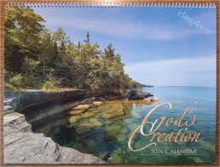
2026 CALENDARS
ARE NOW ON SALE FOR $10 EACH!
IF INTERESTED STOP BY THE CHURCH OFFICE. ALL OF THE PROCEEDS WILL HELP US BUY NEW AND UPDATED KITCHEN SUPPLIES!


We are trying something new on the 4th Sunday of each month. The High School WOW group will be choosing the Pulpit Hymn. Join us as we sing together and praise God with these new and inspirational hymns.

First Reading: Jeremiah 31:31-34
The renewed covenant will not be breakable, but like the old covenant it will expect the people to live upright lives. To know the Lord means that one will defend the cause of the poor and needy (Jer. 22:16). The renewed covenant is possible only because the Lord will forgive iniquity and not remember sin. Our hope lies in a God who forgets.

³¹ The days are surely coming, says the Lord, when I will make a new covenant with the house of Israel and the house of Judah. ³² It will not be like the covenant that I made with their ancestors when I took them by the hand to bring them out of the land of Egypt—a covenant that they broke, though I was their husband, says the Lord.

³³ But this is the covenant that I will make with the house of Israel after those days, says the Lord: I will put my law within them, and I will write it on their hearts, and I will be their God, and they shall be my people. ³⁴ No longer shall they teach one another or say to each other, “Know the Lord,” for they shall all know me, from the least of them to the greatest, says the Lord, for I will forgive their iniquity and remember their sin no more.

Prayer of the Day
Almighty God, gracious Lord, we thank you that your Holy Spirit renews the church in every age. Pour out your Holy Spirit on your faithful people. Keep them steadfast in your word, protect and comfort them in times of trial, defend them against all enemies of the gospel, and bestow on the church your saving peace, through Jesus Christ, our Savior and Lord, who lives and reigns with you and the Holy Spirit, one God, now and forever.
Amen.

Second Reading: Romans 3:19-28
Paul’s words stand at the heart of the preaching of Martin Luther and other Reformation leaders. No human beings make themselves right with God through works of the law. We are brought into a right relationship with God through the divine activity centered in Christ’s death. This act is a gift of grace that liberates us from sin and empowers our faith in Jesus Christ.

¹⁹ Now we know that, whatever the law says, it speaks to those who are under the law, so that every mouth may be silenced and the whole world may be held accountable to God. ²⁰ For no human will be justified before him by deeds prescribed by the law, for through the law comes the knowledge of sin.
²¹ But now, apart from the law, the righteousness of God has been disclosed and is attested by the Law and the Prophets, ²² the righteousness of God through the faith of Jesus Christ for all who believe.

For there is no distinction, ²³ since all have sinned and fall short of the glory of God; ²⁴ they are now justified by his grace as a gift, through the redemption that is in Christ Jesus, ²⁵ whom God put forward as a sacrifice of atonement by his blood, effective through faith. He did this to demonstrate his righteousness, because in his divine forbearance he had passed over the sins previously committed; ²⁶ it was to demonstrate at the present time his own righteousness, so that he is righteous and he justifies the one who has the faith of Jesus.
²⁷ Then what becomes of boasting? It is excluded. Through what kind of law? That of works? No, rather through the law of faith. ²⁸ For we hold that a person is justified by faith apart from works prescribed by the law.

Gospel: John 8:31-36
Jesus speaks of truth and freedom as spiritual realities known through his word. He reveals the truth that sets people free from sin.

³¹ Jesus said to the Jews who had believed in him, “If you continue in my word, you are truly my disciples, ³² and you will know the truth, and the truth will make you free.” ³³ They answered him, “We are descendants of Abraham and have never been slaves to anyone. What do you mean by saying, ‘You will be made free’?”
³⁴ Jesus answered them, “Very truly, I tell you, everyone who commits sin is a slave to sin. ³⁵ The slave does not have a permanent place in the household; the son has a place there forever. ³⁶ So if the Son makes you free, you will be free indeed.”

______________________________________________


The Happy Hatters are looking for more people to join them! New Loomers are always welcome. No experience is required. This is a very easy skill to learn, and it is a lot of fun to create new hats, mittens and scarves. They meet every other Wednesday at 1pm in the Fireside Room. The next meeting is on October 29th. Come join us!!

