ORDER FOR WORSHIP

Reformation Sunday – October 25, 2026
WE PREPARE FOR WORSHIP (Silence and Prayer are appropriate)
Prelude
Sunday School Singers
Announcements
Temple Talk Pat Janke
Confession/Absolution Page 94

WE SING PRAISES TO GOD
Entrance Hymn – A Mighty Fortress Is Our God #504
Bells & Chimes
Prayer of the Day

WE HEAR THE WORD

First Lesson – Jeremiah 31:31-34

Choir Anthem – Amazing Grace
Second Lesson – Romans 3:19-28
Gospel Acclamation – Alleluia Page 205
Gospel – John 8:31-36
Children’s Moment
Sermon – Pastor Don

WE RESPOND WITH SONGS AND STATEMENTS
Pulpit Hymn – Built on a Rock (vs.1,3,5) #652
Sacrament of Holy Baptism See Insert
Prayers of the Church

WE OFFER GIFTS TO GOD AS WE SAY THANKS
Offering
Offertory – Let the Vineyards be Fruitful #182
Offertory Prayer

WE EAT AND DRINK TOGETHER IN CHRIST
Words of Institution Page 108
Lord’s Prayer Page 208
Distribution/Closing Prayer

WE LEAVE TO DO OUR WORK ON GOD’S BEHALF
Benediction
Sending Song – The Church of Christ, in Every Age (vs.1,4,5) #729
Postlude
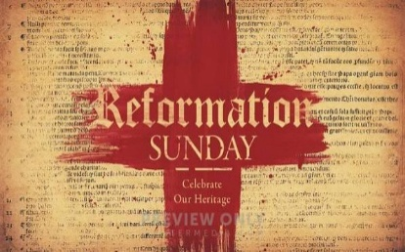
Welcome to worship! We have a passion for people of all ages to gather in worship! Let us join our voices in celebration of God’s grace and join our hands in service for God’s people! We have activity bags available near the doors for the young.

Today’s Radio Broadcast is given in memory of Herman Weber from Leona and family.
_________________________________________________

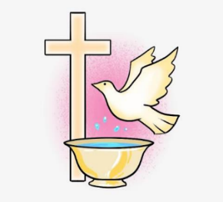
We welcome Baylor Ann-Marie Sandmeyer through the waters of Holy Baptism today. She is the daughter of Jordan and Kaylee Sandmeyer.
Baylor’s sponsors are
Mariah Leimer, Jackson Neuman and
Kane and Leah Glomstad.
May God Bless Baylor and her family.

Our church family would like to offer comfort and care to those who have lost loved ones by sharing handmade prayer shawls as a reminder of God’s love and the prayers that surround them during their time of grief.
We are looking for volunteers who would be willing to knit or crochet prayer shawls for our members and their families. If you enjoy knitting or crocheting, or would like to help with this ministry, we would love to have you join us!
Through this simple act of love, we can share Christ’s comfort, peace, and hope with those who are grieving. If you are interested in helping, please contact the church office.


Prayers for the People

Health for Members
Gene Christianson, Kathy Thalberg, Klayton TeBeest, Inez Johnson, Carol Norman, Don Maland, Alvina Pitt, Steve & Diane Ketelsen,
Dave Anspach, Alissa Warner, Wayne & Phyllis Berglund, Dave Saue,
Bea Hoppe, Tom Birkey, Curtis Winters, Amy Rodeberg, Bob Erickson, Don Haugerud, Dianne Dvergsten, Nancy Dack, Diane & Dennis Loose, Darlene Ulven, Tom Albrecht, Paul Arends, Lynette Arends, Lee Kvanli, Kathy Gilkey, and Marvin Jensen.

Health for Others

Name Requested By
Michele Larson, Tim Johnson, Mike Halvorson DeVon & Lois Vien
Wes Thompson Carmen Haugen
Thomas Heylens Tory & Kena Sonstegard
Sheri Bjornberg Jennifer Hauge
Rodney Pitt Alvina Pitt
Howard Gatchell Sherri Gatchell
Hakki Kalpek, Karen Hemmingson Lois & DeVon Vien
Steve Johnson Carol Norman
Jill Giinthir Allison Voorhees
Renae Eckberg, John Eckberg Pastor Marie Eckberg
Lisa Lund Sally Groothuis
Janice Lund, Nona Wallert Lois Christenson
Amerie Tell, Mitch Augeson, Terry Hermanson Sally Groothuis
Andrea Dreier Mary Ann Nordaune
Lyn Bonnema Margit Bonnema
Delores Bursack Deb & Jerry Larson
Linda Bendickson, Brenda Ulven Darlene Ulven
Trevor Hansen Pat & Ron Binnebose
Andi Moon Pam & Dave Arneson
Jim & Jody Renbarger Barb Smith

Serving in the Military
Kadin Brabender, cousin of Darren & Wendy Augeson;
Bowen Tesch, grandson of Jim & Deb Bowen; Paul Evenson,
son-in-law of Bill & Karyn Maass; Dennis DeJong, friend of Lois Christenson; Sean Prior, grandson of DeVon & Lois Vien; Justin Olsen, grandson of Ken & Janice Olsen; Alan Gronewold, son of Gladys Nelson; Tyler Meyenburg, son of Rick & Mort Meyenburg;
Kirk Larson & Ross Larson, sons of Jerry & Deb Larson;
Daniel Harter & Shane McDonald, sons-in-law of Susan Marcinkowski.

Reformation
Sunday
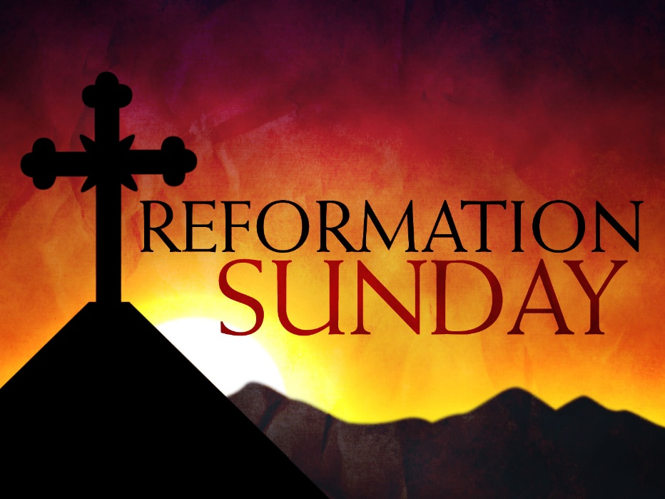
October 25, 2026


OUR SAVIOR’S LUTHERAN
222 NORTH 5TH STREET
MONTEVIDEO, MN
320-269-8824
www.oslcmonte.com
Week of October 26th through November 1st
Monday
4:30 pm Ministry Board
5:30 pm Management Board
Tuesday
10:15 am Staff Meeting
10:30 am Worship on Channel 180
Wednesday
7:00 am Roll with Jesus
2:30 pm Worship on Channel 180
5:00 pm Chimes Practice
6:00 pm Handbell Practice
6:30 pm Confirmation
7:00 pm Choir Practice
Thursday
10:30 am Worship on Channel 180
Friday – Office open till Noon
Sunday
9:00 am Worship w/Holy Communion
10:15 am Sunday School
10:15 am Coffee Fellowship
11:00 am Worship on KDMA 93.9 FM


Christmas Giving for Luther Haven
Luther Haven is requesting monetary donations to make Christmas special for its residents. Our Church Council has donated $500 and invites our congregation to help match this gift. Please make donations by December 4th. Thank you for sharing Christ’s love and Christmas joy with the residents of Luther Haven!

First Reading: Jeremiah 31:31-34
The renewed covenant will not be breakable, but like the old covenant it will expect the people to live upright lives. To know the Lord means that one will defend the cause of the poor and needy (Jer. 22:16). The renewed covenant is possible only because the Lord will forgive iniquity and not remember sin. Our hope lies in a God who forgets.

³¹ The days are surely coming, says the Lord, when I will make a new covenant with the house of Israel and the house of Judah. ³² It will not be like the covenant that I made with their ancestors when I took them by the hand to bring them out of the land of Egypt—a covenant that they broke, though I was their husband, says the Lord. ³³ But this is the covenant that I will make with the house of Israel after those days, says the Lord: I will put my law within them, and I will write it on their hearts, and I will be their God, and they shall be my people. ³⁴ No longer shall they teach one another or say to each other, “Know the Lord,” for they shall all know me, from the least of them to the greatest, says the Lord, for I will forgive their iniquity and remember their sin no more.

Prayer of the Day
Almighty God, gracious Lord, we thank you that your Holy Spirit renews the church in every age. Pour out your Holy Spirit on your faithful people. Keep them steadfast in your word, protect and comfort them in times of trial, defend them against all enemies of the gospel, and bestow on the church your saving peace, through Jesus Christ, our Savior and Lord, who lives and reigns with you and the Holy Spirit, one God, now and forever.
Amen.

Second Reading: Romans 3:19-28
Paul’s words stand at the heart of the preaching of Martin Luther and other Reformation leaders. No human beings make themselves right with God through works of the law. We are brought into a right relationship with God through the divine activity centered in Christ’s death. This act is a gift of grace that liberates us from sin and empowers our faith in Jesus Christ.

¹⁹ Now we know that, whatever the law says, it speaks to those who are under the law, so that every mouth may be silenced and the whole world may be held accountable to God. ²⁰ For no human will be justified before him by deeds prescribed by the law, for through the law comes the knowledge of sin.
²¹ But now, apart from the law, the righteousness of God has been disclosed and is attested by the Law and the Prophets, ²² the righteousness of God through the faith of Jesus Christ for all who believe. For there is no distinction, ²³ since all have sinned and fall short of the glory of God; ²⁴ they are now justified by his grace as a gift, through the redemption that is in Christ Jesus, ²⁵ whom God put forward as a sacrifice of atonement by his blood, effective through faith. He did this to demonstrate his righteousness, because in his divine forbearance he had passed over the sins previously committed; ²⁶ it was to demonstrate at the present time his own righteousness, so that he is righteous and he justifies the one who has the faith of Jesus.
²⁷ Then what becomes of boasting? It is excluded. Through what kind of law? That of works? No, rather through the law of faith. ²⁸ For we hold that a person is justified by faith apart from works prescribed by the law.

Gospel: John 8:31-36
Jesus speaks of truth and freedom as spiritual realities known through his word. He reveals the truth that sets people free from sin.

³¹ Jesus said to the Jews who had believed in him, “If you continue in my word, you are truly my disciples, ³² and you will know the truth, and the truth will make you free.” ³³ They answered him, “We are descendants of Abraham and have never been slaves to anyone. What do you mean by saying, ‘You will be made free’?”
³⁴ Jesus answered them, “Very truly, I tell you, everyone who commits sin is a slave to sin. ³⁵ The slave does not have a permanent place in the household; the son has a place there forever. ³⁶ So if the Son makes you free, you will be free indeed.”


Our thoughts and prayers are with all families who have recently lost loved ones. May God surround them with His comfort and grant them peace during this time of grief.
Gene Christianson and family on the loss of his wife, Linda Christianson. Linda passed away on Wednesday, October 14th at Luther Haven. Her funeral was held here at Our Savior’s on Friday, October 23rd. Blessed be her memory.
Family and friends of George Waters. George passed away on Friday, October 16th at Luther Haven. His funeral was held here at Our Savior’s on Saturday, October 24th. Blessed be his memory.

