ORDER FOR PRAISE WORSHIP

16th Sunday after Pentecost – September 13, 2026
WE PREPARE FOR WORSHIP – (Silence and Prayer are appropriate)
Prelude
Call to Worship – We Bow Down C#12

WE PRAY AND PRAISE
Opening Song – Jesus Loves Me! ELW#595

Blessed be the Holy Trinity, ☩ one God, our creator, our protector, our wellspring of life. Amen.
Trusting that God receives our words and the meditations of our hearts, let us confess our sin.
Silence is kept for reflection.
Merciful God,
You speak blessing and compassion into the world. Forgive us for the ways we act with judgment, cruelty, or indifference. We ignore the needs of our neighbors; we resist your call to oppose injustice; we give in to scarcity and fear; we assume the worst about one another. Cleanse us from our faults and release us from their grasp. Show us your loving kindness. Restore our hearts and repair your world, that we may live in Christ’s ways. Amen.
God proclaims these words of assurance: “Do not fear, for I have redeemed you. I have called you by name. You are mine.”
In ☩ Christ, you are forgiven. In the Spirit, you are made free. Refreshed by the waters of mercy, live anew as beloved children of God. Amen.
Kyrie Eleison Page 184
Glory to God Page 185
Prayer of the Day

WE HEAR GOD’S WORD
First Lesson – Genesis 50:15-21
Milestone Moment – 7th Grade Bibles

Second Lesson – Romans 14:1-12
Gospel Acclamation Page 188
Gospel – Matthew 18:21-35
Children’s Moment – Blessing of Backpacks
Sermon – ‘Retribution or Grace?’ Pastor Don
Pulpit Hymn – Lord, I Lift Your Name on High C#54

WE OFFER OURSELVES TO GOD
Praise Worship Creed
C: We believe in God, the one who comes before us and goes behind us, creating life and opportunities to love and care for the world.
C: We believe in Jesus Christ, who walks with us into real life each day. He is God, yet human like us and he experienced all life’s joys, pains, challenges like we do. But his love is so great that not even sin nor suffering or even death could stop his love. Today, the love of Jesus lives and continues to bring new life to the world.
C: We believe in the Holy Spirit that comes like the wind and blows in and through us to bring God’s power and light to all the world. The Spirit breathes life into us, the body of Christ we call the church, and enables us to follow the way of Christ. Amen.

Prayers of the Church
Prayer Song – Hear Our Prayer #178
Lord’s Prayer Sung
Offering / Offering Prayer

WE GO TO SERVE THE LORD
Benediction
Sending Song – Shine, Jesus, Shine C#27
Postlude


Welcome to Worship! Welcome, everyone! This is the day the Lord has made, and we have come together to rejoice in it! Let us set aside the worries of the week and lift our hearts in praise, gratitude, and expectation for what God will do among us today. Make sure to grab an activity bag for your child, located at the back of the church.

Prayers for the People

Health for Members
Carol Norman, Alvina Pitt, Steve Ketelsen, Dave Anspach,
Alissa Warner, Wayne & Phyllis Berglund, Dave Saue, Bea Hoppe,
Tom Birkey, Penny Worsech, Curtis Winters, Amy Rodeberg,
Bob Erickson, Edith Hendrickson, Don Haugerud, Dianne Dvergsten, Nancy Dack, Diane & Dennis Loose, Darlene Ulven, Tom Albrecht,
Paul Arends, Lynette Arends, Lee Kvanli, Kathy Gilkey and
Marvin Jensen.

Health for Others
Name Requested By
Thomas Heylens Tory & Kena Sonstegard
Mary Howard Pat Nokleby
Sherri Bjornberg Jennifer Hauge
Rodney Pitt Alvina Pitt
Howard Gatchell Sherri Gatchell
Hakki Kalpek, Karen Hemmingson Lois & DeVon Vien
Steve Johnson Carol Norman
Jill Giinthir Allison Voorhees
Renae Eckberg, John Eckberg Pastor Marie Eckberg
Lisa Lund Sally Groothuis
Janice Lund, Nona Wallert Lois Christenson
Amerie Tell, Mitch Augeson, Terry Hermanson Sally Groothuis
Tim & Andrea Dreier Mary Ann Nordaune
Tim Johnson, Mike Halvorson Lois & DeVon Vien
Lyn Bonnema Margit Bonnema
Delores Bursack Deb & Jerry Larson
Linda Bendickson, Brenda Ulven Darlene Ulven
Trevor Hansen Pat & Ron Binnebose
Andi Moon Pam & Dave Arneson
Jim & Jody Renbarger Barb Smith

Serving in the Military
Kadin Brabender, cousin of Darren & Wendy Augeson;
Bowen Tesch, grandson of Jim & Deb Bowen; Paul Evenson,
son-in-law of Bill & Karyn Maass; Dennis DeJong, friend of
Lois Christenson; Sean Prior, grandson of DeVon & Lois Vien;
Justin Olsen, grandson of Ken & Janice Olsen; Alan Gronewold,
son of Gladys Nelson; Tyler Meyenburg, son of Rick & Mort Meyenburg;
Kirk Larson & Ross Larson, sons of Jerry & Deb Larson;
Daniel Harter & Shane McDonald, sons-in-law of Susan Marcinkowski.
16th Sunday after Pentecost
September 13, 2026
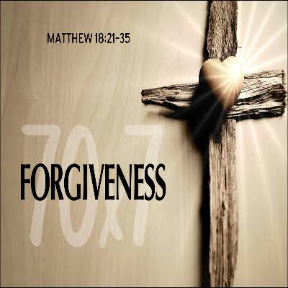


OUR SAVIOR’S LUTHERAN
222 NORTH 5TH STREET
MONTEVIDEO, MN
320-269-8824
www.oslcmonte.com
Week of September 14th through September 20th
Tuesday
10:15 am Staff Meeting
10:30 am Worship on Channel 180
Wednesday
7:00 am Roll with Jesus
1:30 pm WELCA
2:30 pm Worship on Channel 180
5:00 pm Chimes Practice
6:00 pm Handbells Practice
6:30 pm Confirmation
7:00 pm Choir Practice
Thursday
10:30 am Worship on Channel 180
Sunday
9:00 am Worship – 3rd Grade Bibles
10:15 am Sunday School
10:15 am Coffee Fellowship
11:00 am Worship on KDMA 93.9 FM
2:00 pm Senior Lites Event
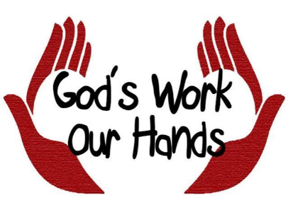
Join us in Bethany Hall after worship for “God’s Work, Our Hands.” There will be projects for all ages and abilities. We hope everyone will join us as we work together to serve others and share God’s love within our community.

Regular Sunday School for preschool through grade 8 will begin next Sunday, September 20th at 10:15 am. All students will gather in the Chapel.

Bibles for our 3rd grade students will be presented during worship next Sunday, September 20th. We look forward to seeing you here as we celebrate and encourage our youth in their faith journey by sharing the Word of God with them.

First Reading: Genesis 50:15-21
After Jacob’s death the brothers of Joseph begged for forgiveness for the crime they had done against him. You intended to do me harm, Joseph said, but God used this as an opportunity to do good and save many lives.

¹⁵ Realizing that their father was dead, Joseph’s brothers said, “What if Joseph still bears a grudge against us and pays us back in full for all the wrong that we did to him?” ¹⁶ So they approached Joseph, saying, “Your father gave this instruction before he died, ¹⁷ ‘Say to Joseph: I beg you, forgive the crime of your brothers and the wrong they did in harming you.’ Now therefore please forgive the crime of the servants of the God of your father.” Joseph wept when they spoke to him. ¹⁸ Then his brothers also wept, fell down before him, and said, “We are here as your slaves.” ¹⁹ But Joseph said to them, “Do not be afraid! Am I in the place of God? ²⁰ Even though you intended to do harm to me, God intended it for good, in order to preserve a numerous people, as he is doing today. ²¹ So have no fear; I myself will provide for you and your little ones.” In this way he reassured them, speaking kindly to them.

Prayer of the Day
O Lord God, merciful judge, you are the inexhaustible fountain of forgiveness. Replace our hearts of stone with hearts that love and adore you, that we may delight in doing your will, through Jesus Christ, our Savior and Lord.
Amen.

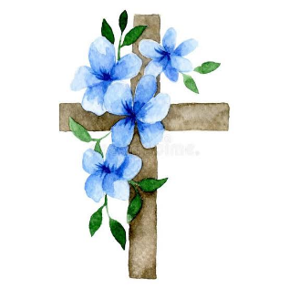
Please extend your hands of comfort to Judy Winge and Gail and Ron Schultz on the passing of their brother, Noel “John” Skonard. John passed away on Sunday, September 6th. His funeral will be held on Monday, September 14th at Rock Haven Church at 10:30am. Blessed be his memory.

Second Reading: Romans 14:1-12
This Christian community has significant struggles with diversity. Here Paul helps us understand that despite different practices in worship and personal piety, we do not judge one another. All Christians belong to the Lord Jesus Christ who died for all of us and will judge each of us.

¹ Welcome those who are weak in faith but not for the purpose of quarreling over opinions. ² Some believe in eating anything, while the weak eat only vegetables. ³ Those who eat must not despise those who abstain, and those who abstain must not pass judgment on those who eat, for God has welcomed them. ⁴ Who are you to pass judgment on slaves of another? It is before their own lord that they stand or fall. And they will be upheld, for the Lord is able to make them stand.
⁵ Some judge one day to be better than another, while others judge all days to be alike. Let all be fully convinced in their own minds. ⁶ Those who observe the day, observe it for the Lord. Also those who eat, eat for the Lord, since they give thanks to God, while those who abstain, abstain for the Lord and give thanks to God.
⁷ For we do not live to ourselves, and we do not die to ourselves. ⁸ If we live, we live to the Lord, and if we die, we die to the Lord; so then, whether we live or whether we die, we are the Lord’s. ⁹ For to this end Christ died and lived again, so that he might be Lord of both the dead and the living.
¹⁰ Why do you pass judgment on your brother or sister? Or you, why do you despise your brother or sister? For we will all stand before the judgment seat of God. ¹¹ For it is written,
“As I live, says the Lord, every knee shall bow to me,
and every tongue shall give praise to God.”
¹² So then, each one of us will be held accountable.

Gospel: Matthew 18:21-35
When Peter asks about the limits of forgiveness, Jesus responds with a parable that suggests human forgiveness should mirror the unlimited mercy of God.

²¹ Peter came and said to Jesus, “Lord, if my brother or sister sins against me, how often should I forgive? As many as seven times?” ²² Jesus said to him, “Not seven times, but, I tell you, seventy-seven times.
²³ “For this reason the kingdom of heaven may be compared to a king who wished to settle accounts with his slaves. ²⁴ When he began the reckoning, one who owed him ten thousand talents was brought to him, ²⁵ and, as he could not pay, the lord ordered him to be sold, together with his wife and children and all his possessions and payment to be made. ²⁶ So the slave fell on his knees before him, saying, ‘Have patience with me, and I will pay you everything.’ ²⁷ And out of pity for him, the lord of that slave released him and forgave him the debt. ²⁸ But that same slave, as he went out, came upon one of his fellow slaves who owed him a hundred denarii, and seizing him by the throat he said, ‘Pay what you owe.’ ²⁹ Then his fellow slave fell down and pleaded with him, ‘Have patience with me, and I will pay you.’ ³⁰ But he refused; then he went and threw him into prison until he would pay the debt. ³¹ When his fellow slaves saw what had happened, they were greatly distressed, and they went and reported to their lord all that had taken place. ³² Then his lord summoned him and said to him, ‘You wicked slave! I forgave you all that debt because you pleaded with me. ³³ Should you not have had mercy on your fellow slave, as I had mercy on you?’ ³⁴ And in anger his lord handed him over to be tortured until he would pay his entire debt. ³⁵ So my heavenly Father will also do to every one of you, if you do not forgive your brother or sister from your heart.”

