ORDER FOR WORSHIP

15th Sunday after Pentecost – September 6, 2026
WE PREPARE FOR WORSHIP (Silence and Prayer are appropriate)
Prelude
Announcements
Confession/Absolution Page 94

WE SING PRAISES TO GOD
Entrance Hymn – Earth and All Stars! #731
Greeting & Kyrie Page 203
Hymn of Praise – Come Let Us Join Page 204
Prayer of the Day

WE HEAR THE WORD

First Lesson – Ezekiel 33:7-11

Special Music – The Descent Sue Winters
Second Lesson – Romans 13:8-14
Gospel Acclamation – Alleluia Page 205
Gospel – Matthew 18:15-20
Children’s Moment
Sermon – Pastor Don

WE RESPOND WITH SONGS AND STATEMENTS
Pulpit Hymn – For the Bread Which You Have Broken #494
The Apostles’ Creed Page 105
Prayers of the Church

WE OFFER GIFTS TO GOD AS WE SAY THANKS
Offering
Offertory – Let the Vineyards be Fruitful #182
Offertory Prayer

WE EAT AND DRINK TOGETHER IN CHRIST
Words of Institution Page 108
Lord’s Prayer Page 208
Distribution/Closing Prayer

WE LEAVE TO DO OUR WORK ON GOD’S BEHALF
Benediction
Sending Song – Go, My Children, with My Blessing #543
Postlude


Welcome to worship! We have a passion for people of all ages to gather in worship! Let us join our voices in celebration of God’s grace and join our hands in service for God’s people! We have activity bags available near the doors for the young.

Today’s Altar Flowers, Radio Broadcast and Facebook Live are given by Robb and Kathy Gilkey in celebration of summer. Thank you for your gifts.

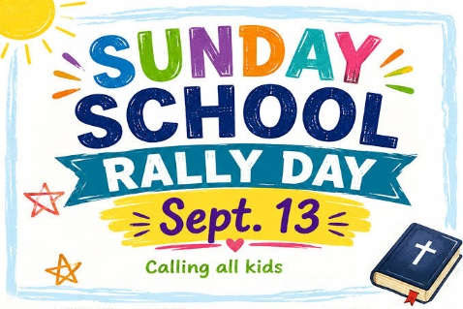
Rally Sunday will be held on Sunday, September 13, immediately following worship in Bethany Hall. This year’s theme will be “God’s Work. Our Hands.”
There will be projects for all ages and abilities. This is an intergenerational event, and we hope everyone will join us as we work together to serve others and share God’s love throughout our community!
Regular Sunday School for preschool through grade 8 will begin on Sunday, September 20, at 10:15 a.m. All students will gather in the chapel.


Please extend your hands of comfort to Duane and Caren Johnson on the passing of their nephew, Randy Lee. Randy passed away on Sunday, August 30th. Funeral arrangements are pending at this time. May God comfort the family during this difficult time.

Prayers for the People

Health for Members
Carol Norman, Alvina Pitt, Steve Ketelsen, Dave Anspach,
Alissa Warner, Wayne & Phyllis Berglund, Dave Saue, Bea Hoppe,
Don Schwarz, Tom Birkey, Penny Worsech, Curtis Winters,
Amy Rodeberg, Bob Erickson, Edith Hendrickson, Don Haugerud, Dianne Dvergsten, Nancy Dack, Diane & Dennis Loose, Darlene Ulven, Tom Albrecht, Paul Arends, Lynette Arends, Lee Kvanli, Kathy Gilkey, and Marvin Jensen.

Health for Others

Name Requested By
Sherri Bjornberg Jennifer Hauge
Rodney Pitt Alvina Pitt
Howard Gatchell Sherri Gatchell
Hakki Kalpek, Karen Hemmingson Lois & DeVon Vien
Steve Johnson Carol Norman
Jill Giinthir Allison Voorhees
Renae Eckberg, John Eckberg Pastor Marie Eckberg
Lisa Lund Sally Groothuis
Janice Lund, Nona Wallert Lois Christenson
Amerie Tell, Mitch Augeson, Terry Hermanson Sally Groothuis
Tim & Andrea Dreier Mary Ann Nordaune
Tim Johnson, Mike Halvorson Lois & DeVon Vien
Lyn Bonnema Margit Bonnema
Delores Bursack Deb & Jerry Larson
Linda Bendickson, Brenda Ulven Darlene Ulven
Trevor Hansen Pat & Ron Binnebose
Andi Moon Pam & Dave Arneson
Jim & Jody Renbarger Barb Smith

Serving in the Military
Kadin Brabender, cousin of Darren & Wendy Augeson;
Bowen Tesch, grandson of Jim & Deb Bowen; Paul Evenson,
son-in-law of Bill & Karyn Maass; Dennis DeJong, friend of Lois Christenson; Sean Prior, grandson of DeVon & Lois Vien; Justin Olsen, grandson of Ken & Janice Olsen; Alan Gronewold, son of Gladys Nelson; Tyler Meyenburg, son of Rick & Mort Meyenburg;
Kirk Larson & Ross Larson, sons of Jerry & Deb Larson;
Daniel Harter & Shane McDonald, sons-in-law of Susan Marcinkowski.

15th Sunday after Pentecost
September 6, 2026
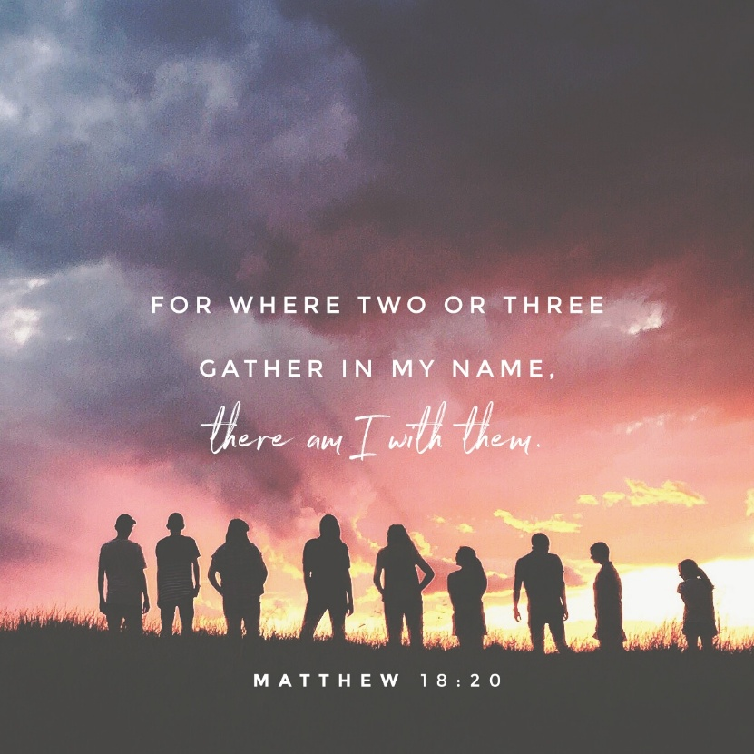


OUR SAVIOR’S LUTHERAN
222 NORTH 5TH STREET
MONTEVIDEO, MN
320-269-8824
www.oslcmonte.com
Week of September 7th through September 13th
Monday Office Closed
Tuesday
10:15 am Staff Meeting
10:30 am Worship on Channel 180
Wednesday
9:30 am Altar Guild
12:30 pm Executive Board
2:30 pm Worship on Channel 180
5:00 pm Church Council
6:30 pm Confirmation Parent Meeting
Thursday
10:30 am Worship on Channel 180
Friday – Office open till Noon
Sunday
9:00 am Praise Worship/7th Grade Bibles/
Blessing of Backpacks
10:15 am Rally Sunday
11:00 am Worship on KDMA 93.9 FM

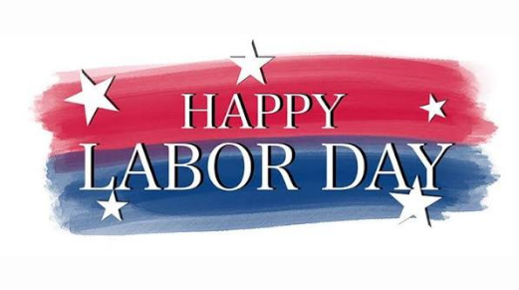
Reminder the Church Office will be closed on Monday, September 7th in honor of Labor Day!

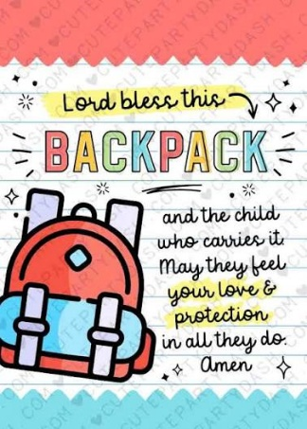
The Blessing of the Backpacks will take place during worship on September 13th. All students are encouraged to bring their backpacks to church to receive a special blessing for the new school year.

First Reading: Ezekiel 33:7-11
God appointed Ezekiel as a sentinel for the house of Israel. Ezekiel must faithfully convey God’s warnings to the people. Remarkably, God—who is about to attack Jerusalem—gives a warning with the hope that repentance will make the attack unnecessary.

⁷ So you, mortal, I have made a sentinel for the house of Israel; whenever you hear a word from my mouth, you shall give them warning from me. ⁸ If I say to the wicked, “O wicked ones, you shall surely die,” and you do not speak to warn the wicked to turn from their ways, the wicked shall die in their iniquity, but their blood I will require at your hand. ⁹ But if you warn the wicked to turn from their ways and they do not turn from their ways, the wicked shall die in their iniquity, but you will have saved your life.
¹⁰ Now you, mortal, say to the house of Israel: Thus you have said: “Our transgressions and our sins weigh upon us, and we waste away because of them; how then can we live?” ¹¹ Say to them: As I live, says the Lord God, I have no pleasure in the death of the wicked but that the wicked turn from their ways and live; turn back, turn back from your evil ways, for why will you die, O house of Israel?

Prayer of the Day
O Lord God, enliven and preserve your church with your perpetual mercy. Without your help, we mortals will fail; remove far from us everything that is harmful and lead us toward all that gives life and salvation, through Jesus Christ, our Savior and Lord.
Amen.

Second Reading: Romans 13:8-14
The obligation of Christians is to love one another and so fulfill the heart and goal of the law. Clothes make the person as we “put on the Lord Jesus Christ” and live today in light of the future God has in store for us.

⁸ Owe no one anything, except to love one another, for the one who loves another has fulfilled the law. ⁹ The commandments, “You shall not commit adultery; you shall not murder; you shall not steal; you shall not covet,” and any other commandment, are summed up in this word, “You shall love your neighbor as yourself.” ¹⁰ Love does no wrong to a neighbor; therefore, love is the fulfilling of the law.
¹¹ Besides this, you know what time it is, how it is already the moment for you to wake from sleep. For salvation is nearer to us now than when we became believers; ¹² the night is far gone; the day is near. Let us then throw off the works of darkness and put on the armor of light; ¹³ let us walk decently as in the day, not in reveling and drunkenness, not in illicit sex and licentiousness, not in quarreling and jealousy. ¹⁴ Instead, put on the Lord Jesus Christ, and make no provision for the flesh, to gratify its desires.
___________________________________________________


Do you know someone who goes above and beyond in serving our church and community?
We are now accepting nominations for Volunteer of the Year! Please take a moment to nominate someone whose time, talents, and dedication have made a difference.
Nominate someone today!
Submit your nomination by dropping it off in the box at the back of the church by October 25th.
Thank you for helping us recognize and celebrate the wonderful volunteers who make our church family special!

Gospel: Matthew 18:15-20
Jesus offers practical advice to his disciples on how individuals—and the church as a whole—should go about restoring relationships when one member has sinned against another.

Jesus said to the disciples: ¹⁵ “If your brother or sister sins against you, go and point out the fault when the two of you are alone. If you are listened to, you have regained that one. ¹⁶ But if you are not listened to, take one or two others along with you, so that every word may be confirmed by the evidence of two or three witnesses. ¹⁷ If that person refuses to listen to them, tell it to the church, and if the offender refuses to listen even to the church, let such a one be to you as a gentile and a tax collector. ¹⁸ Truly I tell you, whatever you bind on earth will be bound in heaven, and whatever you loose on earth will be loosed in heaven. ¹⁹ Again, truly I tell you, if two of you agree on earth about anything you ask, it will be done for you by my Father in heaven. ²⁰ For where two or three are gathered in my name, I am there among them.”

7th Grade Study Bibles
Attention 7th graders and parents! Watch your mail for important information about receiving your Study Bible during worship on September 13th.

3rd Grade Kingstone Bible Set
Attention 3rd graders and parents! Watch your mail for important information about receiving your Kingstone Bible Set during worship on September 20th.

We look forward to celebrating these special milestones with your children!


