ORDER FOR PRAISE WORSHIP

9th Sunday After Pentecost – August 10, 2025

**WE PREPARE FOR WORSHIP** – (Silence and Prayer are appropriate)

Prelude

Call to Worship – *In Christ, A New Creation* See Screen

Announcements

**WE PRAY AND PRAISE**

Opening Song *– The Light of Christ* See Screen

Blessed be the Holy Trinity, **☩** one God, our creator, our protector, our wellspring of life. **Amen.**

Trusting that God receives our words and the meditations of our hearts, let us confess our sin.

*Silence is kept for reflection.*

Merciful God,

**You speak blessing and compassion into the world. Forgive us for the ways we act with judgment, cruelty, or indifference. We ignore the needs of our neighbors; we resist your call to oppose injustice; we give in to scarcity and fear; we assume the worst about one another. Cleanse us from our faults and release us from their grasp. Show us your lovingkindness. Restore our hearts and repair your world, that we may live in Christ’s ways. Amen.**

God proclaims these words of assurance: “Do not fear, for I have redeemed you. I have called you by name. You are mine.” In **☩** Christ, you are forgiven. In the Spirit, you are made free. Refreshed by the waters of mercy, live anew as beloved children of God. **Amen.**

Kyrie Eleison Page 184

Glory to God Page 185

Prayer of the Day

**WE HEAR GOD’S WORD**

First Lesson – Genesis 15:1-6

Second Lesson – Hebrews 11:1-3, 8-16

*Gospel Acclamation* Page 188

Gospel – Luke 12:32-40

Children’s Moment

Sermon – Pastor Don

Pulpit Hymn – *Shine, Jesus Shine* See Screen

**WE OFFER OURSELVES TO GOD**

Praise Worship Creed

**C:** We believe in God, the one who comes before us and goes behind us, creating life and opportunities to love and care for the world.

**C:** We believe in Jesus Christ, who walks with us into real life each day. He is God, yet human like us and he experienced all life’s joys, pains, challenges like we do. But his love is so great that not even sin nor suffering or even death could stop his love. Today, the love of Jesus lives and continues to bring new life to the world.

**C:** We believe in the Holy Spirit that comes like the wind and blows in and through us to bring God’s power and light to all the world. The Spirit breathes life into us, the body of Christ we call the church, and enables us to follow the way of Christ. Amen.

Prayers of the Church   
Prayer Song – *Hear Our Prayer* #178

Lord’s Prayer Sung

Offering / Offering Prayer

**WE GO TO SERVE THE LORD**

Benediction  
Sending Song – *This Little Light of Mine* #677

Postlude

**Ministry of Caring – Please pray for the following.**

**Health for Members**

Don Haugerud; Vernon Loose; Sheryl Maus; Bea Hoppe;

Lois Christenson;Dianne Dvergsten; Kyle Haase; Darwin TeBeest;

Jenell Dahl; Nancy Dack; Diane & Dennis Loose; Mike Fagen;

Julie Rhode; Lowell Hanson; Darlene Ulven; Tom Albrecht; Pastor Chris; Don Maland; Paul Arends; Marvin & Gayle Jensen; Lynette Arends;

Curt Winters; Marilyn Kvanli and Kathy Gilkey.

**Health for Others**

**Name****Requested By**

Delores McKee Pastor Don McKee

Cathy Teske Pam Haugerud

Tim & Andrea Dreier Mary Ann Nordaune

Jerry Cronen Karen Kepner

Tim Johnson, Hakki Kalpek, Mike Halvorson Lois & DeVon Vien

Lyn Bonnema Margit Bonnema

Renae Eckberg Pastor Marie Eckberg

Delores Bursack Deb & Jerry Larson

Neal Dalton Doris Larson

Randy Lee Caren & Duane Johnson

Linda Bendickson, Brenda Ulven Darlene Ulven

Trevor Hansen Pat & Ron Binnebose

Pete Ziegler Rosie Dehli

Gina Jung Thorne Sue Varpness

Willard Arnold Yvonne Ward

Andi Moon Pam & Dave Arneson

Jim & Jody Renbarger Barb Smith

**Serving in the Military**

**Bowen Tesch,** grandson of Jim & Deb Bowen; **Paul Evenson,** son-in-law of Karyn Maass; **Dennis DeJong,** friend of Lois Christenson;

**Sean Prior,** grandson of DeVon & Lois Vien; **Justin Olsen,** grandson of Ken & Janice Olsen; **Alan Gronewold,** son of Gladys Nelson;

**Tyler Meyenburg,** son of Rick & Mort Meyenburg;

**Kirk Larson &** **Ross Larson,** sons of Jerry & Deb Larson;

**Daniel Harter & Shane McDonald,** sons-in-law of Susan Marcinkowski.

**9th Sunday**

**After Pentecost**

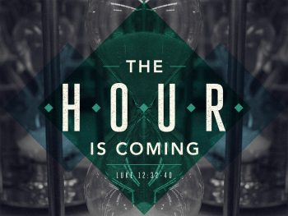**August 10, 2025**

**OUR SAVIOR’S LUTHERAN**

**222 NORTH 5TH STREET**

**MONTEVIDEO, MN**

**320-269-8824**

[**www.oslcmonte.com**](http://www.oslcmonte.com)

**Week of August 11th through August 17th**

**Monday – Office Closed**

5:30 pm Vacation Bible School

**Tuesday**

10:15 am Staff Meeting

10:30 am Worship on Channel 180

11:30 am Altar Guild @ The Rivers

2:00 pm Brookside Communion

5:30 pm Vacation Bible School

**Wednesday**

2:30 pm Worship on Channel 180

**Thursday**

9:00 am Senior Advisory

10:30 am Worship on Channel 180

**Friday – Office Closed**

**Sunday**

9:00 am Worship

11:00 am Worship on KDMA 1460

12:30 pm Senior Lites Barn Theater Trip

**Remember to join us tonight for the start of**

**Vacation Bible School**

**See you at 5:30 pm!**

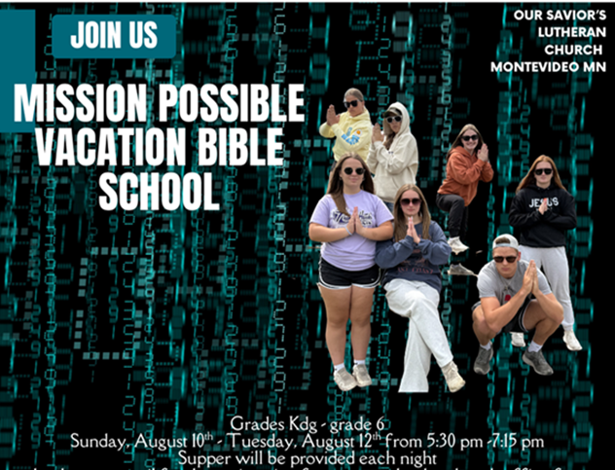

**First Reading: Genesis 15:1-6**

God promises childless and aging Abram that a child of his own will be his heir and that his descendants will number as many as the stars. Abram trusts God’s promise, and through this faith he is considered righteous.

1 After these things the word of the Lord came to Abram in a vision, “Do not be afraid, Abram, I am your shield; your reward shall be very great.” 2 But Abram said, “O Lord God, what will you give me, for I continue childless, and the heir of my house is Eliezer of Damascus?” 3 And Abram said, “You have given me no offspring, so a slave born in my house is to be my heir.” 4 But the word of the Lord came to him, “This man shall not be your heir; no one but your very own issue shall be your heir.” 5 He brought him outside and said, “Look toward heaven and count the stars, if you are able to count them.” Then he said to him, “So shall your descendants be.” 6 And he believed the Lord, and the Lord reckoned it to him as righteousness.

**Summer Worship at Our Savior’s** is an opportunity for us to celebrate as we gather and share our faith in Jesus Christ. Remember to greet those around you this morning.

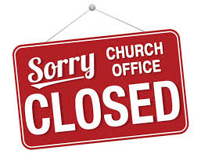

**The office will be closed** this week on Monday, August 11. Sorry for any inconvenience this may cause.



**Remember, there is still time to sign-up** for the Senior Lites trip to the Barn Theater on Sunday,

August 17th. Contact the church office at

269-8824.

**Second Reading: Hebrews 11:1-3, 8-16**

Abraham and Sarah exemplify the vision of faith that people of God enact in every age. Their hope and trust in God’s promise allowed them to face an unknown future and to receive the promise of God.

1 Now faith is the assurance of things hoped for, the conviction of things not seen. 2 Indeed, by faith our ancestors received approval. 3 By faith we understand that the worlds were prepared by the word of God, so that what is seen was made from things that are not visible.  
  
  8 By faith Abraham obeyed when he was called to set out for a place that he was to receive as an inheritance, and he set out, not knowing where he was going. 9 By faith he stayed for a time in the land he had been promised, as in a foreign land, living in tents, as did Isaac and Jacob, who were heirs with him of the same promise. 10 For he looked forward to the city that has foundations, whose architect and builder is God. 11 By faith, with Sarah’s involvement, he received power of procreation, even though he was too old, because he considered him faithful who had promised. 12 Therefore from one person, and this one as good as dead, descendants were born, “as many as the stars of heaven and as the innumerable grains of sand by the seashore.”  
  13 All of these died in faith without having received the promises, but from a distance they saw and greeted them. They confessed that they were strangers and foreigners on the earth, 14 for people who speak in this way make it clear that they are seeking a homeland. 15 If they had been thinking of the land that they had left behind, they would have had the opportunity to return. 16 But as it is, they desire a better homeland, that is, a heavenly one. Therefore, God is not ashamed to be called their God; indeed, he has prepared a city for them.

**Gospel: Luke 12:32-40**

Jesus encourages disciples to invest their hearts and live fully into God’s reign. Instead of facing life with fear, those who know God’s generosity are always ready to receive from God and to give to others.

Jesus said: 32 “Do not be afraid, little flock, for it is your Father’s good pleasure to give you the kingdom. 33 Sell your possessions and give alms. Make purses for yourselves that do not wear out, an unfailing treasure in heaven, where no thief comes near and no moth destroys. 34 For where your treasure is, there your heart will be also.  
  
  35 “Be dressed for action and have your lamps lit; 36 be like those who are waiting for their master to return from the wedding banquet, so that they may open the door for him as soon as he comes and knocks. 37 Blessed are those slaves whom the master finds alert when he comes; truly I tell you, he will fasten his belt and have them sit down to eat, and he will come and serve them. 38 If he comes during the middle of the night or near dawn and finds them so, blessed are those slaves.  
  39 “But know this: if the owner of the house had known at what hour the thief was coming, he would not have let his house be broken into. 40 You also must be ready, for the Son of Man is coming at an hour you do not expect.”

**Prayer of the Day**

Almighty God, you sent your Holy Spirit to be the life and light of your church. Open our hearts to the riches of your grace, that we may be ready to receive you wherever you appear, through Jesus Christ, our Savior and Lord.

**Amen.**