ORDER FOR WORSHIP

7th Sunday After Pentecost – July 27, 2025

**WE PREPARE FOR WORSHIP** - (Silence and Prayer is appropriate)

Prelude

Announcements

Confession/Absolution Page 94

**WE SING PRAISES TO GOD**

Entrance Hymn – *Open Now Thy Gates of Beauty (vs.1,2,4)* #533

Greeting & Kyrie Page 203

Hymn of Praise – *Come Let Us Join* Page 204

Prayer of the Day

**WE HEAR THE WORD**

First Lesson – Genesis 18:20-32

Special Music – *I’ll Walk with God* Jerome Fragodt

Second Lesson – Colossians 2:6-19

Gospel Acclamation – *Alleluia*  Page 205

Gospel – Luke 11:1-13

Children’s Moment

Sermon – Pastor Don

**WE RESPOND WITH SONGS AND STATEMENTS**

Pulpit Hymn – *What a Friend We Have in Jesus* #742

The Apostles’ Creed Page 105

Prayers of the Church

**WE OFFER GIFTS TO GOD AS WE SAY THANKS**

Offering

Offertory – *Let the Vineyards be Fruitful* #182

Offertory Prayer

**WE EAT AND DRINK TOGETHER IN CHRIST**

Words of Institution Page 108

Lord’s Prayer Page 208

*O Lamb of God* Page 208

**WE LEAVE TO DO OUR WORK ON GOD’S BEHALF**

Distribution/Closing Prayer

Benediction

Sending Song – *Go, My Children, with My Blessing* #543

Postlude

**Summer Worship at Our Savior’s Lutheran** is an opportunity for us to celebrate our differences as we gather for that which makes us one: our faith in Jesus Christ. Activity bags are available near the doors for the kids to enjoy.

**The Vase of Flowers** is given in loving memory of Matthew Maus from Auntie Mona. You are forever in my heart!

**Today’s Radio Broadcast** is given in memory of Gene Christenson on what would have been our 69th Wedding Anniversary on July 28th and the 20th anniversary of Gene’s passing on August 2nd from

Lois Christenson.

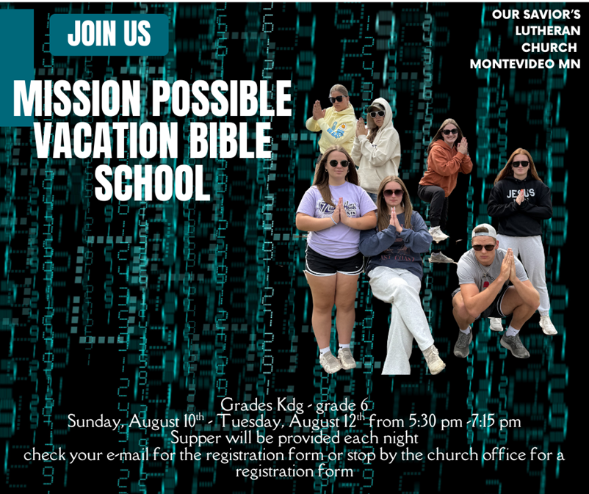

**Ministry of Caring – Please pray for the following.**

**Health for Members**

Vernon Loose; Sheryl Maus; Bea Hoppe; Lois Christenson;

Dianne Dvergsten; Kyle Haase; Darwin TeBeest; Jenell Dahl;

Wayne & Phyllis Berglund; Nancy Dack; Diane & Dennis Loose;

Mike Fagen; Julie Rhode; Lowell Hanson; Darlene Ulven; Tom Albrecht; Pastor Chris; Don Maland; Paul Arends; Marvin & Gayle Jensen;

Lynette Arends; Curt Winters; Marilyn Kvanli and Kathy Gilkey.

**Health for Others**

**Name****Requested By**

Adam Norman Lori Huntley

Cathy Teske Pam Haugerud

Tim & Andrea Dreier Mary Ann Nordaune

Jerry Cronen Karen Kepner

Tim Johnson, Hakki Kalpek, Mike Halvorson Lois & DeVon Vien

Mary Howard Pat Nokleby

Lyn Bonnema Margit Bonnema

Renae Eckberg Pastor Marie Eckberg

Delores Bursack Deb & Jerry Larson

Neal Dalton Doris Larson

Randy Lee Caren & Duane Johnson

Linda Bendickson, Brenda Ulven Darlene Ulven

Trevor Hansen Pat & Ron Binnebose

Pete Ziegler Rosie Dehli

Gina Jung Thorne Sue Varpness

Willard Arnold Yvonne Ward

Andi Moon Pam & Dave Arneson

Manolette Payne Dode Aronson

Jim & Jody Renbarger Barb Smith

**Serving in the Military**

**Paul Evenson,** son-in-law of Karyn Maass; **Dennis DeJong,** friend of Lois Christenson; **Sean Prior,** grandson of DeVon & Lois Vien;

**Justin Olsen,** grandson of Ken & Janice Olsen; **Alan Gronewold,** son of Gladys Nelson; **Tyler Meyenburg,** son of Rick & Mort Meyenburg;

**Kirk Larson &** **Ross Larson,** sons of Jerry & Deb Larson;

**Daniel Harter & Shane McDonald,** sons-in-law of Susan Marcinkowski.

**7th Sunday**

**after Pentecost**

**July 27, 2025**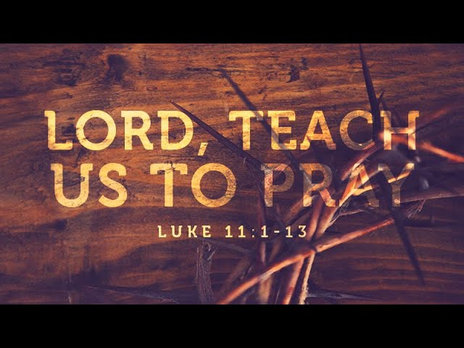

**OUR SAVIOR’S LUTHERAN**

**222 NORTH 5TH STREET**

**MONTEVIDEO, MN**

**320-269-8824**

[**www.oslcmonte.com**](http://www.oslcmonte.com)



**Prayer of the Day**

Almighty and ever-living God, you are always more ready to hear than we are to pray, and you gladly give more than we either desire or deserve. Pour upon us your abundant mercy. Forgive us those things that weigh on our conscience and give us those good things that come only through your Son, Jesus Christ, our Savior and Lord.

**Amen.**

**First Reading: Genesis 18:20-32**

*In today’s reading, Abraham undertakes the role of a mediator between God and sinful humanity. Appealing to God’s justice, Abraham boldly asks for mercy for the city of Sodom for the sake of the few righteous people there, including Abraham’s nephew, Lot.*

20 Then the Lord said, “How great is the outcry against Sodom and Gomorrah and how very grave their sin! 21 I must go down and see whether they have done altogether according to the outcry that has come to me, and if not, I will know.”  
  22 So the men turned from there and went toward Sodom, while Abraham remained standing before the Lord. 23 Then Abraham came near and said, “Will you indeed sweep away the righteous with the wicked? 24 Suppose there are fifty righteous within the city; will you then sweep away the place and not forgive it for the fifty righteous who are in it? 25 Far be it from you to do such a thing, to slay the righteous with the wicked, so that the righteous fare as the wicked! Far be that from you! Shall not the Judge of all the earth do what is just?” 26 And the Lord said, “If I find at Sodom fifty righteous in the city, I will forgive the whole place for their sake.” 27 Abraham answered, “Let me take it upon myself to speak to my lord, I who am but dust and ashes. 28 Suppose five of the fifty righteous are lacking? Will you destroy the whole city for lack of five?” And he said, “I will not destroy it if I find forty-five there.” 29 Again he spoke to him, “Suppose forty are found there.” He answered, “For the sake of forty I will not do it.” 30 Then he said, “Oh, do not let my lord be angry if I speak. Suppose thirty are found there.” He answered, “I will not do it, if I find thirty there.” 31 He said, “Let me take it upon myself to speak to my lord. Suppose twenty are found there.” He answered, “For the sake of twenty I will not destroy it.” 32 Then he said, “Oh, do not let my lord be angry if I speak just once more. Suppose ten are found there.” He answered, “For the sake of ten I will not destroy it.”

**Second Reading: Colossians 2:6-19**

*The writer of this letter warns the congregation in Colossae about “the empty lure” of philosophies and traditions that compromise faith. Through the gift of faith, the church is mystically connected with Christ in his death and resurrection which is enacted in baptism.*

6 As you therefore have received Christ Jesus the Lord, continue to walk in him, 7 rooted and built up in him and established in the faith, just as you were taught, abounding in thanksgiving.  
  8 Watch out that no one takes you captive through philosophy and empty deceit, according to human tradition, according to the elemental principles of the world, and not according to Christ. 9 For in him the whole fullness of deity dwells bodily, 10 and you have come to fullness in him, who is the head of every ruler and authority. 11 In him also you were circumcised with a spiritual circumcision, by the removal of the body of the flesh in the circumcision of Christ; 12 when you were buried with him in baptism, you were also raised with him through faith in the power of God, who raised him from the dead. 13 And when you were dead in trespasses and the uncircumcision of your flesh, God made you alive together with him, when he forgave us all our trespasses, 14 erasing the record that stood against us with its legal demands. He set this aside, nailing it to the cross. 15 He disarmed the rulers and authorities and made a public example of them, triumphing over them in it.   
  16 Therefore, do not let anyone condemn you in matters of food or drink or of observing festivals, new moons, or Sabbaths. 17 These are only a shadow of what is to come, but the body belongs to Christ. 18 Do not let anyone disqualify you, insisting on self-abasement and worship of angels, initiatory visions, puffed up without cause by a human way of thinking, 19 and not holding fast to the head, from whom the whole body, nourished and held together by its ligaments and tendons, grows with a growth that is from God.

**Gospel: Luke 11:1-13**

*In teaching his disciples this prayer, Jesus also reminds them to focus on God’s coming reign, God’s mercy, and the strengthening of the community. Jesus encourages his disciples to childlike trust and persistence in prayer.*

1 Jesus was praying in a certain place, and after he had finished, one of his disciples said to him, “Lord, teach us to pray, as John taught his disciples.”2 So he said to them, “When you pray, say:  
 Father, may your name be revered as holy.  
  May your kingdom come.  
  3 Give us each day our daily bread.  
  4 And forgive us our sins,  
   for we ourselves forgive everyone indebted to us.  
  And do not bring us to the time of trial.”  
  
  5 And he said to them, “Suppose one of you has a friend, and you go to him at midnight and say to him, ‘Friend, lend me three loaves of bread, 6 for a friend of mine has arrived, and I have nothing to set before him.’ 7 And he answers from within, ‘Do not bother me; the door has already been locked, and my children are with me in bed; I cannot get up and give you anything.’ 8 I tell you, even though he will not get up and give him anything out of friendship, at least because of his persistence he will get up and give him whatever he needs.  
  9 “So I say to you, Ask, and it will be given to you; search, and you will find; knock, and the door will be opened for you. 10 For everyone who asks receives, and everyone who searches finds, and for everyone who knocks, the door will be opened. 11 Is there anyone among you who, if your child asked for a fish, would give a snake instead of a fish? 12 Or if the child asked for an egg, would give a scorpion? 13 If you, then, who are evil, know how to give good gifts to your children, how much more will the heavenly Father give the Holy Spirit to those who ask him!”