ORDER FOR WORSHIP

6th Sunday After Pentecost – July 20, 2025

**WE PREPARE FOR WORSHIP** - (Silence and Prayer is appropriate)

Prelude

Announcements

Confession / Absolution Page 94

**WE SING PRAISES TO GOD**

Entrance Hymn – *Immortal, Invisible, God Only Wise* #834

Greeting & Kyrie Page 203

Hymn of Praise – *Glory be to God* Page 204

Prayer of the Day

**WE HEAR THE WORD**

First Lesson – Genesis 18:1-10a

Second Lesson – Colossians 1:15-28

Gospel Acclamation – *Alleluia* Page 205 Gospel – Luke 10:38-42

Children’s Moment

Sermon Pastor Michelle

**WE RESPOND WITH SONGS AND STATEMENT**

Pulpit Hymn – *Jesus, the Very Thought of You* #754

The Apostles’ Creed Page 105

**WE GIVE THANKS**

Offering

Offertory – *Create in Me a Clean Heart* #186

Prayers of the Church

The Lord’s Prayer Sung

**WE LEAVE TO DO OUR WORK ON GOD’S BEHALF**

Benediction

Sending Song – *O Savior, Precious Savior* #820

Postlude

**Welcome to Worship!** We're excited to see so many members and new visitors here to celebrate together in our church home. God has granted us so many gifts and opportunities to share God's love with everyone we meet.

**Today’s Altar Flowers** are given in memory of Gary Huntley on what would have been our 55th Wedding Anniversary on

July 18th from Barb Huntley.

**Today’s Radio Broadcast** is given in memory of Richard Oleson from Barb Oleson.



**Please extend your hands of comfort** to Julie and Gary Boettcher on the death of Julie’s mom, Grace Steffenson. She was also mother-in-law to Terry Dolven.

Blessed be her memory.

**Notice:** If you are using our blank temporary envelopes, like we give to new members, please make sure that you put your name on them so we can credit your giving account accordingly. Thank You!



**Get ready for Vacation Bible School on**

**August 10th, 11th & 12th**

**Parents, watch the mail for**

**information to come soon.**

**Ministry of Caring – Please pray for the following.**

**Health for Members**

Sheryl Maus; Bea Hoppe; Lois Christenson; Dianne Dvergsten;

Kyle Haase; Darwin TeBeest; Jenell Dahl; Wayne & Phyllis Berglund; Nancy Dack; Diane & Dennis Loose; Mike Fagen; Julie Rhode;

Lowell Hanson; Darlene Ulven; Tom Albrecht; Pastor Chris;

Don Maland; Paul Arends; Marvin & Gayle Jensen; Lynette Arends;

Curt Winters; Marilyn Kvanli and Kathy Gilkey.

**Health for Others**

**Name****Requested By**

Cathy Teske Pam Haugerud

Tim & Andrea Dreier Mary Ann Nordaune

Jerry Cronen Karen Kepner

Tim Johnson, Hakki Kalpek, Mike Halvorson Lois & DeVon Vien

Mary Howard Pat Nokleby

Lyn Bonnema Margit Bonnema

Renae Eckberg Pastor Marie Eckberg

Delores Bursack Deb & Jerry Larson

Neal Dalton Doris Larson

Randy Lee Caren & Duane Johnson

Linda Bendickson, Brenda Ulven Darlene Ulven

Trevor Hansen Pat & Ron Binnebose

Pete Ziegler Rosie Dehli

Gina Jung Thorne Sue Varpness

Willard Arnold Yvonne Ward

Andi Moon Pam & Dave Arneson

Manolette Payne Dode Aronson

Jim & Jody Renbarger Barb Smith

**Serving in the Military**

**Paul Evenson,** son-in-law of Karyn Maass; **Dennis DeJong,** friend of Lois Christenson; **Sean Prior,** grandson of DeVon & Lois Vien;

**Justin Olsen,** grandson of Ken & Janice Olsen; **Alan Gronewold,** son of Gladys Nelson; **Tyler Meyenburg,** son of Rick & Mort Meyenburg; **Kirk Larson &** **Ross Larson,** sons of Jerry & Deb Larson;

**Daniel Harter & Shane McDonald,** sons-in-law of Susan Marcinkowski.

**6th Sunday After Pentecost**

**July 20, 2025**



**OUR SAVIOR’S LUTHERAN**

**222 NORTH 5TH STREET**

**MONTEVIDEO, MN**

**320-269-8824**

[oursaviors@oslcmonte.net](mailto:oursaviors@oslcmonte.net)

**Week of July 21st through July 27th**

**Tuesday**

10:15 am Staff Meeting

10:30 am Worship on Channel 180

**Wednesday**

2:30 pm Worship on Channel 180

**Thursday**

10:30 am Worship on Channel 180

**Sunday**

9:00 am Worship/Holy Communion

10:15 am Coffee Fellowship

11:00 am Worship on KDMA 1460

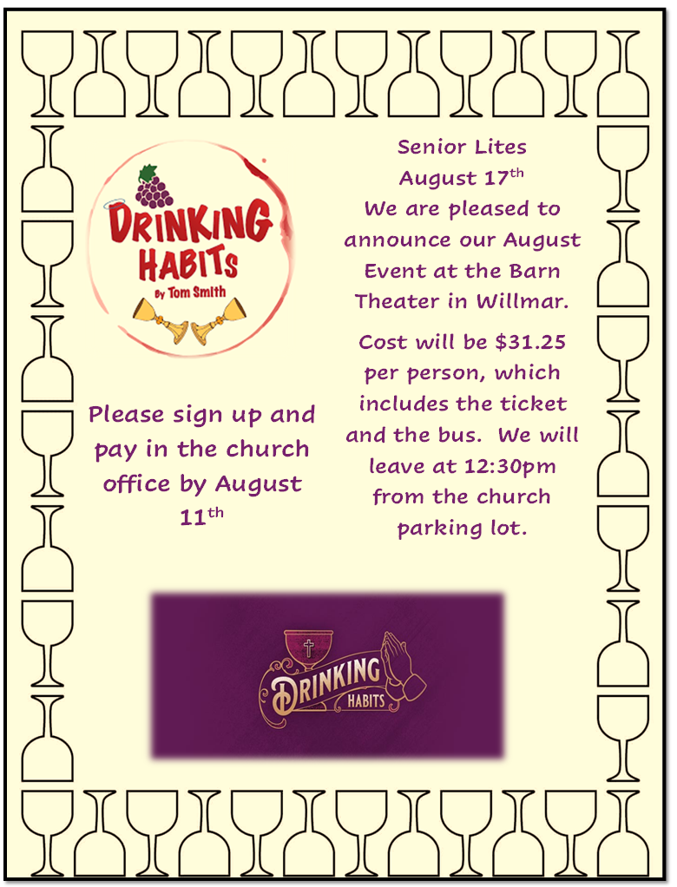

**First Reading: Genesis 18:1-10a**

The Lord visits Abraham and Sarah to tell them that the long-awaited promise of the birth of a child will be fulfilled for them in their old age.

1 The Lord appeared to Abraham by the oaks of Mamre, as he sat at the entrance of his tent in the heat of the day. 2 He looked up and saw three men standing near him. When he saw them, he ran from the tent entrance to meet them and bowed down to the ground. 3 He said, “My lord, if I find favor with you, do not pass by your servant. 4 Let a little water be brought, and wash your feet, and rest yourselves under the tree. 5 Let me bring a little bread, that you may refresh yourselves, and after that you may pass on—since you have come to your servant.” So they said, “Do as you have said.” 6 And Abraham hastened into the tent to Sarah and said, “Make ready quickly three measures of choice flour, knead it, and make cakes.” 7 Abraham ran to the herd and took a calf, tender and good, and gave it to the servant, who hastened to prepare it. 8 Then he took curds and milk and the calf that he had prepared and set it before them, and he stood by them under the tree while they ate.  
  9 They said to him, “Where is your wife Sarah?” And he said, “There, in the tent.” 10a Then one said, “I will surely return to you in due season, and your wife Sarah shall have a son.”

**Prayer of the Day**

Eternal God, you draw near to us in Christ, and you make yourself our guest. Amid the cares of our lives, make us attentive to your presence, that we may treasure your word above all else, through Jesus Christ, our Savior and Lord.

**Amen.**

**Second Reading: Colossians 1:15-28**

This letter offers a mystical teaching, that the great mystery of God is “Christ in you.” Because Christ is present in the church, Christians share in his life, suffering, and glory.

15 Christ Jesus is the image of the invisible God, the firstborn of all creation,16 for in him all things in heaven and on earth were created, things visible and invisible, whether thrones or dominions or rulers or powers—all things have been created through him and for him. 17 He himself is before all things, and in him all things hold together. 18 He is the head of the body, the church; he is the beginning, the firstborn from the dead, so that he might come to have first place in everything. 19 For in him all the fullness of God was pleased to dwell, 20 and through him God was pleased to reconcile to himself all things, whether on earth or in heaven, by making peace through the blood of his cross.  
  21 And you who were once estranged and hostile in mind, doing evil deeds, 22 he has now reconciled in his fleshly body through death, so as to present you holy and blameless and irreproachable before him, 23 provided that you continue securely established and steadfast in the faith, without shifting from the hope promised by the gospel that you heard, which has been proclaimed to every creature under heaven. I, Paul, became a minister of this gospel.  
  24 I am now rejoicing in my sufferings for your sake, and in my flesh I am completing what is lacking in Christ’s afflictions for the sake of his body, that is, the church. 25 I became its minister according to God’s commission that was given to me for you, to make the word of God fully known, 26 the mystery that has been hidden throughout the ages and generations but has now been revealed to his saints. 27 To them God chose to make known how great among the gentiles are the riches of the glory of this mystery, which is Christ in you, the hope of glory. 28 It is he whom we proclaim, warning everyone and teaching everyone in all wisdom, so that we may present everyone mature in Christ.

**Gospel: Luke 10:38-42**

During his visit to the home of Mary and Martha, Jesus reminds Martha that her concern for her many tasks distracts from the one thing that precedes all else: abiding in the presence of God.

38 Now as Jesus and his disciples went on their way, he entered a certain village where a woman named Martha welcomed him. 39 She had a sister named Mary, who sat at Jesus’s feet and listened to what he was saying. 40 But Martha was distracted by her many tasks, so she came to him and asked, “Lord, do you not care that my sister has left me to do all the work by myself? Tell her, then, to help me.” 41 But the Lord answered her, “Martha, Martha, you are worried and distracted by many things, 42 but few things are needed—indeed only one. Mary has chosen the better part, which will not be taken away from her.”

