ORDER FOR WORSHIP

Fourth Sunday after Pentecost – June 21, 2026
WE PREPARE FOR WORSHIP - (Silence and Prayer is appropriate)
Prelude
Announcements
Confession / Absolution Page 94

WE SING PRAISES TO GOD
Entrance Hymn – O God beyond All Praising #880
Greeting & Kyrie Page 203
Hymn of Praise – Glory be to God Page 204
Prayer of the Day

WE HEAR THE WORD
First Lesson – Jeremiah 20:7-13
Special Music – For the Lambs Sue Winters
Second Lesson – Romans 6:1b-11
Gospel Acclamation – Alleluia Page 205
Gospel – Matthew 10:24-39
Children’s Moment
Sermon – Pastor Michelle

WE RESPOND WITH SONGS AND STATEMENT
Pulpit Hymn – How Firm a Foundation #796
The Apostles’ Creed Page 105

WE GIVE THANKS
Offering
Offertory – Create in Me a Clean Heart #186
Prayers of the Church
The Lord’s Prayer Sung

WE LEAVE TO DO OUR WORK ON GOD’S BEHALF
Benediction
Sending Song – If You but Trust in God to Guide You #769
Postlude


Welcome to Worship! We are glad you’re here today. Whether you are joining us in person or online, we pray that this time of worship brings you peace, encouragement, and a deeper connection with God. Please take a moment to prepare your heart as we gather in praise, prayer, and reflection. Everyone is welcome here, come as you are. Let us worship together!

Today’s Altar Flowers and Radio Broadcast are given in honor of all the wonderful fathers in our congregation and community. We give thanks for their love, guidance, faithfulness, and the many ways they bless our lives.
___________________________________________________

Please extend your hands of comfort to Tom and Leanna Albrecht on the death of their son, Brian. He died in Texas at the young age of 54. May God Bless all who mourn.
______________________________________

Our Summer Coffee Fellowship is a wonderful time to gather, connect, and enjoy refreshments together after worship. However, this tradition can only continue if we have volunteers to help host.
If you’re willing to provide treats and assist with setup/cleanup on a Sunday this summer, please sign up on the fellowship board in Bethany Hall (or contact the church office).
If we do not have enough people sign up, Coffee Fellowship will be paused for the summer months.
Thank you for helping make this time of fellowship possible!
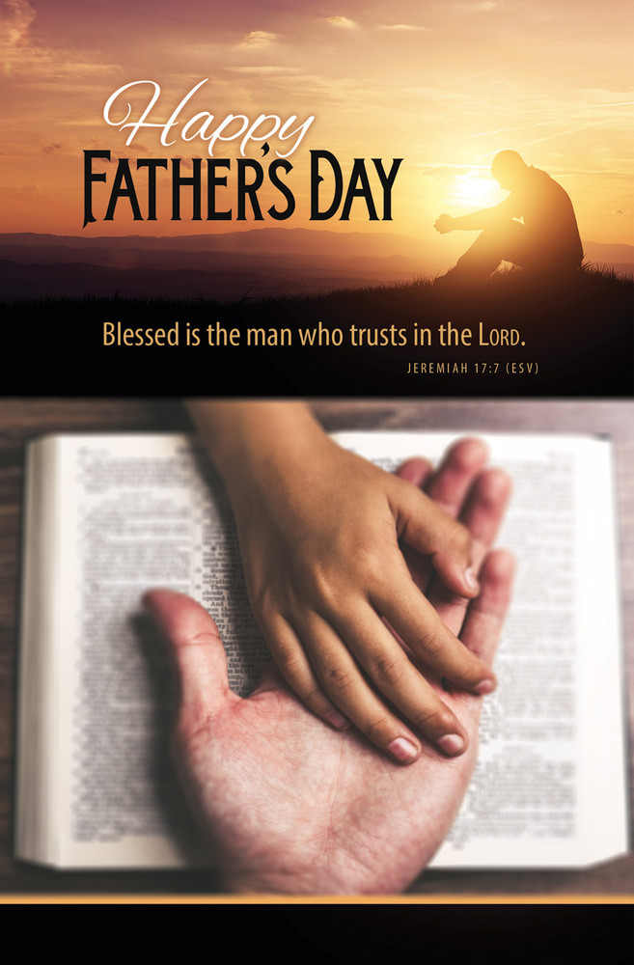
Ministry of Caring
We give thanks to God for God’s healing power. Your prayers have made a big difference in the lives of our people on this list. Please continue to pray for each person by name. As we offer our prayers, God’s love fills us with grace.

Health for Members

Dave Saue, Bea Hoppe, Tom Birkey, Penny Worsech, Curtis Winters, Lisa Ketelsen Anderson, Randy Hanson, Amy Rodeberg, Bob Erickson,
Edith Hendrickson, Andy Anderson, Don Haugerud, Dianne Dvergsten, Nancy Dack, Diane & Dennis Loose, Darlene Ulven, Tom Albrecht,
Don Maland, Paul Arends, Lynette Arends, Lee Kvanli, Marvin Jensen, and Kathy Gilkey.

Health for Others
Name Requested By
Howard Gatchell Sherri Gatchell
Hakki Kalpek, Karen Hemmingson Lois & DeVon Vien
Steve Johnson Carol Norman
Jill Giinthir Allison Voorhees
Janice Lund, Nona Wallert Lois Christenson
Amerie Tell, Mitch Augeson, Terry Hermanson Sally Groothuis
Tim & Andrea Dreier Mary Ann Nordaune
Tim Johnson, Mike Halvorson Lois & DeVon Vien
Lisa Lund Sally Groothuis
Lyn Bonnema Margit Bonnema
Renae Eckberg Pastor Marie Eckberg
Delores Bursack Deb & Jerry Larson
Randy Lee Caren & Duane Johnson
Linda Bendickson, Brenda Ulven Darlene Ulven
Trevor Hansen Pat & Ron Binnebose
Andi Moon Pam & Dave Arneson
Jim & Jody Renbarger Barb Smith

Serving in the Military
Kadin Brabender, cousin of Darren & Wendy Augeson;
Bowen Tesch, grandson of Jim & Deb Bowen; Paul Evenson,
son-in-law of Bill & Karyn Maass; Dennis DeJong, friend of Lois Christenson; Sean Prior, grandson of DeVon & Lois Vien;
Justin Olsen, grandson of Ken & Janice Olsen; Alan Gronewold, son of Gladys Nelson; Tyler Meyenburg, son of Rick & Mort Meyenburg; Kirk Larson & Ross Larson, sons of Jerry & Deb Larson; Daniel Harter & Shane McDonald, sons-in-law of
Susan Marcinkowski.
Week of May June 22nd through June 28th
Tuesday
10:15 am Staff Meeting
10:30 am Worship on Channel 180
Wednesday
2:30 pm Worship on Channel 180
Thursday
10:30 am Worship on Channel 180
Sunday
9:00 am Worship w/Holy Communion
11:00 am Worship on KDMA 93.9 FM

As you leave today, please be sure to pick up a Father’s Day gift available at the

back of the church.
First Reading: Jeremiah 20:7-13
Jeremiah accuses God of forcing him into a ministry that brings him only contempt and persecution. Yet Jeremiah is confident that God will be a strong protector against his enemies and commits his life into God’s hands.

⁷ O Lord, you have enticed me, and I was enticed;
you have overpowered me, and you have prevailed.
I have become a laughingstock all day long; everyone
mocks me.
⁸ For whenever I speak, I must cry out;
I must shout, “Violence and destruction!”
For the word of the Lord has become for me a reproach
and derision all day long.
⁹ If I say, “I will not mention him or speak any more in
his name,” then within me there is something like a
burning fire shut up in my bones; I am weary with holding
it in, and I cannot.
¹⁰ For I hear many whispering: “Terror is all around!
Denounce him! Let us denounce him!” All my close friends
are watching for me to stumble. “Perhaps he can be enticed,
and we can prevail against him and take our revenge
on him.”
¹¹ But the Lord is with me like a terrifying warrior;
therefore my persecutors will stumble, and they will
not prevail. They will be greatly shamed, for they will
not succeed. Their eternal dishonor will never be forgotten.
¹² O Lord of hosts, you test the righteous; you see the
heart and the mind; let me see your retribution upon them,
for to you I have committed my cause.
¹³ Sing to the Lord; praise the Lord! For he has
delivered the life of the needy from the hands of evildoers.

Second Reading: Roman 6:1b-11
In baptism we were incorporated into the reality of Christ’s death and resurrection. We have been made new in Christ through his death and resurrection to live freed from sin.

^{1b} Should we continue in sin in order that grace may increase? ² By no means! How can we who died to sin go on living in it? ³ Do you not know that all of us who were baptized into Christ Jesus were baptized into his death? ⁴ Therefore we were buried with him by baptism into death, so that, just as Christ was raised from the dead by the glory of the Father, so we also might walk in newness of life.

⁵ For if we have been united with him in a death like his, we will certainly be united with him in a resurrection like his. ⁶ We know that our old self was crucified with him so that the body of sin might be destroyed, so we might no longer be enslaved to sin. ⁷ For whoever has died is freed from sin. ⁸ But if we died with Christ, we believe that we will also live with him. ⁹ We know that Christ, being raised from the dead, will never die again; death no longer has dominion over him. ¹⁰ The death he died, he died to sin once for all, but the life he lives, he lives to God. ¹¹ So you also must consider yourselves dead to sin and alive to God in Christ Jesus.

Prayer of the Day
Teach us, good Lord God, to serve you as you deserve, to give and not to count the cost, to fight and not to heed the wounds, to toil and not to seek for rest, to labor and not to ask for reward, except that of knowing that we do your will, through Jesus Christ, our Savior and Lord.
Amen.

Gospel: Matthew 10:24-39
Jesus warns his disciples that their ministry in his name will meet with opposition. However, he assures them that they need not fear for the truth will come to light. Life is found in Christ.

Jesus said to the twelve: ²⁴ “A disciple is not above the teacher nor a slave above the master; ²⁵ it is enough for the disciple to be like the teacher and the slave like the master. If they have called the master of the house Beelzebul, how much more will they malign those of his household!
²⁶ “So have no fear of them, for nothing is covered up that will not be uncovered and nothing secret that will not become known. ²⁷ What I say to you in the dark, tell in the light, and what you hear whispered, proclaim from the housetops. ²⁸ Do not fear those who kill the body but cannot kill the soul; rather, fear the one who can destroy both soul and body in hell. ²⁹ Are not two sparrows sold for a penny? Yet not one of them will fall to the ground apart from your Father. ³⁰ And even the hairs of your head are all counted. ³¹ So do not be afraid; you are of more value than many sparrows.
³² “Everyone, therefore, who acknowledges me before others, I also will acknowledge before my Father in heaven, ³³ but whoever denies me before others, I also will deny before my Father in heaven.
³⁴ “Do not think that I have come to bring peace to the earth; I have not come to bring peace but a sword. ³⁵ For I have come to set a man against his father, and a daughter against her mother, and a daughter-in-law against her mother-in-law,
³⁶ and one’s foes will be members of one’s own household.
³⁷ “Whoever loves father or mother more than me is not worthy of me, and whoever loves son or daughter more than me is not worthy of me, ³⁸ and whoever does not take up the cross and follow me is not worthy of me. ³⁹ Those who find their life will lose it, and those who lose their life for my sake will find it.”

