ORDER FOR WORSHIP

Second Sunday after Pentecost – June 7, 2026
WE PREPARE FOR WORSHIP - (Silence and Prayer is appropriate)
Prelude
Announcements
Confession/Absolution Page 94

WE SING PRAISES TO GOD
Entrance Hymn – Praise to the Lord, the Almighty #858
Greeting & Kyrie Page 203
Hymn of Praise – Come Let Us Join Page 204
Prayer of the Day

WE HEAR THE WORD

First Lesson – Hosea 5:15-6:6
Second Lesson – Romans 4:13-25
Gospel Acclamation – Alleluia Page 205
Gospel – Matthew 9:9-13, 18-26
Children’s Moment
Sermon Pastor Michelle

WE RESPOND WITH SONGS AND STATEMENTS
Pulpit Hymn – Have No Fear, Little Flock #764
The Apostles’ Creed Page 105
Prayers of the Church

WE OFFER GIFTS TO GOD AS WE SAY THANKS
Offering
Offertory – Let the Vineyards be Fruitful #182
Offertory Prayer

WE EAT AND DRINK TOGETHER IN CHRIST
Words of Institution Page 108
Lord’s Prayer Page 208
Distribution/Closing Prayer

WE LEAVE TO DO OUR WORK ON GOD’S BEHALF
Benediction
Sending Song – Joyful, Joyful We Adore Thee #836
Postlude


Welcome to worship! We have a passion for people of all ages to gather in worship! Let us join our voices in celebration of God’s grace and join our hands in service for God’s people! We have activity bags available near the doors for the young.

Today’s Facebook Live is given in celebration of Jared Winter’s birthday on June 14th from Mom & Dad. Happy Birthday Jared!

Be a Blessing – Ways to Give!

You are invited to support our worship ministry by sponsoring:

• Altar Flowers $50 – In honor or memory of a loved one.
• Facebook Live Broadcast $100 – Helping us reach those worshiping from home.
• Radio Broadcast $100 – Sharing our services with the wider community.
Your sponsorship helps enhance our worship experience and extend our ministry beyond our walls. To sponsor a date, please sign up in the church office or call 269-8824. Thank you for your generosity and support.

“Don’t let your faith take a summer vacation! As attendance shifts during the summer months, your giving makes a difference – please consider donating to help the summer slump.”

Ministry of Caring
We give thanks to God for God’s healing power. Your prayers have made a big difference in the lives of our people on this list. Please continue to pray for each person by name. As we offer our prayers, God’s love fills us with grace.

Health for Members
Dave Saue, Bea Hoppe, Tom Birkey, Penny Worsech, Curtis Winters, Lisa Ketelsen Anderson, Randy Hanson, Amy Rodeberg, Bob Erickson, Edith Hendrickson, Andy Anderson, Don Haugerud, Dianne Dvergsten, Nancy Dack, Diane & Dennis Loose, Darlene Ulven, Tom Albrecht, Don Maland, Paul Arends, Lynette Arends, Lee Kvanli, Kathy Gilkey, and Marvin Jensen.

Health for Others

Name Requested By
Howard Gatchell Sherri Gatchell
Hakki Kalpek, Karen Hemmingson Lois & DeVon Vien
Steve Johnson Carol Norman
Jill Giinthir Allison Voorhees
Renae Eckberg Pastor Marie Eckberg
Lisa Lund Sally Groothuis
Janice Lund, Nona Wallert Lois Christenson
Amerie Tell, Mitch Augeson, Terry Hermanson Sally Groothuis
Tim & Andrea Dreier Mary Ann Nordaune
Tim Johnson, Mike Halvorson Lois & DeVon Vien
Lyn Bonnema Margit Bonnema
Delores Bursack Deb & Jerry Larson
Randy Lee Caren & Duane Johnson
Linda Bendickson, Brenda Ulven Darlene Ulven
Trevor Hansen Pat & Ron Binnebose
Andi Moon Pam & Dave Arneson
Jim & Jody Renbarger Barb Smith

Serving in the Military
Kadin Brabender, cousin of Darren & Wendy Augeson;
Bowen Tesch, grandson of Jim & Deb Bowen; Paul Evenson,
son-in-law of Bill & Karyn Maass; Dennis DeJong, friend of Lois Christenson; Sean Prior, grandson of DeVon & Lois Vien; Justin Olsen, grandson of Ken & Janice Olsen; Alan Gronewold, son of Gladys Nelson; Tyler Meyenburg, son of Rick & Mort Meyenburg;
Kirk Larson & Ross Larson, sons of Jerry & Deb Larson;
Daniel Harter & Shane McDonald, sons-in-law of Susan Marcinkowski.

Second Sunday after Pentecost
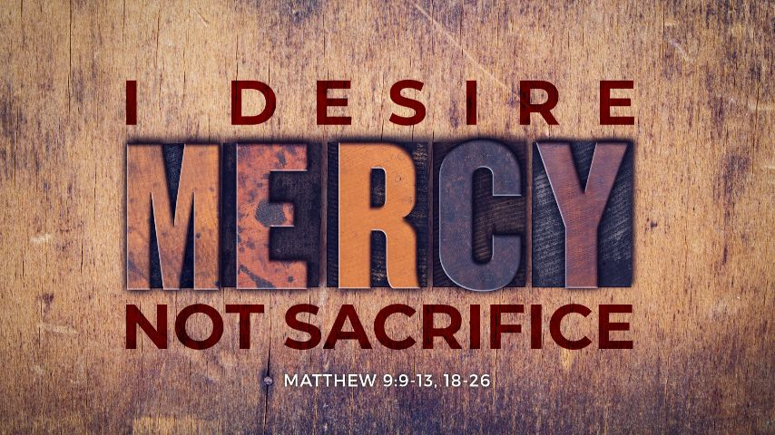
June 7, 2026


OUR SAVIOR’S LUTHERAN
222 NORTH 5TH STREET
MONTEVIDEO, MN
320-269-8824
www.oslcmonte.com

Week of June 8th through June 14th
Tuesday
10:15 am Staff Meeting
11:30 am Staff Support Meeting
10:30 am Worship on Channel 180
Wednesday
9:30 am Altar Guild
2:30 pm Worship on Channel 180
Thursday
10:30 am Worship on Channel 180
11:00 am Senior Communion
Sunday
9:00 am Praise Worship
11:00 am Worship on KDMA 93.9 FM

Senior Communion June 11th
Our Senior Communion event will be on Thursday, June 11th at 11:00 a.m., followed by a meal including chicken/pasta salad, fresh fruit, croissants, and strawberry shortcake parfaits.
This event is intended for Senior members, and for those for whom it is difficult to attend worship at our regular time on Sunday mornings.
Communion will be served in the pews by intinction, and wine and juice will
both be available.
If you require gluten free bread, please let
Pastor Michelle know ahead of time.
Looking forward to this opportunity to gather together
with the group!
Please call the church office at 269-8824 to sign up!

First Reading: Hosea 5:15-6:6
Because the people have trusted in military powers and not God, God decides to withdraw from the scene until Israel acknowledges its guilt and seeks God’s face. The response of the people does not acknowledge this guilt and is as fickle as fog or dew burned away quickly by the sun. God desires loyalty rather than words or meaningless deeds.

¹⁵ I will return again to my place
until they acknowledge their guilt and seek my face.
In their distress they will beg my favor:
^{6:1} “Come, let us return to the Lord,
for it is he who has torn, and he will heal us;
he has struck down, and he will bind us up.
² After two days he will revive us;
on the third day he will raise us up,
that we may live before him.
³ Let us know, let us press on to know the Lord;
his appearing is as sure as the dawn;
he will come to us like the showers,
like the spring rains that water the earth.”
⁴ What shall I do with you, O Ephraim?
What shall I do with you, O Judah?
Your love is like a morning cloud,
like the dew that goes away early.
⁵ Therefore I have hewn them by the prophets;
I have killed them by the words of my mouth,
and my judgment goes forth as the light.
⁶ For I desire steadfast love and not sacrifice,
the knowledge of God rather than burnt offerings.

Second Reading: Romans 4:13-25
Paul presents Abraham as a living model of right relationships. For Abraham and for us, a right relationship with God involves trusting that God’s promises will be fulfilled because God makes the dead alive and calls into existence what otherwise does not exist.

¹³ The promise that he would inherit the world did not come to Abraham or to his descendants through the law but through the righteousness of faith. ¹⁴ For if it is the adherents of the law who are to be the heirs, faith is null and the promise is void. ¹⁵ For the law brings wrath, but where there is no law, neither is there transgression.
¹⁶ For this reason the promise depends on faith, in order that it may rest on grace, so that it may be guaranteed to all his descendants, not only to the adherents of the law but also to those who share the faith of Abraham (who is the father of all of us, ¹⁷ as it is written, “I have made you the father of many nations”), in the presence of the God in whom he believed, who gives life to the dead and calls into existence the things that do not exist. ¹⁸ Hoping against hope, he believed that he would become “the father of many nations,” according to what was said, “So shall your descendants be.”

¹⁹ He did not weaken in faith when he considered his own body, which was already as good as dead (for he was about a hundred years old), and the barrenness of Sarah’s womb. ²⁰ No distrust made him waver concerning the promise of God, but he grew strong in his faith as he gave glory to God, ²¹ being fully convinced that God was able to do what he had promised. ²² Therefore “it was reckoned to him as righteousness.” ²³ Now the words, “it was reckoned to him,” were written not for his sake alone ²⁴ but for ours also. It will be reckoned to us who believe in him who raised Jesus our Lord from the dead, ²⁵ who was handed over for our trespasses and was raised for our justification.

Gospel: Matthew 9:9-13, 18-26
Jesus demonstrates God’s mercy and power, accepting the unacceptable and curing the incurable. Even the dead receive new life.

⁹ As Jesus was walking along, he saw a man called Matthew sitting at the tax-collection station, and he said to him, “Follow me.” And he got up and followed him.
¹⁰ And as he sat at dinner in the house, many tax collectors and sinners came and were sitting with Jesus and his disciples. ¹¹ When the Pharisees saw this, they said to his disciples, “Why does your teacher eat with tax collectors and sinners?” ¹² But when he heard this, he said, “Those who are well have no need of a physician, but those who are sick. ¹³ Go and learn what this means, ‘I desire mercy, not sacrifice.’ For I have not come to call the righteous but sinners.”
¹⁸ While he was saying these things to them, suddenly a leader came in and knelt before him, saying, “My daughter has just died, but come and lay your hand on her, and she will live.” ¹⁹ And Jesus got up and followed him, with his disciples. ²⁰ Then suddenly a woman who had been suffering from a flow of blood for twelve years came up behind him and touched the fringe of his cloak, ²¹ for she was saying to herself, “If I only touch his cloak, I will be made well.”

²² Jesus turned, and seeing her he said, “Take heart, daughter; your faith has made you well.” And the woman was made well from that moment. ²³ When Jesus came to the leader’s house and saw the flute players and the crowd making a commotion, ²⁴ he said, “Go away, for the girl is not dead but sleeping.” And they laughed at him. ²⁵ But when the crowd had been put outside, he went in and took her by the hand, and the girl got up. ²⁶ And the report of this spread through all of that district.

