OUR SAVIOR’S LUTHERAN CHURCH

PALM SUNDAY - MARCH 29, 2026

WE PREPARE FOR WORSHIP
Prelude
Announcements
Special Music – Sunday School Singers

Opening Hymn – All Glory, Laud, and Honor (vs.1,3,5) #344

P Today we follow Jesus, our humble King, into Jerusalem as he begins his final steps to the cross. As the Savior entered the city, a crowd followed him, waving palm branches and calling out, “Hosanna to the Son of David. Blessed is he who comes in the name of the Lord!”
C Hosanna in the highest!
P The prophet Zechariah foretold the way Jesus would enter Jerusalem: “Behold, your king is coming to you; righteous and having salvation is he, humble and mounted on a donkey, on a colt, the foal of a donkey” (Zechariah 9:9).
C Hosanna in the highest!
P The word hosanna means, “Save us!” The people longed for a king who would conquer their enemies and set up a glorious earthly kingdom.
C Save us now, Lord!
P The humble King did not come to set up an earthly kingdom. He came to save us by offering himself as the atoning sacrifice for the sins of the world. He came to bring us salvation and an eternal kingdom.
C Blessed is he who comes in the name of the Lord! Hosanna in the highest!

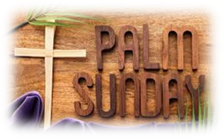
On this joyous Palm Sunday, we happily welcome each worshiper. In our hearts let us all praise our Lord and King, Jesus the Christ. If you are visiting with us and believe that in the Sacrament of Holy Communion, we receive God’s gift of life and forgiveness, we hope that you will join us at the Lord’s Table. We invite all who see God’s presence, to worship with us and share in this fellowship.

Today’s Radio Broadcast is given in memory of Keaton Vickers’ 20th anniversary in heaven from Bruce and Sherrie.


Please extend your hands of comfort to Jerry and Joan Christenson on the passing of Jerry’s brother, Tom Christenson. Tom’s funeral was held here at Our Savior’s on Saturday, March 28th. Blessed be his memory.

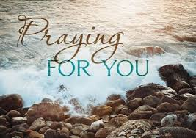
Please keep Mark Haugerud and Melissa Rodeberg and their family in your thoughts and prayers as they face the heartbreaking loss of their home due to a fire. May they find strength, comfort, and support during this incredibly difficult time. Praying they are surrounded by love and that brighter days come soon. ❤️ We invite you to support Mark & Melissa during this time of need. Donations can be made through their GoFundMe page:
https://gofund.me/7df5840ce or simply scan the QR Code below. Please keep them in your prayers.


Ministry Of Caring
We give thanks to God for God’s healing power. Your prayers have
made a big difference in the lives of our people on this list. Please continue to pray for each person by name. As we offer our prayers, God’s love fills us with grace.

Health for Members
Curtis Winters; Randy Hanson; Amy Rodeberg; Lance Tebben;
Bob Erickson; Edith Hendrickson; Andy Anderson; Don Haugerud; Dianne Dvergsten; Nancy Dack; Diane & Dennis Loose; Darlene Ulven; Tom Albrecht; Don Maland; Paul Arends; Lynette Arends; Lee Kvanli; Kathy Gilkey and Marvin & Gayle Jensen.

Health for Others

Name Requested By
Jill Giinthir Allison Voorhees
Renae Eckberg Pastor Marie Eckberg
Lisa Lund Kena Sonstegard
Janice Lund, Nona Wallert Lois Christenson
Amerie Tell, Mitch Augeson, Terry Hermanson Sally Groothuis
Tim & Andrea Dreier Mary Ann Nordaune
Tim Johnson, Mike Halvorson Lois & DeVon Vien
Lisa Lund Sally Groothuis
Lyn Bonnema Margit Bonnema
Delores Bursack Deb & Jerry Larson
Randy Lee Caren & Duane Johnson
Linda Bendickson, Brenda Ulven Darlene Ulven
Trevor Hansen Pat & Ron Binnebose
Andi Moon Pam & Dave Arneson
Jim & Jody Renbarger Barb Smith

Serving in the Military
Kadin Brabender, cousin of Darren & Wendy Augeson;
Bowen Tesch, grandson of Jim & Deb Bowen; Paul Evenson, son-in-law of Karyn Maass; Dennis DeJong, friend of Lois Christenson;
Sean Prior, grandson of DeVon & Lois Vien; Justin Olsen, grandson of Ken & Janice Olsen; Alan Gronewold, son of Gladys Nelson;
Tyler Meyenburg, son of Rick & Mort Meyenburg;
Kirk Larson & Ross Larson, sons of Jerry & Deb Larson;
Daniel Harter & Shane McDonald, sons-in-law of
Susan Marcinkowski.
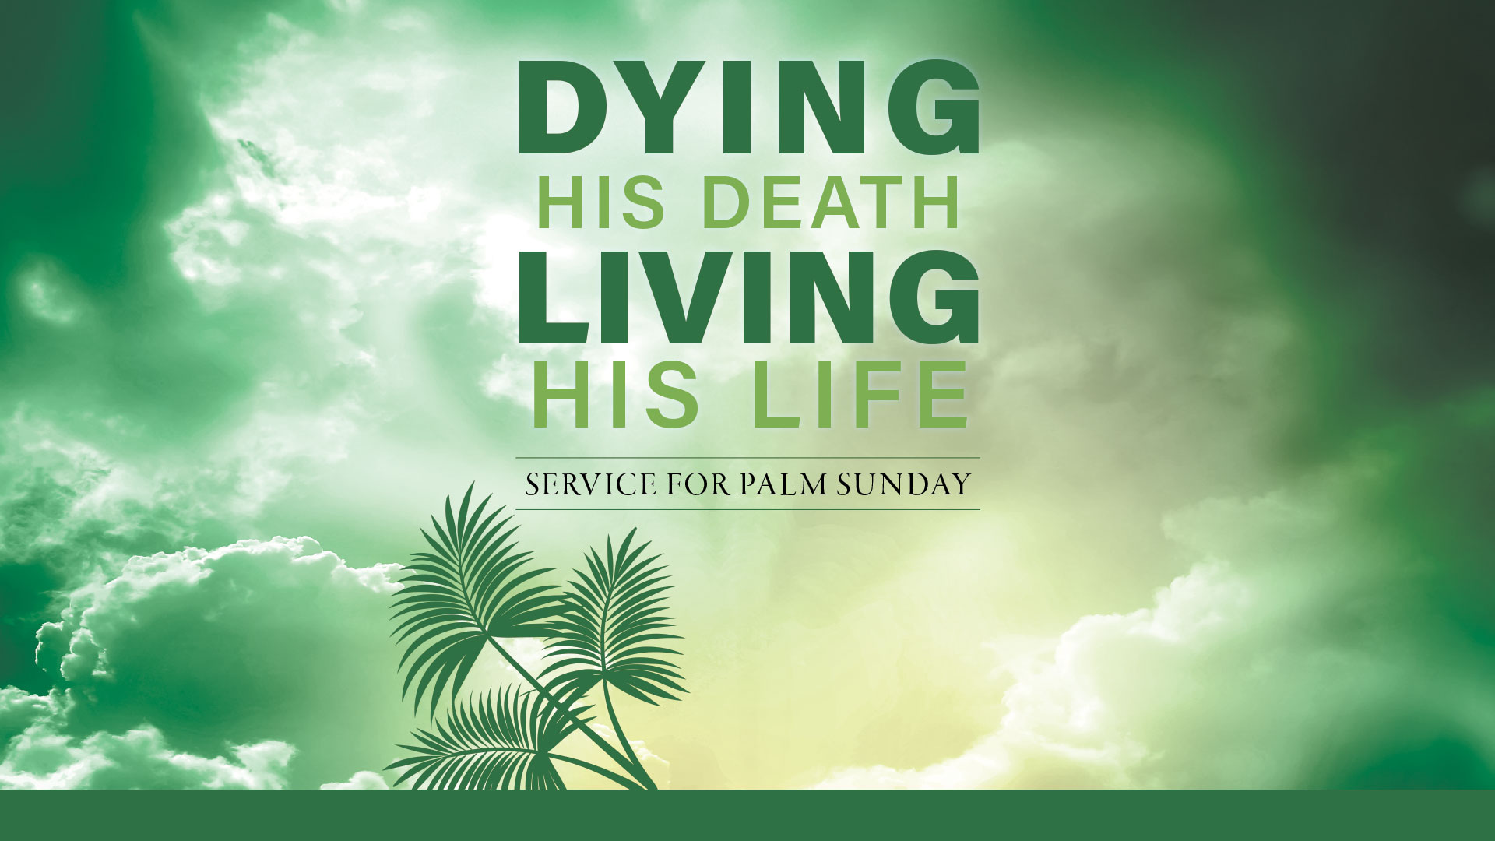

Week of March 30th through April 5th
Monday
9:00 am Quilting
Tuesday
9:00 am Quilting
10:15 am Staff Meeting
10:30 am Worship on Channel 180
Wednesday
7:00 am Roll with Jesus
9:30 am Martha Circle
2:30 pm Worship on Channel 180
7:00 pm Choir Practice
Thursday
10:30 am Worship on Channel 180
6:30 pm Maundy Thursday Worship Service
Friday
7:30 am Good Friday Prayer Vigil in Chapel
6:30 pm Good Friday Worship Service
Sunday
9:30 am Easter Sunday Worship/HC
11:00 am Worship on KDMA 93.9 FM Radio



Palms
When Jesus entered Jerusalem days before his death, crowds welcomed him by waving palm branches, which were common symbols of victory and rejoicing. And so, churches continue to use them in remembrance of that occasion, knowing that Jesus’ crucifixion was ultimately his triumph over sin and death. As early as Leviticus 23:40, God commanded Israel to use palms in a festival of rejoicing. In Revelation 7:9-10, Christian martyrs carried palm branches as they praised the Lamb before the throne of God.

The Confession and Absolution are spoken:
P Let us confess our sins to God and ask his forgiveness for the sake of Jesus, our King and Savior.
C Almighty God, we confess that we are often like the people of Jerusalem on that first Palm Sunday. We want a different kind of king. We want a king who will bring us earthly wealth or power or popularity. We seek things that will satisfy our own selfish desires. We do not follow in the humble steps of Jesus, our King. We do not seek to serve others in his name. Have mercy on us and forgive our sins.
P God has had mercy on us. He sent his Son to be our King and Savior. Jesus entered Jerusalem and took up his path to the cross. On the cross, he bore the burden of our sins in his own body so that we would be forgiven. I announce to you that your sins are forgiven in the name of the Father and of the + Son and of the Holy Spirit. Amen. Our King has saved us and set us free!
C Blessed is he who comes in the name of the Lord! Hosanna in the highest!

WE HEAR THE WORD
First Lesson – Isaiah 50:4-9a
Chimes & Bells
Second Lesson – Philippians 2:5-11
Lenten Verse – Return to the Lord Page 151
Gospel Reading – Matthew 21:1-11
Children’s Moment
Sermon Pastor Michelle

WE RESPOND WITH SONGS AND OFFERINGS
Pulpit Hymn – Ride On, Ride on in Majesty! #346
The Apostles’ Creed Page 105
The Prayers

P Jesus, you are the stone the builders rejected. You were rejected by the people you came to save. You were betrayed and crucified, and through your resurrection you became the cornerstone of your church. You are the cornerstone of our lives. Jesus, our King, blessed are you!
C Hosanna in the highest!
P Jesus, forgive us when we look for a different kind of king who will satisfy our own selfish desires. Forgive us when we do not love others as we should. You are the King who loves us. You are the King we need. You are the King who came to save us. Jesus, our King, blessed are you!
C Hosanna in the highest!
P Jesus, we pray for those who are suffering through illness, fear and grief. Bring them hope and comfort through the promises of your Word. According to your will, bring them healing and grant to them your peace. Jesus, our King, blessed are you!
C Hosanna in the highest!
P Jesus, you entered Jerusalem riding on a donkey, as a humble King bringing salvation. Lead us by the power of the Spirit to walk in humility as you did. As you came to serve us, help us to serve others in your name. Jesus, our King, blessed are you!
C Hosanna in the highest!
P Jesus, you are our King. You are the Lamb of God who was slain to save us. You have brought us into your kingdom and one day we will live in your presence forever. You are worthy of all honor and glory. Jesus, our King, blessed are you!
C Hosanna in the highest! Amen.
The Lord’s Prayer
Offering
Offertory Song – Create in Me #186

WE LEAVE TO DO OUR WORK ON GOD’S BEHALF
The Benediction
P Worthy is the Lamb who was slain, to receive power and wealth and wisdom and might and honor and glory and blessing!
C To him who sits on the throne and to the Lamb be blessing and honor and glory and might forever and ever!
P The Lord bless you and keep you; the Lord make his face to shine upon you and be gracious to you; the Lord lift up his countenance upon you and give you peace.
C Amen.

Closing Hymn – Christ, the Life of All the Living #339
Postlude

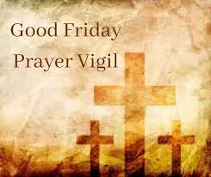
Good Friday Prayer Vigil will be held from 7:30 am until 6:30 pm on Good Friday, April 3rd in the Chapel. All are welcome anytime during the day to stop in and pray. It is a great opportunity to simply sit in the quietness on
Good Friday.

Please join us for Maundy Thursday Worship, April 2nd and Good Friday Worship, April 3rd at 6:30 pm.



Please join us in Bethany Hall after worship today for cake and coffee to celebrate Dave Hedin’s retirement!

First Reading: Isaiah 50:4-9a
The servant of the Lord expresses absolute confidence in his final vindication, despite the fact that he has been struck and spit upon. This characteristic of the servant played an important role in the early church’s understanding of the suffering, death, and resurrection of Jesus.

⁴ The Lord God has given me a trained tongue, that I may know how to sustain the weary with a word. Morning by morning he wakens, wakens my ear to listen as those who are taught.
⁵ The Lord God has opened my ear, and I was not rebellious; I did not turn backward. ⁶ I gave my back to those who struck me and my cheeks to those who pulled out the beard; I did not hide my face from insult and spitting.
⁷ The Lord God helps me; therefore, I have not been disgraced; therefore I have set my face like flint, and I know that I shall not be put to shame; ⁸ he who vindicates me is near. Who will contend with me? Let us stand in court together. Who are my adversaries? Let them confront me.
⁹ It is the Lord God who helps me; who will declare me guilty? All of them will wear out like a garment; the moth will eat them up.

Second Reading: Philippians 2:5-11
Paul uses an early Christian hymn to help us comprehend Jesus’ obedient selflessness on the cross and how God has made Christ lord over all reality. The perspective of the cross becomes the way we rightly understand God, Christ, our own lives, and fellowship within the community of Christ.

⁵ Let the same mind be in you that was in Christ Jesus,
⁶ who, though he existed in the form of God, did not regard equality with God as something to be grasped, ⁷ but emptied himself, taking the form of a slave, assuming human likeness. And being found in appearance as a human,
⁸ he humbled himself and became obedient to the point of death—even death on a cross. ⁹ Therefore God exalted him even more highly and gave him the name that is above every other name,
¹⁰ so that at the name given to Jesus every knee should bend, in heaven and on earth and under the earth, ¹¹ and every tongue should confess that Jesus Christ is Lord, to the glory of God the Father.

Gospel: Matthew 21:1-11
Jesus enters Jerusalem.
¹ When they had come near Jerusalem and had reached Bethphage, at the Mount of Olives, Jesus sent two disciples, ² saying to them, “Go into the village ahead of you, and immediately you will find a donkey tied and a colt with her; untie them and bring them to me. ³ If anyone says anything to you, just say this, ‘The Lord needs them.’ And he will send them immediately.”

⁴ This took place to fulfill what had been spoken through the prophet: ⁵ “Tell the daughter of Zion, Look, your king is coming to you, humble and mounted on a donkey, and on a colt, the foal of a donkey.”

⁶ The disciples went and did as Jesus had directed them; ⁷ they brought the donkey and the colt and put their cloaks on them, and he sat on them. ⁸ A very large crowd spread their cloaks on the road, and others cut branches from the trees and spread them on the road.

⁹ The crowds that went ahead of him and that followed were shouting, “Hosanna to the Son of David! Blessed is the one who comes in the name of the Lord! Hosanna in the highest heaven!”

¹⁰ When he entered Jerusalem, the whole city was in turmoil, asking, “Who is this?” ¹¹ The crowds were saying, “This is the prophet Jesus from Nazareth in Galilee.”

Prayer of the Day
Lord Jesus, our King and Friend, enter into our midst, and enter into our hearts just as you entered into Jerusalem on that very first Palm Sunday. Grant us your Holy Spirit so that we might be humble and lowly in your heart, and always ready to receive you as our King. We pray this in your name. Amen.

