ORDER FOR WORSHIP

Fourth Sunday After Epiphany – February 1, 2026
WE PREPARE FOR WORSHIP - (Silence and Prayer is appropriate)
Prelude
Announcements
Confession/Absolution Page 94

WE SING PRAISES TO GOD
Entrance Hymn – We Praise You, O God #870
Greeting & Kyrie Page 203
Hymn of Praise – Come Let Us Join Page 204
Prayer of the Day

WE HEAR THE WORD

First Lesson – Micah 6:1-8

Choir Anthem – Rise, Shine!
Second Lesson – 1 Corinthians 1:18-31
Gospel Acclamation – Alleluia Page 205
Gospel – Matthew 5:1-12
Children’s Moment
Sermon – Pastor Don

WE RESPOND WITH SONGS AND STATEMENTS
Pulpit Hymn – Just As I Am, without One Plea #592
The Apostles’ Creed Page 105
Prayers of the Church

WE OFFER GIFTS TO GOD AS WE SAY THANKS
Offering
Offertory – Let the Vineyards be Fruitful #182
Offertory Prayer

WE EAT AND DRINK TOGETHER IN CHRIST
Words of Institution Page 108
Lord’s Prayer Page 208
O Lamb of God Page 208
Distribution/Closing Prayer

WE LEAVE TO DO OUR WORK ON GOD’S BEHALF
Benediction
Sending Song – Rise Up, O Saints of God! #669
Postlude


Welcome to worship! We have a passion for people of all ages to gather in worship! Let us join our voices in celebration of God’s grace and join our hands in service for God’s people! We have activity bags available near the doors for the young.

Today’s Altar Flowers and Radio Broadcast are given in honor of our loving mom, Bea Hoppe, who is celebrating her 90th birthday, which was on January 31st from her children.


Please extend your hands of comfort to Sue and Lee Varpness on the passing of
Sue’s sister, Gina Jung Thorne. May God comfort them during this difficult time.

Our sympathies go out to the family and friends of Bruce Falla. Bruce passed away January 23rd at Brookside. His funeral will be held on Saturday, February 7th at Anderson TeBeest Funeral Home at 11:00 am. Blessed be his memory.

Please remember in your prayers the family of Shirley Dukowitz. Her siblings are Alvina Pitt, Darlene Anderson, Ernie (Kathy) Christianson, and Gene (Linda) Christianson. Shirley passed away on January 20th at her home. A visitation service will be held on Saturday, January 31st at the Anderson-TeBeest Funeral Home. May God comfort her family.
Ministry of Caring
We give thanks to God for God’s healing power. Your prayers have made a big difference in the lives of our people on this list. Please continue to pray for each person by name. As we offer our prayers, God’s love fills us with grace.

Health for Members
Wayne Thalberg; Bob Erickson; Edith Hendrickson; Andy Anderson;
Don Haugerud; Sheryl Maus; Bea Hoppe; Dianne Dvergsten;
Darwin TeBeest; Nancy Dack; Diane & Dennis Loose; Lowell Hanson; Darlene Ulven; Tom Albrecht; Don Maland; Paul Arends; Lynette Arends; Curt Winters; Lee Kvanli; Kathy Gilkey and Marvin & Gayle Jensen.

Health for Others

Name Requested By
Timothy Cushman Sheryl Maus
Kaia McDonald Susan Marcinkowski
Lisa Lund Sally Groothuis
Ruth Ann Lee Jerry Lee
Dennis DeGrote Mae Nelson
Pat Haugen Ginny Koenen
Paul Rice Mary Rice
Janice Lund, Delaine Christenson, Nona Wallert Lois Christenson
Amerie Tell, Mitch Augeson, Terry Hermanson Sally Groothuis
Tim & Andrea Dreier Mary Ann Nordaune
Jerry Cronen Karen Kepner
Tim Johnson, Mike Halvorson Lois & DeVon Vien
Lyn Bonnema Margit Bonnema
Delores Bursack Deb & Jerry Larson
Neal Dalton Doris Larson
Randy Lee Caren & Duane Johnson
Linda Bendickson, Brenda Ulven Darlene Ulven
Trevor Hansen Pat & Ron Binnebose
Andi Moon Pam & Dave Arneson
Jim & Jody Renbarger Barb Smith

Serving in the Military
Bowen Tesch, grandson of Jim & Deb Bowen; Paul Evenson, son-in-law of Karyn Maass; Dennis DeJong, friend of Lois Christenson;
Sean Prior, grandson of DeVon & Lois Vien; Justin Olsen, grandson of Ken & Janice Olsen; Alan Gronewold, son of Gladys Nelson;
Tyler Meyenburg, son of Rick & Mort Meyenburg;
Kirk Larson & Ross Larson, sons of Jerry & Deb Larson;
Daniel Harter & Shane McDonald, sons-in-law of Susan Marcinkowski.

Fourth Sunday
After Epiphany
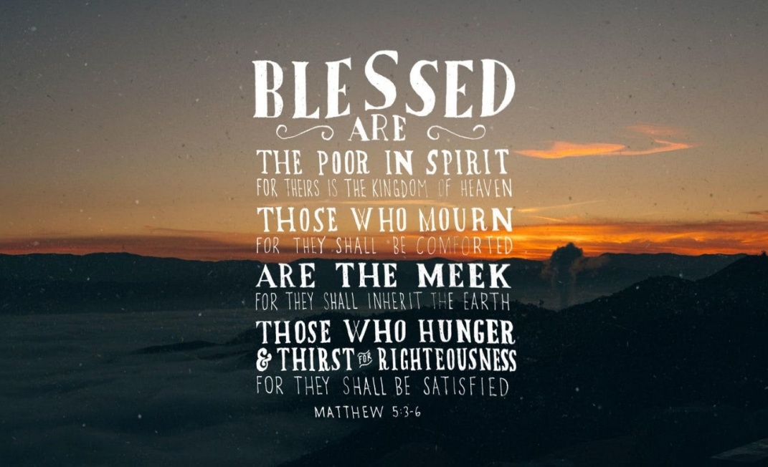
February 1, 2026


OUR SAVIOR’S LUTHERAN
222 NORTH 5TH STREET
MONTEVIDEO, MN
320-269-8824
www.oslcmonte.com

Week of February 2nd through February 8th
Monday
5:00 pm Dorcas Circle
Tuesday
10:15 am Staff Meeting
10:30 am Worship on Channel 180
Wednesday
7:00 am Roll with Jesus
9:30 am Martha Circle
1:00 pm Happy Hatters
2:30 pm Worship on Channel 180
5:00 pm Chime Practice
6:00 pm Handbell Practice
6:30 pm Confirmation
7:00 pm W.O.W.
7:00 pm Choir Practice
Thursday
9:00 am Senior Advisory Board
10:30 am Worship on Channel 180
Sunday
9:00 am Praise Worship
10:15 am Coffee Fellowship / Sunday School
11:00 am Worship on KDMA

Celebrating 90 Years!
Please join us after the service today in Bethany Hall as we celebrate Bea Hoppe’s 90th Birthday.
Cake will be served, and your presence will be a blessing!



First Reading: Micah 6:1-8
With the mountains and the foundations of the earth as the jury, God brings a lawsuit against Israel. God has “wearied” Israel with a long history of saving acts. God does not want or expect lavish sacrifices to attempt to earn divine favor. Rather God empowers the people to do justice, to love loyalty to God, and to walk shrewdly in God’s service.

¹ Hear what the Lord says:
Rise, plead your case before the mountains,
and let the hills hear your voice.
² Hear, you mountains, the case of the Lord,
and you enduring foundations of the earth,
for the Lord has a case against his people,
and he will contend with Israel.
³ “O my people, what have I done to you?
In what have I wearied you? Answer me!
⁴ For I brought you up from the land of Egypt
and redeemed you from the house of slavery,
and I sent before you Moses,
Aaron, and Miriam.
⁵ O my people, remember now what King Balak of Moab devised,
what Balaam son of Beor answered him,
and what happened from Shittim to Gilgal,
that you may know the saving acts of the Lord.”
⁶ “With what shall I come before the Lord
and bow myself before God on high?
Shall I come before him with burnt offerings,
with calves a year old?
⁷ Will the Lord be pleased with thousands of rams,
with ten thousands of rivers of oil?
Shall I give my firstborn for my transgression,
the fruit of my body for the sin of my soul?”
⁸ He has told you, O mortal, what is good,
and what does the Lord require of you
but to do justice and to love kindness
and to walk humbly with your God?

Second Reading: 1 Corinthians 1:18-31
According to the world’s standards of power and might, the message of the cross seems stupid and offensive. Yet this word reveals the paradoxical way God has chosen to work power and salvation through weakness, rejection, and suffering. Hence the message of the cross becomes true wisdom and power for believers.

¹⁸ The message about the cross is foolishness to those who are perishing, but to us who are being saved it is the power of God. ¹⁹ For it is written,
“I will destroy the wisdom of the wise,
and the discernment of the discerning I will thwart.”
²⁰ Where is the one who is wise? Where is the scholar? Where is the debater of this age? Has not God made foolish the wisdom of the world? ²¹ For since, in the wisdom of God, the world did not know God through wisdom, God decided, through the foolishness of the proclamation, to save those who believe. ²² For Jews ask for signs and Greeks desire wisdom, ²³ but we proclaim Christ crucified, a stumbling block to Jews and foolishness to gentiles, ²⁴ but to those who are the called, both Jews and Greeks, Christ the power of God and the wisdom of God. ²⁵ For God’s foolishness is wiser than human wisdom, and God’s weakness is stronger than human strength.
²⁶ Consider your own call, brothers and sisters: not many of you were wise by human standards, not many were powerful, not many were of noble birth. ²⁷ But God chose what is foolish in the world to shame the wise; God chose what is weak in the world to shame the strong; ²⁸ God chose what is low and despised in the world, things that are not, to abolish things that are, ²⁹ so that no one might boast in the presence of God. ³⁰ In contrast, God is why you are in Christ Jesus, who became for us wisdom from God, and righteousness and sanctification and redemption, ³¹ in order that, as it is written, “Let the one who boasts, boast in the Lord.”

Gospel: Matthew 5:1-12
Jesus opens the Sermon on the Mount by naming those who are blessed in the reign of God.

¹ When Jesus saw the crowds, he went up the mountain, and after he sat down, his disciples came to him. ² And he began to speak and taught them, saying:
³ “Blessed are the poor in spirit, for theirs is the kingdom of heaven.
⁴ “Blessed are those who mourn, for they will be comforted.
⁵ “Blessed are the meek, for they will inherit the earth.
⁶ “Blessed are those who hunger and thirst for righteousness, for they will be filled.
⁷ “Blessed are the merciful, for they will receive mercy.
⁸ “Blessed are the pure in heart, for they will see God.
⁹ “Blessed are the peacemakers, for they will be called children of God.
¹⁰ “Blessed are those who are persecuted for the sake of righteousness, for theirs is the kingdom of heaven.
¹¹ “Blessed are you when people revile you and persecute you and utter all kinds of evil against you falsely on my account. ¹² Rejoice and be glad, for your reward is great in heaven, for in the same way they persecuted the prophets who were before you.”

Prayer of the Day
Holy God, you confound the world’s wisdom in giving your kingdom to the lowly and the pure in heart. Give us such a hunger and thirst for justice, and perseverance in striving for peace, that in our words and deeds the world may see the life of your Son, Jesus Christ, our Savior and Lord.
Amen.

