ORDER FOR PRAISE WORSHIP

Baptism of Our Lord – January 11, 2026
WE PREPARE FOR WORSHIP – (Silence and Prayer are appropriate)
Prelude
Call to Worship – Hallelujah! We Sing Your Praises #535
Announcements

WE PRAY AND PRAISE
Opening Song – Down to the River to Pray See Screen

Blessed be the Holy Trinity, ☩ one God, our creator, our protector, our wellspring of life. Amen.
Trusting that God receives our words and the meditations of our hearts, let us confess our sin.
Silence is kept for reflection.
Merciful God,
You speak blessing and compassion into the world. Forgive us for the ways we act with judgment, cruelty, or indifference. We ignore the needs of our neighbors; we resist your call to oppose injustice; we give in to scarcity and fear; we assume the worst about one another. Cleanse us from our faults and release us from their grasp. Show us your loving kindness. Restore our hearts and repair your world, that we may live in Christ’s ways. Amen.
God proclaims these words of assurance: “Do not fear, for I have redeemed you. I have called you by name. You are mine.”
In ☩ Christ, you are forgiven. In the Spirit, you are made free. Refreshed by the waters of mercy, live anew as beloved children of God. Amen.

Kyrie Eleison Page 184
Glory to God Page 185
Prayer of the Day

WE HEAR GOD’S WORD
First Lesson – Isaiah 42:1-9
Milestone Moment See Insert

Second Lesson – Acts 10:34-43
Gospel Acclamation Page 188
Gospel – Matthew 3:13-17
Children’s Moment
Sermon Pastor Don
Pulpit Hymn – All Who Believe and Are Baptized #442
WE OFFER OURSELVES TO GOD
Praise Worship Creed
C: We believe in God, the one who comes before us and goes behind us, creating life and opportunities to love and care for the world.
C: We believe in Jesus Christ, who walks with us into real life each day. He is God, yet human like us and he experienced all life’s joys, pains, challenges like we do. But his love is so great that not even sin nor suffering or even death could stop his love. Today, the love of Jesus lives and continues to bring new life to the world.
C: We believe in the Holy Spirit that comes like the wind and blows in and through us to bring God’s power and light to all the world. The Spirit breathes life into us, the body of Christ we call the church, and enables us to follow the way of Christ. Amen.

Prayers of the Church
Prayer Song – Hear Our Prayer #178
Lord’s Prayer Sung
Offering / Offering Prayer

WE GO TO SERVE THE LORD
Benediction
Sending Song – The Light of Christ See Screen
Postlude

Please extend your hands of comfort to Amy Hogrefe and family on the passing of her father, Bill Zarnke. Bill passed away Friday, January 2nd at the Appleton Care Center. The funeral was held Saturday, January 10th at Watson Lutheran Church. Blessed be his memory.

Ministry of Caring
We give thanks to God for God’s healing power. Your prayers have made a big difference in the lives of our people on this list. Please continue to pray for each person by name. As we offer our prayers, God’s love fills us with grace.

Health for Members
Wayne Thalberg; Bob Erickson; Edith Hendrickson; Andy Anderson;
Don Haugerud; Sheryl Maus; Bea Hoppe; Dianne Dvergsten;
Darwin TeBeest; Nancy Dack; Diane & Dennis Loose; Lowell Hanson; Darlene Ulven; Tom Albrecht; Don Maland; Paul Arends; Lynette Arends; Curt Winters; Lee Kvanli; Kathy Gilkey and Marvin & Gayle Jensen.

Health for Others
Name Requested By
Kaia McDonald Susan Marcinkowski
Lisa Lund Sally Groothuis
Ruth Ann Lee Jerry Lee
Dennis DeGrote Mae Nelson
Pat Haugen Ginny Koenen
Paul Rice Mary Rice
Janice Lund, Delaine Christenson, Nona Wallert Lois Christenson
Amerie Tell, Mitch Augeson, Terry Hermanson Sally Groothuis
Tim & Andrea Dreier Mary Ann Nordaune
Jerry Cronen Karen Kepner
Tim Johnson, Mike Halvorson Lois & DeVon Vien
Lyn Bonnema Margit Bonnema
Delores Bursack Deb & Jerry Larson
Neal Dalton Doris Larson
Randy Lee Caren & Duane Johnson
Linda Bendickson, Brenda Ulven Darlene Ulven
Trevor Hansen Pat & Ron Binnebose
Gina Jung Thorne Sue Varpness
Andi Moon Pam & Dave Arneson
Jim & Jody Renbarger Barb Smith

Serving in the Military
Bowen Tesch, grandson of Jim & Deb Bowen; Paul Evenson, son-in-law of Karyn Maass; Dennis DeJong, friend of Lois Christenson;
Sean Prior, grandson of DeVon & Lois Vien; Justin Olsen, grandson of Ken & Janice Olsen; Alan Gronewold, son of Gladys Nelson;
Tyler Meyenburg, son of Rick & Mort Meyenburg;
Kirk Larson & Ross Larson, sons of Jerry & Deb Larson;
Daniel Harter & Shane McDonald, sons-in-law of Susan Marcinkowski.
Baptism of
Our Lord
January 11, 2026
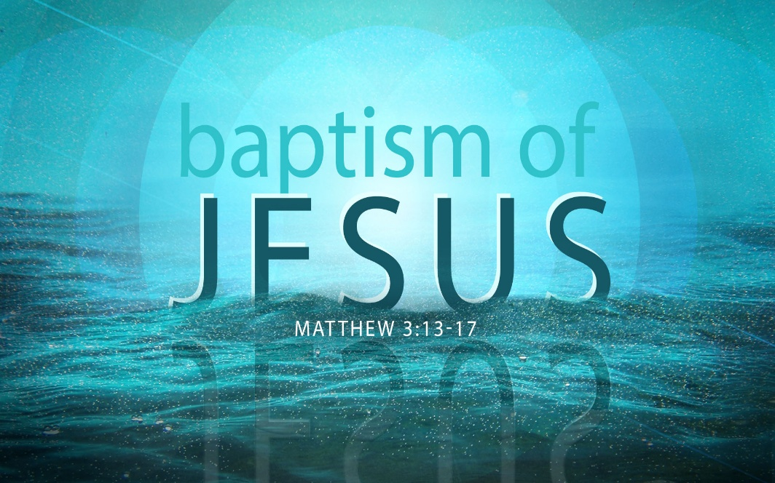


OUR SAVIOR’S LUTHERAN
222 NORTH 5TH STREET
MONTEVIDEO, MN
320-269-8824
www.oslcmonte.com


Week of January 12th through January 18th
Tuesday
10:15 am Staff Meeting
10:30 am Worship on Channel 180
2:00 pm Brookside Holy Communion
Wednesday
7:00 am Roll with Jesus
9:30 am Altar Guild
11:30 am Executive Board
2:30 pm Worship on Channel 180
5:00 pm Church Council
5:00 pm Chimes Practice
6:00 pm Handbell Practice
6:30 pm Confirmation
7:00 pm WOW
7:00 pm Choir Practice
Thursday
10:30 am Worship on Channel 180
Sunday
9:00 am Worship
10:15 am Sunday School/Coffee Fellowship
11:00 am Worship on KDMA 1460


OSLC Annual Meeting will be held on Sunday, January 25th following our worship service. We will meet in the sanctuary. Please remember that we need to have a quorum of 75 members. We hope that you will make every effort to attend our meeting.

Prayer of the Day
O God our Father, at the baptism of Jesus you proclaimed him your beloved Son and anointed him with the Holy Spirit. Make all who are baptized into Christ faithful to their calling to be your daughters and sons, and empower us all with your Spirit, through Jesus Christ, our Savior and Lord, who lives and reigns with you and the Holy Spirit, one God, now and forever.
Amen.
Thank You!
Thank you so much for all your coat and hat donations. Your generosity means so much and we simply couldn’t do what we do without amazing people like you!

Youth News

Sign up for Wednesday Night Confirmation Meals
Are you curious about what happens on Wednesday evenings at our church with our confirmation youth? Here’s one way to find out! We have an opportunity for you. There are 6 Wednesday Night Confirmation Meals that you can sign up for to help out. Those nights are in January, February and April. Parents of confirmands are encouraged to provide at least one simple supper during the year, but anyone is welcome to sign up!
To help out, call the church office at 269-8824 or go to our church website and look for the confirmation tab and
sign up there!

Senior High Students

Roll With Jesus
Join us for our Drive Thru Breakfast on Wednesday mornings from 7:00-7:45 am.


W.O.W
Join us for Worship on Wednesday at 7:00pm
First Reading: Isaiah 42:1-9
God’s servant is endowed with God’s spirit in order to bring justice to the nations. The servant will not exercise authority boisterously or with violence, nor will weariness ever prevent the fulfilling of the servant’s task. God’s old promises have been fulfilled; the servant’s new assignment is to bring light to the nations.

¹ Here is my servant, whom I uphold,
my chosen, in whom my soul delights;
I have put my spirit upon him;
he will bring forth justice to the nations.
² He will not cry out or lift up his voice
or make it heard in the street;
³ a bruised reed he will not break,
and a dimly burning wick he will not quench;
he will faithfully bring forth justice.
⁴ He will not grow faint or be crushed
until he has established justice in the earth,
and the coastlands wait for his teaching.
⁵ Thus says God, the Lord,
who created the heavens and stretched them out,
who spread out the earth and what comes from it,
who gives breath to the people upon it
and spirit to those who walk in it:
⁶ I am the Lord; I have called you in righteousness;
I have taken you by the hand and kept you;
I have given you as a covenant to the people,
a light to the nations,
⁷ to open the eyes that are blind,
to bring out the prisoners from the dungeon,
from the prison those who sit in darkness.
⁸ I am the Lord; that is my name;
my glory I give to no other,
nor my praise to idols.
⁹ See, the former things have come to pass,
and new things I now declare;
before they spring forth,
I tell you of them.

Second Reading: Acts 10:34-43
Peter crosses the sharp religious boundary separating Jews from Gentiles and proclaims the good news of God’s inclusive forgiveness in Jesus’ name to Cornelius, a Roman centurion. As a result of Peter’s preaching, Cornelius and his family become the first Gentiles to be baptized in the name of Jesus Christ.

³⁴ Peter began to speak to Cornelius and his household: “I truly understand that God shows no partiality, ³⁵ but in every people anyone who fears him and practices righteousness is acceptable to him. ³⁶ You know the message he sent to the people of Israel, preaching peace by Jesus Christ—he is Lord of all. ³⁷ That message spread throughout Judea, beginning in Galilee after the baptism that John announced: ³⁸ how God anointed Jesus of Nazareth with the Holy Spirit and with power; how he went about doing good and healing all who were oppressed by the devil, for God was with him. ³⁹ We are witnesses to all that he did both in Judea and in Jerusalem. They put him to death by hanging him on a tree, ⁴⁰ but God raised him on the third day and allowed him to appear, ⁴¹ not to all the people but to us who were chosen by God as witnesses and who ate and drank with him after he rose from the dead. ⁴² He commanded us to preach to the people and to testify that he is the one ordained by God as judge of the living and the dead. ⁴³ All the prophets testify about him that everyone who believes in him receives forgiveness of sins through his name.”

Gospel: Matthew 3:13-17
Before Jesus begins his ministry, he is baptized by John, touched by the Spirit, and identified publicly as God’s child.

¹³ Jesus came from Galilee to John at the Jordan, to be baptized by him. ¹⁴ John would have prevented him, saying, “I need to be baptized by you, and do you come to me?” ¹⁵ But Jesus answered him, “Let it be so now, for it is proper for us in this way to fulfill all righteousness.” Then he consented. ¹⁶ And when Jesus had been baptized, just as he came up from the water, suddenly the heavens were opened to him and he saw God’s Spirit descending like a dove and alighting on him. ¹⁷ And a voice from the heavens said, “This is my Son, the Beloved, with whom I am well pleased.”

