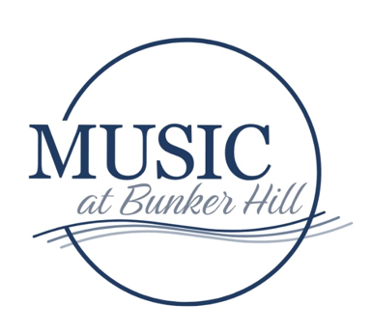**DONATE/TICKETS BY MAIL SEASON 18 2025-2026**

**VOICEMAIL:** (856) 494-6077   
**CONTACT: mcframpton@musicatbunkerhill.org**

**Your donation will help Music at Bunker Hill continue to present live   
classical music in Southern New Jersey and support our new student   
scholarship program. Donations in any amount are welcome.**

**PRINT AND COMPLETE FORM**, enclose check to Music at Bunker Hill, and mail to

MaBH

PO Box 202

Grenloch, NJ 08032

You will be added to our email newsletter list and US mail annual mailing. You may opt out at any time.

|  |  |
| --- | --- |
| Name: | Email: |
| Address: | Phone: |
| City: | State:                      Zip: |

**TICKETS BY MAIL-** Please refer to website for ticket information: [www.musicatbunkerhill.org](http://www.musicatbunkerhill.org). Concert dates 10/5/25, 11/2/25, 11/16/25, 3/15/26, 5/10/26, 6/7/26. Tickets $30 Senior/Adult, $5 Student, Subscribe to six concerts: Early Bird Subscriber $143 by Sept 1. Season Subscriber $156 by Oct 6.

|  |  |  |  |
| --- | --- | --- | --- |
| TICKET date or SUBSCRIBE | NUMBER OF TICKETS | PRICE PER TICKET | TOTAL |
|  |  |  |  |
|  |  |  |  |
|  |  |  |  |
|  |  |  |  |
|  |  |  |  |
|  |  |  |  |

**BE A DONOR and support MUSIC AT BUNKER HILL in 2025-2026. Donors are listed in program book.**

**_____**Angel $1,000 _____Benefactor $500 _____Sustainer $400

_____Supporter $200   _____ Donor $100  _____Patron $50         other $ ________

Please include me on program book donor page as follows:  
  
Name______________________________________________________ or _____ Anonymous

Your contribution is tax deductible and will help immensely during this unusual year. Music at Bunker Hill

is a NJ nonprofit corporation, 501(c)3. You will receive a donation acknowledgement for your

tax records.