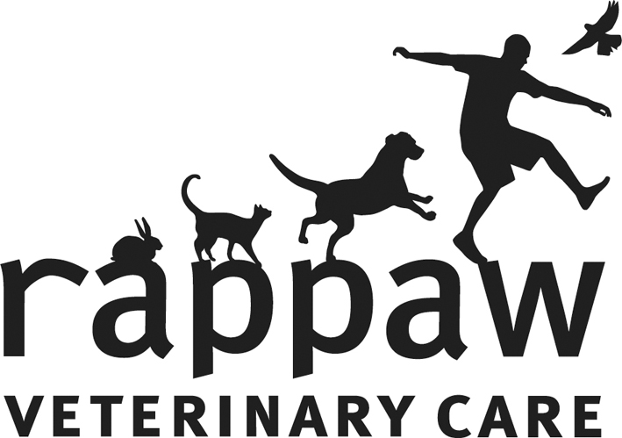 Rappaw Veterinary Care, Tawa
Cattery Admission & Consent Form

Pet’s Name: Vaccination due:
Owners First Name: Last Name:
Address:

I wish my cat to stay | From:_________________ | To:___________________

Emergency Contact | Name:  Phone Number:

Food
Health Problems
Medications | Y N | Name:  Last given: (am/pm) Due: | Name:  Last given: (am/pm) Due:
Last worm & flea treatment |  | Name:  Last given:
Any further services you would like done while here
Weight

Diet:
While in the care of Rappaw Veterinary Care your cat will be fed Royal Canin dry and wet food specific to their age. If your cat is on any other products ie. Hills Prescription Diet we will require you to provide this. Alternatively we can bill you for a bag to be used here with the remainder to be taken home at the end of your cats stay.

Fleas & Worms:
If your cat shows signs of having live fleas or worms while in the care of Rappaw Veterinary Care and is not up to date with a reputable (vet supplied) flea and worm treatment, we will treat your cat at an additional charge.

Owner or Agents Declaration
I declare, that to the best of my knowledge the cat described on the form is:
- Not suffering from any infectious disease
- In good health and not suffering from any disorder which Rappaw Veterinary Care is unaware of
In the event of illness or injury to my cat, I give permission for any urgent medical, surgical or diagnostic procedures which are, in the opinion of a Veterinarian of Rappaw Veterinary Care, required to be carried out during the cat stay. Staff will endeavour to contact the person given as an emergency contact, to discuss any treatment required, prior to such treatment being given.

I understand that the daily rate will be worked out on a per night basis and that payment in full is required when the cat is discharged including any extra costs incurred while here.

Signed: ________________________________________
_____________________________________________________________________
Articles bought in:
Cage | ❑ | _________________ | Medication | ❑ | __________________
Toys | ❑ | __________________ | Bedding | ❑ | __________________
Other | ❑ | __________________ | Food | ❑ | __________________

