Wilson County Partnership for Children
Child Care Resource and Referral
Professional Development Workshop/Training Registration Form

(Complete 1 Form for Each Attendee)

October 2026
Review the workshops listed. Mark an X in the first column besides the workshops you plan to attend, submit the form with payment. You are required to complete demographic information to do so click on the link below
Wilson County Partnership for Children Child Care Resource and Referral In-Service Training Roster

Payment Options:
- By Mail: (check or money order) to: Wilson County Partnership for Children - Attn. Workshop Registration Desk to PO Box 2661, Wilson, NC 27894. Make all payments to Wilson County Partnership for Children
- Put registration form and payment in an envelope and place the drop box located in front of Wilson County Partnership for Children@109 Park Ave. West, Wilson NC (Check, Money Order, or Exact Cash only)
- All payments must be received 7 days prior to the workshop date indicated. *No walk-in
registrations will be accepted on the day of training.
Name: | Address: | City, State, Zip:
County: | Work Phone: | Cell or Home Phone:
Email: |  | Amount Enclosed:
Name & Address of Home or Center Where Employed:
NOTE: If you register to receive a free workshop and do not show for it, the Partnership reserves the right to charge you for that workshop and no other free registrations will be afforded to you.
 | Workshop/Activity Title | Date | Description | Time | Location | Fee | Instructor/Credits
□ | CPR/First Aid  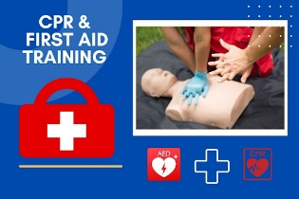  Audience: All Providers | 10/08/26 | Heartsaver Pediatric First Aid CPR AED is a classroom instructor-led course that teaches participants to respond to and manage illnesses and injuries in an adult, child and infant in the first few minutes until professional help arrives | 6:30pm  -  8:30pm | Wilson County Partnership for Children  Register by  10/1/26 | $55.00 | Jen Schick  Private Trainer  2.0 CHC’s
□ | The Power of Scribbling  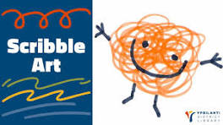  Audience: All Providers | 10/13/26 | Learning to write names starts way before a child puts a pencil to paper. In this workshop participants will embrace the power of marking and learn how to support children in the early stages of writing development. | 6:30pm  -  8:30pm | Virtual  Register by 10/06/26 | $5.00 | Carrie Becker  Private Trainer  2.0 CHC’s
 | Preschool Math & Manipulatives  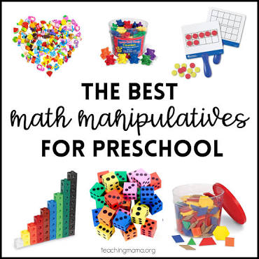  Audience: All Providers | 10/22/26 | In this Training you will see how Preschool Math focuses on developing early numeracy, logical thinking through hands-on experiments. Manipulative, objects like puzzles, blocks and counters, give the children an opportunity to have different learning experiences. | 6:30pm  -  8:30pm | Virtual  Register by 10/15/26 | $5.00 | Shawanna Manning  Private Trainer  2.0 CHC’s
NOTE: Wilson County Partnership for Children will no longer transfer monies to another class if
you do not attend the class that you registered for. No Refunds or Transfers. The only time we will transfer funds will be if Wilson County Partnership for Children cancel the class.

