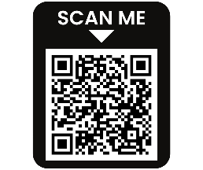
June 2026
Review the workshops listed. Mark with an X in the first column besides the trainings/workshops you plan to attend, submit the form with payment.

Payment Options:
- Send a check or money order to: Wilson County Partnership for Children PO Box 2661, Wilson, NC 27894
- Place your registration form and payment in an envelope and: Drop it in the drop box outside the WCPFC at
109 Park Ave W, Wilson, NC 27893, or hand it directly to the staff at the reception desk.
- All payments must be received 7 days prior to the training/workshop date.
Name: | Address: | City, State, Zip:
County: | Work Phone: | Cell or Home Phone:
Email: |  | Amount Enclosed:
Name & Address of Home or Center Where Employed:
NOTE: If you register to receive a free workshop and do not show for it, the Partnership reserves the right to charge you for that workshop and no other free registration will be afforded to you. No money transfers will be allowed for another class unless WCPFC cancels the class.
 | Workshop/Activity Title | Date/  Time | Description | Location | Fee | Instructor/  Credits
□ | The ABC of Transitions  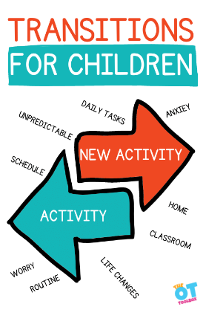 | 06/04/26 | This hands-on session focuses on transforming transition time from wasted energy into meaningful, smooth, and emotionally supportive learning moments. Participants will systematically assess their own daily schedules, learn to eliminate unnecessary transitions, and master engaging, proven strategies to guide children seamlessly from one activity to the next. | Wilson County Partnership for Children  Register by 05/28/26 | $5.00 | Kyndra Boyette  Private Trainer  2.0 CHC’s
□ | CPR/First Aid   | 06/11/26  6:30pm  -  8:30pm | Heart Saver Pediatric First Aid CPR AED is a classroom instructor-led course that teaches participants to respond to and manage illnesses and injuries in an adult, child, and infant in the first few minutes until professional help arrives. | Wilson County Partnership for Children  Register by  06/04/26* | $55.00 | Jen Schick  Private Trainer  2.0 CHC’s

