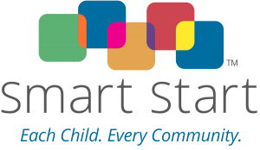

**Wilson County Partnership for Children**

**Board Meetings for 2025-2026 Fiscal Year**

|  |  |
| --- | --- |
| **Full Board Meetings** | **Executive Committee Meetings** |
| September 17, 2025-Annual Meeting | August 20, 2025 |
| November 12, 2025 | March 18, 2026 |
| January 28, 2026 | April 15, 2026 |
| May 20, 2026 | June 24, 2026 |
| September 23, 2026-Annual Meeting | August 19, 2026 |
|  |  |
|  |  |
|  |  |
|  |  |

Board voted for full board to meet quarterly and Executive Committee to meet at other times. There are no meetings scheduled for December, February, or July. All approvals/revisions for budgets usually take place in May, June, November, and sometimes January.

**Board Meeting Times: 12:00pm unless otherwise indicated.**