Wilson County Partnership for Children
Child Care Resource and Referral
Professional Development Workshop/Training Registration Form

(Complete 1 Form for Each Attendee)

August 2026
Review the workshops listed. Mark an X in the first column besides the workshops you plan to attend, submit the form with payment. You are required to complete demographic information to do so click on the link below
Wilson County Partnership for Children Child Care Resource and Referral In-Service Training Roster

Payment Options:
- By Mail: (check or money order) to: Wilson County Partnership for Children - Attn. Workshop Registration Desk to PO Box 2661, Wilson, NC 27894. Make all payments to Wilson County Partnership for Children
- Put registration form and payment in an envelope and place the drop box located in front of Wilson County Partnership for Children@109 Park Ave. West, Wilson NC (Check, Money Order, or Exact Cash only)
- All payments must be received 7 days prior to the workshop date indicated. *No walk-in
registrations will be accepted on the day of training.
Name: | Address: | City, State, Zip:
County: | Work Phone: | Cell or Home Phone:
Email: |  | Amount Enclosed:
Name & Address of Home or Center Where Employed:
NOTE: If you register to receive a free workshop and do not show for it, the Partnership reserves the right to charge you for that workshop and no other free registrations will be afforded to you.
 | Workshop/Activity Title | Date | Description | Time | Location | Fee | Instructor/Credits
□ | CPR/First Aid  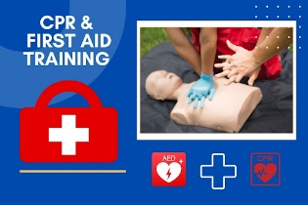  Audience: All Providers | 08/04/26 | Heartsaver Pediatric First Aid CPR AED is a classroom instructor-led course that teaches participants to respond to and manage illnesses and injuries in an adult, child and infant in the first few minutes until professional help arrives | 6:30pm  -  8:30pm | Wilson County Partnership for Children  Register by 07/28/26 | $55.00 | Jen Schick  Private Trainer  2.0 CHC’s
 | Cultural Influences on Behavior    Audience: All Providers | 08/13/26 | Culture has a profound influence on child development, shaping how children learn, think and behave. When educators are able to include cultures in the classroom, they create a space that is welcoming and supportive of all children. By understanding the cultural backgrounds of the children in their care, educators can create a more inclusive learning environment. | 6:30pm  -  8:30pm | Virtual  Register by 08/06/26 | $5.00 | Kyndra Boyette  Private Trainer  2.0 CHC’s
□ | Respect The Bubble  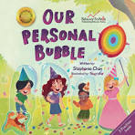  Audience: All Providers | 08/25/26 | During this interactive workshop participants will learn techniques and strategies they can use in their own classroom setting to help their children learn to “Respect the Bubble”. | 6:30pm  -  8:30pm | Virtual  Register by 08/18/26 | $5.00 | Carrie Becker  Private Trainer  2.0 CHC’s
NOTE: Wilson County Partnership for Children will no longer transfer monies to another class if
you do not attend the class that you registered for. No Refunds or Transfers. The only time we will transfer funds will be if Wilson County Partnership for Children cancel the class.

