
`
April 2026
Review the workshops listed. Mark with an X in the first column besides the trainings/workshops you plan to attend, submit the form with payment.

Payment Options:
- Send a check or money order to: Wilson County Partnership for Children PO Box 2661, Wilson, NC 27894
- Place your registration form and payment in an envelope and: Drop it in the drop box outside the WCPFC at
109 Park Ave W, Wilson, NC 27893, or hand it directly to the staff at the reception desk.
- All payments must be received 7 days prior to the training/workshop date.
Name: | Address: | City, State, Zip:
County: | Work Phone: | Cell or Home Phone:
Email: |  | Amount Enclosed:
Name & Address of Home or Center Where Employed:
NOTE: If you register to receive a free workshop and do not show for it, the Partnership reserves the right to charge you for that workshop and no other free registration will be afforded to you. No money transfers will be allowed for another class unless WCPFC cancels the class.
 | Workshop/Activity Title | Date/  Time | Description | Location | Fee | Instructor/  Credits
□ | You Want Me To Do What? Learning Routines & Schedules  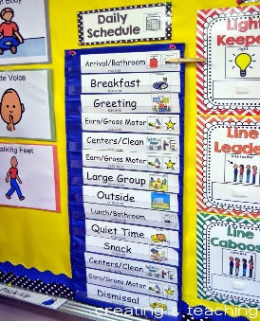 | 04/02/26  6:30pm  -  8:30pm | The environment you create is your most powerful tool. In this hands-on workshop, you'll learn how to shift from reactive discipline to proactive environmental design. Teachers will assess their own classroom space and leave with immediate, supportive strategies to implement routines and schedules that work for them, teach children expectations, and foster calm and cooperation for all. | Virtual  Register by 03/26/26 | $5.00 | Kyndra Boyette  Private Trainer  2.0 CHC/s
□ | CPR/First Aid   | 04/09/26  6:30pm  -  8:30pm | Heart Saver Pediatric First Aid CPR AED is a classroom instructor-led course that teaches participants to respond to and manage illnesses and injuries in an adult, child, and infant in the first few minutes until professional help arrives. | Wilson County Partnership for Children  Register by  04/02/26 | $55.00 | Jen Schick  Private Trainer  2.0 CHC’s
□ | Mary Artis Kids on the Lawn   | 04/11/26  10:00am  -  2:00pm | This event recognizes the value of all young children in our community and is a wonderful time for local families to have fun together while learning about ways to help ensure their children learn, grow and thrive daily.” Mary Artis’ Kids on the Lawn offers families a chance to come out together for fun, food and entertainment. | Wilson County Public Library Front Lawn  Register by 03/26/26 | Free | All WCPFC Staff  &  Various Community Partners
□ | Director’s Forum: Burnout Prevention in the Child Care Setting  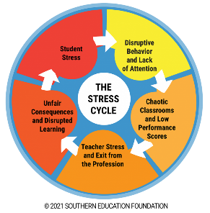 | 04/16/26  12:00pm  -  2:00pm | This training will address how burnout affects childcare teachers, children, parents and administrators of childcare centers. We will take time to define burnout, understand how to recognize it, look at some strategies to reduce burnout, identify the causes of burnout and discuss solutions for recovering from burnout. All participants will be able to see how specifically burnout is related to childcare providers while understanding the importance of working out a plan to reduce it | Virtual  Register by  04/09/26 | Free | Takisha Jones  Private Trainer  2.0 CHC’s

