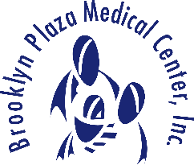

Patient Code of Conduct and Responsibilities

Brooklyn Plaza Medical Center believes in treating people with respect and keeping them healthy. In order to achieve this, we need to provide a safe and healthy environment for all patients and their families. BPMC expects you to adhere to the following rule and responsibilities:
- Provide your care team with complete and accurate information about all present and past medical history, past illnesses, hospitalizations, and medications. Report all unexpected health changes in you condition to your provider.
- Keep your appointment or contact us at least 24 hours in advance if you need to cancel so that another patient may be able to be seen.
- Follow the treatment plan recommended by the provider who is primarily responsible for you care.
- Assure that the financial obligations for your health care are fulfilled, as promptly as possible
- Be considerate of the rights of others (i.e. patients and staff) by limiting noise and in appropriate behavior. You are responsible for respecting the health center and others’ property and agree to follow the health center’s rules an regulations below that affect your care and conduct.

  - NO profanity
  - NO threatening or intimidating language
  - NO disruptive or violent behavior
  - NO possession of weapons
  - No drinking or drug use on premises
  - NO damaging or defacing BPMC property
  - NO cell phone usage on property
  - Abide by the agency-wide “no smoking” policy

Adherence to the code of conduct is expected of all patients and it will be enforced to the full extent of the law. Violators are subject to removal from the facility and/or discharge from the practice and if necessary, prosecution.

___________________ ____________________ __________
Print Name Signature Date

