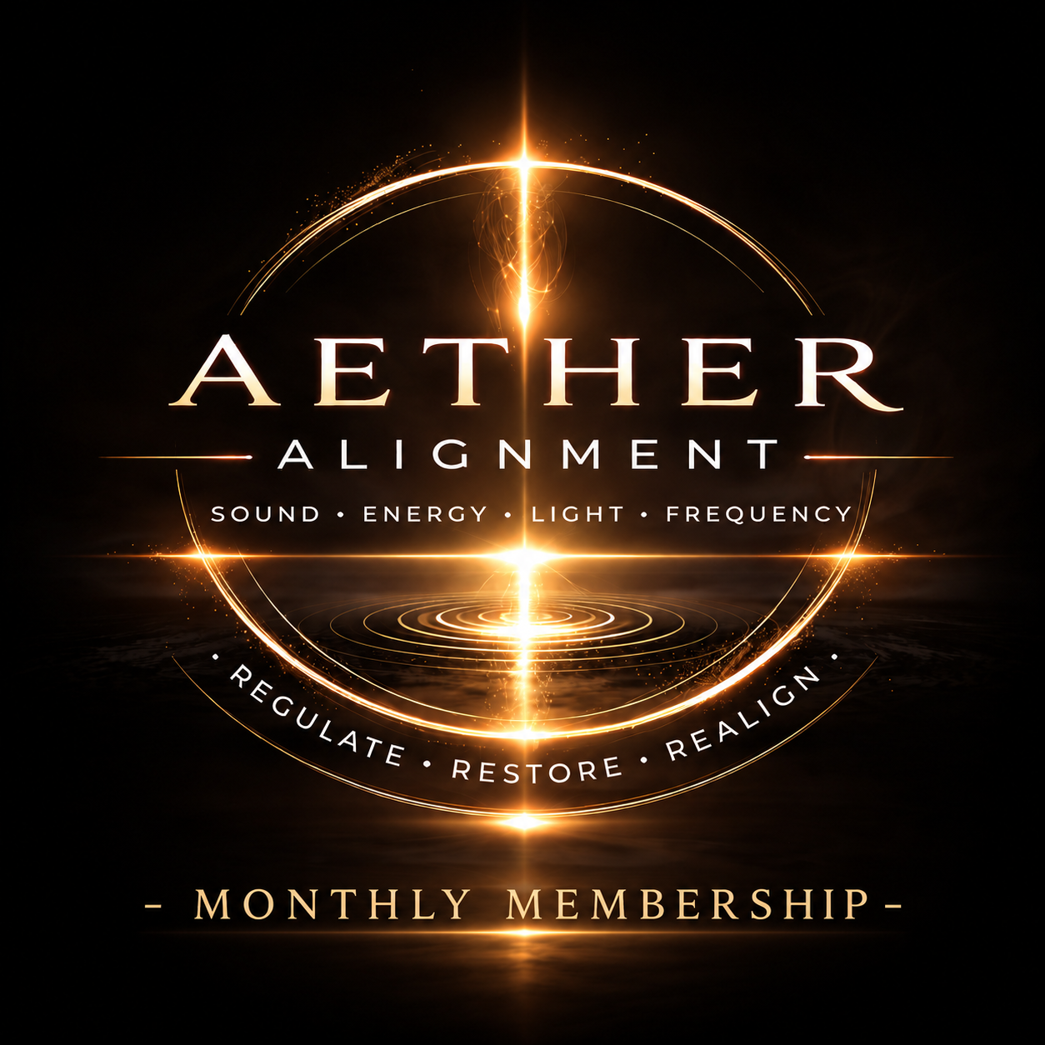

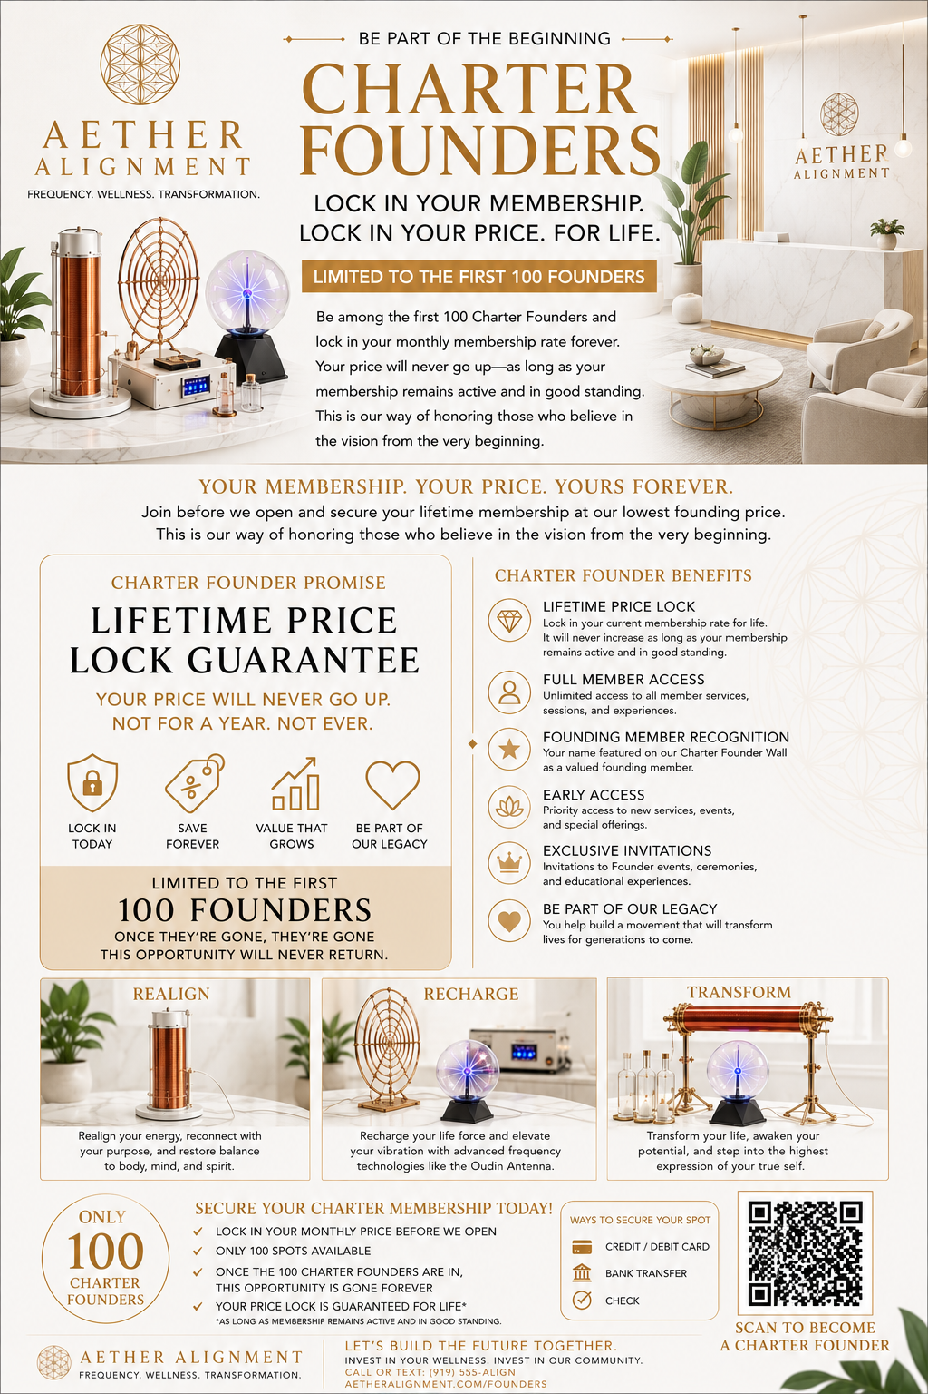

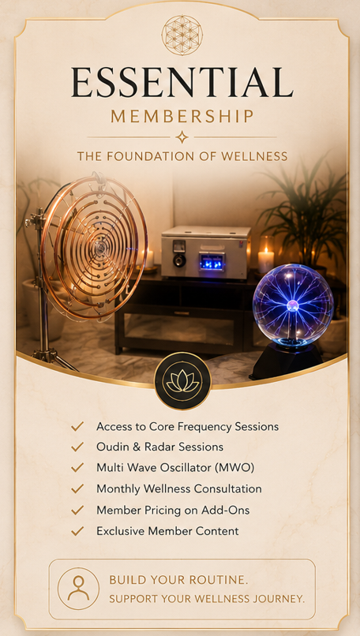

Aether Alignment
Legacy Founder Membership Agreement & Charter
(Draft for Legal Review)
This draft is intended as a starting point and should be reviewed by a North Carolina attorney before accepting Founder investments.

Welcome
Thank you for becoming one of the first twenty Legacy Founders of Aether Alignment. Your investment helps establish the business and its community.

Founder Information
Founder #: ____ of 100
Member: __________________
Date: __________________

1. Founder Investment
The Member agrees to make a one-time Founder Investment of $5,555. Upon acceptance and receipt of payment, the Member receives Legacy Founder status subject to this Agreement.

2. Legacy Founder Benefits
• Lifetime Legacy Membership
• No recurring monthly dues for the Legacy Membership level
• Priority scheduling (subject to availability)
• Founder appreciation events
• Early access to new experiences
• Optional Founder recognition
• Numbered Founder Certificate

3. Lifetime Membership
Lifetime refers to the Member's lifetime while the membership remains in good standing. The membership is for personal use.

4. Included Benefits
Core Legacy Membership benefits are included. Future premium services, workshops, retail products, certifications, guest practitioners, and specialty offerings may require additional fees unless specifically included.

5. Reservations
Reservations may be required and are subject to availability.

6. Member Responsibilities
Members agree to follow studio policies, respect staff and other members, and use equipment responsibly.

7. Suspension or Termination
Membership may be suspended or terminated for fraud, illegal conduct, threats, harassment, theft, intentional property damage, or repeated policy violations.

8. Refund Policy
The Founder Investment is generally non-refundable. If Aether Alignment does not open within ______ months after accepting the investment, the following remedy will apply: __________________.

9. Health Acknowledgement
The Member understands the services are wellness experiences and not medical diagnosis or treatment.

10. Transferability
Membership is non-transferable unless approved in writing by Aether Alignment.

11. Governing Law
This Agreement is governed by North Carolina law. The parties agree to attempt good-faith discussion and mediation before litigation where appropriate.

Signatures
Member Name
Signature
Date
Founder Number
Aether Alignment Representative

