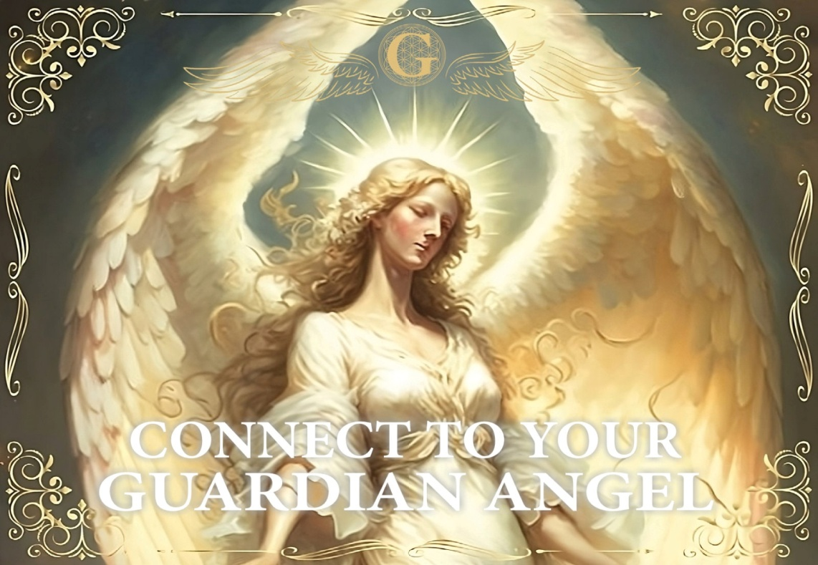
CONNECT TO YOUR GUARDIAN ANGEL
& other Beings of Light
Saturday November 15, 2025
9:30 am – 1:30 pm
$125

- Mini Angel Reading & Angelic Energy Healing by Mary Silvernail
- Learn how to raise your vibration to meet Angelic frequencies
- Receive personal messages and signs from your Angelic Guide
- Strengthen your intuitive gifts in a safe, sacred space
- Introduction to Angelic Hierarchy & other Light Beings

Seats are limited – Call 609-242-3900 to register (all deposits final)

Workshop held at:
Hope Hypnosis & Holistic Center LLC
465 Route 9
Waretown, NJ 08758

