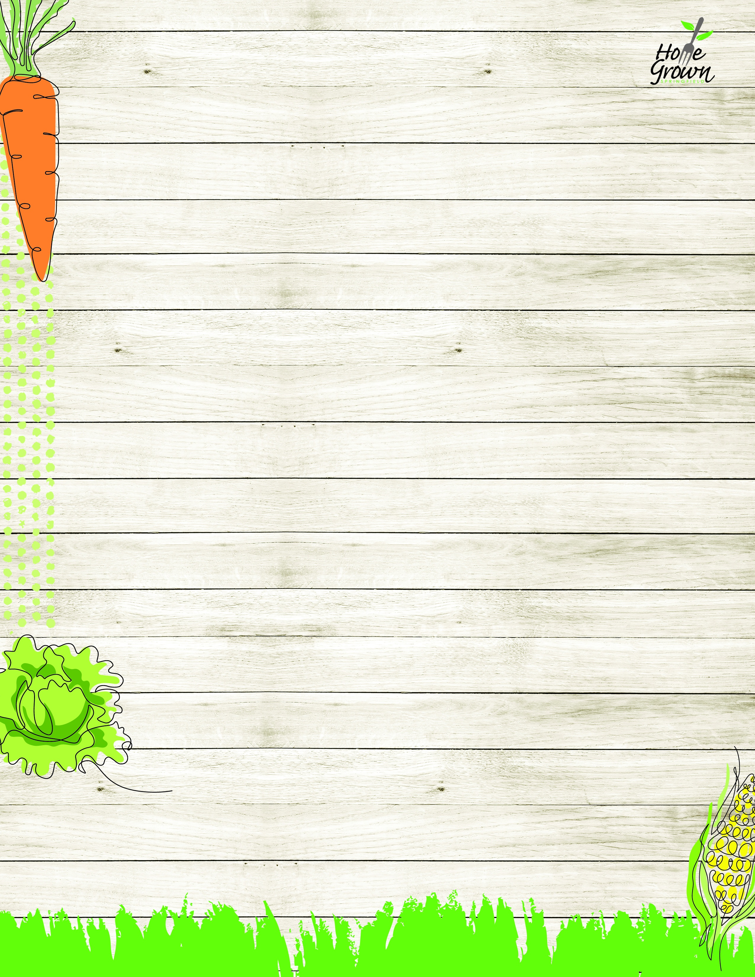

VEGETARIAN LUNCH
August-September 2026
MONDAY
TUESDAY
WEDNESDAY
WEDNESDAY
THURSDAY
FRIDAY
8/24
Cheese Calzone with Marinara Sauce
OR
Garden Salad with Roll
French Fries
Black Bean Salad
8/25
Seasoned Rice & Beans
OR
Garden Salad with Roll
Steamed Carrots
Celery Sticks
8/26
Mac & Cheese
OR
Garden Salad with Roll
Roasted Broccoli
Grape Tomatoes
8/26
Mac & Cheese
OR
Garden Salad with Roll
Roasted Broccoli
Grape Tomatoes
8/27
Waffles w/Sunbutter Cup
& Syrup
OR
Garden Salad with Roll
Mashed Sweet Potatoes
Chilled Corn
8/28
Veggie Pizza or
Cheese Pizza
OR
Garden Salad with Roll
Side Caesar Salad
Celery Sticks
8/31
Cheese Nachos w/Salsa
OR
Hummus Bento Box
with Roll
Steamed Corn
Black Bean Salad
9/1
No School
9/2
Baked Ziti with
Plant-based Bolognese
OR
Hummus Bento Box
with Roll
Roasted Broccoli
Carrot Sticks
9/2
Baked Ziti with
Plant-based Bolognese
OR
Hummus Bento Box
with Roll
Roasted Broccoli
Carrot Sticks
9/3
Cheddar Bowl w/Mashed Potatoes, Corn & Roll
OR
Hummus Bento Box
with Roll
Local Mashed Potato
Chilled Corn
9/4
Veggie Pizza or
Cheese Pizza
OR
Hummus Bento Box
with Roll
Seasoned Green Beans
Cucumber Salad
9/7
No School
9/8
Cheese Calzone with Pizza Sauce
OR
Vegan Mediterranean Salad with Roll
Mashed Butternut
Celery Sticks
9/9
French Toast w/Sunbutter Cup & Syrup
OR
Vegan Mediterranean Salad with Roll
Tater Tots
Carrot Sticks
9/9
French Toast w/Sunbutter Cup & Syrup
OR
Vegan Mediterranean Salad with Roll
Tater Tots
Carrot Sticks
9/10
Plant-based Taco Salad w/Seasoned Rice
OR
Vegan Mediterranean Salad with Roll
Stewed Black Beans
Grape Tomatoes
9/11
Veggie Pizza or
Cheese Pizza
OR
Vegan Mediterranean Salad with Roll
Steamed Broccoli
Celery Sticks
9/14
Cheese Calzone with Marinara Sauce
OR
Kale & Apple Salad
w/Roll
French Fries
Celery Sticks
9/15
Seasoned Rice & Beans
OR
Kale & Apple Salad w/Roll
Veggie Baked Beans
Grape Tomatoes
9/16
Pasta, Marinara, and Mozzarella Cheese
OR
Kale & Apple Salad
w/Roll
Roasted Broccoli
Carrot Sticks
9/16
Pasta, Marinara, and Mozzarella Cheese
OR
Kale & Apple Salad
w/Roll
Roasted Broccoli
Carrot Sticks
9/17
Bean & Cheese Nachos
OR
Kale & Apple Salad
w/Roll
Seasoned Green Beans
Chilled Corn
9/18
Veggie Pizza or
Cheese Pizza
OR
Kale & Apple Salad
w/Roll
Roasted Local Root Veg
Celery Sticks
9/21
Cheese Calzone with Marinara Sauce
OR
Garden Salad with Roll
French Fries
Black Bean Salad
9/22
Seasoned Rice & Beans
OR
Garden Salad with Roll
Steamed Carrots
Celery Sticks
9/23
Mac & Cheese
OR
Garden Salad with Roll
Roasted Broccoli
Grape Tomatoes
9/23
Mac & Cheese
OR
Garden Salad with Roll
Roasted Broccoli
Grape Tomatoes
9/24
Waffles w/Sunbutter Cup
& Syrup
OR
Garden Salad with Roll
Mashed Sweet Potatoes
Chilled Corn
9/25
Veggie Pizza or
Cheese Pizza
OR
Garden Salad with Roll
Side Caesar Salad
Celery Sticks

VEGETARIAN LUNCH
September-October 2026
MONDAY
TUESDAY
WEDNESDAY
WEDNESDAY
THURSDAY
FRIDAY
9/28
Cheese Calzone with Marinara Sauce
OR
Hummus Bento Box
with Roll
Steamed Peas
Carrot Sticks
9/29
Cheese Nachos w/Salsa
OR
Hummus Bento Box
with Roll
Steamed Corn
Black Bean Salad
9/30
Baked Ziti with
Plant-based Bolognese
OR
Hummus Bento Box
with Roll
Roasted Broccoli
Carrot Sticks
9/30
Baked Ziti with
Plant-based Bolognese
OR
Hummus Bento Box
with Roll
Roasted Broccoli
Carrot Sticks
10/1
Cheddar Bowl w/Mashed Potatoes, Corn & Roll
OR
Hummus Bento Box
with Roll
Local Mashed Potato
Chilled Corn
10/2
Veggie Pizza or
Cheese Pizza
OR
Hummus Bento Box
with Roll
Seasoned Green Beans
Cucumber Salad

