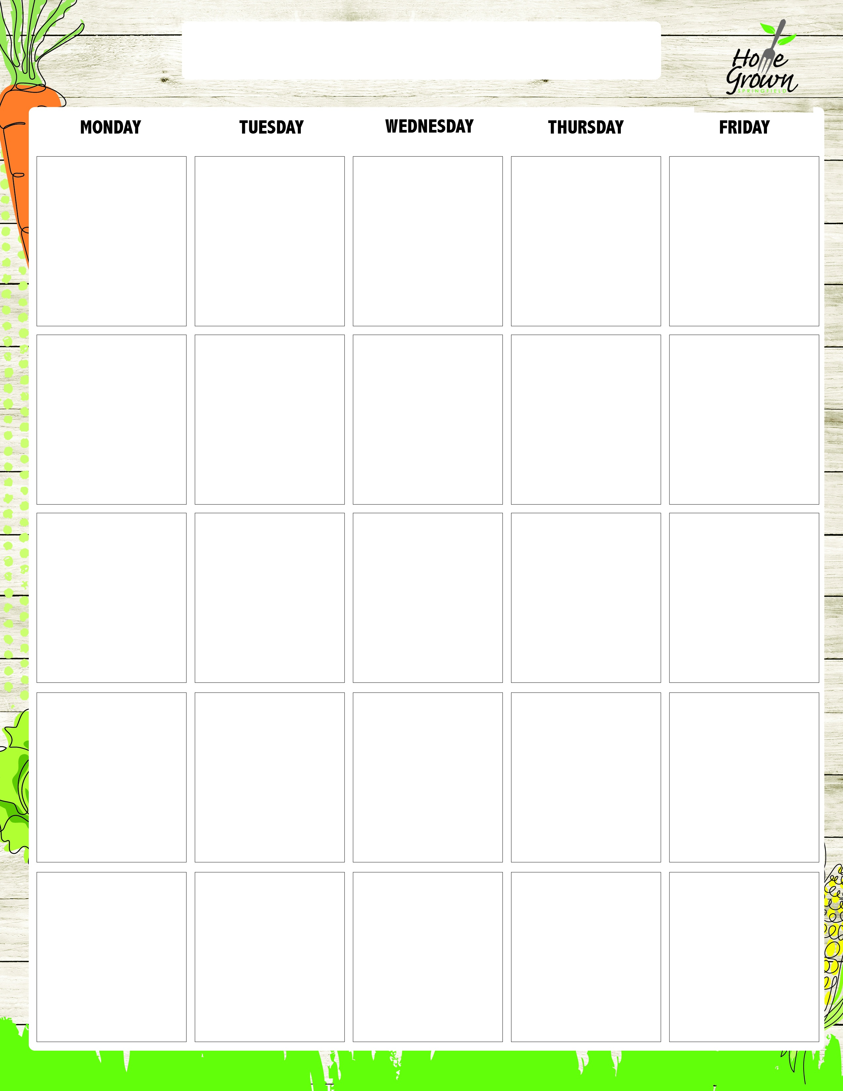
SECONDARY GRAB & GO
August-September 2026
8/24
Spiced Apple Muffin
OR
Mini Cinnamon Rolls
Giant Goldfish Cracker
8/25
French Toast Sticks w/Syrup
OR
Egg & Cheese
English Muffin
Local Granola
8/26
Peach Parfait w/Sweet Babu’s Granola
OR
Bagel w/Spread
Cheese Stick
8/27
Spiced Apple Pocket
OR
Pumpkin Streusel Muffin
Scooby Snacks
8/28
Egg & Cheese
English Muffin
OR
Spiced Apple Muffin
Giant Goldfish Cracker
8/31
Pumpkin Streusel Muffin
OR
Apple Strudel Pastry
Giant Goldfish Cracker
9/1
No School
9/2
Apple Cinnamon Parfait w/Sweet Babu’s Granola
OR
Raspberry Roll
Cheese Stick
9/3
Chorizo, Potato & Cheese Pocket
OR
Bagel w/Spread
Scooby Snacks
9/4
CNC Chicken Sausage & Cheese Maple Flatbread
OR
Pumpkin Streusel Muffin
Giant Goldfish Cracker
9/7
No School
9/8
Bagel w/Spread
OR
Wild Blueberry Muffin
Local Granola
9/9
Wild Blueberry Pocket
OR
CNC Chicken Sausage & Cheese Maple Flatbread
Cheese Stick
9/10
Pineapple Parfait w/ Sweet Babu’s Granola
OR
Bagel w/Spread
Scooby Snacks
9/11
Egg & Cheese
English Muffin
OR
Spiced Apple Muffin
Giant Goldfish Cracker
9/14
Wild Blueberry Muffin
OR
Apple Strudel Pastry
Giant Goldfish Cracker
9/15
Bacon, Egg, Potato & Cheese Pocket
OR
Raspberry Roll
Local Granola
9/16
Flakey Biscuit with Creamy Sausage Gravy
OR
Bagel w/Spread
Cheese Stick
9/17
Very Berry Parfait w/ Sweet Babu’s Granola
OR
Wild Blueberry Pocket
Scooby Snacks
9/18
CNC Chicken Sausage & Cheese English Muffin
OR
Pumpkin Streusel Muffin
Giant Goldfish Cracker
9/21
Spiced Apple Muffin
OR
Mini Cinnamon Rolls
Giant Goldfish Cracker
9/22
French Toast Sticks w/Syrup
OR
Egg & Cheese
English Muffin
Local Granola
9/23
Peach Parfait w/Sweet Babu’s Granola
OR
Bagel w/Spread
Cheese Stick
9/24
Spiced Apple Pocket
OR
CNC Chicken Sausage & Cheese English Muffin
Scooby Snacks
9/25
Egg & Cheese
English Muffin
OR
Wild Blueberry Muffin
Giant Goldfish Cracker

SECONDARY GRAB & GO
September-October 2026
9/28
Pumpkin Streusel Muffin
OR
Apple Strudel Pastry
Giant Goldfish Cracker
9/29
Pancakes with Syrup
OR
Flakey Biscuit with Creamy Sausage Gravy
Local Granola
9/30
Apple Cinnamon Parfait w/Sweet Babu’s Granola
OR
Raspberry Roll
Cheese Stick
10/1
Chorizo, Potato & Cheese Pocket
OR
Bagel w/Spread
Scooby Snacks
10/2
CNC Chicken Sausage & Cheese Maple Flatbread
OR
Pumpkin Streusel Muffin
Giant Goldfish Cracker

