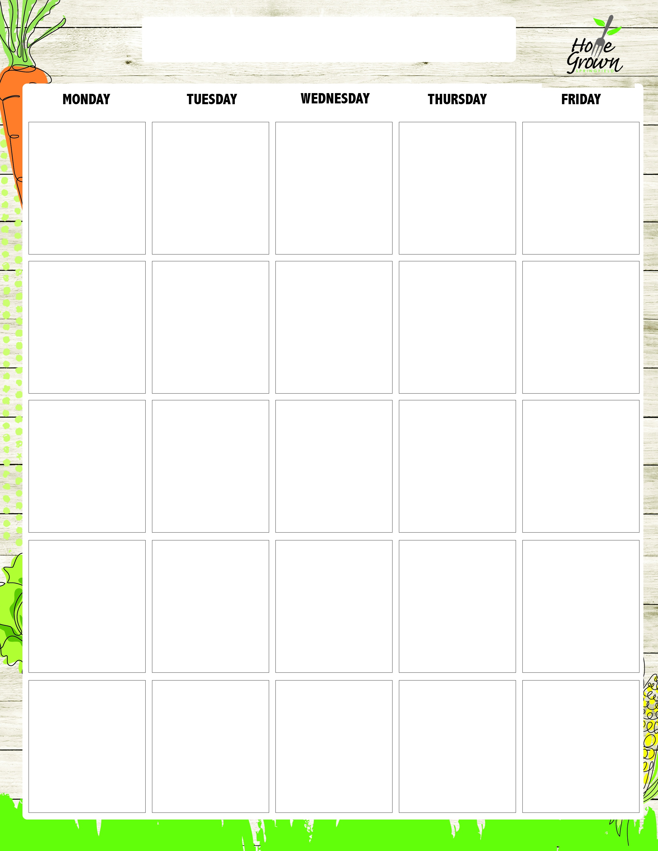
SECONDARY SATELLITE BREAKFAST
August-September 2026
8/24
Spiced Apple Muffin
Giant Goldfish Cracker
Fresh Whole Fruit
100% Juice
1% or Fat Free Milk
8/25
French Toast with Syrup
Local Granola
Fresh Whole Fruit
100% Juice
1% or Fat Free Milk
8/26
Yogurt & Granola
Cheese Stick
Fresh Whole Fruit
100% Juice
1% or Fat Free Milk
8/27
Spiced Apple Pocket
Scooby Snacks
Fresh Whole Fruit
100% Juice
1% or Fat Free
8/28
Egg & Cheese
English Muffin
Giant Goldfish Cracker
Fresh Whole Fruit
100% Juice
1% or Fat Free Milk
8/31
Pumpkin Streusel Muffin
Giant Goldfish Cracker
Fresh Whole Fruit
100% Juice
1% or Fat Free Milk
9/1
No School
9/2
Mini Cinnamon Rolls
Cheese Stick
Fresh Whole Fruit
100% Juice
1% or Fat Free Milk
9/3
Chorizo, Potato
& Cheese Pocket
Scooby Snacks
Fresh Whole Fruit
100% Juice
1% or Fat Free Milk
9/4
CNC Chicken Sausage & Cheese Maple Flatbread
Giant Goldfish Cracker
Fresh Whole Fruit
100% Juice
1% or Fat Free Milk
9/7
No School
9/8
Bagel w/Spread
Local Granola
Fresh Whole Fruit
100% Juice
1% or Fat Free Milk
9/9
Wild Blueberry Pocket
Cheese Stick
Fresh Whole Fruit
100% Juice
1% or Fat Free Milk
9/10
OATrageous Mango Overnight Oats
Scooby Snacks
Fresh Whole Fruit
100% Juice
1% or Fat Free Milk
9/11
Egg & Cheese
English Muffin
Giant Goldfish Cracker
Fresh Whole Fruit
100% Juice
1% or Fat Free Milk
9/14
Wild Blueberry Muffin
Giant Goldfish Cracker
Fresh Whole Fruit
100% Juice
1% or Fat Free Milk
9/15
Bacon, Egg, Potato & Cheese Pocket
Local Granola
Fresh Whole Fruit
100% Juice
1% or Fat Free Milk
9/16
Flakey Biscuit with Creamy Sausage Gravy
Scooby Snacks
Fresh Whole Fruit
100% Juice
1% or Fat Free Milk
9/17
Raspberry Roll
Cheese Stick
Fresh Whole Fruit
100% Juice
1% or Fat Free Milk
9/18
CNC Chicken Sausage & Cheese English Muffin
Giant Goldfish Cracker
Fresh Whole Fruit
100% Juice
1% or Fat Free Milk
9/21
Spiced Apple Muffin
Giant Goldfish Cracker
Fresh Whole Fruit
100% Juice
1% or Fat Free Milk
9/22
French Toast with Syrup
Local Granola
Fresh Whole Fruit
100% Juice
1% or Fat Free Milk
9/23
Yogurt & Granola
Cheese Stick
Fresh Whole Fruit
100% Juice
1% or Fat Free Milk
9/24
Spiced Apple Pocket
Scooby Snacks
Fresh Whole Fruit
100% Juice
1% or Fat Free
9/25
Egg & Cheese
English Muffin
Giant Goldfish Cracker
Fresh Whole Fruit
100% Juice
1% or Fat Free Milk

SECONDARY SATELLITE BREAKFAST
September-October 2026
9/28
Pumpkin Streusel Muffin
Giant Goldfish Cracker
Fresh Whole Fruit
100% Juice
1% or Fat Free Milk
9/29
Pancakes with Syrup
Local Granola
Fresh Whole Fruit
100% Juice
1% or Fat Free Milk
9/30
Mini Cinnamon Rolls
Cheese Stick
Fresh Whole Fruit
100% Juice
1% or Fat Free Milk
10/1
Chorizo, Potato
& Cheese Pocket
Scooby Snacks
Fresh Whole Fruit
100% Juice
1% or Fat Free Milk
10/2
CNC Chicken Sausage & Cheese Maple Flatbread
Giant Goldfish Cracker
Fresh Whole Fruit
100% Juice
1% or Fat Free Milk

