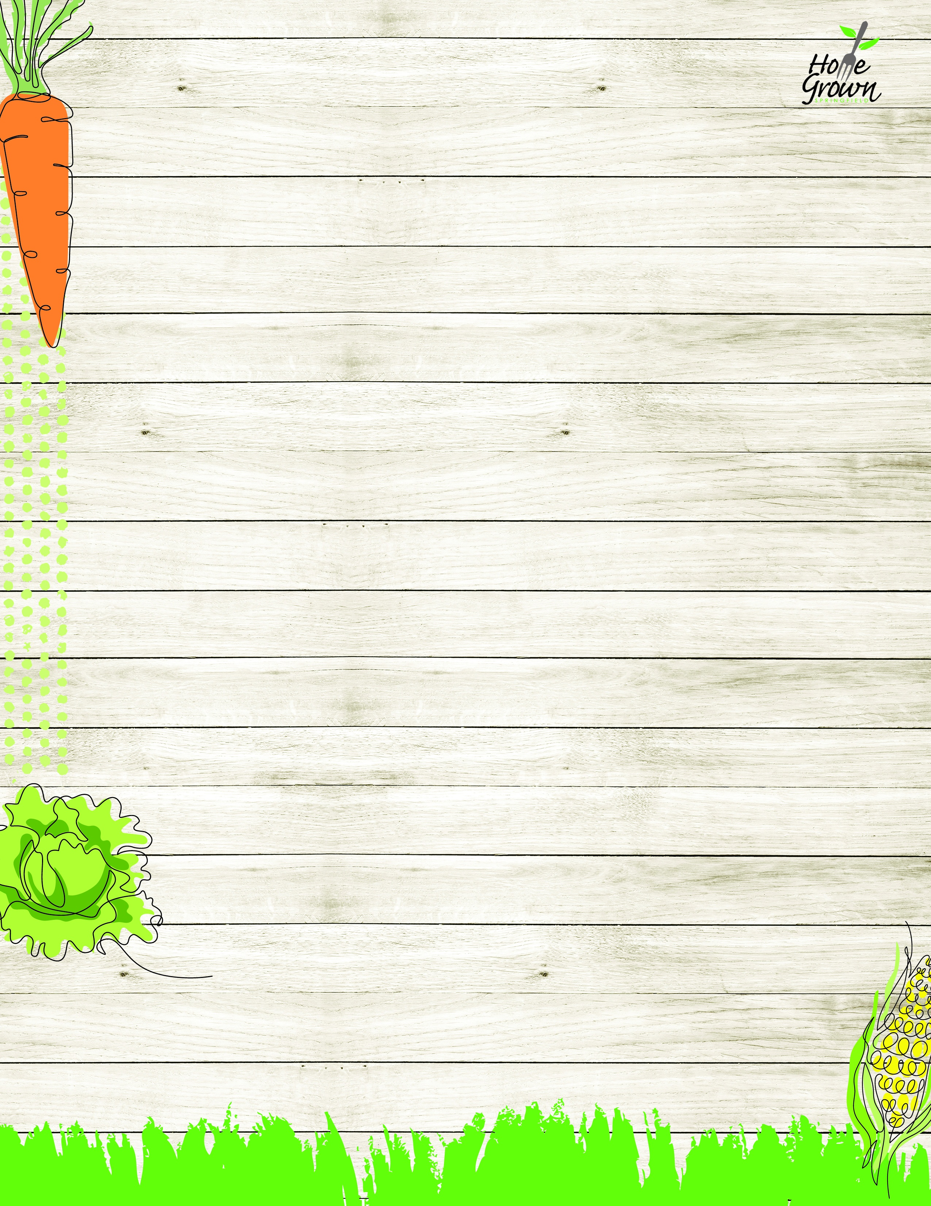

SICS LUNCH
SICS Lunch: August 24-28
MONDAY
TUESDAY
WEDNESDAY
WEDNESDAY
THURSDAY
FRIDAY
Cheeseburger w/ fresh lettuce, tomato, and onion
General Tso’s Chicken with Veggie Fried Rice
Mac n Cheese
Mac n Cheese
Chicken & Waffles, Apple Topping and Syrup
Pepperoni Pizza
OR
Cheese Pizza
Steak & Cheese Calzone with Ranch Dipping Sauce
Stuffed Cheesy bread w/Marinara
Cheese Pizza
Pepperoni Pizza
Cheese Pizza
Pepperoni Pizza
Chicken & Waffles w/Drumstick & Toppings
Stuffed Cheesy bread w/Marinara
Nacho Bar
Plant-based Halal Nacho Crumbles, Cheese Sauce,
Sour Cream, Salsa,
Tortilla Chips
Turkey & Cheese Sandwich
Sunbutter & Jelly Sandwich
Cheese Sandwich
Turkey & Cheese Sandwich
Sunbutter & Jelly Sandwich
Cheese Sandwich
Turkey & Cheese Sandwich
Sunbutter & Jelly Sandwich
Cheese Sandwich
Chicken Caesar Salad with Roll
Garden Salad with Roll
Turkey & Cheese Sandwich
Sunbutter & Jelly Sandwich
Cheese Sandwich
Chicken Caesar Salad with Roll
Garden Salad with Roll
Turkey & Cheese Sandwich
Sunbutter & Jelly Sandwich
Cheese Sandwich
Chicken Caesar Salad with Roll
Garden Salad with Roll
Turkey & Cheese Sandwich
Sunbutter & Jelly Sandwich
Cheese Sandwich
French Fries
Carrot Sticks
Seasoned Green Beans
Celery Sticks
Roasted Broccoli
Grape Tomatoes
Roasted Broccoli
Grape Tomatoes
Mashed Sweet Potatoes
Chilled Corn
Side Caesar Salad
Black Bean Salad
Available Daily:
Assorted Fresh Fruit
Chilled Fruit
Fat Free Chocolate, 1% White or Fat Free White Milk
Available Daily:
Assorted Fresh Fruit
Chilled Fruit
Fat Free Chocolate, 1% White or Fat Free White Milk
Available Daily:
Assorted Fresh Fruit
Chilled Fruit
Fat Free Chocolate, 1% White or Fat Free White Milk
Available Daily:
Assorted Fresh Fruit
Chilled Fruit
Fat Free Chocolate, 1% White or Fat Free White Milk
Available Daily:
Assorted Fresh Fruit
Chilled Fruit
Fat Free Chocolate, 1% White or Fat Free White Milk
Available Daily:
Assorted Fresh Fruit
Chilled Fruit
Fat Free Chocolate, 1% White or Fat Free White Milk

SICS LUNCH
Week of August 31- September 4 Week of August 31- September 4
MONDAY
TUESDAY
WEDNESDAY
THURSDAY
FRIDAY
Cheese Nachos w/ Salsa
NO SCHOOL
Baked Ziti w/Plant-based Bolognese
Cheddar Chicken Bowl
w/Roll
Pepperoni Pizza
OR
Cheese Pizza
Hawaiian Pineapple Chicken Bowl
with Brown Rice & Corn & Pineapple Salsa
Grilled Cheese

Chicken Patty Sandwich
Cheddar Chicken Bowl w/Tenders & Roll
Ham & Cheese Calzone w/Honey Mustard
Chipotle Rice Bar
Chipotle Chicken, Seasoned Rice, Pico de Gallo, Cheddar Cheese, Roasted
Corn, Sour Cream
Chicken Cobb Salad w/Dinner Roll
Hummus Bento Box with Roll
Turkey Ham & Cheese on Kaiser
Sunbutter & Jelly Sandwich
Cheese Sandwich
Chicken Cobb Salad w/Dinner Roll
Hummus Bento Box with Roll
Turkey Ham & Cheese on Kaiser
Sunbutter & Jelly Sandwich
Cheese Sandwich
Chicken Cobb Salad w/Dinner Roll
Hummus Bento Box with Roll
Turkey Ham & Cheese on Kaiser
Sunbutter & Jelly Sandwich
Cheese Sandwich
Chicken Cobb Salad w/Dinner Roll
Hummus Bento Box with Roll
Turkey Ham & Cheese on Kaiser
Sunbutter & Jelly Sandwich
Cheese Sandwich
Chicken Cobb Salad w/Dinner Roll
Hummus Bento Box with Roll
Turkey Ham & Cheese on Kaiser
Sunbutter & Jelly Sandwich
Cheese Sandwich
Steamed Corn
Black Bean Salad

Roasted Broccoli
Carrot Sticks
Local Mashed
Potatoes
Chilled Corn
Seasoned Green
Beans
Cucumber Salad
Available Daily:
Assorted Fresh Fruit
Chilled Fruit
Fat Free Chocolate, 1% White or Fat Free White Milk
Available Daily:
Assorted Fresh Fruit
Chilled Fruit
Fat Free Chocolate, 1% White or Fat Free White Milk
Available Daily:
Assorted Fresh Fruit
Chilled Fruit
Fat Free Chocolate, 1% White or Fat Free White Milk
Available Daily:
Assorted Fresh Fruit
Chilled Fruit
Fat Free Chocolate, 1% White or Fat Free White Milk
Available Daily:
Assorted Fresh Fruit
Chilled Fruit
Fat Free Chocolate, 1% White or Fat Free White Milk

SICS LUNCH
Week of September 7-11 Week of September 7-11
MONDAY
TUESDAY
WEDNESDAY
THURSDAY
FRIDAY
NO SCHOOL
Chicken Patty OR Spicy Chicken Patty Sandwich w/fresh lettuce, tomato, onion
French Toast Sticks with CNC Chicken Breakfast Sausage
& Syrup
Plant-based Taco Salad with
Seasoned Rice & Pico de Gallo
Pepperoni Pizza
OR
Cheese Pizza

Cheese Calzone w/Marinara
Grilled Cheese
Cheese Pizza
Pepperoni Pizza
Cheese Calzone w/Marinara
Grilled Cheese
Asopao de Pollo
Stewed Chicken Thighs with Plantains, Arroz con Frijoles
Vegan Mediterranean Salad with Roll
Garden Salad with Roll
Turkey & Cheese Sandwich
Sunbutter & Jelly Sandwich
Cheese Sandwich
Vegan Mediterranean Salad with Roll
Garden Salad with Roll
Turkey & Cheese Sandwich
Sunbutter & Jelly Sandwich
Cheese Sandwich
Vegan Mediterranean Salad with Roll
Garden Salad with Roll
Turkey & Cheese Sandwich
Sunbutter & Jelly Sandwich
Cheese Sandwich
Vegan Mediterranean Salad with Roll
Garden Salad with Roll
Turkey & Cheese Sandwich
Sunbutter & Jelly Sandwich
Cheese Sandwich
Vegan Mediterranean Salad with Roll
Garden Salad with Roll
Turkey & Cheese Sandwich
Sunbutter & Jelly Sandwich
Cheese Sandwich

Tater Tots
Carrot Sticks
Mashed Butternut
Celery Sticks
Stewed Black Beans
Grape Tomatoes
Steamed Broccoli
Celery Sticks

SICS LUNCH
Week of September 14-18
MONDAY
TUESDAY
WEDNESDAY
THURSDAY
FRIDAY
Chicken Nuggets
CNC BBQ Sauce, Roll
Sweet Battered
Mini Turkey Corn Dogs
Pasta & Meatballs with Marinara & Parmesan Cheese
Huli Huli Chicken with Rice Pilaf
Pepperoni Pizza
OR
Cheese Pizza
Pepperoni Calzone w/Marinara
Spicy Chicken Patty
Grilled Cheese
Pepperoni Calzone w/Marinara
Hot Dog
Cheeseburger
Grilled Cheese
Loaded Baked Potato with Plant-based Nacho Crumbles, Cheese Sauce & Dinner Roll
Kale & Apple Salad
Hummus Bento Box with Roll
Turkey Ham & Cheese Sandwich
Sunbutter & Jelly Sandwich
Cheese Sandwich
Kale & Apple Salad
Hummus Bento Box with Roll
Turkey Ham & Cheese Sandwich
Sunbutter & Jelly Sandwich
Cheese Sandwich
Kale & Apple Salad
Hummus Bento Box with Roll
Turkey Ham & Cheese Sandwich
Sunbutter & Jelly Sandwich
Cheese Sandwich
Kale & Apple Salad
Hummus Bento Box with Roll
Turkey Ham & Cheese Sandwich
Sunbutter & Jelly Sandwich
Cheese Sandwich
Kale & Apple Salad
Hummus Bento Box with Roll
Turkey Ham & Cheese Sandwich
Sunbutter & Jelly Sandwich
Cheese Sandwich
French Fries
Celery Sticks
Veggie Baked Beans
Grape Tomatoes
Roasted Broccoli
Carrot Sticks
Seasoned Green Beans
Chilled Corn
Roasted Local Root Vegetables
Celery Sticks
Available Daily:
Assorted Fresh Fruit
Chilled Fruit
Fat Free Chocolate, 1% White or Fat Free White Milk
Available Daily:
Assorted Fresh Fruit
Chilled Fruit
Fat Free Chocolate, 1% White or Fat Free White Milk
Available Daily:
Assorted Fresh Fruit
Chilled Fruit
Fat Free Chocolate, 1% White or Fat Free White Milk
Available Daily:
Assorted Fresh Fruit
Chilled Fruit
Fat Free Chocolate, 1% White or Fat Free White Milk
Available Daily:
Assorted Fresh Fruit
Chilled Fruit
Fat Free Chocolate, 1% White or Fat Free White Milk

SICS LUNCH
Week of September 21-25
MONDAY
TUESDAY
WEDNESDAY
THURSDAY
FRIDAY
Cheeseburger w/ fresh lettuce, tomato, and onion
General Tso’s Chicken with Veggie Fried Rice
Mac n Cheese
Chicken & Waffles, Apple Topping and Syrup
Pepperoni Pizza
OR
Cheese Pizza
Steak & Cheese Calzone with Ranch Dipping Sauce
Grilled Cheese
Stuffed Cheesy bread w/Marinara
Grilled Cheese
Cheese Pizza
Pepperoni Pizza
Chicken & Waffles w/Drumstick & Toppings
Stuffed Cheesy bread w/Marinara
Nacho Bar
Plant-based Halal Nacho Crumbles, Cheese Sauce,
Sour Cream, Salsa,
Tortilla Chips
Chicken Caesar Salad with Roll
Garden Salad with Roll
Turkey & Cheese Sandwich
Sunbutter & Jelly Sandwich
Cheese Sandwich
Chicken Caesar Salad with Roll
Garden Salad with Roll
Turkey & Cheese Sandwich
Sunbutter & Jelly Sandwich
Cheese Sandwich
Chicken Caesar Salad with Roll
Garden Salad with Roll
Turkey & Cheese Sandwich
Sunbutter & Jelly Sandwich
Cheese Sandwich
Chicken Caesar Salad with Roll
Garden Salad with Roll
Turkey & Cheese Sandwich
Sunbutter & Jelly Sandwich
Cheese Sandwich
Chicken Caesar Salad with Roll
Garden Salad with Roll
Turkey & Cheese Sandwich
Sunbutter & Jelly Sandwich
Cheese Sandwich
French Fries
Carrot Sticks
Seasoned Green Beans
Celery Sticks
Roasted Broccoli
Grape Tomatoes
Mashed Sweet Potatoes
Chilled Corn
Side Caesar Salad
Black Bean Salad
Available Daily:
Assorted Fresh Fruit
Chilled Fruit
Fat Free Chocolate, 1% White or Fat Free White Milk
Available Daily:
Assorted Fresh Fruit
Chilled Fruit
Fat Free Chocolate, 1% White or Fat Free White Milk
Available Daily:
Assorted Fresh Fruit
Chilled Fruit
Fat Free Chocolate, 1% White or Fat Free White Milk
Available Daily:
Assorted Fresh Fruit
Chilled Fruit
Fat Free Chocolate, 1% White or Fat Free White Milk
Available Daily:
Assorted Fresh Fruit
Chilled Fruit
Fat Free Chocolate, 1% White or Fat Free White Milk

SICS LUNCH
Week of September 28- October 2 Week of September 28- October 2
MONDAY
TUESDAY
WEDNESDAY
THURSDAY
FRIDAY
Italian Meatball Sub w/parmesan cheese
Cheese Nachos
w/Salsa
Baked Ziti w/Plant-based Bolognese
Cheddar Chicken Bowl
w/Roll
Pepperoni Pizza
OR
Cheese Pizza
Ham & cheese Calzone w/Honey Mustard
Grilled Cheese
Hawaiian Pineapple Chicken Bowl
with Brown Rice & Corn & Pineapple Salsa
Grilled Cheese
Chicken Patty Sandwich
Cheddar Chicken Bowl w/Tenders & Roll
Ham & Cheese Calzone w/Honey Mustard
Chipotle Rice Bar
Chipotle Chicken, Seasoned Rice, Pico de Gallo, Cheddar Cheese, Roasted
Corn, Sour Cream
Chicken Cobb Salad w/Dinner Roll
Hummus Bento Box with Roll
Turkey Ham & Cheese on Kaiser
Sunbutter & Jelly Sandwich
Cheese Sandwich
Chicken Cobb Salad w/Dinner Roll
Hummus Bento Box with Roll
Turkey Ham & Cheese on Kaiser
Sunbutter & Jelly Sandwich
Cheese Sandwich
Chicken Cobb Salad w/Dinner Roll
Hummus Bento Box with Roll
Turkey Ham & Cheese on Kaiser
Sunbutter & Jelly Sandwich
Cheese Sandwich
Chicken Cobb Salad w/Dinner Roll
Hummus Bento Box with Roll
Turkey Ham & Cheese on Kaiser
Sunbutter & Jelly Sandwich
Cheese Sandwich
Chicken Cobb Salad w/Dinner Roll
Hummus Bento Box with Roll
Turkey Ham & Cheese on Kaiser
Sunbutter & Jelly Sandwich
Cheese Sandwich
Steamed Carrots
Grape Tomatoes
Steamed Corn
Black Bean Salad
Roasted Broccoli
Carrot Sticks
Local Mashed
Potatoes
Chilled Corn
Seasoned Green
Beans
Cucumber Salad
Available Daily:
Assorted Fresh Fruit
Chilled Fruit
Fat Free Chocolate, 1% White or Fat Free White Milk
Available Daily:
Assorted Fresh Fruit
Chilled Fruit
Fat Free Chocolate, 1% White or Fat Free White Milk
Available Daily:
Assorted Fresh Fruit
Chilled Fruit
Fat Free Chocolate, 1% White or Fat Free White Milk
Available Daily:
Assorted Fresh Fruit
Chilled Fruit
Fat Free Chocolate, 1% White or Fat Free White Milk
Available Daily:
Assorted Fresh Fruit
Chilled Fruit
Fat Free Chocolate, 1% White or Fat Free White Milk

