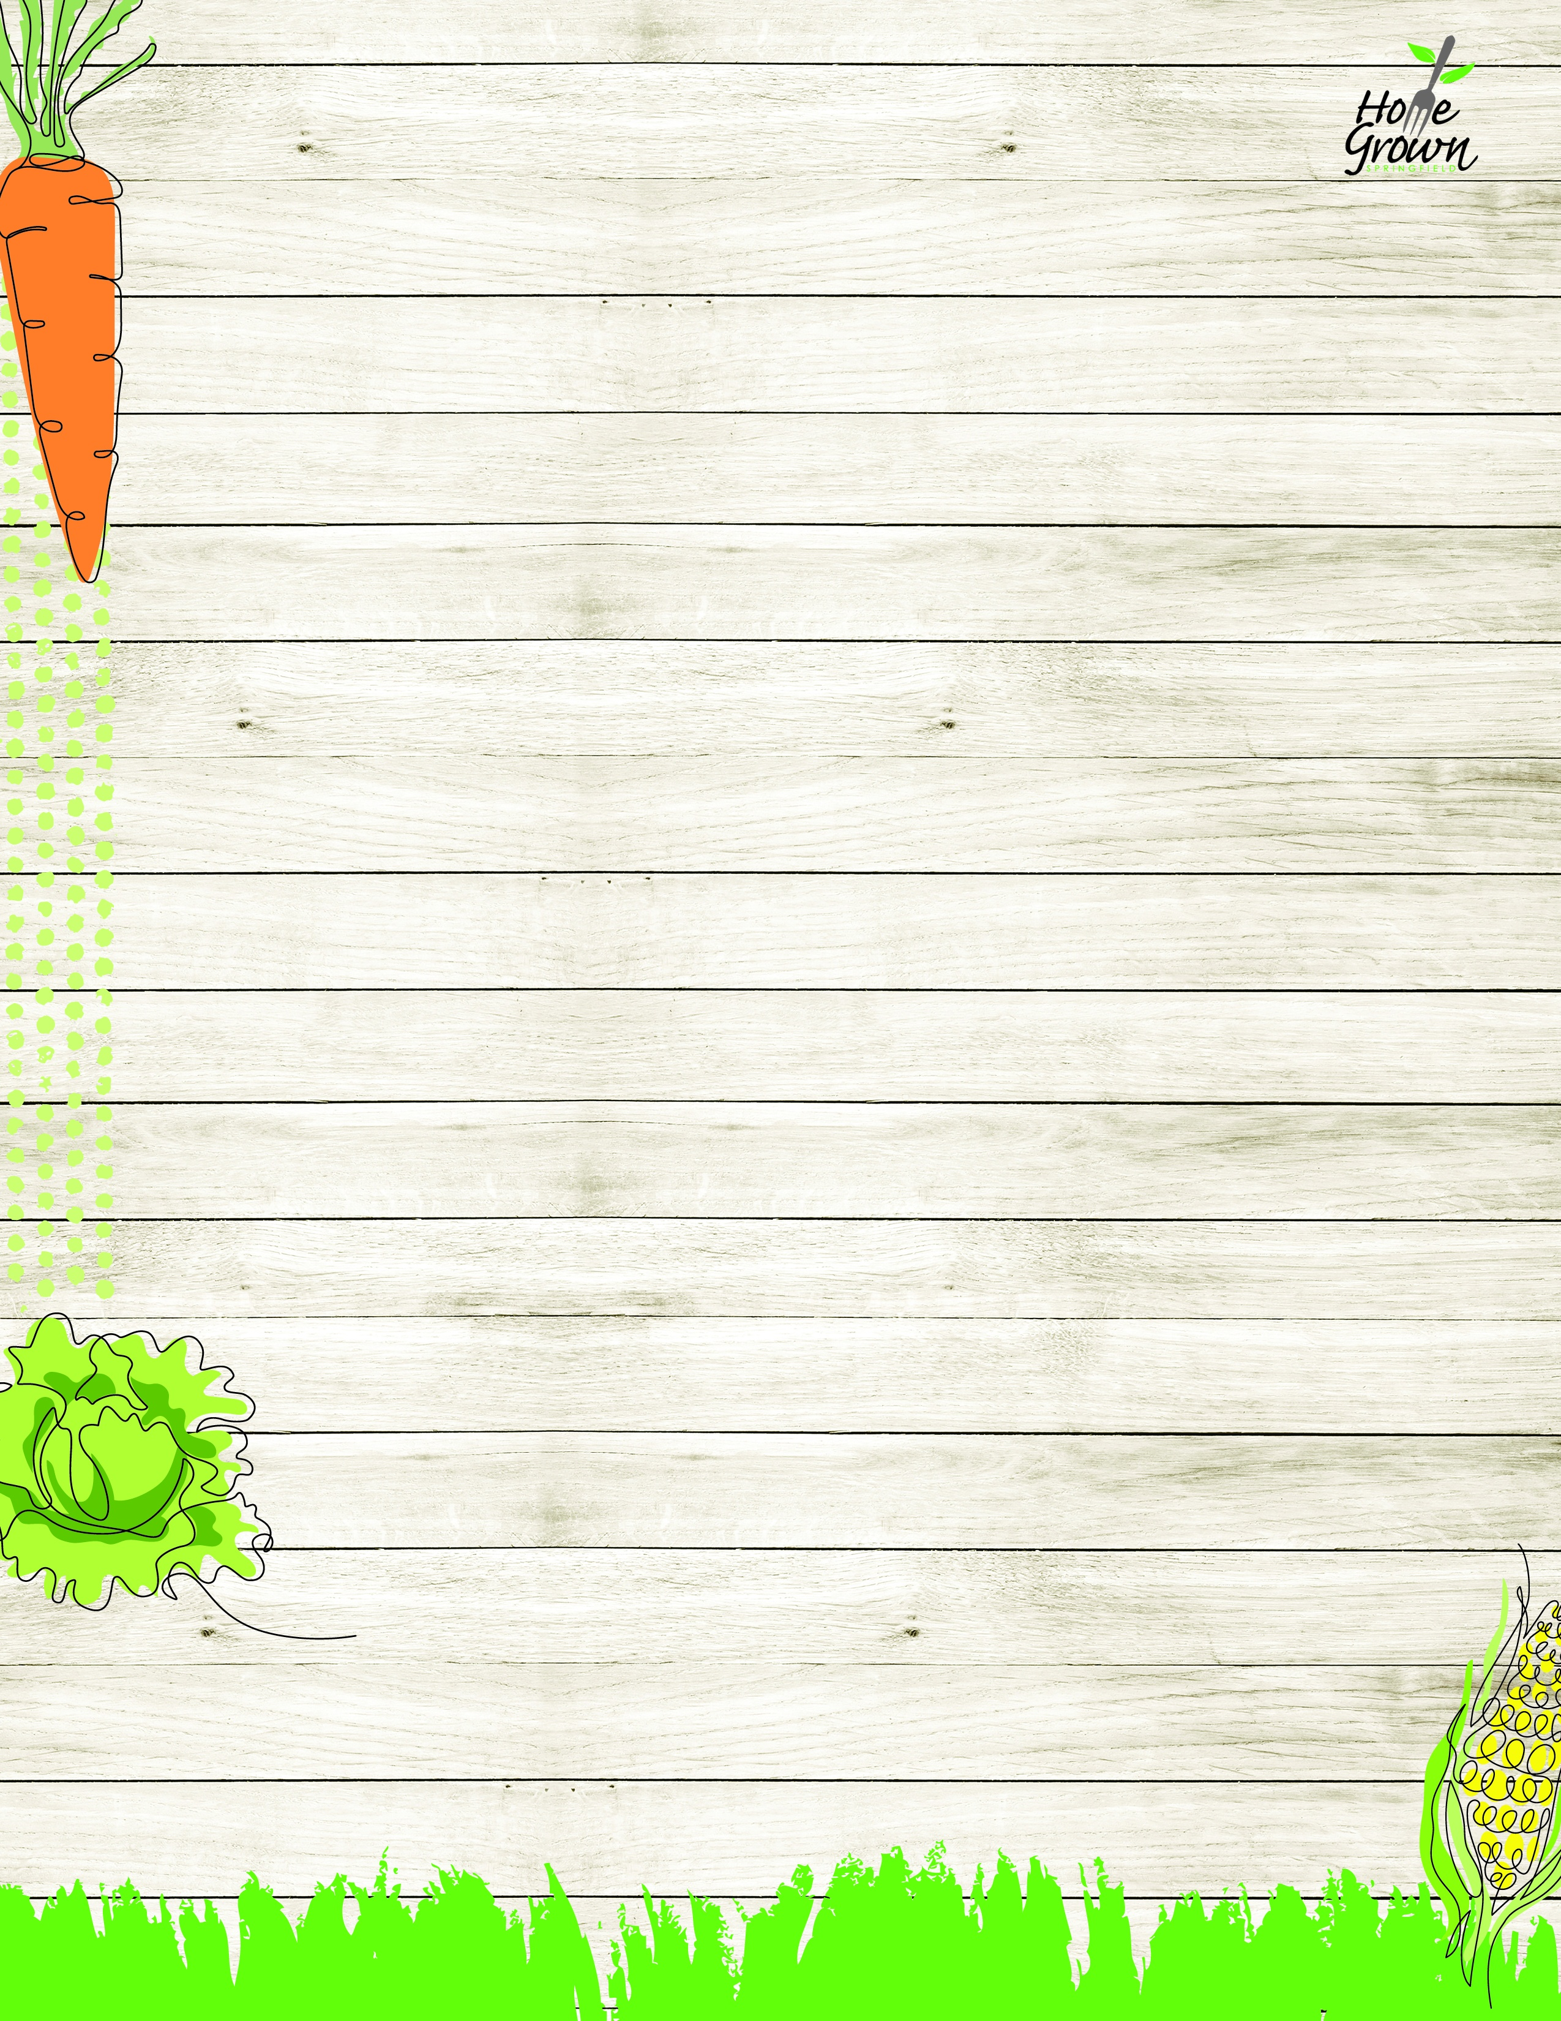

SAT MS LUNCH
Springfield Middle Schools Week of August 24-28
MONDAY
TUESDAY
WEDNESDAY
WEDNESDAY
WEDNESDAY
THURSDAY
FRIDAY
CREATE
Steak & Cheese Calzone with Ranch Dipping Sauce
General Tso’s Chicken with Veggie Fried Rice
Mac n Cheese
Mac n Cheese
Mac n Cheese
Chicken Drumstick & Waffles, Apple Topping and Syrup
Nacho Bar
PB Nacho Crumbles, Cheese Sauce,
Sour Cream, Salsa,
Tortilla Chips
GRILL
Spicy Chicken
Patty
Hot Dog
Cheeseburger
Cheeseburger
Grilled Cheese
Grilled Cheese
Chicken Patty
GRILL

Sides – Sliced Tomato, Green Leaf Lettuce, Sliced Onion
Sides – Sliced Tomato, Green Leaf Lettuce, Sliced Onion
Sides – Sliced Tomato, Green Leaf Lettuce, Sliced Onion
Sides – Sliced Tomato, Green Leaf Lettuce, Sliced Onion
FAST TAKES
Garden Salad & a Roll
Turkey & Cheese on Kaiser
Sunbutter & Jelly Sandwich
Garden Salad & a Roll
Turkey & Cheese on Kaiser
Sunbutter & Jelly Sandwich
Garden Salad & a Roll
Turkey & Cheese on Kaiser
Sunbutter & Jelly Sandwich
Chicken Caesar Salad with Roll
Garden Salad & a Roll
Turkey & Cheese on Kaiser
Sunbutter & Jelly Sandwich
Chicken Caesar Salad with Roll
Garden Salad & a Roll
Turkey & Cheese on Kaiser
Sunbutter & Jelly Sandwich
Chicken Caesar Salad with Roll
Garden Salad & a Roll
Turkey & Cheese on Kaiser
Sunbutter & Jelly Sandwich
Chicken Caesar Salad with Roll
Garden Salad & a Roll
Turkey & Cheese on Kaiser
Sunbutter & Jelly Sandwich
SIDES COLD LINE ALTERNATE
French Fries
Carrot Sticks
Seasoned Green Beans
Celery Sticks
Roasted Broccoli
Grape Tomatoes
Roasted Broccoli
Grape Tomatoes
Roasted Broccoli
Grape Tomatoes
Mashed Sweet Potatoes
Chilled Corn
Roasted Corn
Black Bean Salad
SIDES COLD LINE ALTERNATE
Chilled Corn

Broccoli Florets
Broccoli Florets
Broccoli Florets
Grape Tomatoes
Chilled Corn
AVAILABLE DAILY
Available Daily:
Assorted Fresh Fruit
Fat Free Chocolate, 1% White or Fat Free White Milk
Available Daily:
Assorted Fresh Fruit
Fat Free Chocolate, 1% White or Fat Free White Milk
Available Daily:
Assorted Fresh Fruit
Fat Free Chocolate, 1% White or Fat Free White Milk
Available Daily:
Assorted Fresh Fruit
Fat Free Chocolate, 1% White or Fat Free White Milk
Available Daily:
Assorted Fresh Fruit
Fat Free Chocolate, 1% White or Fat Free White Milk
Available Daily:
Assorted Fresh Fruit
Fat Free Chocolate, 1% White or Fat Free White Milk
Available Daily:
Assorted Fresh Fruit
Fat Free Chocolate, 1% White or Fat Free White Milk

SAT MS LUNCH
Springfield Middle Schools August 31- September 4
MONDAY
TUESDAY
WEDNESDAY
THURSDAY
FRIDAY
CREATE
Spicy Chicken
Patty
NO
SCHOOL
Ziti w/Plant-based Bolognese
w/Parmesan Cheese
Cheddar Chicken Bowl w/Tenders & Roll
Stuffed Cheesy bread w/Marinara
PIZZA
Daily Options:
Cheese Pizza
Pepperoni Pizza
Daily Options:
Cheese Pizza
Pepperoni Pizza
Daily Options:
Cheese Pizza
Pepperoni Pizza
Daily Options:
Cheese Pizza
Pepperoni Pizza
Daily Options:
Cheese Pizza
Pepperoni Pizza
ON THE GO
Buffalo Chicken Salad with Roll
Garden Salad with Hummus and a Roll
Turkey Ham & Cheese on Kaiser
Sunbutter & Jelly Sandwich
Buffalo Chicken Salad with Roll
Garden Salad with Hummus and a Roll
Turkey Ham & Cheese on Kaiser
Sunbutter & Jelly Sandwich
Buffalo Chicken Salad with Roll
Garden Salad with Hummus and a Roll
Turkey Ham & Cheese on Kaiser
Sunbutter & Jelly Sandwich
Buffalo Chicken Salad with Roll
Garden Salad with Hummus and a Roll
Turkey Ham & Cheese on Kaiser
Sunbutter & Jelly Sandwich
Buffalo Chicken Salad with Roll
Garden Salad with Hummus and a Roll
Turkey Ham & Cheese on Kaiser
Sunbutter & Jelly Sandwich
EXTRA
Steamed Carrots
Celery Sticks

Roasted Broccoli
Carrot Sticks
Local Mashed
Potatoes
Chilled Corn
Seasoned Green
Beans
Cucumber Salad
EXTRA
Grape Tomatoes

Broccoli Florets

AVAILABLE DAILY
Available Daily:
Assorted Fresh Fruit
Fat Free Chocolate, 1% White or Fat Free White Milk
Available Daily:
Assorted Fresh Fruit
Fat Free Chocolate, 1% White or Fat Free White Milk
Available Daily:
Assorted Fresh Fruit
Fat Free Chocolate, 1% White or Fat Free White Milk
Available Daily:
Assorted Fresh Fruit
Fat Free Chocolate, 1% White or Fat Free White Milk
Available Daily:
Assorted Fresh Fruit
Fat Free Chocolate, 1% White or Fat Free White Milk

SAT MS LUNCH
Springfield Middle Schools September 7-11
MONDAY
TUESDAY
WEDNESDAY
THURSDAY
FRIDAY
CREATE
NO
SCHOOL
Cheese Calzone w/Marinara
French Toast Sticks with CNC Chicken Breakfast Sausage
& Syrup
Plant-based Taco Salad with Seasoned Rice & Salsa
Pepperoni Pizza
OR
Cheese Pizza
GRILL

Spicy Chicken Patty
Hot Dog
Chicken Patty
Cheeseburger
GRILL
Sides – Sliced Tomato, Green Leaf Lettuce, Sliced Onion
Sides – Sliced Tomato, Green Leaf Lettuce, Sliced Onion
Sides – Sliced Tomato, Green Leaf Lettuce, Sliced Onion
Sides – Sliced Tomato, Green Leaf Lettuce, Sliced Onion
Sides – Sliced Tomato, Green Leaf Lettuce, Sliced Onion
ON THE GO
Crispy Chicken Salad with Roll
Garden Salad and a Roll
Turkey & Cheese on Kaiser
Sunbutter & Jelly Sandwich
Crispy Chicken Salad with Roll
Garden Salad and a Roll
Turkey & Cheese on Kaiser
Sunbutter & Jelly Sandwich
Crispy Chicken Salad with Roll
Garden Salad and a Roll
Turkey & Cheese on Kaiser
Sunbutter & Jelly Sandwich
Crispy Chicken Salad with Roll
Garden Salad and a Roll
Turkey & Cheese on Kaiser
Sunbutter & Jelly Sandwich
Crispy Chicken Salad with Roll
Garden Salad and a Roll
Turkey & Cheese on Kaiser
Sunbutter & Jelly Sandwich
EXTRA

French Fries
Carrot Sticks
Mashed Butternut
Celery Sticks
Black Bean Salad
Grape Tomatoes
Chilled Corn
Broccoli Florets
COLD LINE ALTERNATE

Chilled Corn

AVAILABLE DAILY
Available Daily:
Assorted Fresh Fruit
Fat Free Chocolate, 1% White or Fat Free White Milk
Available Daily:
Assorted Fresh Fruit
Fat Free Chocolate, 1% White or Fat Free White Milk
Available Daily:
Assorted Fresh Fruit
Fat Free Chocolate, 1% White or Fat Free White Milk
Available Daily:
Assorted Fresh Fruit
Fat Free Chocolate, 1% White or Fat Free White Milk
Available Daily:
Assorted Fresh Fruit
Fat Free Chocolate, 1% White or Fat Free White Milk

SAT MS LUNCH
Springfield Middle School September 14-18
MONDAY
TUESDAY
WEDNESDAY
THURSDAY
FRIDAY
CREATE
Chicken Nuggets
CNC BBQ Sauce, Roll
Sweet Battered Mini Turkey Corn Dogs
Penne Pasta w/
Marinara & Mozzarella Cheese
Huli Huli Chicken with Rice Pilaf
Nacho Bar
PB Nacho Crumbles, Cheese Sauce,
Sour Cream, Salsa,
Tortilla Chips
PIZZA
Daily Options:
Cheese Pizza
Pepperoni Pizza
Daily Options:
Cheese Pizza
Pepperoni Pizza
Daily Options:
Cheese Pizza
Pepperoni Pizza
Daily Options:
Cheese Pizza
Pepperoni Pizza
Daily Options:
Cheese Pizza
Pepperoni Pizza
ON THE GO
Chef Salad with Roll
Garden Salad with Hummus and a Roll
Turkey Ham & Cheese on Kaiser
Sunbutter & Jelly Sandwich
Chef Salad with Roll
Garden Salad with Hummus and a Roll
Turkey Ham & Cheese on Kaiser
Sunbutter & Jelly Sandwich
Chef Salad with Roll
Garden Salad with Hummus and a Roll
Turkey Ham & Cheese on Kaiser
Sunbutter & Jelly Sandwich
Chef Salad with Roll
Garden Salad with Hummus and a Roll
Turkey Ham & Cheese on Kaiser
Sunbutter & Jelly Sandwich
Chef Salad with Roll
Garden Salad with Hummus and a Roll
Turkey Ham & Cheese on Kaiser
Sunbutter & Jelly Sandwich
EXTRA
French Fries
Celery Sticks
Veggie Baked Beans
Grape Tomatoes
Roasted Broccoli
Carrot Sticks
Seasoned Green Beans
Chilled Corn
Roasted Local Root Vegetables
Black Bean Salad
EXTRA
Chilled Corn

Broccoli Florets
Celery Sticks
Carrot Sticks
AVAILABLE DAILY
Available Daily:
Assorted Fresh Fruit
Fat Free Chocolate, 1% White or Fat Free White Milk
Available Daily:
Assorted Fresh Fruit
Fat Free Chocolate, 1% White or Fat Free White Milk
Available Daily:
Assorted Fresh Fruit
Fat Free Chocolate, 1% White or Fat Free White Milk
Available Daily:
Assorted Fresh Fruit
Fat Free Chocolate, 1% White or Fat Free White Milk
Available Daily:
Assorted Fresh Fruit
Fat Free Chocolate, 1% White or Fat Free White Milk

SAT MS LUNCH
Springfield Middle Schools September 21-25
MONDAY
TUESDAY
WEDNESDAY
WEDNESDAY
THURSDAY
FRIDAY
CREATE
Steak & Cheese Calzone with Ranch Dipping Sauce
General Tso’s Chicken with Veggie Fried Rice
Mac n Cheese
Mac n Cheese
Chicken Drumstick & Waffles, Apple Topping and Spicy Syrup
Nacho Bar
PB Nacho Crumbles, Cheese Sauce,
Sour Cream, Salsa,
Tortilla Chips
GRILL
Spicy Chicken
Patty
Hot Dog
Cheeseburger
Grilled Cheese
Grilled Cheese
Chicken Patty
GRILL
Sides – Sliced Tomato, Green Leaf Lettuce, Sliced Onion
Sides – Sliced Tomato, Green Leaf Lettuce, Sliced Onion
Sides – Sliced Tomato, Green Leaf Lettuce, Sliced Onion
Sides – Sliced Tomato, Green Leaf Lettuce, Sliced Onion
Sides – Sliced Tomato, Green Leaf Lettuce, Sliced Onion
Sides – Sliced Tomato, Green Leaf Lettuce, Sliced Onion
FAST TAKES
Chicken Caesar Salad with Roll
Garden Salad & a Roll
Turkey & Cheese on Kaiser
Sunbutter & Jelly Sandwich
Chicken Caesar Salad with Roll
Garden Salad & a Roll
Turkey & Cheese on Kaiser
Sunbutter & Jelly Sandwich
Chicken Caesar Salad with Roll
Garden Salad & a Roll
Turkey & Cheese on Kaiser
Sunbutter & Jelly Sandwich
Chicken Caesar Salad with Roll
Garden Salad & a Roll
Turkey & Cheese on Kaiser
Sunbutter & Jelly Sandwich
Chicken Caesar Salad with Roll
Garden Salad & a Roll
Turkey & Cheese on Kaiser
Sunbutter & Jelly Sandwich
Chicken Caesar Salad with Roll
Garden Salad & a Roll
Turkey & Cheese on Kaiser
Sunbutter & Jelly Sandwich
SIDES COLD LINE ALTERNATE
French Fries
Carrot Sticks
Seasoned Green Beans
Celery Sticks
Roasted Broccoli
Grape Tomatoes
Roasted Broccoli
Grape Tomatoes
Mashed Sweet Potatoes
Chilled Corn
Roasted Corn
Black Bean Salad
SIDES COLD LINE ALTERNATE
Chilled Corn

Broccoli Florets
Broccoli Florets

Chilled Corn
AVAILABLE DAILY
Available Daily:
Assorted Fresh Fruit
Fat Free Chocolate, 1% White or Fat Free White Milk
Available Daily:
Assorted Fresh Fruit
Fat Free Chocolate, 1% White or Fat Free White Milk
Available Daily:
Assorted Fresh Fruit
Fat Free Chocolate, 1% White or Fat Free White Milk
Available Daily:
Assorted Fresh Fruit
Fat Free Chocolate, 1% White or Fat Free White Milk
Available Daily:
Assorted Fresh Fruit
Fat Free Chocolate, 1% White or Fat Free White Milk
Available Daily:
Assorted Fresh Fruit
Fat Free Chocolate, 1% White or Fat Free White Milk

SAT MS LUNCH
Springfield Middle Schools September 28- October 2
MONDAY
TUESDAY
WEDNESDAY
THURSDAY
FRIDAY
CREATE
Italian Meatball
Sub w/Parmesan Cheese
Spicy Chicken
Patty
Ziti w/Plant-based Bolognese
w/Parmesan Cheese
Cheddar Chicken Bowl w/Tenders & Roll
Stuffed Cheesy bread w/Marinara
PIZZA
Daily Options:
OMM Cheese Pizza
OMM Pepperoni Pizza
Daily Options:
OMM Cheese Pizza
OMM Pepperoni Pizza
Daily Options:
OMM Cheese Pizza
OMM Pepperoni Pizza
Daily Options:
OMM Cheese Pizza
OMM Pepperoni Pizza
Daily Options:
OMM Cheese Pizza
OMM Pepperoni Pizza
ON THE GO
Buffalo Chicken Salad with Roll
Garden Salad with Hummus and a Roll
Turkey Ham & Cheese on Kaiser
Sunbutter & Jelly Sandwich
Buffalo Chicken Salad with Roll
Garden Salad with Hummus and a Roll
Turkey Ham & Cheese on Kaiser
Sunbutter & Jelly Sandwich
Buffalo Chicken Salad with Roll
Garden Salad with Hummus and a Roll
Turkey Ham & Cheese on Kaiser
Sunbutter & Jelly Sandwich
Buffalo Chicken Salad with Roll
Garden Salad with Hummus and a Roll
Turkey Ham & Cheese on Kaiser
Sunbutter & Jelly Sandwich
Buffalo Chicken Salad with Roll
Garden Salad with Hummus and a Roll
Turkey Ham & Cheese on Kaiser
Sunbutter & Jelly Sandwich
EXTRA
Steamed Carrots
Grape Tomatoes
Steamed Corn
Black Bean Salad
Roasted Broccoli
Carrot Sticks
Local Mashed
Potatoes
Chilled Corn
Seasoned Green
Beans
Cucumber Salad
EXTRA

Chilled Corn
Broccoli Florets

AVAILABLE DAILY
Available Daily:
Assorted Fresh Fruit
Fat Free Chocolate, 1% White or Fat Free White Milk
Available Daily:
Assorted Fresh Fruit
Fat Free Chocolate, 1% White or Fat Free White Milk
Available Daily:
Assorted Fresh Fruit
Fat Free Chocolate, 1% White or Fat Free White Milk
Available Daily:
Assorted Fresh Fruit
Fat Free Chocolate, 1% White or Fat Free White Milk
Available Daily:
Assorted Fresh Fruit
Fat Free Chocolate, 1% White or Fat Free White Milk

