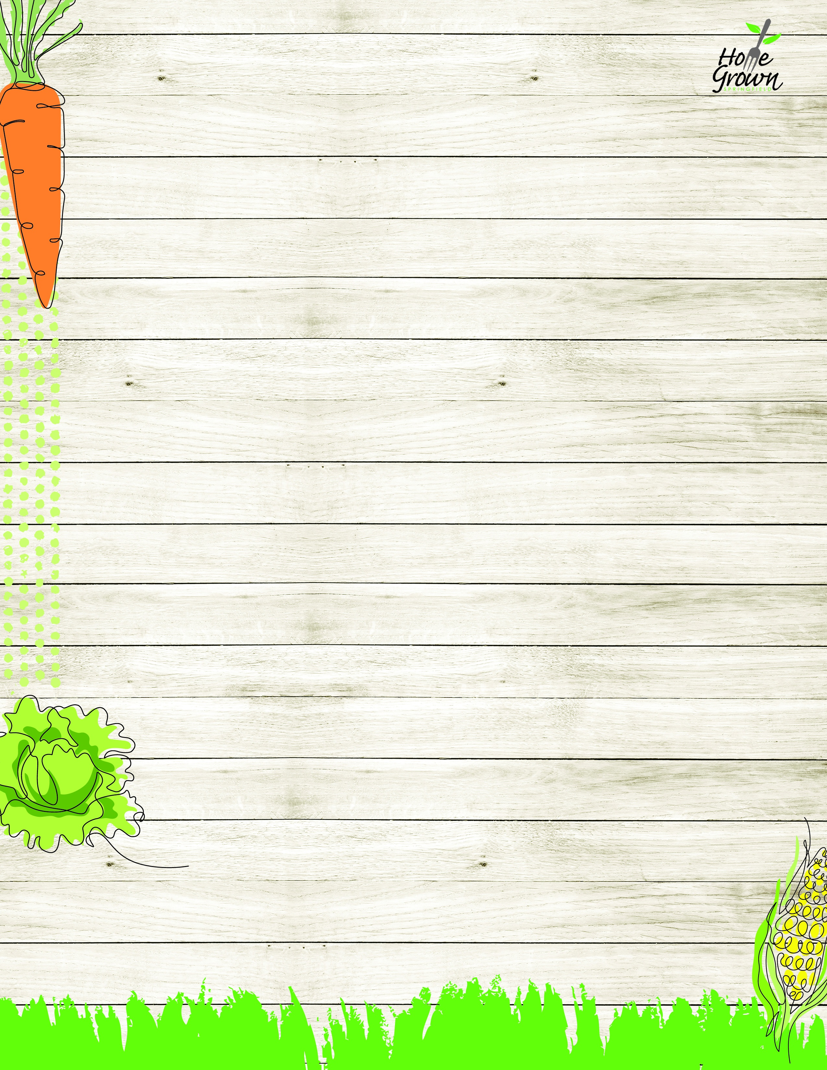

SAT LUNCH
Springfield Elementary Schools Week of August 24-28
MONDAY
TUESDAY
WEDNESDAY
THURSDAY
FRIDAY
Halal Cheeseburger w/fresh lettuce, tomato, onion
General Tso’s Chicken with Veggie Fried Rice
Mac n Cheese
Chicken Drumstick & Waffles, Apple Topping and Syrup
Pepperoni Pizza
OR
Cheese Pizza
Chicken Caesar Salad with Roll
Garden Salad & a Roll
Turkey & Cheese Sandwich
Sunbutter & Jelly Sandwich
Cheese Sandwich
Chicken Caesar Salad with Roll
Garden Salad & a Roll
Turkey & Cheese Sandwich
Sunbutter & Jelly Sandwich
Cheese Sandwich
Chicken Caesar Salad with Roll
Garden Salad & a Roll
Turkey & Cheese Sandwich
Sunbutter & Jelly Sandwich
Cheese Sandwich
Chicken Caesar Salad with Roll
Garden Salad & a Roll
Turkey & Cheese Sandwich
Sunbutter & Jelly Sandwich
Cheese Sandwich
Chicken Caesar Salad with Roll
Garden Salad & a Roll
Turkey & Cheese Sandwich
Sunbutter & Jelly Sandwich
Cheese Sandwich
French Fries
Carrot Sticks
Seasoned Green Beans
Celery Sticks
Roasted Broccoli
Grape Tomatoes
Mashed Sweet Potatoes
Chilled Corn
Steamed Broccoli
Black Bean Salad
Available Daily:
Assorted Fresh Fruit
Fat Free Chocolate, 1% White or Fat Free White Milk
Available Daily:
Assorted Fresh Fruit
Fat Free Chocolate, 1% White or Fat Free White Milk
Available Daily:
Assorted Fresh Fruit
Fat Free Chocolate, 1% White or Fat Free White Milk
Available Daily:
Assorted Fresh Fruit
Fat Free Chocolate, 1% White or Fat Free White Milk
Available Daily:
Assorted Fresh Fruit
Fat Free Chocolate, 1% White or Fat Free White Milk

SAT LUNCH
Week of August 31- September 4
MONDAY
TUESDAY
WEDNESDAY
THURSDAY
FRIDAY
Cheese Nachos w/ Salsa
NO SCHOOL
Ziti w/Plant-based Bolognese
w/Parmesan Cheese
Cheddar Chicken Bowl
w/Roll
Pepperoni Pizza
OR
Cheese Pizza
Buffalo Chicken Salad with Roll
Garden Salad with Hummus and a Roll
Turkey Ham & Cheese Sandwich
Sunbutter & Jelly Sandwich
Cheese Sandwich
Buffalo Chicken Salad with Roll
Garden Salad with Hummus and a Roll
Turkey Ham & Cheese Sandwich
Sunbutter & Jelly Sandwich
Cheese Sandwich
Buffalo Chicken Salad with Roll
Garden Salad with Hummus and a Roll
Turkey Ham & Cheese Sandwich
Sunbutter & Jelly Sandwich
Cheese Sandwich
Buffalo Chicken Salad with Roll
Garden Salad with Hummus and a Roll
Turkey Ham & Cheese Sandwich
Sunbutter & Jelly Sandwich
Cheese Sandwich
Buffalo Chicken Salad with Roll
Garden Salad with Hummus and a Roll
Turkey Ham & Cheese Sandwich
Sunbutter & Jelly Sandwich
Cheese Sandwich
Steamed Corn
Black Bean Salad

Roasted Broccoli
Carrot Sticks
Local Mashed
Potatoes
Chilled Corn
Seasoned Green
Beans
Cucumber Salad
Available Daily:
Assorted Fresh Fruit
Fat Free Chocolate, 1% White or Fat Free White Milk
Available Daily:
Assorted Fresh Fruit
Fat Free Chocolate, 1% White or Fat Free White Milk
Available Daily:
Assorted Fresh Fruit
Fat Free Chocolate, 1% White or Fat Free White Milk
Available Daily:
Assorted Fresh Fruit
Fat Free Chocolate, 1% White or Fat Free White Milk
Available Daily:
Assorted Fresh Fruit
Fat Free Chocolate, 1% White or Fat Free White Milk

SAT LUNCH
Week of September 7-11
MONDAY
TUESDAY
WEDNESDAY
THURSDAY
FRIDAY
NO
SCHOOL
Chicken Patty
Sandwich w/fresh lettuce, tomato, onion
French Toast Sticks with CNC Chicken Breakfast Sausage
& Syrup
Plant-based Taco Salad with Seasoned Rice & Salsa
Pepperoni Pizza
OR
Cheese Pizza
Crispy Chicken Salad with Roll
Garden Salad and a Roll
Turkey & Cheese Sandwich
Sunbutter & Jelly Sandwich
Cheese Sandwich
Crispy Chicken Salad with Roll
Garden Salad and a Roll
Turkey & Cheese Sandwich
Sunbutter & Jelly Sandwich
Cheese Sandwich
Crispy Chicken Salad with Roll
Garden Salad and a Roll
Turkey & Cheese Sandwich
Sunbutter & Jelly Sandwich
Cheese Sandwich
Crispy Chicken Salad with Roll
Garden Salad and a Roll
Turkey & Cheese Sandwich
Sunbutter & Jelly Sandwich
Cheese Sandwich
Crispy Chicken Salad with Roll
Garden Salad and a Roll
Turkey & Cheese Sandwich
Sunbutter & Jelly Sandwich
Cheese Sandwich

French Fries
Carrot Sticks
Mashed Butternut
Celery Sticks
Black Bean Salad
Grape Tomatoes
Chilled Corn
Broccoli Florets
Available Daily:
Assorted Fresh Fruit
Fat Free Chocolate, 1% White or Fat Free White Milk
Available Daily:
Assorted Fresh Fruit
Fat Free Chocolate, 1% White or Fat Free White Milk
Available Daily:
Assorted Fresh Fruit
Fat Free Chocolate, 1% White or Fat Free White Milk
Available Daily:
Assorted Fresh Fruit
Fat Free Chocolate, 1% White or Fat Free White Milk
Available Daily:
Assorted Fresh Fruit
Fat Free Chocolate, 1% White or Fat Free White Milk

SAT LUNCH
Week of September 14-18
MONDAY
TUESDAY
WEDNESDAY
THURSDAY
FRIDAY
Chicken Nuggets
CNC BBQ Sauce, Roll
Sweet Battered Mini Turkey Corn Dogs
Penne Pasta w/
Marinara & Mozzarella Cheese
Huli Huli Chicken with Rice Pilaf
Pepperoni Pizza
OR
Cheese Pizza
Chef Salad with Roll
Garden Salad with Hummus and a Roll
Turkey Ham & Cheese Sandwich
Sunbutter & Jelly Sandwich
Cheese Sandwich
Chef Salad with Roll
Garden Salad with Hummus and a Roll
Turkey Ham & Cheese Sandwich
Sunbutter & Jelly Sandwich
Cheese Sandwich
Chef Salad with Roll
Garden Salad with Hummus and a Roll
Turkey Ham & Cheese Sandwich
Sunbutter & Jelly Sandwich
Cheese Sandwich
Chef Salad with Roll
Garden Salad with Hummus and a Roll
Turkey Ham & Cheese Sandwich
Sunbutter & Jelly Sandwich
Cheese Sandwich
Chef Salad with Roll
Garden Salad with Hummus and a Roll
Turkey Ham & Cheese Sandwich
Sunbutter & Jelly Sandwich
Cheese Sandwich
French Fries
Celery Sticks
Veggie Baked Beans
Grape Tomatoes
Roasted Broccoli
Carrot Sticks
Seasoned Green Beans
Chilled Corn
Roasted Local Root Vegetables
Cucumber Salad
Available Daily:
Assorted Fresh Fruit
Fat Free Chocolate, 1% White or Fat Free White Milk
Available Daily:
Assorted Fresh Fruit
Fat Free Chocolate, 1% White or Fat Free White Milk
Available Daily:
Assorted Fresh Fruit
Fat Free Chocolate, 1% White or Fat Free White Milk
Available Daily:
Assorted Fresh Fruit
Fat Free Chocolate, 1% White or Fat Free White Milk
Available Daily:
Assorted Fresh Fruit
Fat Free Chocolate, 1% White or Fat Free White Milk

SAT LUNCH
Springfield Elementary Schools Week of September 21-25
MONDAY
TUESDAY
WEDNESDAY
THURSDAY
FRIDAY
Halal Cheeseburger w/fresh lettuce, tomato, onion
General Tso’s Chicken with Veggie Fried Rice
Mac n Cheese
Chicken & Waffles, Apple Topping and Spicy Syrup
Pepperoni Pizza
OR
Cheese Pizza
Chicken Caesar Salad with Roll
Garden Salad & a Roll
Turkey & Cheese Sandwich
Sunbutter & Jelly Sandwich
Cheese Sandwich
Chicken Caesar Salad with Roll
Garden Salad & a Roll
Turkey & Cheese Sandwich
Sunbutter & Jelly Sandwich
Cheese Sandwich
Chicken Caesar Salad with Roll
Garden Salad & a Roll
Turkey & Cheese Sandwich
Sunbutter & Jelly Sandwich
Cheese Sandwich
Chicken Caesar Salad with Roll
Garden Salad & a Roll
Turkey & Cheese Sandwich
Sunbutter & Jelly Sandwich
Cheese Sandwich
Chicken Caesar Salad with Roll
Garden Salad & a Roll
Turkey & Cheese Sandwich
Sunbutter & Jelly Sandwich
Cheese Sandwich
French Fries
Carrot Sticks
Seasoned Green Beans
Celery Sticks
Roasted Broccoli
Grape Tomatoes
Mashed Sweet Potatoes
Chilled Corn
Steamed Broccoli
Black Bean Salad
Available Daily:
Assorted Fresh Fruit
Fat Free Chocolate, 1% White or Fat Free White Milk
Available Daily:
Assorted Fresh Fruit
Fat Free Chocolate, 1% White or Fat Free White Milk
Available Daily:
Assorted Fresh Fruit
Fat Free Chocolate, 1% White or Fat Free White Milk
Available Daily:
Assorted Fresh Fruit
Fat Free Chocolate, 1% White or Fat Free White Milk
Available Daily:
Assorted Fresh Fruit
Fat Free Chocolate, 1% White or Fat Free White Milk

SAT LUNCH
Week of September 28- October 2
MONDAY
TUESDAY
WEDNESDAY
THURSDAY
FRIDAY
Italian Meatball Sub w/Parmesan Cheese
Cheese Nachos w/Toasted Tomato Salsa Fresca
Ziti w/Plant-based Bolognese
w/Parmesan Cheese
Cheddar Chicken Bowl
w/Roll
Pepperoni Pizza
OR
Cheese Pizza
Buffalo Chicken Salad with Roll
Garden Salad with Hummus and a Roll
Turkey Ham & Cheese Sandwich
Sunbutter & Jelly Sandwich
Cheese Sandwich
Buffalo Chicken Salad with Roll
Garden Salad with Hummus and a Roll
Turkey Ham & Cheese Sandwich
Sunbutter & Jelly Sandwich
Cheese Sandwich
Buffalo Chicken Salad with Roll
Garden Salad with Hummus and a Roll
Turkey Ham & Cheese Sandwich
Sunbutter & Jelly Sandwich
Cheese Sandwich
Buffalo Chicken Salad with Roll
Garden Salad with Hummus and a Roll
Turkey Ham & Cheese Sandwich
Sunbutter & Jelly Sandwich
Cheese Sandwich
Buffalo Chicken Salad with Roll
Garden Salad with Hummus and a Roll
Turkey Ham & Cheese Sandwich
Sunbutter & Jelly Sandwich
Cheese Sandwich
Steamed Carrots
Grape Tomatoes
Steamed Corn
Black Bean Salad
Roasted Broccoli
Carrot Sticks
Local Mashed
Potatoes
Chilled Corn
Seasoned Green
Beans
Cucumber Salad
Available Daily:
Assorted Fresh Fruit
Fat Free Chocolate, 1% White or Fat Free White Milk
Available Daily:
Assorted Fresh Fruit
Fat Free Chocolate, 1% White or Fat Free White Milk
Available Daily:
Assorted Fresh Fruit
Fat Free Chocolate, 1% White or Fat Free White Milk
Available Daily:
Assorted Fresh Fruit
Fat Free Chocolate, 1% White or Fat Free White Milk
Available Daily:
Assorted Fresh Fruit
Fat Free Chocolate, 1% White or Fat Free White Milk

