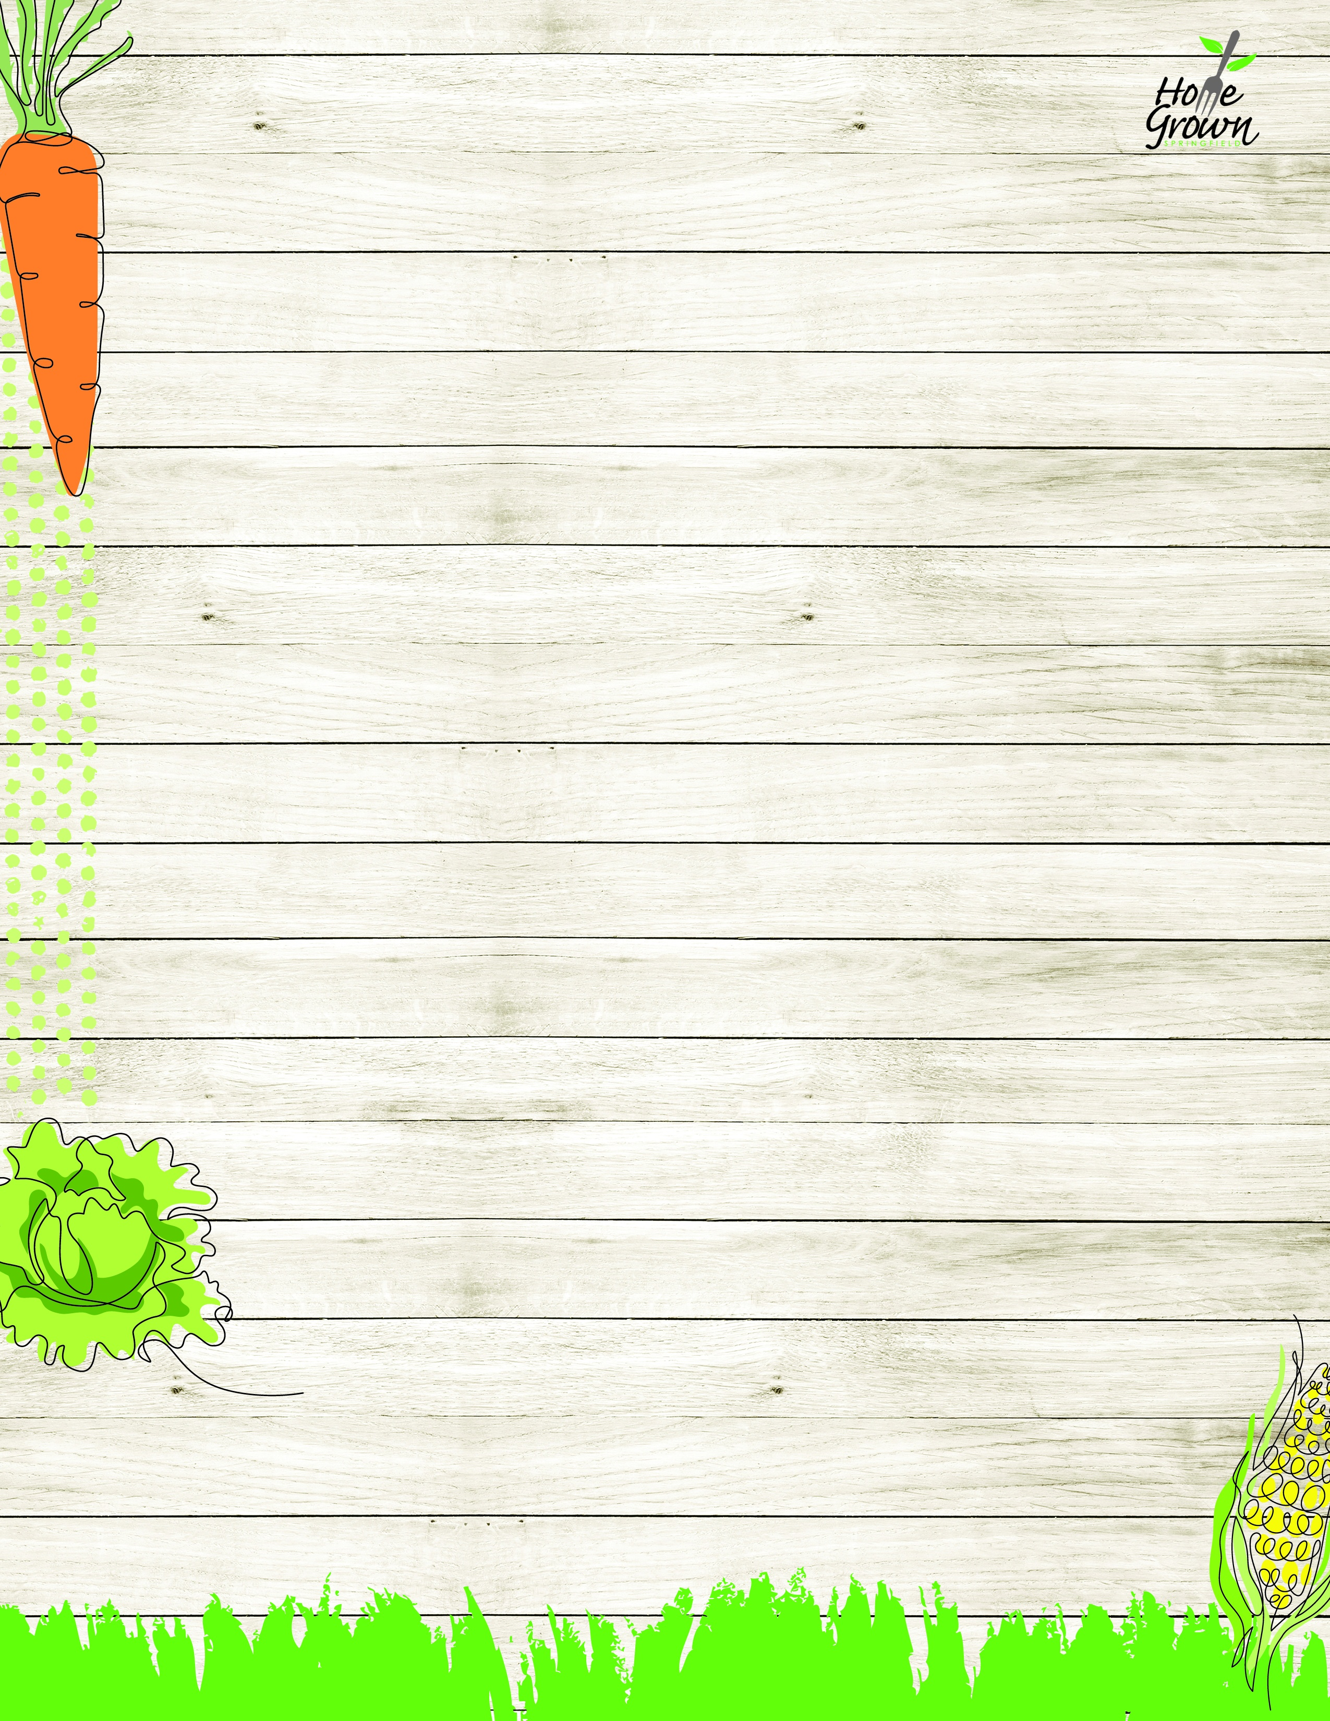

PRE-K & DAYCARE BREAKFAST
September-October 2026
MONDAY
TUESDAY
WEDNESDAY
WEDNESDAY
THURSDAY
FRIDAY
9/14
Wild Blueberry Muffin
OR
Assorted Cereal
Fresh Whole Fruit
1% or Fat Free Milk
9/15
Assorted Cereal
Fresh Whole Fruit
1% or Fat Free Milk
9/16
Flakey Biscuit with Creamy Sausage Gravy
OR
Assorted Cereal
Fresh Whole Fruit
1% or Fat Free Milk
9/16
Flakey Biscuit with Creamy Sausage Gravy
OR
Assorted Cereal
Fresh Whole Fruit
1% or Fat Free Milk
9/17
Assorted Cereal
Fresh Whole Fruit
1% or Fat Free Milk
9/18
Chicken Sausage & Cheese English Muffin
OR
Assorted Cereal
Fresh Whole Fruit
1% or Fat Free Milk
9/21
Spiced Apple Muffin
OR
Assorted Cereal
Fresh Whole Fruit
1% or Fat Free Milk
9/22
French Toast w/Syrup
OR
Assorted Cereal
Fresh Whole Fruit
1% or Fat Free Milk
9/23
Yogurt with Cinnamon Goldfish Cracker
OR
Assorted Cereal
Fresh Whole Fruit
1% or Fat Free Milk
9/23
Yogurt with Cinnamon Goldfish Cracker
OR
Assorted Cereal
Fresh Whole Fruit
1% or Fat Free Milk
9/24
Assorted Cereal
Fresh Whole Fruit
1% or Fat Free Milk
9/25
Egg & Cheese English Muffin
OR
Assorted Cereal
Fresh Whole Fruit
1% or Fat Free Milk
9/28
Pumpkin Streusel Muffin
OR
Assorted Cereal
Fresh Whole Fruit
1% or Fat Free Milk
9/29
Pancakes w/Syrup
OR
Assorted Cereal
Fresh Whole Fruit
1% or Fat Free Milk
9/30
Assorted Cereal
Fresh Whole Fruit
1% or Fat Free Milk
9/30
Assorted Cereal
Fresh Whole Fruit
1% or Fat Free Milk
10/1
Bagel w/Spread
OR
Assorted Cereal
Fresh Whole Fruit
1% or Fat Free Milk
10/2
Assorted Cereal
Fresh Whole Fruit
1% or Fat Free Milk

