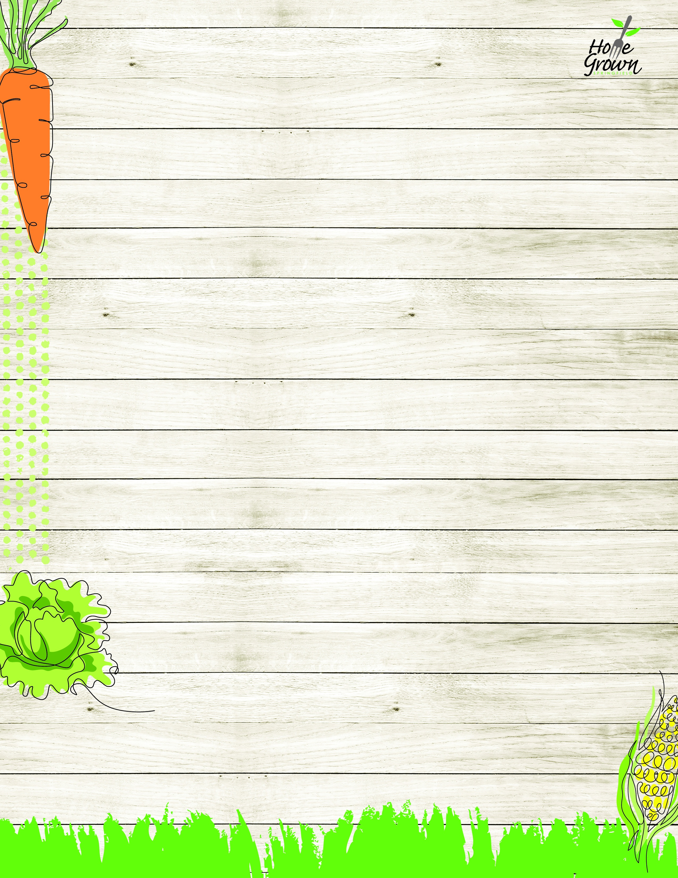

MIDDLE SCHOOL LUNCH
Springfield Modified Middle Schools August 24-28
MONDAY
TUESDAY
WEDNESDAY
THURSDAY
FRIDAY
CREATE
Steak & Cheese Calzone with Ranch Dipping Sauce
General Tso’s Chicken with Veggie Fried Rice
Mac n Cheese
Chicken Drumstick & Waffles, Apple Topping and Spicy Syrup
Nacho Bar
PB Nacho Crumbles, Cheese Sauce,
Sour Cream, Salsa,
Tortilla Chips
PIZZA/ GRILL

Falafel Parm Sandwich
Cheese Pizza
Pepperoni Pizza
Cheese Calzone w/Marinara
Spicy Chicken Patty
ON THE GO
Chicken Caesar Salad with Roll
Garden Salad with Roll
Turkey & Cheese on Kaiser
Sunbutter & Jelly Sandwich
Chicken Caesar Salad with Roll
Garden Salad with Roll
Turkey & Cheese on Kaiser
Sunbutter & Jelly Sandwich
Chicken Caesar Salad with Roll
Garden Salad with Roll
Turkey & Cheese on Kaiser
Sunbutter & Jelly Sandwich
Chicken Caesar Salad with Roll
Garden Salad with Roll
Turkey & Cheese on Kaiser
Sunbutter & Jelly Sandwich
Chicken Caesar Salad with Roll
Garden Salad with Roll
Turkey & Cheese on Kaiser
Sunbutter & Jelly Sandwich
EXTRA
French Fries
Carrot Sticks
Seasoned Green Beans
Celery Sticks
Roasted Broccoli
Grape Tomatoes
Mashed Sweet Potatoes
Chilled Corn
Side Caesar Salad
Black Bean Salad
EXTRA
Chilled Corn

Broccoli Florets
Grape Tomatoes

AVAILABLE DAILY
Available Daily:
Assorted Fresh Fruit
Chilled Fruit
Fat Free Chocolate, 1% White or Fat Free White Milk
Available Daily:
Assorted Fresh Fruit
Chilled Fruit
Fat Free Chocolate, 1% White or Fat Free White Milk
Available Daily:
Assorted Fresh Fruit
Chilled Fruit
Fat Free Chocolate, 1% White or Fat Free White Milk
Available Daily:
Assorted Fresh Fruit
Chilled Fruit
Fat Free Chocolate, 1% White or Fat Free White Milk
Available Daily:
Assorted Fresh Fruit
Chilled Fruit
Fat Free Chocolate, 1% White or Fat Free White Milk

MIDDLE SCHOOL LUNCH
Springfield Modified Middle School August 31- September 4
MONDAY
TUESDAY
WEDNESDAY
THURSDAY
FRIDAY
CREATE
Hawaiian Pineapple Chicken Bowl
with Brown Rice, Corn & Pineapple Salsa, Black Beans
NO
SCHOOL
Baked Ziti w/Plant-based Bolognese
& Garlic Dinner Roll
Cheddar Chicken Bowl w/Tenders
Chipotle Rice Bar
Chipotle Chicken, Seasoned Rice, Pico de Gallo, Cheddar Cheese, Roasted Corn, Sour Cream
GRILL/ PIZZA
Stuffed Cheesy Bread w/Marinara

Crispy Chicken Sandwich
Stuffed Cheesy Bread w/Marinara
Halal Cheeseburger
ON THE GO
Chicken Cobb Salad w/Dinner Roll
Hummus Bento Box w/Dinner Roll
Turkey Ham & Cheese on Kaiser
Sunbutter & Jelly Sandwich
Chicken Cobb Salad w/Dinner Roll
Hummus Bento Box w/Dinner Roll
Turkey Ham & Cheese on Kaiser
Sunbutter & Jelly Sandwich
Chicken Cobb Salad w/Dinner Roll
Hummus Bento Box w/Dinner Roll
Turkey Ham & Cheese on Kaiser
Sunbutter & Jelly Sandwich
Chicken Cobb Salad w/Dinner Roll
Hummus Bento Box w/Dinner Roll
Turkey Ham & Cheese on Kaiser
Sunbutter & Jelly Sandwich
Chicken Cobb Salad w/Dinner Roll
Hummus Bento Box w/Dinner Roll
Turkey Ham & Cheese on Kaiser
Sunbutter & Jelly Sandwich
EXTRA
Steamed Carrots
Celery Sticks

Roasted Broccoli
Carrot Sticks
Local Mashed Potatoes
Chilled Corn
Stewed Beans
Cucumber Salad
EXTRA
Grape Tomatoes

Broccoli Florets

Black Bean Salad
AVAILABLE DAILY
Available Daily:
Assorted Fresh Fruit
Chilled Fruit
Fat Free Chocolate, 1% White or Fat Free White Milk
Available Daily:
Assorted Fresh Fruit
Chilled Fruit
Fat Free Chocolate, 1% White or Fat Free White Milk
Available Daily:
Assorted Fresh Fruit
Chilled Fruit
Fat Free Chocolate, 1% White or Fat Free White Milk
Available Daily:
Assorted Fresh Fruit
Chilled Fruit
Fat Free Chocolate, 1% White or Fat Free White Milk
Available Daily:
Assorted Fresh Fruit
Chilled Fruit
Fat Free Chocolate, 1% White or Fat Free White Milk

MIDDLE SCHOOL LUNCH
Springfield Modified Middle Schools September 7-11
MONDAY
TUESDAY
WEDNESDAY
THURSDAY
FRIDAY
CREATE
NO
SCHOOL
Philly Cheese
Steak Hoagie Sandwich
French Toast Sticks with CNC Chicken Breakfast Sausage
& Syrup
Plant-based Taco Salad with
Seasoned Rice
& Pico de Gallo
Asopao de Pollo
Chicken Stew with Seasoned Rice
GRILL/ PIZZA

Cheese Calzone w/Marinara
Falafel Parm Sandwich
Spicy Chicken Patty
Cheese Pizza
Pepperoni Pizza
ON THE GO
Vegan Mediterranean Salad with Roll
Garden Salad with Roll
Turkey & Cheese on Kaiser
Sunbutter & Jelly Sandwich
Vegan Mediterranean Salad with Roll
Garden Salad with Roll
Turkey & Cheese on Kaiser
Sunbutter & Jelly Sandwich
Vegan Mediterranean Salad with Roll
Garden Salad with Roll
Turkey & Cheese on Kaiser
Sunbutter & Jelly Sandwich
Vegan Mediterranean Salad with Roll
Garden Salad with Roll
Turkey & Cheese on Kaiser
Sunbutter & Jelly Sandwich
Vegan Mediterranean Salad with Roll
Garden Salad with Roll
Turkey & Cheese on Kaiser
Sunbutter & Jelly Sandwich
EXTRA

French Fries
Carrot Sticks
Mashed Butternut
Celery Sticks
Stewed Black Beans
Cucumber Salad
Chilled Corn
Broccoli Florets
EXTRA

Chilled Corn
Carrot Sticks
Black Bean Salad

AVAILABLE DAILY
Available Daily:
Assorted Fresh Fruit
Chilled Fruit
Fat Free Chocolate, 1% White or Fat Free White Milk
Available Daily:
Assorted Fresh Fruit
Chilled Fruit
Fat Free Chocolate, 1% White or Fat Free White Milk
Available Daily:
Assorted Fresh Fruit
Chilled Fruit
Fat Free Chocolate, 1% White or Fat Free White Milk
Available Daily:
Assorted Fresh Fruit
Chilled Fruit
Fat Free Chocolate, 1% White or Fat Free White Milk
Available Daily:
Assorted Fresh Fruit
Chilled Fruit
Fat Free Chocolate, 1% White or Fat Free White Milk

MIDDLE SCHOOL LUNCH
Springfield Modified Middle Schools September 14-18
MONDAY
TUESDAY
WEDNESDAY
THURSDAY
FRIDAY
CREATE
Chicken Nuggets
CNC BBQ Sauce, Roll
Sweet Battered
Mini Turkey Corn Dogs
Pasta & Meatballs with Marinara & Parmesan Cheese
Huli Huli Chicken with Rice Pilaf
Loaded Baked Potato with Plant-based Nacho Crumbles, Cheese Sauce & Garlic Roll
GRILL/ PIZZA
Cheese Pizza
Pepperoni Pizza
Pepperoni Calzone w/Marinara
Crispy Chicken Sandwich
Halal Cheeseburger
Pepperoni Calzone w/Marinara
ON THE GO
Kale & Apple Salad with Roll
Hummus Bento Box with Roll
Turkey Ham & Cheese on Kaiser
Sunbutter & Jelly Sandwich
Kale & Apple Salad with Roll
Hummus Bento Box with Roll
Turkey Ham & Cheese on Kaiser
Sunbutter & Jelly Sandwich
Kale & Apple Salad with Roll
Hummus Bento Box with Roll
Turkey Ham & Cheese on Kaiser
Sunbutter & Jelly Sandwich
Kale & Apple Salad with Roll
Hummus Bento Box with Roll
Turkey Ham & Cheese on Kaiser
Sunbutter & Jelly Sandwich
Kale & Apple Salad with Roll
Hummus Bento Box with Roll
Turkey Ham & Cheese on Kaiser
Sunbutter & Jelly Sandwich
EXTRA
French Fries
Celery Sticks
Veggie Baked Beans
Grape Tomatoes
Roasted Broccoli
Carrot Sticks
Seasoned Green Beans
Chilled Corn
Roasted Local Root Vegetables
Black Bean Salad
EXTRA
Chilled Corn
Black Bean Salad
Broccoli Florets
Celery Sticks
Carrot Sticks
AVAILABLE DAILY
Available Daily:
Assorted Fresh Fruit
Chilled Fruit
Fat Free Chocolate, 1% White or Fat Free White Milk
Available Daily:
Assorted Fresh Fruit
Chilled Fruit
Fat Free Chocolate, 1% White or Fat Free White Milk
Available Daily:
Assorted Fresh Fruit
Chilled Fruit
Fat Free Chocolate, 1% White or Fat Free White Milk
Available Daily:
Assorted Fresh Fruit
Chilled Fruit
Fat Free Chocolate, 1% White or Fat Free White Milk
Available Daily:
Assorted Fresh Fruit
Chilled Fruit
Fat Free Chocolate, 1% White or Fat Free White Milk

MIDDLE SCHOOL LUNCH
Springfield Modified Middle Schools September 21-25
MONDAY
TUESDAY
WEDNESDAY
THURSDAY
FRIDAY
CREATE
Steak & Cheese Calzone with Ranch Dipping Sauce
General Tso’s Chicken with Veggie Fried Rice
Mac n Cheese
Chicken Drumstick & Waffles, Apple Topping and Spicy Syrup
Nacho Bar
PB Nacho Crumbles, Cheese Sauce,
Sour Cream, Salsa,
Tortilla Chips
PIZZA/ GRILL
Cheese Pizza
Pepperoni Pizza
Falafel Parm Sandwich
Cheese Pizza
Pepperoni Pizza
Halal Cheeseburger
Cheese Pizza
Pepperoni Pizza
ON THE GO
Chicken Caesar Salad with Roll
Garden Salad with Roll
Turkey & Cheese on Kaiser
Sunbutter & Jelly Sandwich
Chicken Caesar Salad with Roll
Garden Salad with Roll
Turkey & Cheese on Kaiser
Sunbutter & Jelly Sandwich
Chicken Caesar Salad with Roll
Garden Salad with Roll
Turkey & Cheese on Kaiser
Sunbutter & Jelly Sandwich
Chicken Caesar Salad with Roll
Garden Salad with Roll
Turkey & Cheese on Kaiser
Sunbutter & Jelly Sandwich
Chicken Caesar Salad with Roll
Garden Salad with Roll
Turkey & Cheese on Kaiser
Sunbutter & Jelly Sandwich
EXTRA
French Fries
Carrot Sticks
Seasoned Green Beans
Celery Sticks
Roasted Broccoli
Grape Tomatoes
Mashed Sweet Potatoes
Chilled Corn
Side Caesar Salad
Black Bean Salad
EXTRA
Chilled Corn
Celery Sticks
Broccoli Florets
Grape Tomatoes

AVAILABLE DAILY
Available Daily:
Assorted Fresh Fruit
Chilled Fruit
Fat Free Chocolate, 1% White or Fat Free White Milk
Available Daily:
Assorted Fresh Fruit
Chilled Fruit
Fat Free Chocolate, 1% White or Fat Free White Milk
Available Daily:
Assorted Fresh Fruit
Chilled Fruit
Fat Free Chocolate, 1% White or Fat Free White Milk
Available Daily:
Assorted Fresh Fruit
Chilled Fruit
Fat Free Chocolate, 1% White or Fat Free White Milk
Available Daily:
Assorted Fresh Fruit
Chilled Fruit
Fat Free Chocolate, 1% White or Fat Free White Milk

MIDDLE SCHOOL LUNCH
Springfield Modified Middle Schools September 28- October 2
MONDAY
TUESDAY
WEDNESDAY
THURSDAY
FRIDAY
CREATE
Italian Meatball Sub
Hawaiian Pineapple Chicken Bowl
with Brown Rice, Corn & Pineapple Salsa
Baked Ziti w/Plant-based Bolognese
& Garlic Dinner Roll
Cheddar Chicken Bowl w/Tenders
Chipotle Rice Bar
Chipotle Chicken, Seasoned Rice, Pico de Gallo, Cheddar Cheese, Roasted Corn, Sour Cream
GRILL/ PIZZA
Cheese Pizza
Pepperoni Pizza
Stuffed Cheesy Bread w/Marinara
Crispy Chicken Sandwich
Stuffed Cheesy Bread w/Marinara
Halal Cheeseburger
ON THE GO
Chicken Cobb Salad w/Dinner Roll
Hummus Bento Box with OMM Toast Points
Turkey Ham & Cheese on Kaiser
Sunbutter & Jelly Sandwich
Chicken Cobb Salad w/Dinner Roll
Hummus Bento Box with OMM Toast Points
Turkey Ham & Cheese on Kaiser
Sunbutter & Jelly Sandwich
Chicken Cobb Salad w/Dinner Roll
Hummus Bento Box with OMM Toast Points
Turkey Ham & Cheese on Kaiser
Sunbutter & Jelly Sandwich
Chicken Cobb Salad w/Dinner Roll
Hummus Bento Box with OMM Toast Points
Turkey Ham & Cheese on Kaiser
Sunbutter & Jelly Sandwich
Chicken Cobb Salad w/Dinner Roll
Hummus Bento Box with OMM Toast Points
Turkey Ham & Cheese on Kaiser
Sunbutter & Jelly Sandwich
EXTRA
Peppers & Onions
Cucumber Salad
Steamed Carrots
Grape Tomatoes
Roasted Broccoli
Carrot Sticks
Local Mashed Potatoes
Chilled Corn
Black Bean Salad
Cucumber Salad
EXTRA
Cucumber Salad
Grape Tomatoes
Broccoli Florets
Chilled Corn

AVAILABLE DAILY
Available Daily:
Assorted Fresh Fruit
Chilled Fruit
Fat Free Chocolate, 1% White or Fat Free White Milk
Available Daily:
Assorted Fresh Fruit
Chilled Fruit
Fat Free Chocolate, 1% White or Fat Free White Milk
Available Daily:
Assorted Fresh Fruit
Chilled Fruit
Fat Free Chocolate, 1% White or Fat Free White Milk
Available Daily:
Assorted Fresh Fruit
Chilled Fruit
Fat Free Chocolate, 1% White or Fat Free White Milk
Available Daily:
Assorted Fresh Fruit
Chilled Fruit
Fat Free Chocolate, 1% White or Fat Free White Milk

