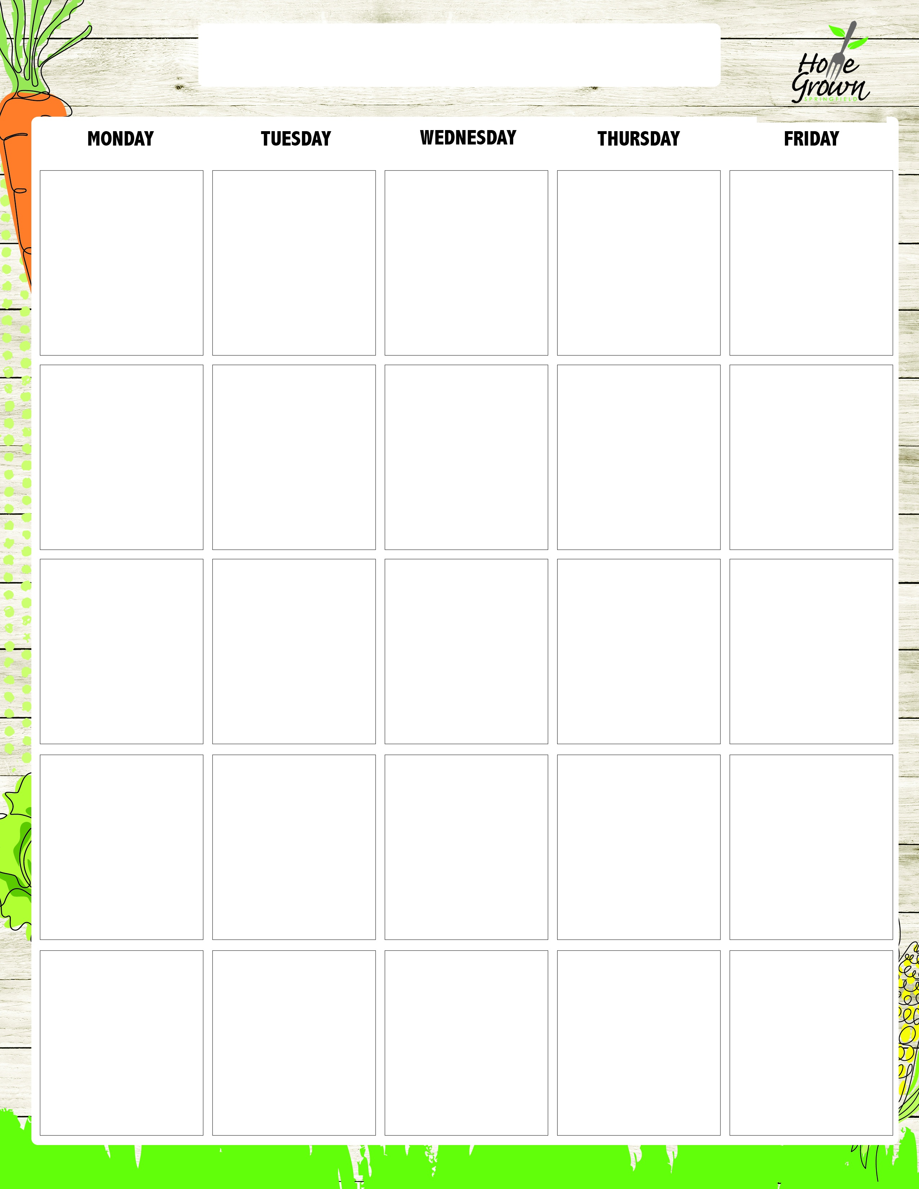
GF SECONDARY BREAKFAST
August-September 2026
8/24
Assorted GF Cereal
Fresh Whole Fruit
100% Juice
1% or Fat Free Milk
8/25
GF Blueberry Muffin
OR
Assorted GF Cereal
Fresh Whole Fruit
100% Juice
1% or Fat Free Milk
8/26
Peach Parfait w/Sweet Babu’s Granola
OR
Assorted GF Cereal
Fresh Whole Fruit
100% Juice
1% or Fat Free Milk
8/27
GF English Muffin
with Jelly or Butter
OR
Assorted GF Cereal
Fresh Whole Fruit
100% Juice
1% or Fat Free Milk
8/28
Rice cakes with Sunbutter and Jelly
OR
Assorted GF Cereal
Fresh Whole Fruit
100% Juice
1% or Fat Free Milk
8/31
GF Blueberry Muffin
OR
Assorted GF Cereal
Fresh Whole Fruit
100% Juice
1% or Fat Free Milk
9/1
No School
9/2
Apple Cinnamon Parfait w/Sweet Babu’s Granola
OR
Assorted GF Cereal
Fresh Whole Fruit
100% Juice
1% or Fat Free Milk
9/3
Assorted GF Cereal
Fresh Whole Fruit
100% Juice
1% or Fat Free Milk
9/4
GF English Muffin
with Jelly or Butter
OR
Assorted GF Cereal
Fresh Whole Fruit
100% Juice
1% or Fat Free Milk
9/7
No School
9/8
GF Blueberry Muffin
OR
Assorted GF Cereal
Fresh Whole Fruit
100% Juice
1% or Fat Free Milk
9/9
Assorted GF Cereal
Fresh Whole Fruit
100% Juice
1% or Fat Free Milk
9/10
Pineapple Parfait w/ Sweet Babu’s Granola
OR
Assorted GF Cereal
Fresh Whole Fruit
100% Juice
1% or Fat Free Milk
9/11
Rice cakes with Sunbutter and Jelly
OR
Assorted GF Cereal
Fresh Whole Fruit
100% Juice
1% or Fat Free Milk
9/14
GF Blueberry Muffin
OR
Assorted GF Cereal
Fresh Whole Fruit
100% Juice
1% or Fat Free Milk
9/15
Assorted GF Cereal
Fresh Whole Fruit
100% Juice
1% or Fat Free Milk
9/16
Rice cakes with Sunbutter and Jelly
OR
Assorted GF Cereal
Fresh Whole Fruit
100% Juice
1% or Fat Free Milk
9/17
Very Berry Parfait w/ Sweet Babu’s Granola
OR
Assorted GF Cereal
Fresh Whole Fruit
100% Juice
1% or Fat Free Milk
9/18
GF English Muffin
with Jelly or Butter
OR
Assorted GF Cereal
Fresh Whole Fruit
100% Juice
1% or Fat Free Milk
9/21
Assorted GF Cereal
Fresh Whole Fruit
100% Juice
1% or Fat Free Milk
9/22
GF Blueberry Muffin
OR
Assorted GF Cereal
Fresh Whole Fruit
100% Juice
1% or Fat Free Milk
9/23
Peach Parfait w/Sweet Babu’s Granola
OR
Assorted GF Cereal
Fresh Whole Fruit
100% Juice
1% or Fat Free Milk
9/24
GF English Muffin
with Jelly or Butter
OR
Assorted GF Cereal
Fresh Whole Fruit
100% Juice
1% or Fat Free Milk
9/25
Rice cakes with Sunbutter and Jelly
OR
Assorted GF Cereal
Fresh Whole Fruit
100% Juice
1% or Fat Free Milk

GF SECONDARY BREAKFAST
September-October 2026
9/28
GF Blueberry Muffin
OR
Assorted GF Cereal
Fresh Whole Fruit
100% Juice
1% or Fat Free Milk
9/29
Rice cakes with Sunbutter and Jelly
OR
Assorted GF Cereal
Fresh Whole Fruit
100% Juice
1% or Fat Free Milk
9/30
Apple Cinnamon Parfait w/Sweet Babu’s Granola
OR
Assorted GF Cereal
Fresh Whole Fruit
100% Juice
1% or Fat Free Milk
10/1
Assorted GF Cereal
Fresh Whole Fruit
100% Juice
1% or Fat Free Milk
10/2
GF English Muffin
with Jelly or Butter
OR
Assorted GF Cereal
Fresh Whole Fruit
100% Juice
1% or Fat Free Milk

