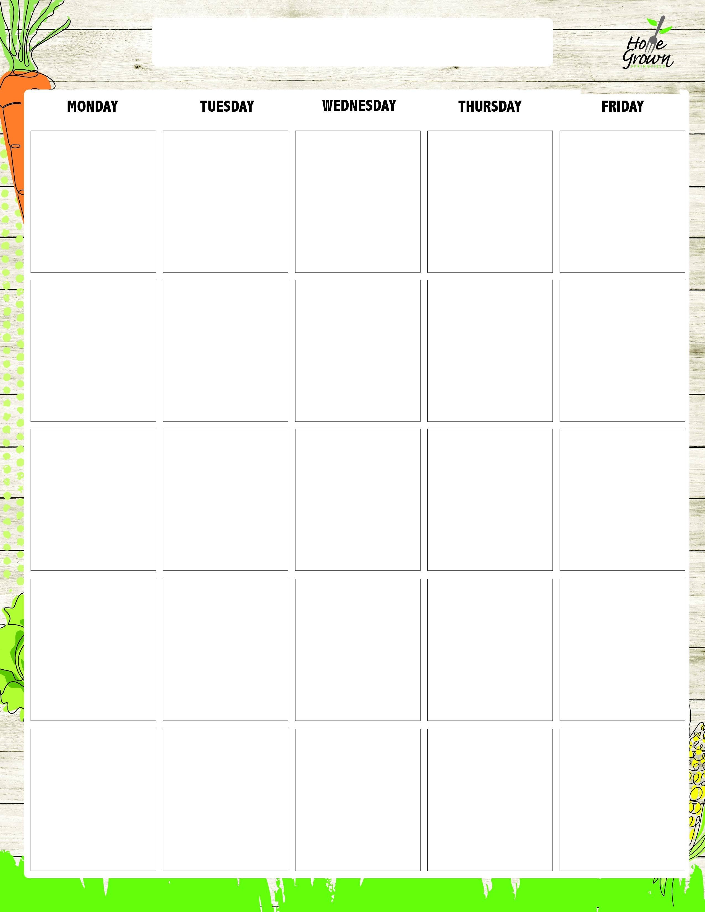
GLUTEN-FREE ELEMENTARY LUNCH
August-September 2026
8/24
GF Cheeseburger
On a Bun w/Fresh Lettuce & Tomato
Chicken Caesar Salad (No Croutons) with GF Roll
Garden Salad (No Croutons) with GF Roll
Turkey & Cheese Sandwich on GF Bread
Sunbutter & Jelly Sandwich on GF Bread
Cheese Sandwich on GF Bread
French Fries
Black Bean Salad
Available Daily:
Assorted Fresh Fruit
Fat Free Chocolate, 1% White or Fat Free White Milk
8/25
AF Salsa Chicken
w/Rice
Chicken Caesar Salad (No Croutons) with GF Roll
Garden Salad (No Croutons) with GF Roll
Turkey & Cheese Sandwich on GF Bread
Sunbutter & Jelly Sandwich on GF Bread
Cheese Sandwich on GF Bread
Steamed Carrots
Celery Sticks
Available Daily:
Assorted Fresh Fruit
Fat Free Chocolate, 1% White or Fat Free White Milk
8/26
GF Mac & Cheese
Chicken Caesar Salad (No Croutons) with GF Roll
Garden Salad (No Croutons) with GF Roll
Turkey & Cheese Sandwich on GF Bread
Sunbutter & Jelly Sandwich on GF Bread
Cheese Sandwich on GF Bread
Roasted Broccoli
Grape Tomatoes
Available Daily:
Assorted Fresh Fruit
Fat Free Chocolate, 1% White or Fat Free White Milk
8/27
GF Breaded Chicken Tenders
Chicken Caesar Salad (No Croutons) with GF Roll
Garden Salad (No Croutons) with GF Roll
Turkey & Cheese Sandwich on GF Bread
Sunbutter & Jelly Sandwich on GF Bread
Cheese Sandwich on GF Bread
CNC Mashed Sweet Potatoes
Chilled Corn
Available Daily:
Assorted Fresh Fruit
Fat Free Chocolate, 1% White or Fat Free White Milk
8/28
GF Pizza Bagel
Chicken Caesar Salad (No Croutons) with GF Roll
Garden Salad (No Croutons) with GF Roll
Turkey & Cheese Sandwich on GF Bread
Sunbutter & Jelly Sandwich on GF Bread
Cheese Sandwich on GF Bread
Steamed Broccoli
Carrot Sticks
Available Daily:
Assorted Fresh Fruit
Fat Free Chocolate, 1% White or Fat Free White Milk
8/31
GF Bean & Cheese Nachos
Chicken Cobb Salad with GF Roll
Hummus Bento Box with GF Roll
Turkey Ham & Cheese Sandwich on GF Bread
Sunbutter & Jelly Sandwich on GF Bread
Cheese Sandwich on GF Bread
Steamed Corn
Black Bean Salad
Available Daily:
Assorted Fresh Fruit
Fat Free Chocolate, 1% White or Fat Free White Milk
9/1
No School
9/2
GF Pasta w/Plant-
based Bolognese
Chicken Cobb Salad with GF Roll
Hummus Bento Box with GF Roll
Turkey Ham & Cheese Sandwich on GF Bread
Sunbutter & Jelly Sandwich on GF Bread
Cheese Sandwich on GF Bread
Roasted Broccoli
Carrot Sticks
Available Daily:
Assorted Fresh Fruit
Fat Free Chocolate, 1% White or Fat Free White Milk
9/3
GF Cheddar Chicken Bowl
Chicken Cobb Salad with GF Roll
Hummus Bento Box with GF Roll
Turkey Ham & Cheese Sandwich on GF Bread
Sunbutter & Jelly Sandwich on GF Bread
Cheese Sandwich on GF Bread
CNC Mashed Potatoes
Chilled Corn
Available Daily:
Assorted Fresh Fruit
Fat Free Chocolate, 1% White or Fat Free White Milk
9/4
GF Pizza Bagel
Chicken Cobb Salad with GF Roll
Hummus Bento Box with GF Roll
Turkey Ham & Cheese Sandwich on GF Bread
Sunbutter & Jelly Sandwich on GF Bread
Cheese Sandwich on GF Bread
Seasoned Green beans
Cucumber Salad
Available Daily:
Assorted Fresh Fruit
Fat Free Chocolate, 1% White or Fat Free White Milk
9/7
No School
9/8
GF Pulled Pork Sandwich w/Cole Slaw
Vegan Mediterranean Salad (No Croutons) with GF Roll
Garden Salad (No Croutons) with GF Roll
Turkey & Cheese Sandwich on GF Bread
Sunbutter & Jelly Sandwich on GF Bread
Cheese Sandwich on GF Bread
Mashed Butternut
Celery Sticks
Available Daily:
Assorted Fresh Fruit
Fat Free Chocolate, 1% White or Fat Free White Milk
9/9
Breakfast for Lunch:
GF Bagel with
Sunbutter
Vegan Mediterranean Salad (No Croutons) with GF Roll
Garden Salad (No Croutons) with GF Roll
Turkey & Cheese Sandwich on GF Bread
Sunbutter & Jelly Sandwich on GF Bread
Cheese Sandwich on GF Bread
Tater Tots
Carrot Sticks
Available Daily:
Assorted Fresh Fruit
Fat Free Chocolate, 1% White or Fat Free White Milk
9/10
Plant-based Taco
Salad w/Seasoned Rice
Vegan Mediterranean Salad (No Croutons) with GF Roll
Garden Salad (No Croutons) with GF Roll
Turkey & Cheese Sandwich on GF Bread
Sunbutter & Jelly Sandwich on GF Bread
Cheese Sandwich on GF Bread
Stewed Black Beans
Grape Tomatoes
Available Daily:
Assorted Fresh Fruit
Fat Free Chocolate, 1% White or Fat Free White Milk
9/11
GF Pizza Bagel
Vegan Mediterranean Salad (No Croutons) with GF Roll
Garden Salad (No Croutons) with GF Roll
Turkey & Cheese Sandwich on GF Bread
Sunbutter & Jelly Sandwich on GF Bread
Cheese Sandwich on GF Bread
Steamed Broccoli
Celery Sticks
Available Daily:
Assorted Fresh Fruit
Fat Free Chocolate, 1% White or Fat Free White Milk
9/14
GF Breaded Chicken Tenders
GF Kale & Apple Salad (No Granola) with GF Roll
Hummus Bento Box with GF Roll
Turkey Ham & Cheese Sandwich on GF Bread
Sunbutter & Jelly Sandwich on GF Bread
Cheese Sandwich on GF Bread
Vegetarian Baked Beans
Celery Sticks
Available Daily:
Assorted Fresh Fruit
Fat Free Chocolate, 1% White or Fat Free White Milk
9/15
GF Bean & Cheese Nachos
GF Kale & Apple Salad (No Granola) with GF Roll
Hummus Bento Box with GF Roll
Turkey Ham & Cheese Sandwich on GF Bread
Sunbutter & Jelly Sandwich on GF Bread
Cheese Sandwich on GF Bread
Black Bean Salad
Cucumber Salad
Available Daily:
Assorted Fresh Fruit
Fat Free Chocolate, 1% White or Fat Free White Milk
9/16
GF Pasta, Marinara, Mozzarella Cheese
GF Kale & Apple Salad (No Granola) with GF Roll
Hummus Bento Box with GF Roll
Turkey Ham & Cheese Sandwich on GF Bread
Sunbutter & Jelly Sandwich on GF Bread
Cheese Sandwich on GF Bread
Steamed Broccoli
Carrot Sticks
Available Daily:
Assorted Fresh Fruit
Fat Free Chocolate, 1% White or Fat Free White Milk
9/17
Seasoned Chicken Thighs w/Rice Pilaf
GF Kale & Apple Salad (No Granola) with GF Roll
Hummus Bento Box with GF Roll
Turkey Ham & Cheese Sandwich on GF Bread
Sunbutter & Jelly Sandwich on GF Bread
Cheese Sandwich on GF Bread
CNC Mashed
Sweet Potato
Chilled Corn
Available Daily:
Assorted Fresh Fruit
Fat Free Chocolate, 1% White or Fat Free White Milk
9/18
GF Pizza Bagel
GF Kale & Apple Salad (No Granola) with GF Roll
Hummus Bento Box with GF Roll
Turkey Ham & Cheese Sandwich on GF Bread
Sunbutter & Jelly Sandwich on GF Bread
Cheese Sandwich on GF Bread
Roasted Local Veg
Celery Sticks
Available Daily:
Assorted Fresh Fruit
Fat Free Chocolate, 1% White or Fat Free White Milk
9/21
GF Cheeseburger
On a Bun w/Fresh Lettuce & Tomato
Chicken Caesar Salad (No Croutons) with GF Roll
Garden Salad (No Croutons) with GF Roll
Turkey & Cheese Sandwich on GF Bread
Sunbutter & Jelly Sandwich on GF Bread
Cheese Sandwich on GF Bread
French Fries
Black Bean Salad
Available Daily:
Assorted Fresh Fruit
Fat Free Chocolate, 1% White or Fat Free White Milk
9/22
AF Salsa Chicken
w/Rice
Chicken Caesar Salad (No Croutons) with GF Roll
Garden Salad (No Croutons) with GF Roll
Turkey & Cheese Sandwich on GF Bread
Sunbutter & Jelly Sandwich on GF Bread
Cheese Sandwich on GF Bread
Steamed Carrots
Celery Sticks
Available Daily:
Assorted Fresh Fruit
Fat Free Chocolate, 1% White or Fat Free White Milk
9/23
GF Mac & Cheese
Chicken Caesar Salad (No Croutons) with GF Roll
Garden Salad (No Croutons) with GF Roll
Turkey & Cheese Sandwich on GF Bread
Sunbutter & Jelly Sandwich on GF Bread
Cheese Sandwich on GF Bread
Roasted Broccoli
Grape Tomatoes
Available Daily:
Assorted Fresh Fruit
Fat Free Chocolate, 1% White or Fat Free White Milk
9/24
GF Breaded Chicken Tenders w/GF Roll
Chicken Caesar Salad (No Croutons) with GF Roll
Garden Salad (No Croutons) with GF Roll
Turkey & Cheese Sandwich on GF Bread
Sunbutter & Jelly Sandwich on GF Bread
Cheese Sandwich on GF Bread
CNC Mashed Sweet Potatoes
Chilled Corn
Available Daily:
Assorted Fresh Fruit
Fat Free Chocolate, 1% White or Fat Free White Milk
9/25
GF Pizza Bagel
Chicken Caesar Salad (No Croutons) with GF Roll
Garden Salad (No Croutons) with GF Roll
Turkey & Cheese Sandwich on GF Bread
Sunbutter & Jelly Sandwich on GF Bread
Cheese Sandwich on GF Bread
Steamed Broccoli
Carrot Sticks
Available Daily:
Assorted Fresh Fruit
Fat Free Chocolate, 1% White or Fat Free White Milk

GLUTEN-FREE ELEMENTARY LUNCH
September-October 2026
9/28
Hot Dog on a
GF Bun
Chicken Cobb Salad with GF Roll
Hummus Bento Box with GF Roll
Turkey Ham & Cheese Sandwich on GF Bread
Sunbutter & Jelly Sandwich on GF Bread
Cheese Sandwich on GF Bread
Steamed Corn
Black Bean Salad
Available Daily:
Assorted Fresh Fruit
Fat Free Chocolate, 1% White or Fat Free White Milk
9/29
GF Bean & Cheese Nachos
Chicken Cobb Salad with GF Roll
Hummus Bento Box with GF Roll
Turkey Ham & Cheese Sandwich on GF Bread
Sunbutter & Jelly Sandwich on GF Bread
Cheese Sandwich on GF Bread
Steamed Corn
Black Bean Salad
Available Daily:
Assorted Fresh Fruit
Fat Free Chocolate, 1% White or Fat Free White Milk
9/30
GF Pasta w/Plant-
based Bolognese
Chicken Cobb Salad with GF Roll
Hummus Bento Box with GF Roll
Turkey Ham & Cheese Sandwich on GF Bread
Sunbutter & Jelly Sandwich on GF Bread
Cheese Sandwich on GF Bread
Roasted Broccoli
Carrot Sticks
Available Daily:
Assorted Fresh Fruit
Fat Free Chocolate, 1% White or Fat Free White Milk
10/1
GF Cheddar Chicken Bowl
Chicken Cobb Salad with GF Roll
Hummus Bento Box with GF Roll
Turkey Ham & Cheese Sandwich on GF Bread
Sunbutter & Jelly Sandwich on GF Bread
Cheese Sandwich on GF Bread
CNC Mashed Potatoes
Chilled Corn
Available Daily:
Assorted Fresh Fruit
Fat Free Chocolate, 1% White or Fat Free White Milk
10/2
GF Pizza Bagel
Chicken Cobb Salad with GF Roll
Hummus Bento Box with GF Roll
Turkey Ham & Cheese Sandwich on GF Bread
Sunbutter & Jelly Sandwich on GF Bread
Cheese Sandwich on GF Bread
Seasoned Green beans
Cucumber Salad
Available Daily:
Assorted Fresh Fruit
Fat Free Chocolate, 1% White or Fat Free White Milk

