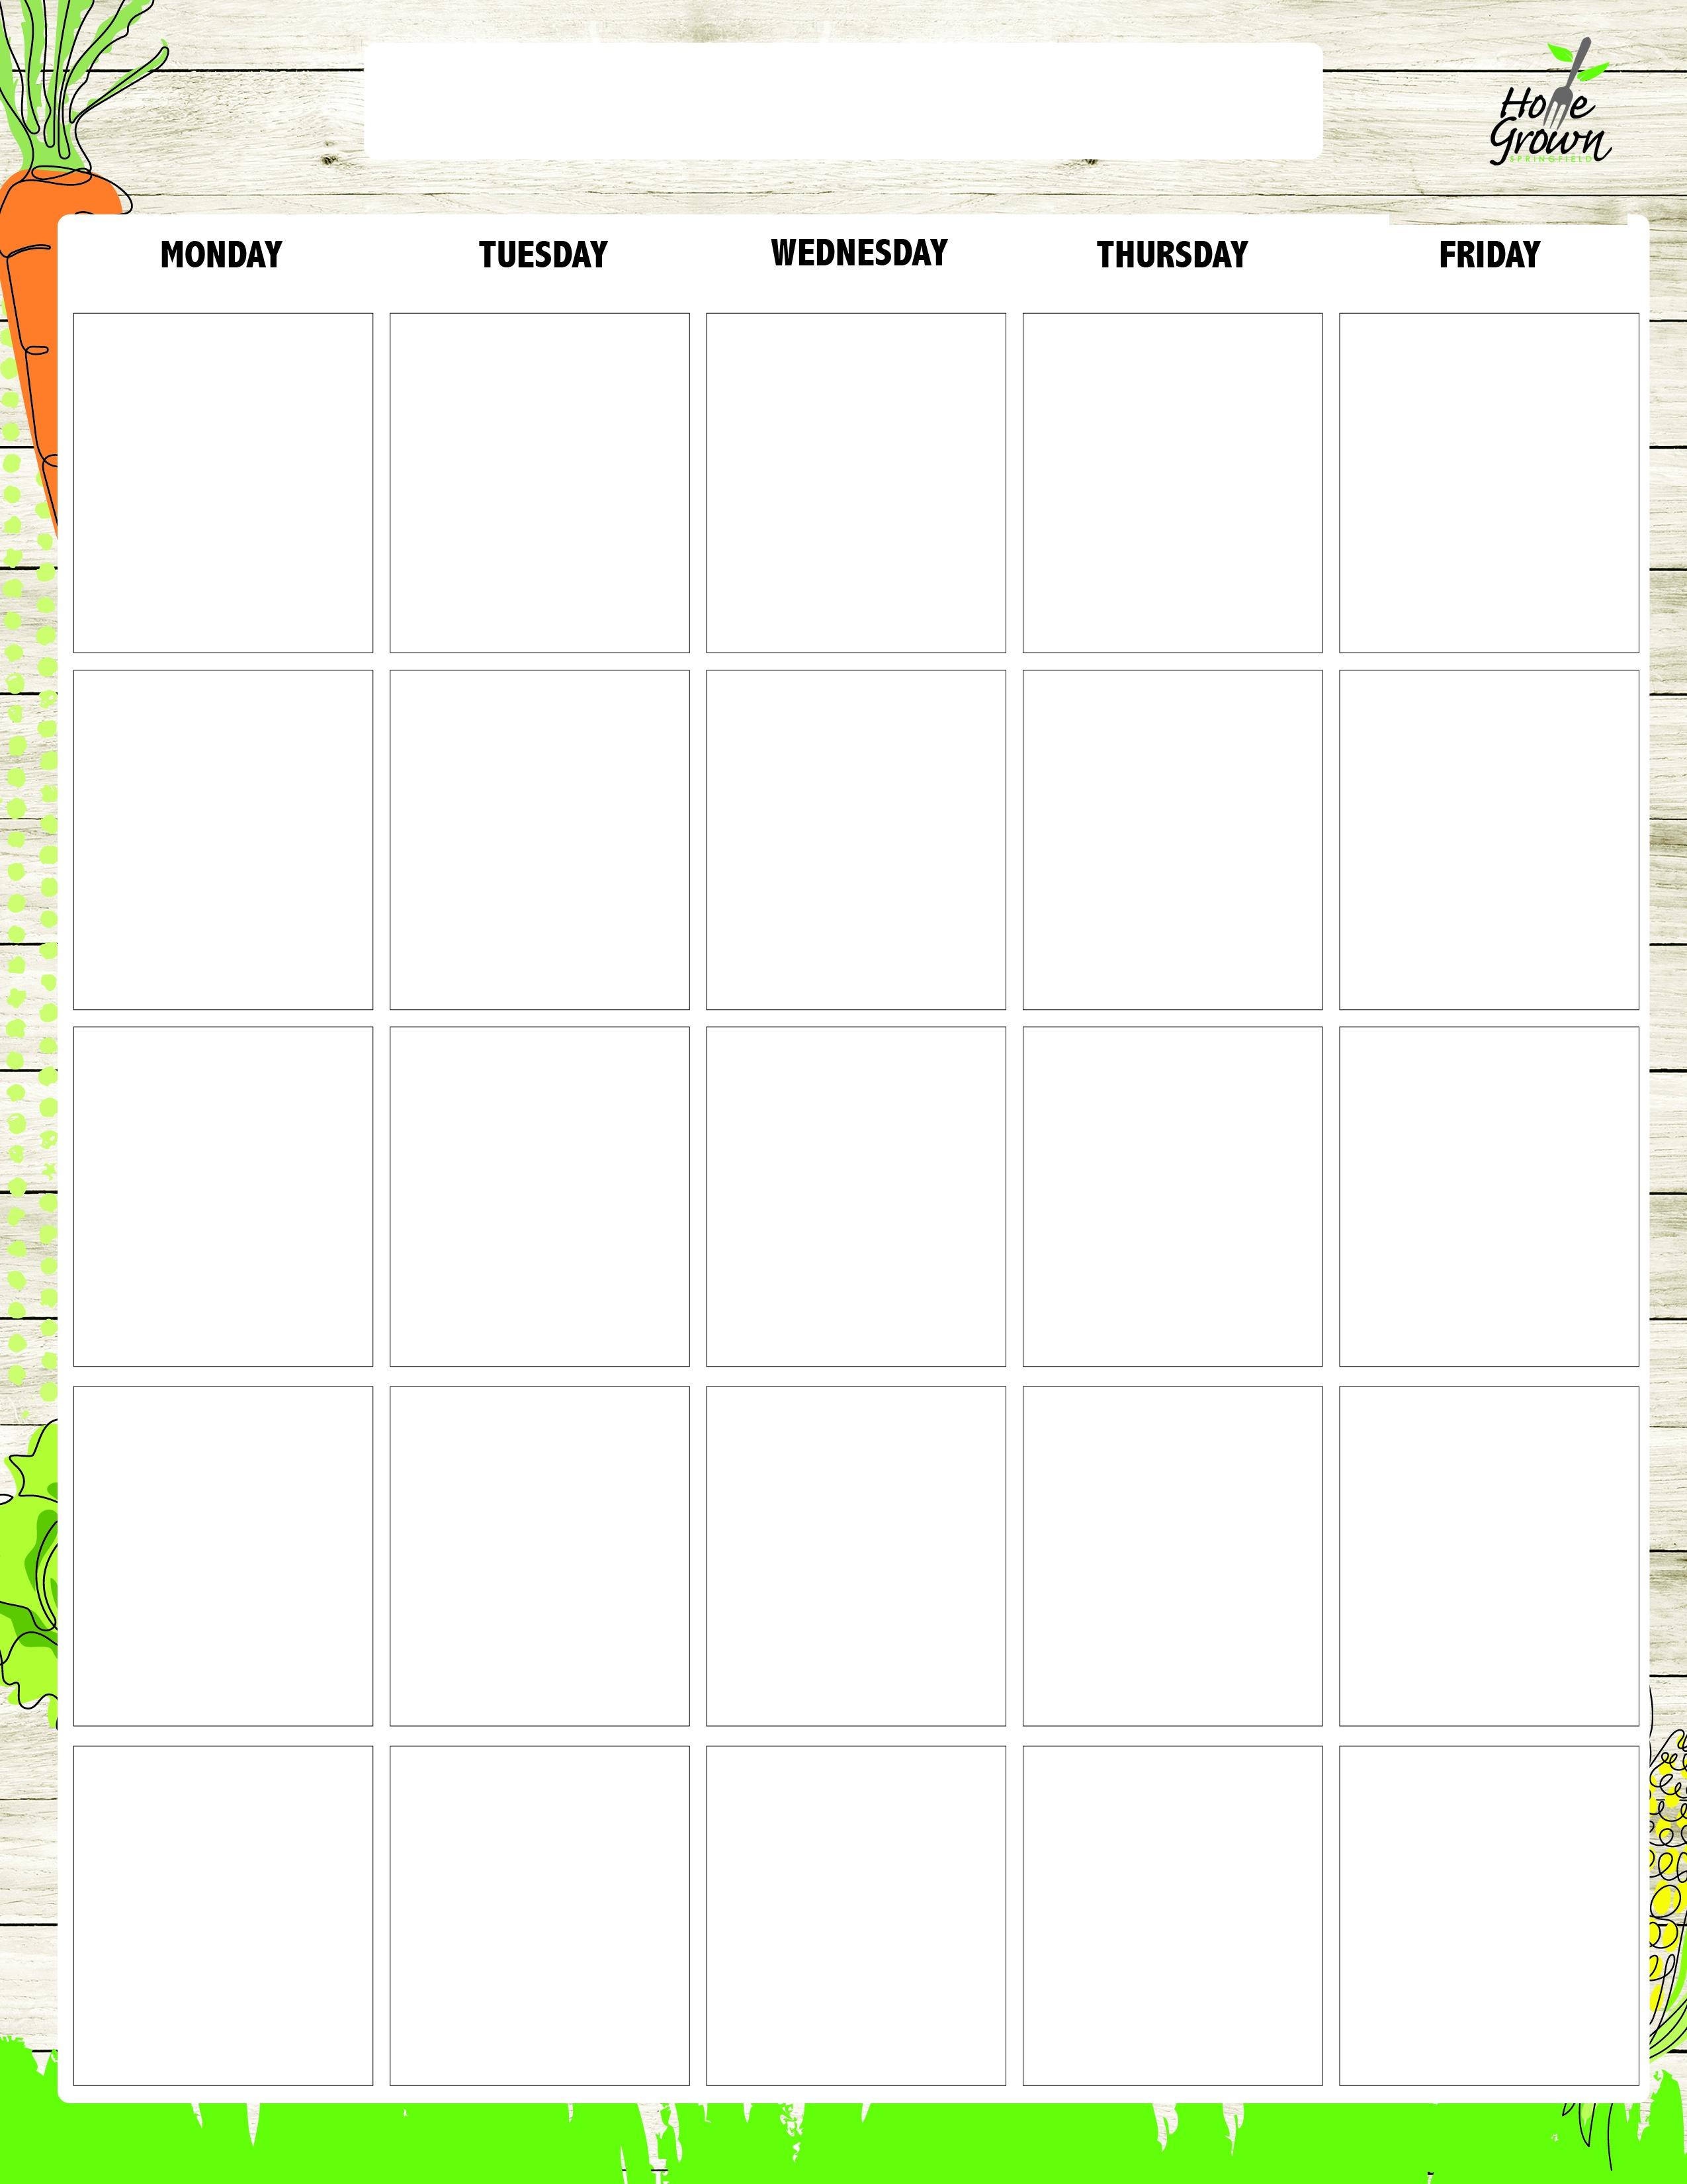
EGG-FREE LUNCH
August-September 2026
8/24
Cheeseburger on
a Bun
Chicken Caesar Salad with Roll (No Caesar Dressing)
Garden Salad (No Egg) with Roll
Turkey Ham & Cheese Sandwich
Sunbutter & Jelly Sandwich
Cheese Sandwich
French Fries
Black Bean Salad
Available Daily:
Assorted Fresh Fruit
Fat Free Chocolate, 1% White or Fat Free White Milk
8/25
General Tso’s Chicken w/Veggie Fried Rice
Chicken Caesar Salad with Roll (No Caesar Dressing)
Garden Salad (No Egg) with Roll
Turkey Ham & Cheese Sandwich
Sunbutter & Jelly Sandwich
Cheese Sandwich
Steamed Carrots
Celery Sticks
Available Daily:
Assorted Fresh Fruit
Fat Free Chocolate, 1% White or Fat Free White Milk
8/26
Mac & Cheese
Chicken Caesar Salad with Roll (No Caesar Dressing)
Garden Salad (No Egg) with Roll
Turkey Ham & Cheese Sandwich
Sunbutter & Jelly Sandwich
Cheese Sandwich
Roasted Broccoli
Grape Tomatoes
Available Daily:
Assorted Fresh Fruit
Fat Free Chocolate, 1% White or Fat Free White Milk
8/27
Chicken & Waffles
Chicken Caesar Salad with Roll (No Caesar Dressing)
Garden Salad (No Egg) with Roll
Turkey Ham & Cheese Sandwich
Sunbutter & Jelly Sandwich
Cheese Sandwich
CNC Mashed Sweet Potatoes
Chilled Corn
Available Daily:
Assorted Fresh Fruit
Fat Free Chocolate, 1% White or Fat Free White Milk
8/28
Cheese or Pepperoni Pizza
Chicken Caesar Salad with Roll (No Caesar Dressing)
Garden Salad (No Egg) with Roll
Turkey Ham & Cheese Sandwich
Sunbutter & Jelly Sandwich
Cheese Sandwich
Steamed Broccoli
Carrot Sticks
Available Daily:
Assorted Fresh Fruit
Fat Free Chocolate, 1% White or Fat Free White Milk
8/31
Cheese Nachos
Chicken Cobb Salad with Roll
Hummus Bento Box with Roll
Turkey Ham & Cheese Sandwich
Sunbutter & Jelly Sandwich
Cheese Sandwich
Steamed Corn
Black Bean Salad
Available Daily:
Assorted Fresh Fruit
Fat Free Chocolate, 1% White or Fat Free White Milk
9/1
No School
9/2
Baked Ziti w/Plant-
based Bolognese
Chicken Cobb Salad with Roll
Hummus Bento Box with Roll
Turkey Ham & Cheese Sandwich
Sunbutter & Jelly Sandwich
Cheese Sandwich
Roasted Broccoli
Carrot Sticks
Available Daily:
Assorted Fresh Fruit
Fat Free Chocolate, 1% White or Fat Free White Milk
9/3
Cheddar Chicken Bowl
w/Roll
Chicken Cobb Salad with Roll
Hummus Bento Box with Roll
Turkey Ham & Cheese Sandwich
Sunbutter & Jelly Sandwich
Cheese Sandwich
CNC Mashed Potatoes
Chilled Corn
Available Daily:
Assorted Fresh Fruit
Fat Free Chocolate, 1% White or Fat Free White Milk
9/4
Cheese or Pepperoni Pizza
Chicken Cobb Salad with Roll
Hummus Bento Box with Roll
Turkey Ham & Cheese Sandwich
Sunbutter & Jelly Sandwich
Cheese Sandwich
Seasoned Green beans
Cucumber Salad
Available Daily:
Assorted Fresh Fruit
Fat Free Chocolate, 1% White or Fat Free White Milk
9/7
No School
9/8
Pulled Pork Sandwich w/Cole Slaw
Vegan Mediterranean Salad with Roll
Garden Salad (No Egg) with Roll
Turkey & Cheese Sandwich on GF Bread
Sunbutter & Jelly Sandwich on GF Bread
Cheese Sandwich on GF Bread
Mashed Butternut
Celery Sticks
Available Daily:
Assorted Fresh Fruit
Fat Free Chocolate, 1% White or Fat Free White Milk
9/9
Breakfast for Lunch
W/French Toast & CNC Chicken Sausage
Vegan Mediterranean Salad with Roll
Garden Salad (No Egg) with Roll
Turkey & Cheese Sandwich on GF Bread
Sunbutter & Jelly Sandwich on GF Bread
Cheese Sandwich on GF Bread
Tater Tots
Carrot Sticks
Available Daily:
Assorted Fresh Fruit
Fat Free Chocolate, 1% White or Fat Free White Milk
9/10
Plant-based Taco
Salad w/Seasoned Rice (NO RANCH)
Vegan Mediterranean Salad with Roll
Garden Salad (No Egg) with Roll
Turkey & Cheese Sandwich on GF Bread
Sunbutter & Jelly Sandwich on GF Bread
Cheese Sandwich on GF Bread
Stewed Black Beans
Grape Tomatoes
Available Daily:
Assorted Fresh Fruit
Fat Free Chocolate, 1% White or Fat Free White Milk
9/11
Cheese or Pepperoni Pizza
Vegan Mediterranean Salad with Roll
Garden Salad (No Egg) with Roll
Turkey & Cheese Sandwich on GF Bread
Sunbutter & Jelly Sandwich on GF Bread
Cheese Sandwich on GF Bread
Steamed Broccoli
Celery Sticks
Available Daily:
Assorted Fresh Fruit
Fat Free Chocolate, 1% White or Fat Free White Milk
9/14
Chicken Nuggets
W/Roll & CNC BBQ Sauce
Kale & Apple Salad with Roll
Hummus Bento Box with Roll
Turkey Ham & Cheese Sandwich
Sunbutter & Jelly Sandwich
Cheese Sandwich
Vegetarian Baked Beans
Celery Sticks
Available Daily:
Assorted Fresh Fruit
Fat Free Chocolate, 1% White or Fat Free White Milk
9/15
Mini Turkey
Corn Dogs
Kale & Apple Salad with Roll
Hummus Bento Box with Roll
Turkey Ham & Cheese Sandwich
Sunbutter & Jelly Sandwich
Cheese Sandwich
Black Bean Salad
Cucumber Salad
Available Daily:
Assorted Fresh Fruit
Fat Free Chocolate, 1% White or Fat Free White Milk
9/16
Penne Pasta & Meatballs
Kale & Apple Salad with Roll
Hummus Bento Box with Roll
Turkey Ham & Cheese Sandwich
Sunbutter & Jelly Sandwich
Cheese Sandwich
Steamed Broccoli
Carrot Sticks
Available Daily:
Assorted Fresh Fruit
Fat Free Chocolate, 1% White or Fat Free White Milk
9/17
Huli Huli Chicken w/Rice Pilaf
Kale & Apple Salad with Roll
Hummus Bento Box with Roll
Turkey Ham & Cheese Sandwich
Sunbutter & Jelly Sandwich
Cheese Sandwich
CNC Mashed
Sweet Potato
Chilled Corn
Available Daily:
Assorted Fresh Fruit
Fat Free Chocolate, 1% White or Fat Free White Milk
9/18
Cheese or Pepperoni Pizza
Kale & Apple Salad with Roll
Hummus Bento Box with Roll
Turkey Ham & Cheese Sandwich
Sunbutter & Jelly Sandwich
Cheese Sandwich
Roasted Local Veg
Celery Sticks
Available Daily:
Assorted Fresh Fruit
Fat Free Chocolate, 1% White or Fat Free White Milk
9/21
Cheeseburger on
a Bun
Chicken Caesar Salad with Roll (No Caesar Dressing)
Garden Salad (No Egg) with Roll
Turkey Ham & Cheese Sandwich
Sunbutter & Jelly Sandwich
Cheese Sandwich
French Fries
Black Bean Salad
Available Daily:
Assorted Fresh Fruit
Fat Free Chocolate, 1% White or Fat Free White Milk
9/22
General Tso’s Chicken w/Veggie Fried Rice
Chicken Caesar Salad with Roll (No Caesar Dressing)
Garden Salad (No Egg) with Roll
Turkey Ham & Cheese Sandwich
Sunbutter & Jelly Sandwich
Cheese Sandwich
Steamed Carrots
Celery Sticks
Available Daily:
Assorted Fresh Fruit
Fat Free Chocolate, 1% White or Fat Free White Milk
9/23
Mac & Cheese
Chicken Caesar Salad with Roll (No Caesar Dressing)
Garden Salad (No Egg) with Roll
Turkey Ham & Cheese Sandwich
Sunbutter & Jelly Sandwich
Cheese Sandwich
Roasted Broccoli
Grape Tomatoes
Available Daily:
Assorted Fresh Fruit
Fat Free Chocolate, 1% White or Fat Free White Milk
9/24
Chicken & Waffles
Chicken Caesar Salad with Roll (No Caesar Dressing)
Garden Salad (No Egg) with Roll
Turkey Ham & Cheese Sandwich
Sunbutter & Jelly Sandwich
Cheese Sandwich
CNC Mashed Sweet Potatoes
Chilled Corn
Available Daily:
Assorted Fresh Fruit
Fat Free Chocolate, 1% White or Fat Free White Milk
9/25
Cheese or Pepperoni Pizza
Chicken Caesar Salad with Roll (No Caesar Dressing)
Garden Salad (No Egg) with Roll
Turkey Ham & Cheese Sandwich
Sunbutter & Jelly Sandwich
Cheese Sandwich
Steamed Broccoli
Carrot Sticks
Available Daily:
Assorted Fresh Fruit
Fat Free Chocolate, 1% White or Fat Free White Milk

EGG-FREE LUNCH
September-October 2026
9/28
Italian Meatball
Sub
Chicken Cobb Salad with Roll
Hummus Bento Box with Roll
Turkey Ham & Cheese Sandwich
Sunbutter & Jelly Sandwich
Cheese Sandwich
Green Peas
Carrot Sticks
Available Daily:
Assorted Fresh Fruit
Fat Free Chocolate, 1% White or Fat Free White Milk
9/29
Cheese Nachos
Chicken Cobb Salad with Roll
Hummus Bento Box with Roll
Turkey Ham & Cheese Sandwich
Sunbutter & Jelly Sandwich
Cheese Sandwich
Steamed Corn
Black Bean Salad
Available Daily:
Assorted Fresh Fruit
Fat Free Chocolate, 1% White or Fat Free White Milk
9/30
Baked Ziti w/Plant-
based Bolognese
Chicken Cobb Salad with Roll
Hummus Bento Box with Roll
Turkey Ham & Cheese Sandwich
Sunbutter & Jelly Sandwich
Cheese Sandwich
Roasted Broccoli
Carrot Sticks
Available Daily:
Assorted Fresh Fruit
Fat Free Chocolate, 1% White or Fat Free White Milk
10/1
Cheddar Chicken Bowl
w/Roll
Chicken Cobb Salad with Roll
Hummus Bento Box with Roll
Turkey Ham & Cheese Sandwich
Sunbutter & Jelly Sandwich
Cheese Sandwich
CNC Mashed Potatoes
Chilled Corn
Available Daily:
Assorted Fresh Fruit
Fat Free Chocolate, 1% White or Fat Free White Milk
10/2
Cheese or Pepperoni Pizza
Chicken Cobb Salad with Roll
Hummus Bento Box with Roll
Turkey Ham & Cheese Sandwich
Sunbutter & Jelly Sandwich
Cheese Sandwich
Seasoned Green beans
Cucumber Salad
Available Daily:
Assorted Fresh Fruit
Fat Free Chocolate, 1% White or Fat Free White Milk

