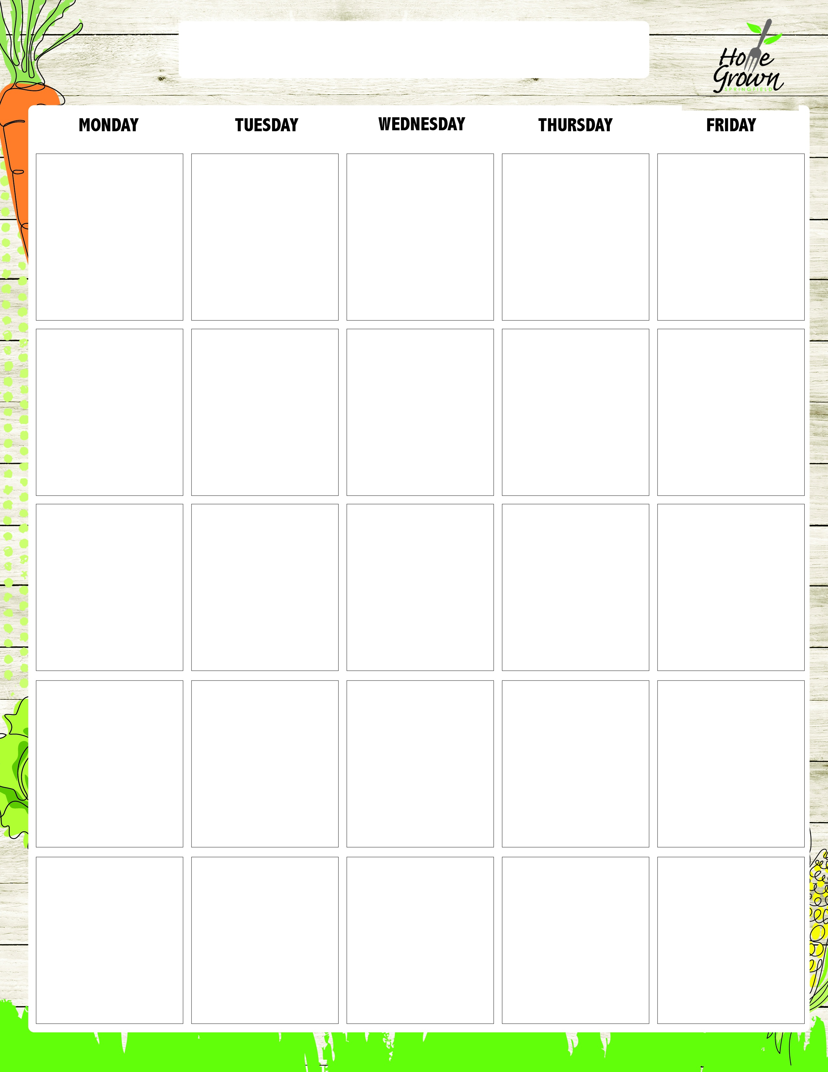
ELEMENTARY LUNCH
August-September 2026
8/24
Cheeseburger on a Roll
OR
Grilled Cheese
Turkey & Cheese
French Fries
Black Bean Salad
8/25
General Tso’s Chicken w/Veggie Fried Rice
OR
Stuffed Cheesy Bread
Garden Salad with Roll
Turkey & Cheese
Steamed Carrots
Celery Sticks
8/26
Mac & Cheese
OR
Grilled Cheese
Chicken Caesar Salad with Roll
Garden Salad with Roll
Turkey & Cheese
Roasted Broccoli
Grape Tomatoes
8/27
Chicken & Waffles with Syrup
OR
Stuffed Cheesy Bread
Chicken Caesar Salad with Roll
Garden Salad with Roll
Turkey & Cheese
Mashed Sweet Potatoes
Chilled Corn
8/28
OMM Pizzas
OR
Grilled Cheese
Chicken Caesar Salad with Roll
Garden Salad with Roll
Turkey & Cheese
Side Caesar Salad
Celery Sticks
8/31
Cheese Nachos w/Salsa
OR
Grilled Cheese
Cobb Salad w/Roll
Hummus Bento w/Roll
Turkey Ham & Cheese Sandwich
Steamed Corn
Black Bean Salad
9/1
No School
9/2
Baked Ziti with
Plant-based Bolognese
OR
Grilled Cheese
Cobb Salad w/Roll
Hummus Bento w/Roll
Turkey Ham & Cheese Sandwich
Steamed Broccoli
Carrot Sticks
9/3
Cheddar Chicken Bowl w/Roll
OR
Ham & Cheese Calzone w/Honey Mustard Dip
Cobb Salad w/Roll
Hummus Bento w/Roll
Turkey Ham & Cheese Sandwich
Local Mashed Potato
Chilled Corn
9/4
OMM Pizzas
OR
Grilled Cheese
Cobb Salad w/Roll
Hummus Bento w/Roll
Turkey Ham & Cheese Sandwich
Seasoned Green Beans
Cucumber Salad
9/7
No School
9/8
BBQ Pulled Pork Sandwich w/Cole Slaw
OR
Cheese Calzone w/Dip
Vegan Mediterranean Salad with Roll
Garden Salad with Roll Turkey & Cheese Sandwich
Mashed Butternut
Celery Sticks
9/9
French Toast, CNC Chicken Sausage, Syrup
OR
Grilled Cheese
Vegan Mediterranean Salad with Roll
Garden Salad with Roll Turkey & Cheese Sandwich
Tater Tots
Carrot Sticks
9/10
Plant-based Taco Salad w/Seasoned Rice
OR
Cheese Calzone w/Dip
Vegan Mediterranean Salad with Roll
Garden Salad with Roll Turkey & Cheese Sandwich
Stewed Black Beans
Grape Tomatoes
9/11
OMM Pizzas
OR
Grilled Cheese
Vegan Mediterranean Salad with Roll
Garden Salad with Roll Turkey & Cheese Sandwich
Steamed Broccoli
Celery Sticks
9/14
Chicken Nuggets w/ Dinner Roll & BBQ Sauce
OR
Grilled Cheese
Kale & Apple Salad w/Roll
Hummus Bento w/Roll
Turkey Ham & Cheese
French Fries
Celery Sticks
9/15
Sweet Battered Mini Turkey Corn Dog
OR
Pepperoni Calzone w/dip
Kale & Apple Salad w/Roll
Hummus Bento w/Roll
Turkey Ham & Cheese
Veggie Baked Beans
Grape Tomatoes
9/16
Pasta & Meatballs w/Marinara
OR
Grilled Cheese
Kale & Apple Salad w/Roll
Hummus Bento w/Roll
Turkey Ham & Cheese
Roasted Broccoli
Carrot Sticks
9/17
Huli Huli Chicken with Rice Pilaf
OR
Pepperoni Calzone w/dip
Kale & Apple Salad w/Roll Hummus Bento w/Roll
Turkey Ham & Cheese
Seasoned Green Beans
Chilled Corn
9/18
OMM Pizzas
OR
Grilled Cheese
Kale & Apple Salad w/Roll Hummus Bento w/Roll
Turkey Ham & Cheese
Roasted Local Root Veg
Celery Sticks
9/21
Cheeseburger on a Roll
OR
Grilled Cheese
Chicken Caesar Salad with Roll
Garden Salad with Roll
Turkey & Cheese
French Fries
Black Bean Salad
9/22
General Tso’s Chicken w/Veggie Fried Rice
OR
Stuffed Cheesy Bread
Chicken Caesar Salad with Roll
Garden Salad with Roll
Turkey & Cheese
Steamed Carrots
Celery Sticks
9/23
Mac & Cheese
OR
Grilled Cheese
Chicken Caesar Salad with Roll
Garden Salad with Roll
Turkey & Cheese
Roasted Broccoli
Grape Tomatoes
9/24
Chicken & Waffles with Syrup
OR
Stuffed Cheesy Bread
Chicken Caesar Salad with Roll
Garden Salad with Roll
Turkey & Cheese
Mashed Sweet Potatoes
Chilled Corn
9/25
OMM Pizzas
OR
Grilled Cheese
Chicken Caesar Salad with Roll
Garden Salad with Roll
Turkey & Cheese
Side Caesar Salad
Celery Sticks

ELEMENTARY LUNCH
September-October 2026
9/28
Italian Meatball Sub w/Parmesan Cheese
OR
Grilled Cheese
Cobb Salad w/Roll
Hummus Bento w/Roll
Turkey Ham & Cheese Sandwich
Steamed Peas
Carrot Sticks
9/29
Cheese Nachos w/Roasted Salsa Fresca
OR
Ham & Cheese Calzone w/Honey Mustard Dip
Cobb Salad w/Roll
Hummus Bento w/Roll
Turkey Ham & Cheese Sandwich
Steamed Corn
Black Bean Salad
9/30
Baked Ziti with
Plant-based Bolognese
OR
Grilled Cheese
Cobb Salad w/Roll
Hummus Bento w/Roll
Turkey Ham & Cheese Sandwich
Steamed Broccoli
Carrot Sticks
10/1
Cheddar Chicken Bowl w/Roll
OR
Ham & Cheese Calzone w/Honey Mustard Dip
Cobb Salad w/Roll
Hummus Bento w/Roll
Turkey Ham & Cheese Sandwich
Local Mashed Potato
Chilled Corn
10/2
OMM Pizzas
OR
Grilled Cheese
Cobb Salad w/Roll
Hummus Bento w/Roll
Turkey Ham & Cheese Sandwich
Seasoned Green Beans
Cucumber Salad

