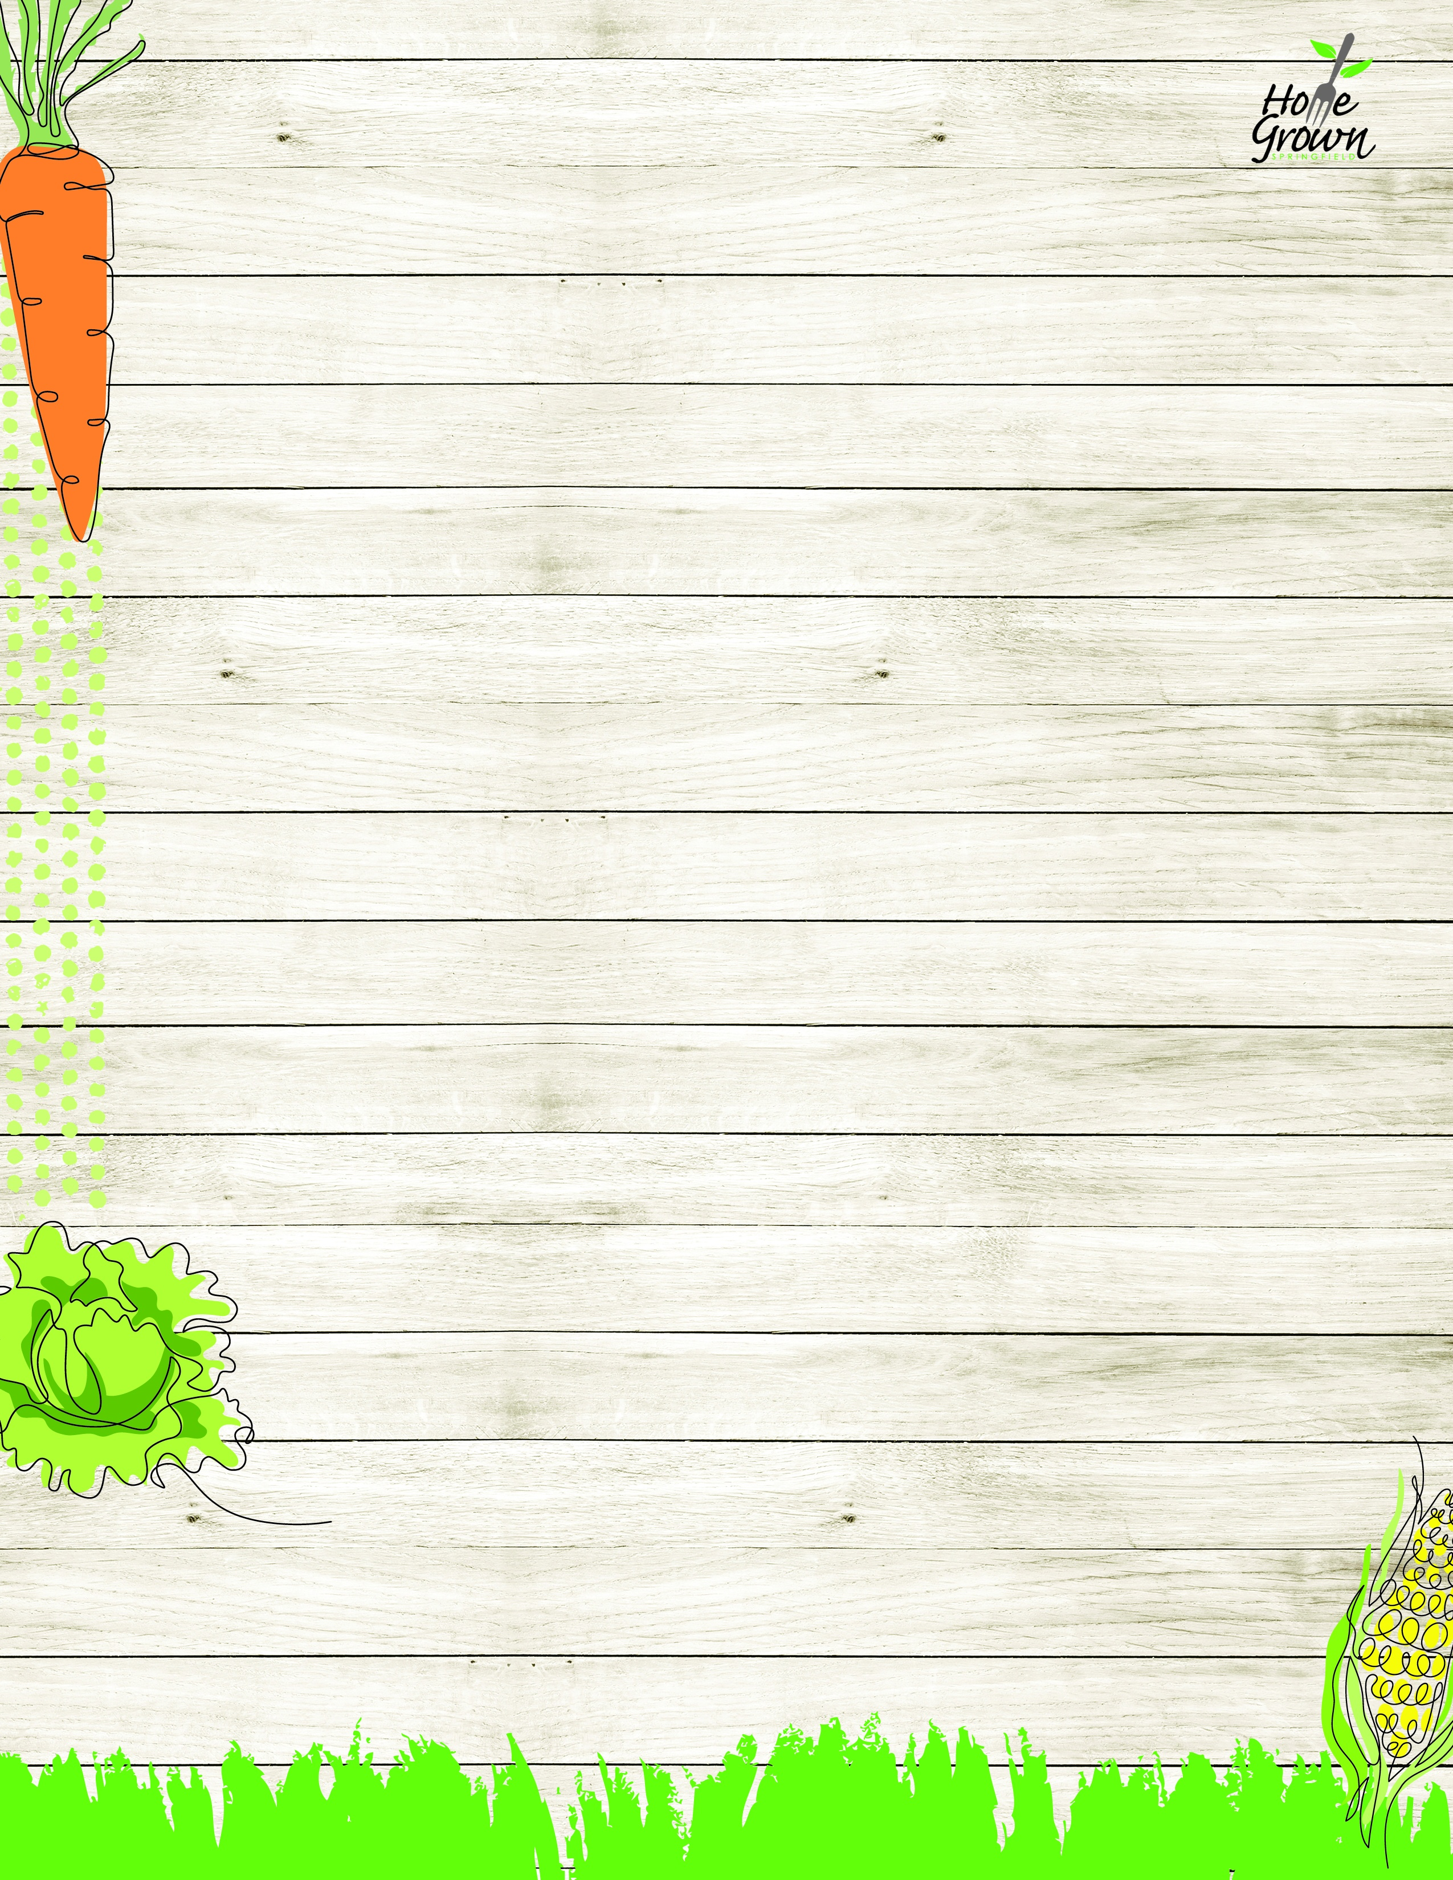

PRE-PLATE VEGETARIAN LUNCH
August-September 2026
MONDAY
TUESDAY
WEDNESDAY
WEDNESDAY
THURSDAY
FRIDAY
8/24
Black Bean Burger with Carrots & Corn
Hummus Bento Box with Roll
8/25
Cheese Calzone with Pizza Dipping Sauce and Baked Beans & Celery
Hummus Bento Box with Roll
8/26
Mac & Cheese, Green Beans, Carrots
Hummus Bento Box
with Roll
8/26
Mac & Cheese, Green Beans, Carrots
Hummus Bento Box
with Roll
8/27
Seasoned Rice, Local Stewed Beans w/ Green Beans & Corn
Hummus Bento Box
with Roll
8/28
Cheese Pizza with Steamed Carrots and Broccoli
Hummus Bento Box with Roll
8/31
Cheese Nachos w/Fiesta Corn & Black Beans, Baby Carrots
Garden Salad with Broccoli, Carrots & Dinner Roll
9/1
No School
9/2
Plant-based Lazy Lasagna, Broccoli, Carrots
Garden Salad with Corn, Celery & Dinner Roll
9/2
Plant-based Lazy Lasagna, Broccoli, Carrots
Garden Salad with Corn, Celery & Dinner Roll
9/3
Loaded Baked Potato, Cheese sauce, Broccoli and a Roll
Garden Salad with Broccoli, Carrots & Dinner Roll
9/4
Cheese Pizza
with Steamed Carrots & Green Beans
Garden Salad with Corn, Celery & Dinner Roll
9/7
No School
9/8
Black Bean Burger
with Carrots & Corn
Hummus Bento Box
with Roll
9/9
Pancakes, Sunbutter, Tater Tots, Baby Carrots & Syrup
Hummus Bento Box
with Roll
9/9
Pancakes, Sunbutter, Tater Tots, Baby Carrots & Syrup
Hummus Bento Box
with Roll
9/10
Seasoned Rice, Local Stewed Beans w/ Green Beans & Corn
Hummus Bento Box
with Roll
9/11
Cheese Pizza with Steamed Carrots and Broccoli
Hummus Bento Box with Roll
9/14
Cheese Nachos w/Fiesta Corn & Black Beans, Baby Carrots
Garden Salad with Broccoli, Carrots & Dinner Roll
9/15
Cheese Calzone with Pizza Dipping Sauce and Baked Beans & Celery
Garden Salad with Corn, Celery & Dinner Roll
9/16
Creamy Penne Alfredo, Broccoli, Carrots
Garden Salad with Broccoli, Carrots & Dinner Roll
9/16
Creamy Penne Alfredo, Broccoli, Carrots
Garden Salad with Broccoli, Carrots & Dinner Roll
9/17
Loaded Baked Potato, Cheese sauce, Broccoli and a Roll
Garden Salad with Corn, Celery & Dinner Roll
9/18
Cheese Pizza
with Steamed Carrots & Green Beans
Garden Salad with Broccoli, Carrots & Dinner Roll
9/21
Black Bean Burger with Carrots & Corn
Hummus Bento Box with Roll
9/22
Cheese Calzone with Pizza Dipping Sauce and Baked Beans & Celery
Hummus Bento Box with Roll
9/23
Mac & Cheese, Green Beans, Carrots
Hummus Bento Box
with Roll
9/23
Mac & Cheese, Green Beans, Carrots
Hummus Bento Box
with Roll
9/24
Seasoned Rice, Local Stewed Beans w/Green Beans & Corn
Hummus Bento Box
with Roll
9/25
Cheese Pizza with Steamed Carrots and Broccoli
Hummus Bento Box with Roll

PRE-PLATE VEGETARIAN LUNCH
September-October 2026
MONDAY
TUESDAY
WEDNESDAY
WEDNESDAY
THURSDAY
FRIDAY
9/28
Cheese Nachos w/Fiesta Corn & Black Beans, Baby Carrots
Garden Salad with Corn, Celery & Dinner Roll
9/29
Seasoned Rice, Local Stewed Beans w/Green Beans & Corn
Garden Salad with Broccoli, Carrots & Dinner Roll
9/30
Plant-based Lazy Lasagna, Broccoli, Carrots
Garden Salad with Corn, Celery & Dinner Roll
9/30
Plant-based Lazy Lasagna, Broccoli, Carrots
Garden Salad with Corn, Celery & Dinner Roll
10/1
Loaded Baked Potato, Cheese sauce, Broccoli and a Roll
Garden Salad with Broccoli, Carrots & Dinner Roll
10/2
Cheese Pizza
with Steamed Carrots & Green Beans
Garden Salad with Corn, Celery & Dinner Roll

