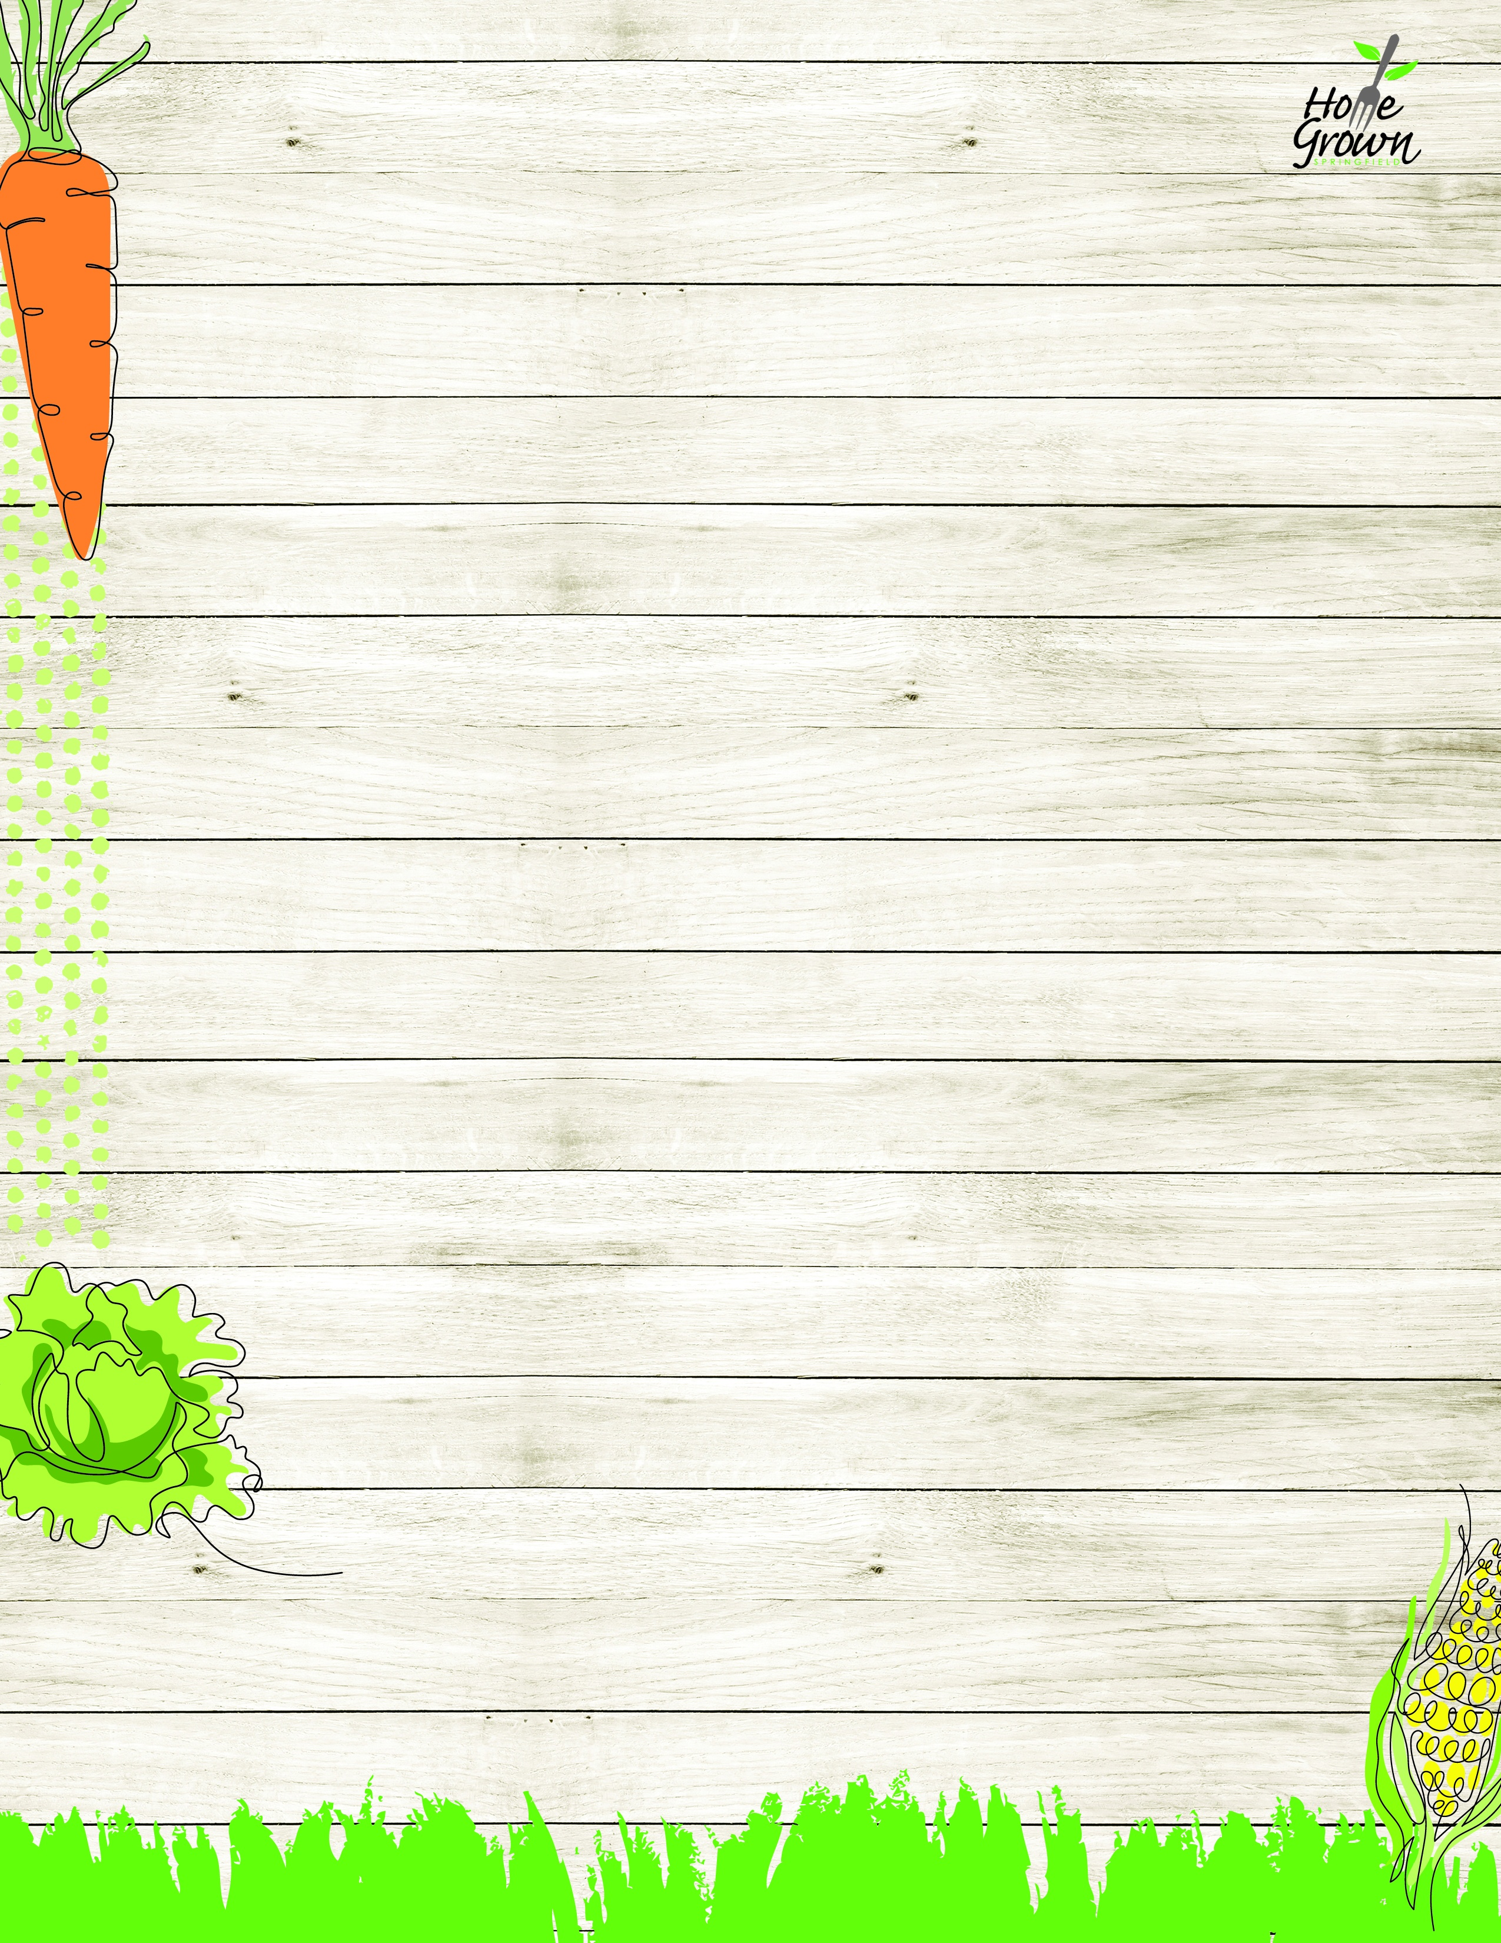

DROP-OFF PRE-PLATE LUNCH
August-September 2026
MONDAY
TUESDAY
WEDNESDAY
WEDNESDAY
THURSDAY
FRIDAY
8/24
Cheeseburger w/Baked Beans, Tater Tots
Turkey & Cheese Sandwich, Broccoli, Grape Tomatoes
8/25
General Tso’s Chicken, Veggie Fried Rice, Broccoli, Carrots
Chicken Caesar Salad
with Roll, Carrot Sticks
& Corn Salsa
8/26
Mac & Cheese, Broccoli, Carrots
Turkey & Cheese Sandwich, Broccoli, Grape Tomatoes
8/26
Mac & Cheese, Broccoli, Carrots
Turkey & Cheese Sandwich, Broccoli, Grape Tomatoes
8/27
Chicken & Waffles, Sweet Potato, Baked Beans
Chicken Caesar Salad
with Roll, Carrot Sticks
& Corn Salsa
8/28
Cheese Pizza with Steamed Carrots and Broccoli
Turkey & Cheese Sandwich, Broccoli, Grape Tomatoes
8/31
Cheese Nachos, Fiesta Corn & Black Bean Salsa & Baby Carrots
Turkey Ham & Cheese Sandwich with Bean Salad & Carrot Stick
9/1
No School
9/2
Plant-based Lazy Lasagna, Broccoli, Carrots
Turkey Ham & Cheese Sandwich with Bean Salad & Carrot Stick
9/2
Plant-based Lazy Lasagna, Broccoli, Carrots
Turkey Ham & Cheese Sandwich with Bean Salad & Carrot Stick
9/3
Cheddar Chicken Bowl, Mashed Potatoes, Roll
Buffalo Chicken Salad w/Roll, Celery Sticks, Broccoli
9/4
Cheese Pizza
with Steamed Carrots & Green Beans
Turkey Ham & Cheese Sandwich with Bean Salad & Carrot Stick
9/7
No School
9/8
Chicken Patty Sandwich, Baked Beans, Green beans
Crispy Chicken Salad with Roll, Celery & Corn Salsa
9/9
Pancakes, Sausage, Tater Tots, Baby Carrots & Syrup
Turkey & Cheese Sandwich, Broccoli, Grape Tomatoes
9/9
Pancakes, Sausage, Tater Tots, Baby Carrots & Syrup
Turkey & Cheese Sandwich, Broccoli, Grape Tomatoes
9/10
Seasoned Rice, Local Stewed Beans w/ Green Beans & Corn
Crispy Chicken Salad with Roll, Celery & Corn Salsa
9/11
Cheese Pizza with Steamed Carrots and Broccoli
Turkey & Cheese Sandwich, Broccoli, Grape Tomatoes
9/14
Chicken Nuggets with Potato Wedges, Baked Beans and a Roll
Turkey Ham & Cheese Sandwich with Bean Salad & Carrot Stick
9/15
Beef Picadillo, Seasoned Rice, Green beans, Corn
Chef Salad with Roll, Celery & Carrot Sticks
9/16
Creamy Penne Alfredo, Broccoli, Carrots
Turkey Ham & Cheese Sandwich with Bean Salad & Carrot Stick
9/16
Creamy Penne Alfredo, Broccoli, Carrots
Turkey Ham & Cheese Sandwich with Bean Salad & Carrot Stick
9/17
Loaded Baked Potato, Cheese sauce, Broccoli and a Roll
Chef Salad with Roll, Celery & Carrot Sticks
9/18
Cheese Pizza
with Steamed Carrots & Green Beans
Turkey Ham & Cheese Sandwich with Bean Salad & Carrot Stick
9/21
Cheeseburger w/Baked Beans, Tater Tots
Turkey & Cheese Sandwich, Broccoli, Grape Tomatoes
9/22
General Tso’s Chicken, Veggie Fried Rice, Broccoli, Carrots
Chicken Caesar Salad
with Roll, Carrot Sticks
& Corn Salsa
9/23
Mac & Cheese, Broccoli, Carrots
Turkey & Cheese Sandwich, Broccoli, Grape Tomatoes
9/23
Mac & Cheese, Broccoli, Carrots
Turkey & Cheese Sandwich, Broccoli, Grape Tomatoes
9/24
Chicken & Waffles, Sweet Potato, Baked Beans
Chicken Caesar Salad
with Roll, Carrot Sticks
& Corn Salsa
9/25
Cheese Pizza with Steamed Carrots and Broccoli
Turkey & Cheese Sandwich, Broccoli, Grape Tomatoes

DROP-OFF PRE-PLATE LUNCH
September-October 2026
MONDAY
TUESDAY
WEDNESDAY
WEDNESDAY
THURSDAY
FRIDAY
9/28
Cheese Nachos, Fiesta Corn & Black Bean Salsa & Celery Sticks
Turkey Ham & Cheese Sandwich with Bean Salad & Carrot Stick
9/29
Hawaiian Pineapple Chicken Bowl with Carrots, Green beans
Buffalo Chicken Salad w/Roll, Celery Sticks, Broccoli
9/30
Plant-based Lazy Lasagna, Broccoli, Carrots
Turkey Ham & Cheese Sandwich with Bean Salad & Carrot Stick
9/30
Plant-based Lazy Lasagna, Broccoli, Carrots
Turkey Ham & Cheese Sandwich with Bean Salad & Carrot Stick
10/1
Cheddar Chicken Bowl, Mashed Potatoes, Roll
Buffalo Chicken Salad w/Roll, Celery Sticks, Broccoli
10/2
Cheese Pizza
with Steamed Carrots & Green Beans
Turkey Ham & Cheese Sandwich with Bean Salad & Carrot Stick

