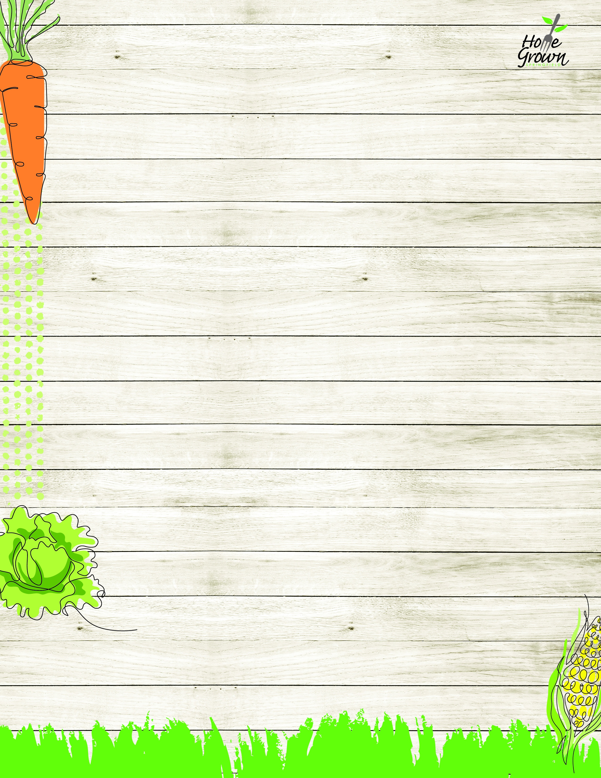

ALLERGY-FREE PRE-PLATE LUNCH
August-September 2026
MONDAY
TUESDAY
WEDNESDAY
WEDNESDAY
THURSDAY
FRIDAY
8/24
AF Chicken Fajitas with Baked Beans & Corn
8/25
GF Pasta & Meat Sauce
with Carrots and Broccoli
8/26
AF BBQ Chicken
with Rice, Corn &
Green Beans
8/26
AF BBQ Chicken
with Rice, Corn &
Green Beans
8/27
AF Chicken Tenders w/
Rice, Sweet Potato,
and Broccoli
8/28
AF Ground Beef Nachos with Seasoned Black Beans & Baby Carrots
8/31
AF Chicken Tenders w/
Rice, Sweet Potato,
and Broccoli
9/1
No School
9/2
AF Ground Beef Nachos with Seasoned Black Beans & Baby Carrots
9/2
AF Ground Beef Nachos with Seasoned Black Beans & Baby Carrots
9/3
AF BBQ Pulled Chicken Sandwich, Green Beans and Home Fries
9/4
AF Chicken Fajitas with Baked Beans & Corn
9/7
No School
9/8
AF Chicken Fajitas with Baked Beans & Corn
9/9
GF Pasta & Meat Sauce
with Carrots and Broccoli
9/9
GF Pasta & Meat Sauce
with Carrots and Broccoli
9/10
AF Chicken Tenders w/
Rice, Sweet Potato,
and Broccoli
9/11
AF Ground Beef Nachos with Seasoned Black Beans & Baby Carrots
9/14
GF Pasta & Meat Sauce
with Carrots and Broccoli
9/15
AF Chicken Fajitas with Baked Beans & Corn
9/16
AF BBQ Chicken
with Rice, Corn &
Green Beans
9/16
AF BBQ Chicken
with Rice, Corn &
Green Beans
9/17
AF Ground Beef Nachos with Seasoned Black Beans & Baby Carrots
9/18
AF BBQ Pulled Chicken Sandwich, Green Beans and Home Fries
9/21
AF Chicken Fajitas with Baked Beans & Corn
9/22
GF Pasta & Meat Sauce
with Carrots and Broccoli
9/23
AF BBQ Chicken
with Rice, Corn &
Green Beans
9/23
AF BBQ Chicken
with Rice, Corn &
Green Beans
9/24
AF Chicken Tenders w/
Rice, Sweet Potato,
and Broccoli
9/25
AF Ground Beef Nachos with Seasoned Black Beans & Baby Carrots

ALLERGY-FREE PRE-PLATE LUNCH
September-October 2026
MONDAY
TUESDAY
WEDNESDAY
WEDNESDAY
THURSDAY
FRIDAY
9/28
AF Chicken Tenders w/
Rice, Sweet Potato,
and Broccoli
9/29
GF Pasta & Meat Sauce
with Carrots and Broccoli
9/30
AF Ground Beef Nachos with Seasoned Black Beans & Baby Carrots
9/30
AF Ground Beef Nachos with Seasoned Black Beans & Baby Carrots
10/1
AF BBQ Pulled Chicken Sandwich, Green Beans and Home Fries
10/2
AF Chicken Fajitas with Baked Beans & Corn

