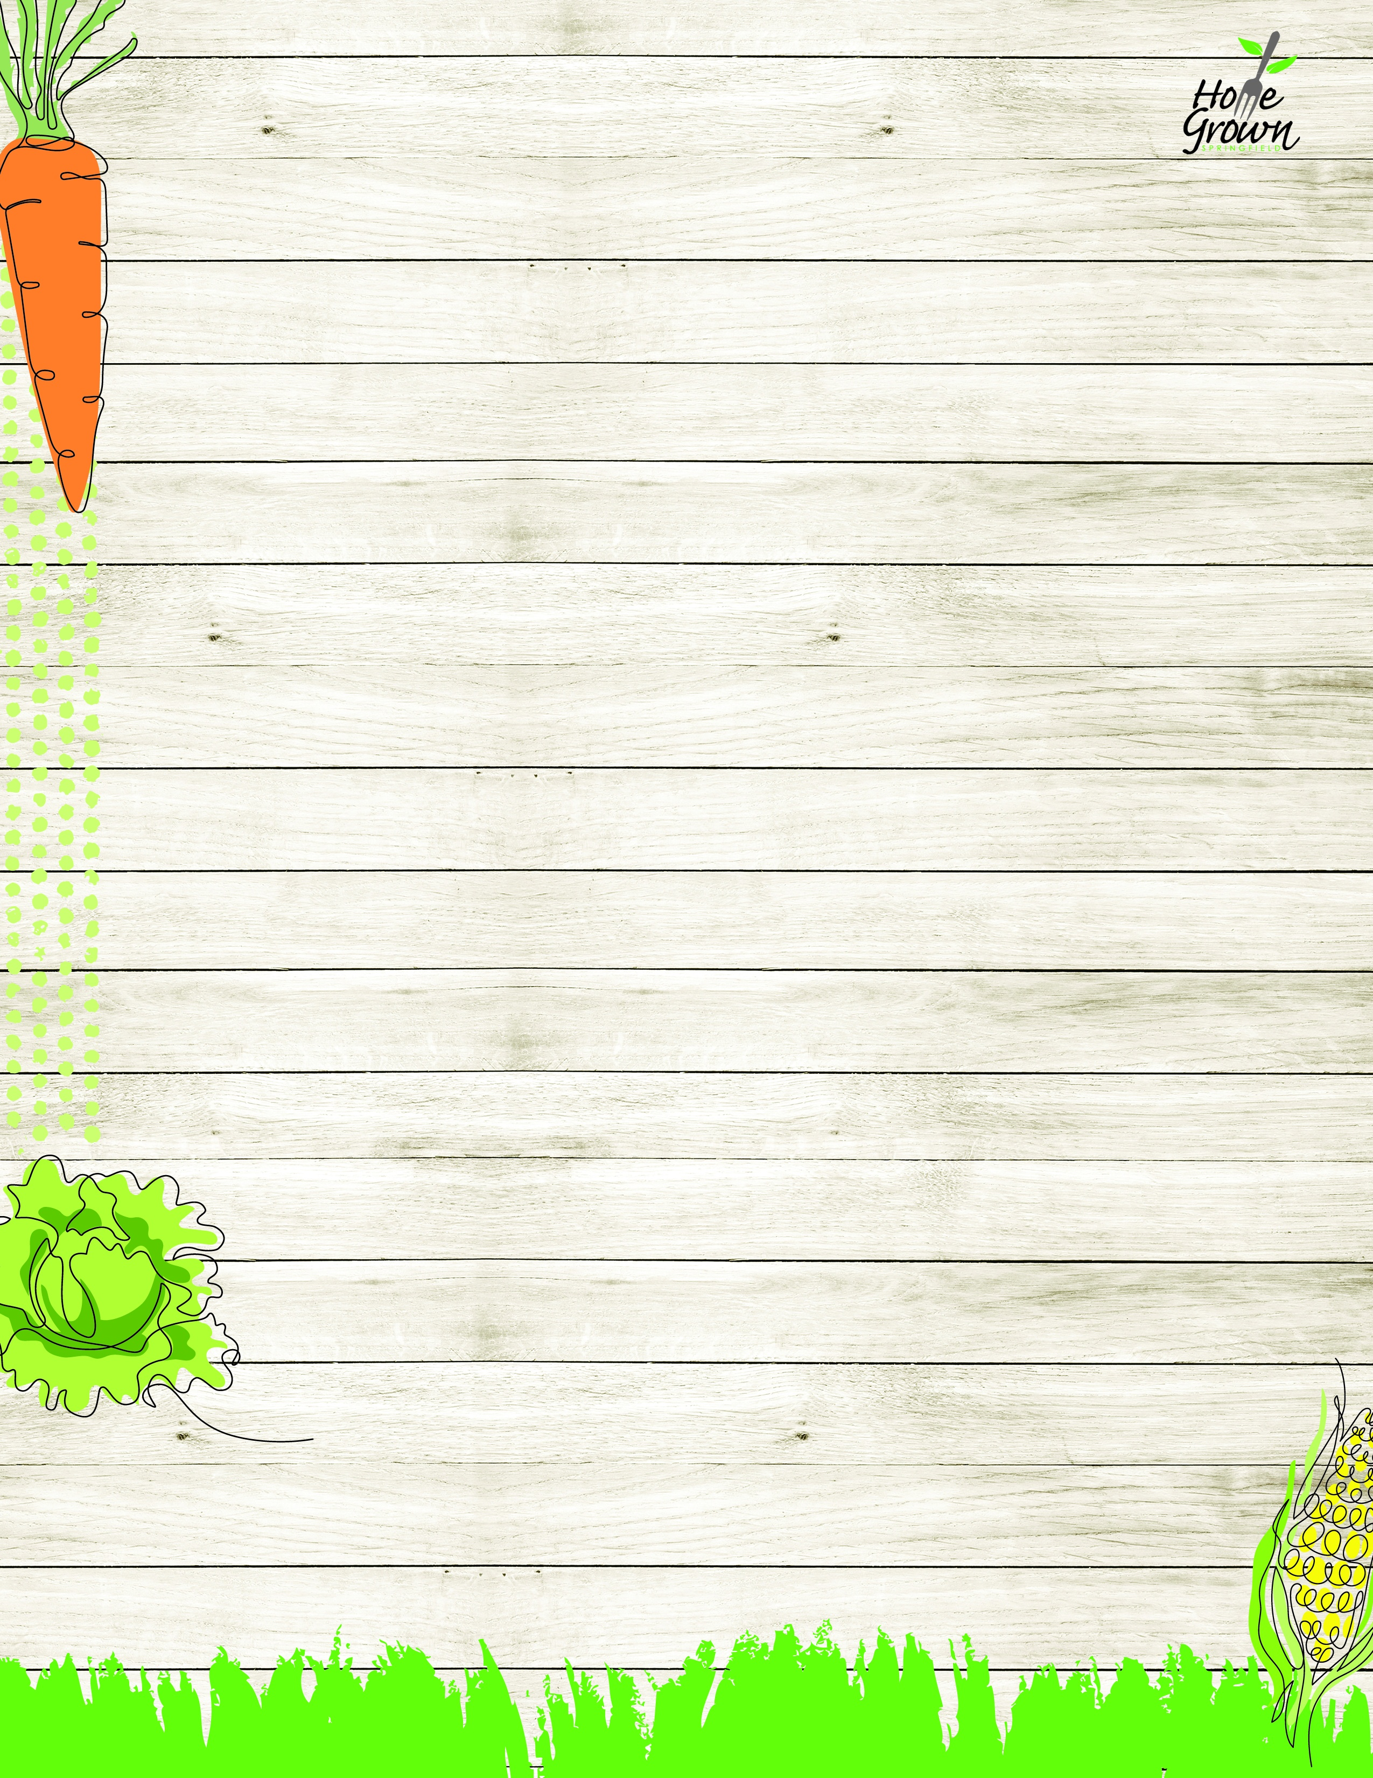

COLD BREAKFAST
August-September 2026
MONDAY
TUESDAY
WEDNESDAY
WEDNESDAY
THURSDAY
FRIDAY
8/24
Assorted Cereal
Giant Goldfish Cracker
Fresh Whole Fruit
100% Juice
1% or Fat Free Milk
8/25
Spiced Apple Muffin
OR
Assorted Cereal
Local Granola
Fresh Whole Fruit
100% Juice
1% or Fat Free Milk
8/26
Yogurt & Granola
OR
Assorted Cereal
Cheese Stick
Fresh Whole Fruit
100% Juice
1% or Fat Free Milk
8/26
Yogurt & Granola
OR
Assorted Cereal
Cheese Stick
Fresh Whole Fruit
100% Juice
1% or Fat Free Milk
8/27
Spiced Apple Pocket
OR
Assorted Cereal
Scooby Snacks
Fresh Whole Fruit
100% Juice
1% or Fat Free Milk
8/28
Blueberry Belvita Biscuit
OR
Assorted Cereal
Giant Goldfish Cracker
Fresh Whole Fruit
100% Juice
1% or Fat Free Milk
8/31
Pumpkin Streusel Muffin
OR
Assorted Cereal
Giant Goldfish Cracker
Fresh Whole Fruit
100% Juice
1% or Fat Free Milk
9/1
No School
9/2
Mini Cinnamon Rolls OR
Assorted Cereal
Cheese Stick
Fresh Whole Fruit
100% Juice
1% or Fat Free Milk
9/2
Mini Cinnamon Rolls OR
Assorted Cereal
Cheese Stick
Fresh Whole Fruit
100% Juice
1% or Fat Free Milk
9/3
Nutri-Grain Bar
OR
Assorted Cereal
Scooby Snacks
Fresh Whole Fruit
100% Juice
1% or Fat Free Milk
9/4
Blueberry Belvita Biscuit
OR
Assorted Cereal
Giant Goldfish Cracker
Fresh Whole Fruit
100% Juice
1% or Fat Free Milk
9/7
No School
9/8
Bagel w/Spread
OR
Assorted Cereal
Cheese Stick
Fresh Whole Fruit
100% Juice
1% or Fat Free Milk
9/9
Wild Blueberry Pocket
OR
Assorted Cereal
Local Granola
Fresh Whole Fruit
100% Juice
1% or Fat Free Milk
9/9
Wild Blueberry Pocket
OR
Assorted Cereal
Local Granola
Fresh Whole Fruit
100% Juice
1% or Fat Free Milk
9/10
OATrageous Mango Overnight Oats
OR
Assorted Cereal
Scooby Snacks
Fresh Whole Fruit
100% Juice
1% or Fat Free Milk
9/11
Blueberry Belvita Biscuit
OR
Assorted Cereal
Giant Goldfish Cracker
Fresh Whole Fruit
100% Juice
1% or Fat Free Milk
9/14
Wild Blueberry Muffin
OR
Assorted Cereal
Giant Goldfish Cracker
Fresh Whole Fruit
100% Juice
1% or Fat Free Milk
9/15
Nutri-Grain Bar
OR
Assorted Cereal
Cheese Stick
Fresh Whole Fruit
100% Juice
1% or Fat Free Milk
9/16
Apple Strudel Pastry
OR
Assorted Cereal
Local Granola
Fresh Whole Fruit
100% Juice
1% or Fat Free Milk
9/16
Apple Strudel Pastry
OR
Assorted Cereal
Local Granola
Fresh Whole Fruit
100% Juice
1% or Fat Free Milk
9/17
Raspberry Roll
OR
Assorted Cereal
Scooby Snacks
Fresh Whole Fruit
100% Juice
1% or Fat Free Milk
9/18
Blueberry Belvita Biscuit
OR
Assorted Cereal
Giant Goldfish Cracker
Fresh Whole Fruit
100% Juice
1% or Fat Free Milk
9/21
Spiced Apple Muffin
OR
Assorted Cereal
Giant Goldfish Cracker
Fresh Whole Fruit
100% Juice
1% or Fat Free Milk
9/22
Bagel w/Spread
OR
Assorted Cereal
Local Granola
Fresh Whole Fruit
100% Juice
1% or Fat Free Milk
9/23
Yogurt & Granola
OR
Assorted Cereal
Cheese Stick
Fresh Whole Fruit
100% Juice
1% or Fat Free Milk
9/23
Yogurt & Granola
OR
Assorted Cereal
Cheese Stick
Fresh Whole Fruit
100% Juice
1% or Fat Free Milk
9/24
Spiced Apple Pocket
OR
Assorted Cereal
Scooby Snacks
Fresh Whole Fruit
100% Juice
1% or Fat Free Milk
9/25
Blueberry Belvita Biscuit
OR
Assorted Cereal
Giant Goldfish Cracker
Fresh Whole Fruit
100% Juice
1% or Fat Free Milk

COLD BREAKFAST
September-October 2026
MONDAY
TUESDAY
WEDNESDAY
WEDNESDAY
THURSDAY
FRIDAY
9/28
Pumpkin Streusel Muffin
OR
Assorted Cereal
Giant Goldfish Cracker
Fresh Whole Fruit
100% Juice
1% or Fat Free Milk
9/29
Apple Strudel Pastry
OR
Assorted Cereal
Local Granola
Fresh Whole Fruit
100% Juice
1% or Fat Free Milk
9/30
Mini Cinnamon Rolls OR
Assorted Cereal
Cheese Stick
Fresh Whole Fruit
100% Juice
1% or Fat Free Milk
9/30
Mini Cinnamon Rolls OR
Assorted Cereal
Cheese Stick
Fresh Whole Fruit
100% Juice
1% or Fat Free Milk
10/1
Nutri-Grain Bar
OR
Assorted Cereal
Scooby Snacks
Fresh Whole Fruit
100% Juice
1% or Fat Free Milk
10/2
Blueberry Belvita Biscuit
OR
Assorted Cereal
Giant Goldfish Cracker
Fresh Whole Fruit
100% Juice
1% or Fat Free Milk

