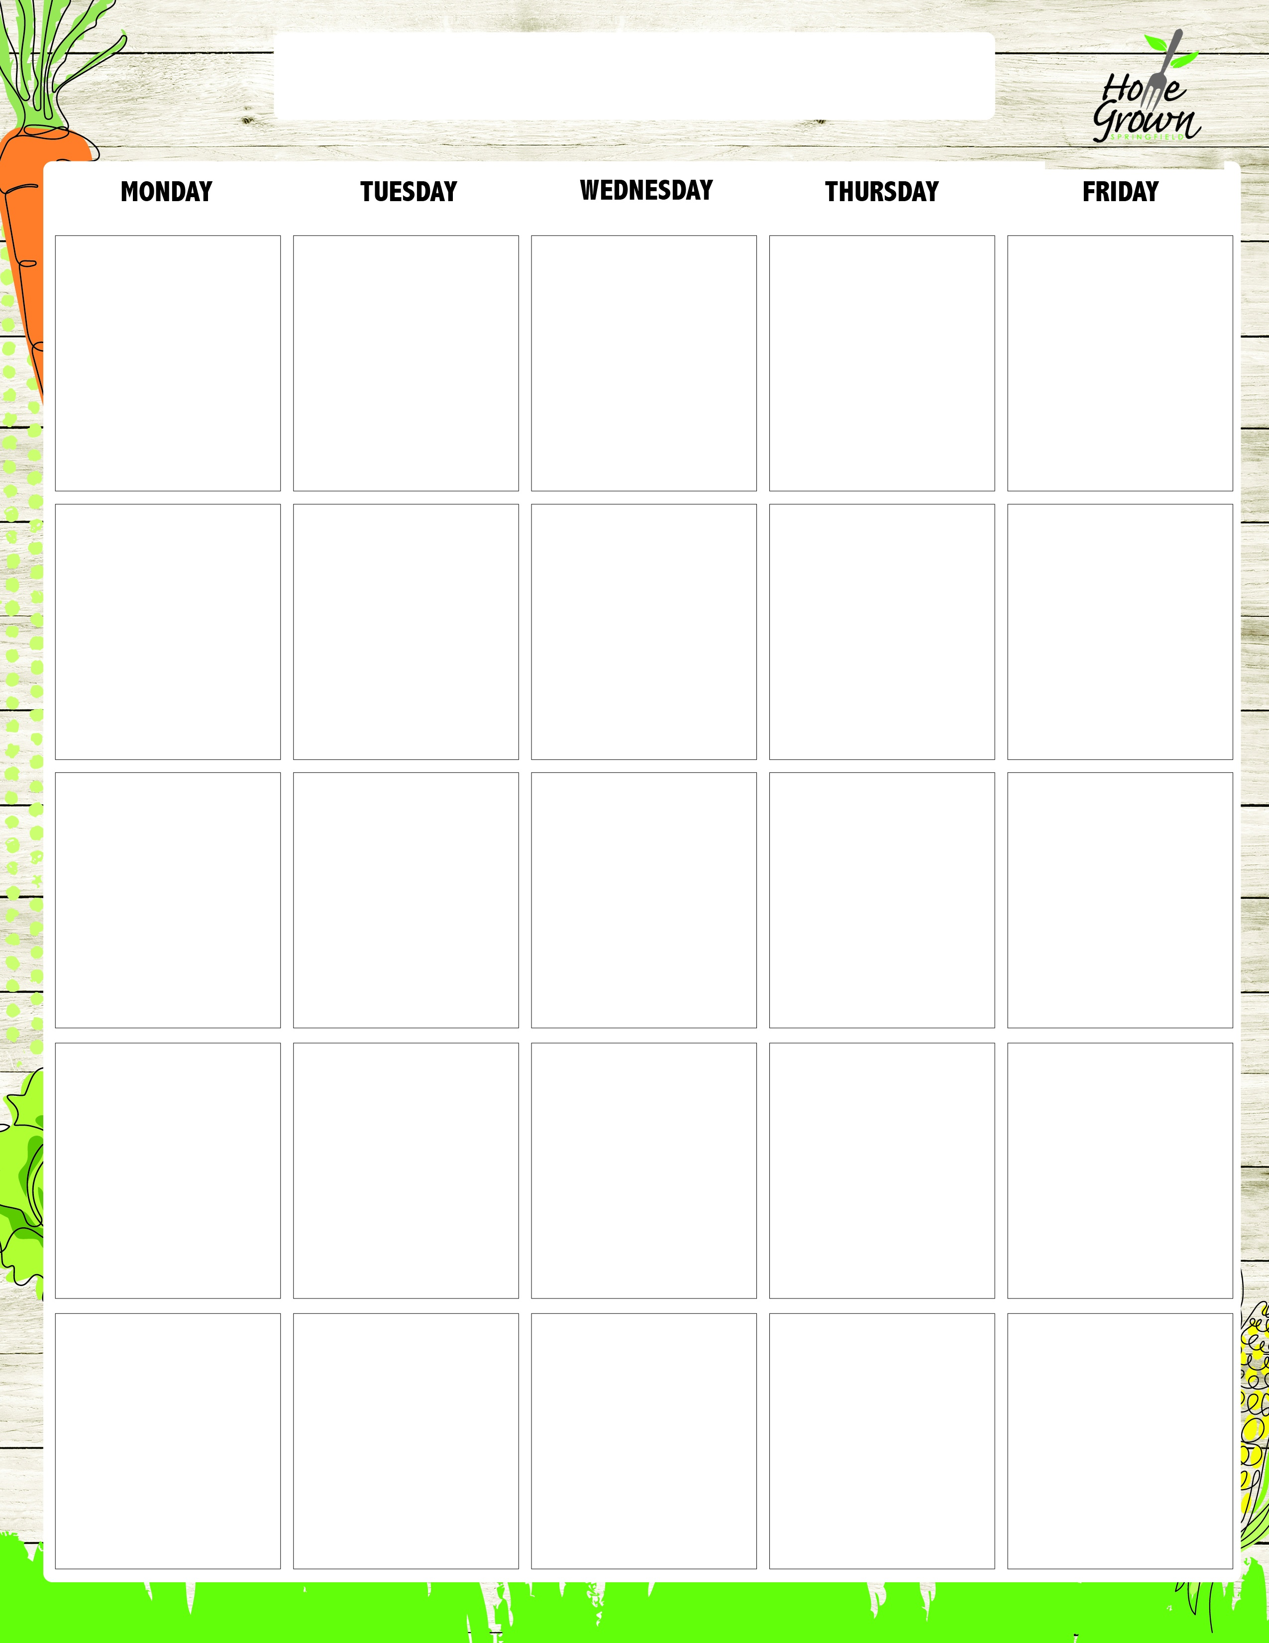
ALLERGY-FREE BREAKFAST
August-September 2026
8/24
Assorted Cereal with
Rice Cakes and Jelly or Sunbutter
Fresh Fruit
100% Juice
8/25
GF English Muffin with Jelly or Sunbutter
Fresh Fruit
100% Juice
8/26
Assorted Cereal with
Rice Cakes and Jelly or Sunbutter
Fresh Fruit
100% Juice
8/27
Assorted Cereal with
Rice Cakes and Jelly or Sunbutter
Fresh Fruit
100% Juice
8/28
Assorted Cereal with
Rice Cakes and Jelly or Sunbutter
Fresh Fruit
100% Juice
8/31
GF English Muffin with Jelly or Sunbutter
Fresh Fruit
100% Juice
9/1
No School
9/2
Assorted Cereal with
Rice Cakes and Jelly or Sunbutter
Fresh Fruit
100% Juice
9/3
Assorted Cereal with
Rice Cakes and Jelly or Sunbutter
Fresh Fruit
100% Juice
9/4
Assorted Cereal with
Rice Cakes and Jelly or Sunbutter
Fresh Fruit
100% Juice
9/7
No School
9/8
GF English Muffin with Jelly or Sunbutter
Fresh Fruit
100% Juice
9/9
Assorted Cereal with
Rice Cakes and Jelly or Sunbutter
Fresh Fruit
100% Juice
9/10
Assorted Cereal with
Rice Cakes and Jelly or Sunbutter
Fresh Fruit
100% Juice
9/11
Assorted Cereal with
Rice Cakes and Jelly or Sunbutter
Fresh Fruit
100% Juice
9/14
Assorted Cereal with
Rice Cakes and Jelly or Sunbutter
Fresh Fruit
100% Juice
9/15
Assorted Cereal with
Rice Cakes and Jelly or Sunbutter
Fresh Fruit
100% Juice
9/16
GF English Muffin with Jelly or Sunbutter
Fresh Fruit
100% Juice
9/17
Assorted Cereal with
Rice Cakes and Jelly or Sunbutter
Fresh Fruit
100% Juice
9/18
Assorted Cereal with
Rice Cakes and Jelly or Sunbutter
Fresh Fruit
100% Juice
9/21
Assorted Cereal with
Rice Cakes and Jelly or Sunbutter
Fresh Fruit
100% Juice
9/22
Assorted Cereal with
Rice Cakes and Jelly or Sunbutter
Fresh Fruit
100% Juice
9/23
Assorted Cereal with
Rice Cakes and Jelly or Sunbutter
Fresh Fruit
100% Juice
9/24
GF English Muffin with Jelly or Sunbutter
Fresh Fruit
100% Juice
9/25
Assorted Cereal with
Rice Cakes and Jelly or Sunbutter
Fresh Fruit
100% Juice

ALLERGY-FREE BREAKFAST
September-October 2026
9/28
Assorted Cereal with
Rice Cakes and Jelly or Sunbutter
Fresh Fruit
100% Juice
9/29
Assorted Cereal with
Rice Cakes and Jelly or Sunbutter
Fresh Fruit
100% Juice
9/30
Assorted Cereal with
Rice Cakes and Jelly or Sunbutter
Fresh Fruit
100% Juice
10/1
Assorted Cereal with
Rice Cakes and Jelly or Sunbutter
Fresh Fruit
100% Juice
10/2
GF English Muffin with Jelly or Sunbutter
Fresh Fruit
100% Juice

