St. Maximilian Kolbe Catholic Church
Commemorative Pavers Order Form

Name: _______________________________________________________________________________
Address: _____________________________________________________________________________
City: _______________________________________________ State: ____________ Zip: ____________
Preferred Phone #: ____________________________ Alternate Phone #: _________________________

Paver Area # (Check one): 1 2 3 4 5 6 7 8 9 White Paver
Inscription: One character per box (including spaces and punctuation)
Line 1:
Line 2:
Line 3:
Additional Line: $20.00
Line 4:

Add a symbol: $5.00 each Symbol (s): Heart Cross
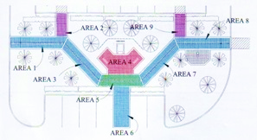
Cost of Paver: __________________________
Extra Line: _____________________________
Symbol (s): _____________________________
Total Amount due: _______________________

Area #1 (8"x8") - $200 Area #6 (8"x8") - $200
Area #2 (8"x8") - $100 Area #7 (8"x8") - $200
Area #3 (8"x8") - $200 Area #8 (8"x8") - $200
Area #4 (8"x8") - $400 Area #9 (8"x8") - $100
Area #5 (8"x8") - $300 White (4"x8") - $300
For Office Use Only:
Taken by: ____________________ Order Date: ________________ Completion date:_______________

Payment Type:
Cash Check# ____________ Credit/Debit Card Amount Received:__________________

