ORPC Report
June 2025 to June 2026

Michael Bender

Achievements and Tasks
This report reflects the work of the editorial board between June 1st 2025 and June 1st 2026. It is kept in this cycle to ensure comparability to previous years and numbers.

Short version:
- Downloads: we had 356,531 total downloads in 25-26, compared to 401,347 in the same period 24/25. This is a decrease of 11.2%.
Note: The previous two years have been exceptional outliers in terms of downloads (both >400k/year). Downloads are still 9% higher than 22/23 (and all years before).
- Contributions: 1 additional publication since the last report, 12 under review, 3 in the final revision.
- The expanded board functions well. Caroline Ng Tseung-Wong left the board. We are looking for a replacement.
- Perspective: With the additional board members, we expect to increase contributions.

Representation in Databases and on the Internet
Submissions have increased, but only marginally (1 publication).
It remains difficult to motivate authors across all stages (from early career researchers to more senior colleagues) to commit to new projects.
We are still preparing materials and a restructuring to reapply for WoS/Clarivate/PsycInfo, For that, ORPC should have a reliable count over a longer time period of at least five articles per year to qualify for PsycInfo. The same applies for the Directory of Open Access Journals (DOAJ).
We continue our workflow and are in contact with 50+ contributors.

New Strategies
We are not yet soliciting papers in other languages than English (this was a pilot we started, but was dependent on the input from other committees in IACCP). For the reporting period, we have not worked on this, as there is no clarity on who sits on the knowledge exchange committee or the language committee (see About Us - International Association for Cross-Cultural Psychology).
We are in the process of updating submission guidelines and the online presence to prepare for the Psychinfo registration.

Publication Work
We added 1 new article since the last report. The ORPC website currently has 149 published articles. This is much less progress compared to last year (when there were 5 articles). But the pipeline looks promising (see also below for strategy). The editorial board has agreement from several authors to produce contributions (but this remains difficult).

Editorial Assistant
The editorial assistant is currently Olivia Bates bateso@mail.gvsu.edu. The tasks also include review and formatting of papers for the IACCP proceedings. Funding for this position remains with Wolfgang Friedlmeier (who originally set up the arrangement), and who will also look for a replacement once Olivia discontinues (as employment conditions are better than in the Netherlands). Olivia graduated this Spring and can continue her work only until end of November 2026.
We had $1116.38 surplus at the end of the 2024/25 fiscal year. The editorial assistant was paid $1007.36 for the editorial work that included review and formatting of IACCP Proceedings papers as well as ORPC papers during 2025/2026. As requested, the EC approved $1500 and we have currently $1609.02 in the account. Expecting a higher rate of new articles in ORPC, we plan for a budget of about $1500 for the editorial assistant plus additional work for the upcoming Leuven proceedings. The conference organizers will likely provide some budget for the editorial work (covering 50% of the costs).
The hourly payment for the editorial assistant is $15. We pay $75 for an article, assuming an average workload of about five hours. If the article takes more than five hours of work, we extend the payment accordingly. The editorial assistant is also investing time in checking the ORPC website regarding mistakes, checking broken links, and any other issue related to the website to ensure that everything is up to date.

Associate Editors
The current board has started working in Fall 2023. There is still some heterogeneity in terms of having established steady operations after an extensive onboarding procedure, with the majority of associate editors now soliciting contributions and processing submissions.
We have achieved a better geographical representation with the current board, as well as a better gender ratio, and diversity of academic perspectives. This hopefully will help in reaching out to a more diverse population of contributors.
The board includes:
- Michael Bender
- Rachana Bhangaonkar
- Wolfgang Friedlmeier
- Judith Gibbons
- Johannes Karl
- Vladimir Ponizovskiy
- Paraskevi Simou
- Walt Lonner [founding and advising editor]
We are actively looking for a replacement for Caroline Ng Tseung-Wong. The current composition of the editorial board can be found here: https://scholarworks.gvsu.edu/orpc/editorialboard.html

Usage of the Website
For 2025/26 (from June 1st to June 1st ) we had 356,531 downloads, compared to 401,347 in 24/25 (which was an exceptionally good year, as the year before with >400k downloads). There has been a decrease in downloads: 11.2%. We are still 9% higher than in the June 2022-June 2023 period.
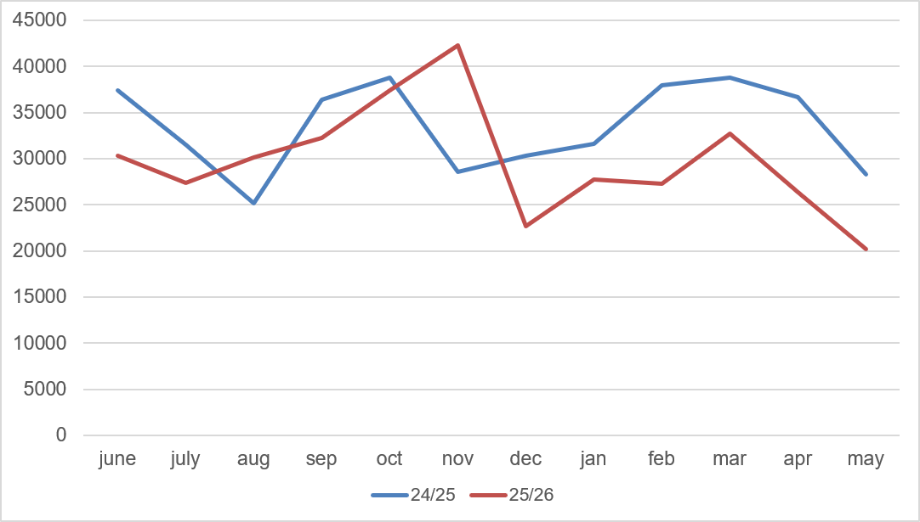
Figure 1. Fulltext downloads (June 2025-June 2026) compared to year before

Plans for 2025/2026

Goals
The main goals are similar to the goals of last year:
- To publish new articles and to invite authors for contributions (see below for strategies).
- To publish updated former articles
- To explore/resume new policy on translating articles from underrepresented contexts (new language policy to support/accept translations)
- To sustain and increase high usage
- To reapply for WoS/Clarivate/PsycInfo

Strategies and Activities

New contributions
The most important issue remains to find new and creative ways to increase the submission of papers to ORPC. Researchers still experience time constraints. To secure 2-3 reviewers, we still regularly need to go through 12+ requests (which are targeted requests, aiming for people with relevant expertise and connection with the subject area). We are considering ways to facilitate this process and provide a positive experience for the reviewers so they return (e.g., streamlining the publishing system).
We continue recruiting not only established researchers in the field as potential authors but also young researchers as many do a diligent literature review for their thesis. Such review could be easily written up and summarize the current state of art which would perfectly fulfill the criteria of ORPC.
We have been in touch with 70+ authors, and are working through the connections we are making. Twelve manuscripts are currently under review, three of these are in the final round of revision. Four manuscripts are expected to be submitted at the end of the summer or in early Fall.

Updating Articles
We continue to ask authors to update their papers.

Activities
We are organizing a roundtable discussion in Leuven 2026.
We have an OSF page (https://osf.io/ezrxv/) for keeping records, advertisements, and calls in a central place, accessible for the board members.

I would like to thank the editorial board for their hard work and creative ideas to position the ORPC. I am excited to work with such a vibrant and energetic new editorial board and am looking forward to what we can achieve together. I am specifically grateful for the continued guidance by Walt Lonner and my predecessor Wolfgang Friedlmeier.
I am looking forward to continuing and expanding the success of the ORPC.

Michael Bender
Tilburg, Wednesday, July 8, 2026

