Journal of Cross-Cultural Psychology
2025 - 2026 Editor’s Report

Sylvia Xiaohua Chen, JCCP Editor

July 1, 2026

The Journal of Cross-Cultural Psychology (JCCP) remains a leading interdisciplinary forum for the dissemination of research that explores the interplay between culture and psychological processes. Our commitment to publishing high-quality empirical research on important cross-cultural questions in social, developmental, cognitive, linguistic, personality, organizational and other areas of psychology has positioned us at the forefront of the field.

I was appointed as Editor-in-Chief (EiC) since 2022 and managed manuscripts from December 2022 to the end of February 2026. As new Co-Editors, Antonio Terracciano and Theodore Bartholomew, have begun processing new submissions since March 1 and June 15, 2026, respectively, while I continued to handle other EiC duties such as making final decisions on assigned and revised manuscripts, overseeing production, handling inquiries and appeals, preparing reports, and coordinating with Sage. Our former EiC, Debbie L. Best, has continued the role of Special Issues Editor, while our Founding Editor, Walter J. Lonner, continues to serve as Founding and Contributing Editor during the reporting period.

This report encompasses the calendar years from January 1, 2025 to June 15, 2026, with some older information included for reference.

- JOURNAL STATISTICS

Submissions Received

During the period from January 1 to December 31, 2025, we received a record-high total of 808 manuscripts, including 648 original manuscripts and 160 revised manuscripts. This represents an increase from 647 manuscripts in 2024. From January 1 to June 15, 2026, we received a total of 416 manuscripts, consisting of 356 original and 60 revised manuscripts. These figures have been growing over the past few years, demonstrating a steady increase in the number of manuscript submissions from 2023 to 2026.
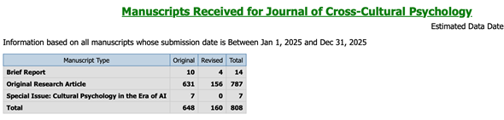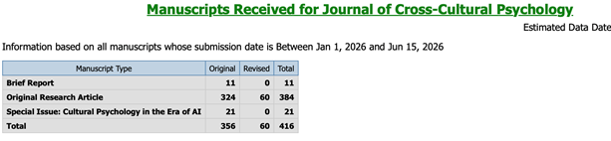

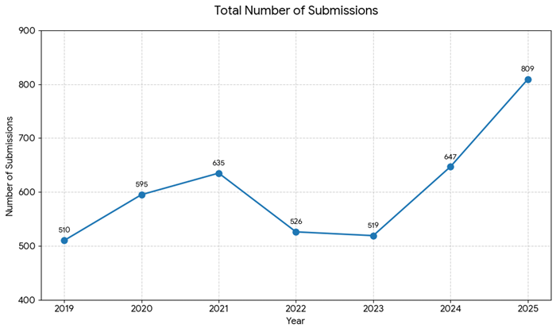

Published Articles

Since 2022, JCCP has been published eight times a year by Sage Publications Inc. In 2025, eight issues were published in January, March, April, June, July, September, October, and December, totaling 1,051 pages. In 2026, five issues have been published in January, March, April, June, and July. The next three issues are expected to be published in September, October, and December. Due to the large number of manuscripts submitted during this reporting period, filling the eight issues and meeting the 100-page budget per issue is no longer as difficult as it once was. Each published issue contained at least 150 pages, with the recent issues increasing from 164 pages in April, 167 in June, to 179 pages in July.

Special Issues and Sections

We published one Special Issue (SI) in 2025, and another SI has issued a call for submissions and is currently processing submissions.

Special Issue published:

Title: Mapping Human Morality: Human Universals and Cultural Differences
Guest Editors: Xiaomeng Hu, Emma E. Buchtel, Feng Yu, and Joan G. Miller
The Call for Papers was published in the May 2022 issue. Thirteen papers were submitted in 2023, eight of which were revised and resubmitted. Seven revised manuscripts were submitted in 2024. Five revised manuscripts were published in June 2025.

Special Issue in progress:

Title: Cultural Psychology in the Era of AI
Guest Editors: Michael Shengtao Wu, Tonglin Jiang, Angela K.-y. Leung, Lin Qiu, and Kaiping Peng.
The Call for Papers was published in August 2025 on the JCCP website. Thirty-five manuscripts have been submitted to this SI.

Accept-Reject Ratio

The overall rejection rate was 89.3% for January 1 to December 31, 2025 and 92.7% for January 1 to June 15, 2026. JCCP’s rejection rate has consistently remained above 85% over the past five years, mostly above 90%, and reached 94.2% in 2023. According to Sage’s statistics displayed on the JCCP website, the acceptance rate is 9.4%.

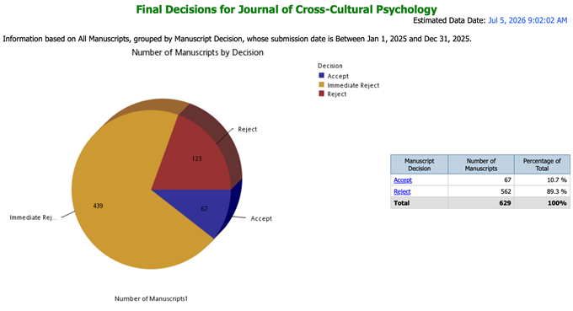

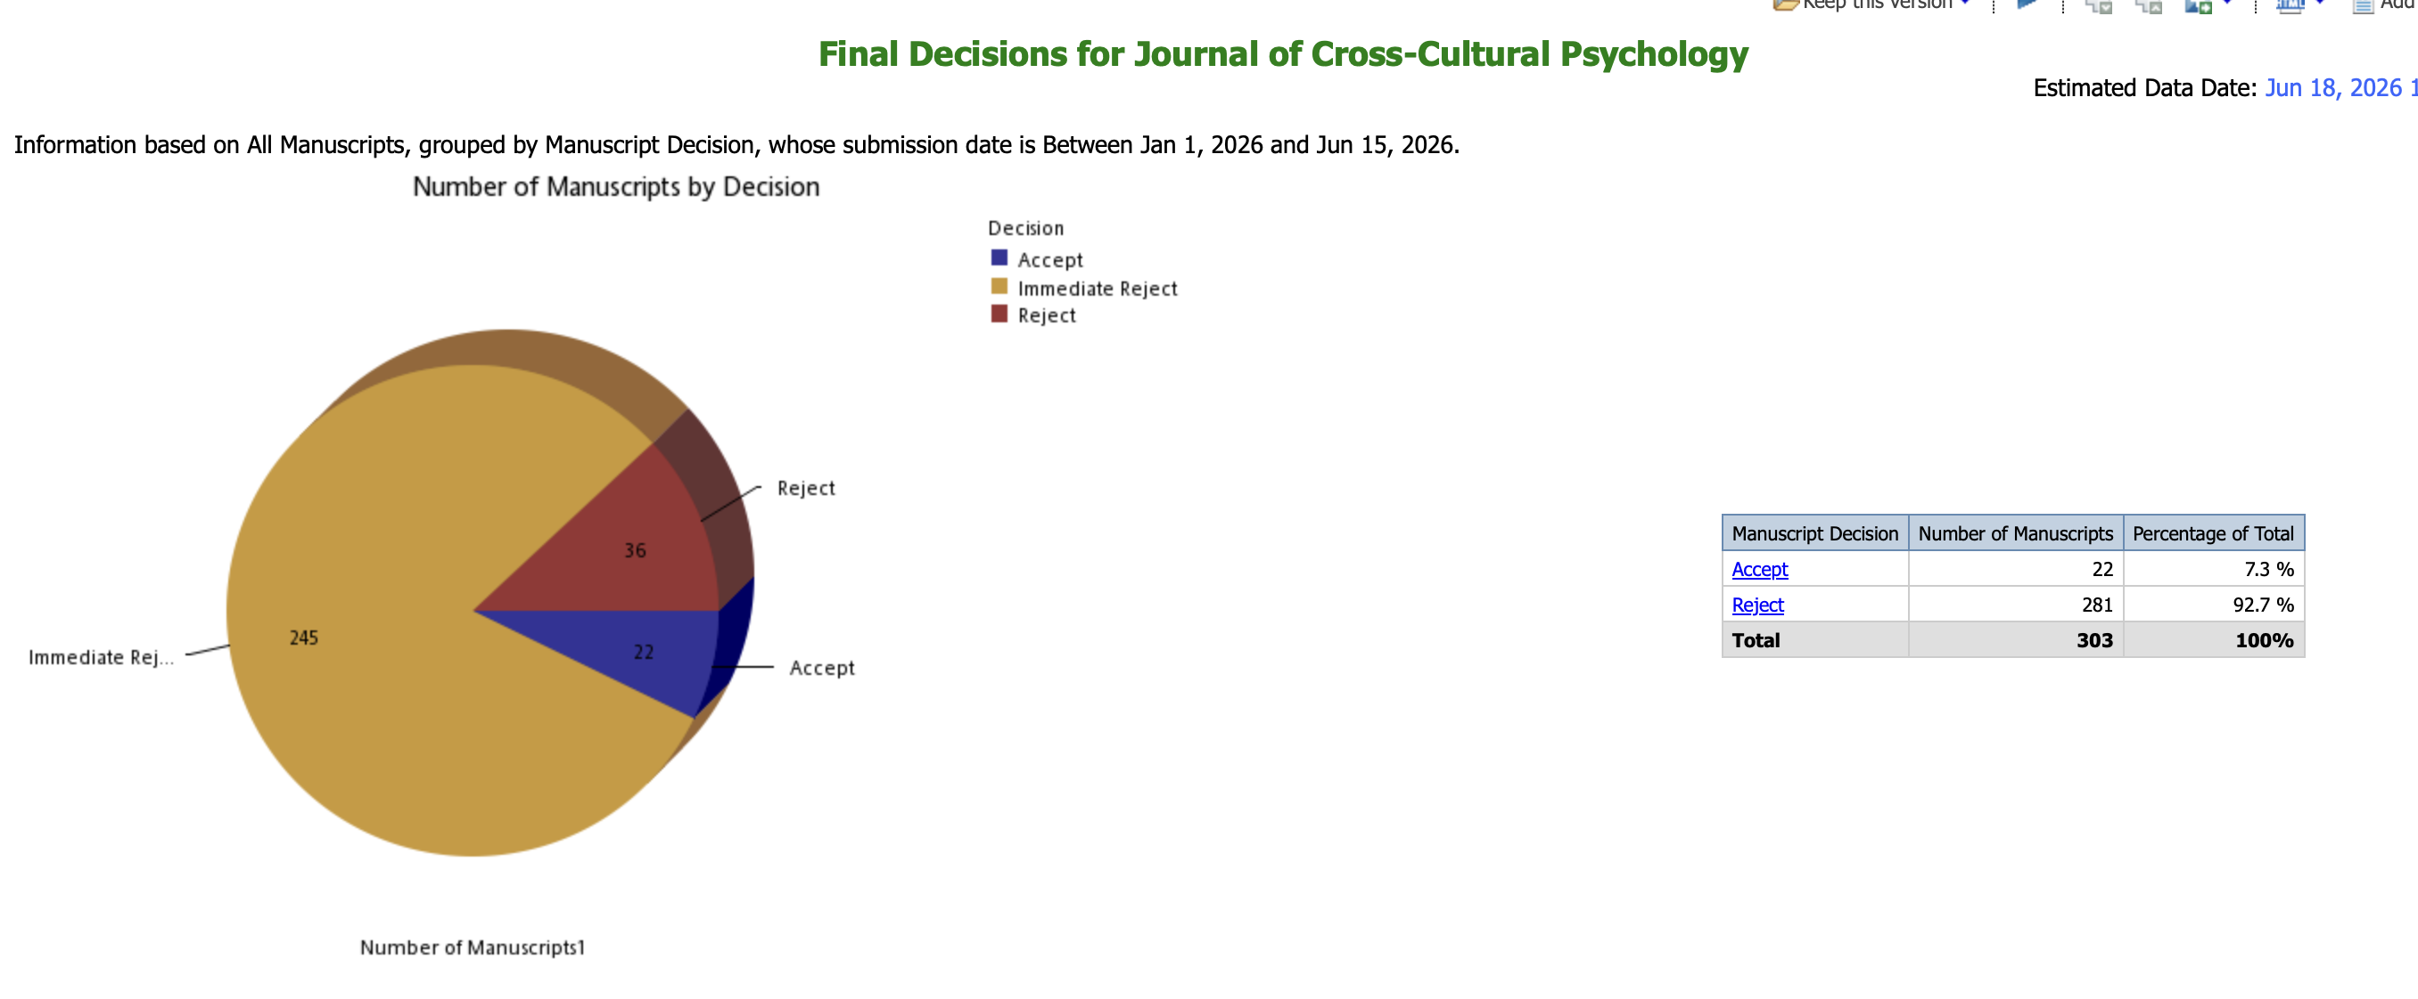
EiC screened new submissions (except for Special Issues) and made decisions of immediate rejection or assignment to an Associate Editor. Our desk rejection rate was over 60% and 70% in 2025 and the first six months of 2026. Antonio and I desk reject manuscripts that do not align with JCCP’s mission or that are unlikely to survive the review process, providing a brief rationale for desk rejection in the decision letters. To expedite decisions, I occasionally asked Associate Editors to preview manuscripts outside my area (social and personality psychology) to suggest if they should be desk rejected, and the Associate Editors are permitted to desk reject papers. This accelerates the process for manuscripts that are not suitable for JCCP or that are unlikely to be successful. We have received "thank you" messages from authors of rejected manuscripts, expressing disappointment but also appreciation for the quick decision and the helpful feedback.

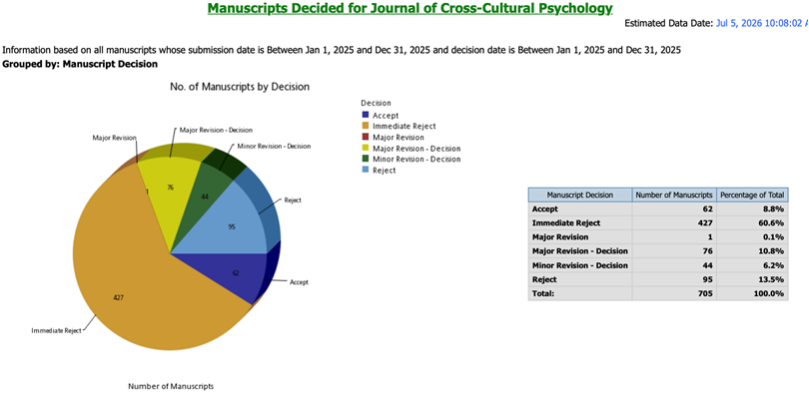
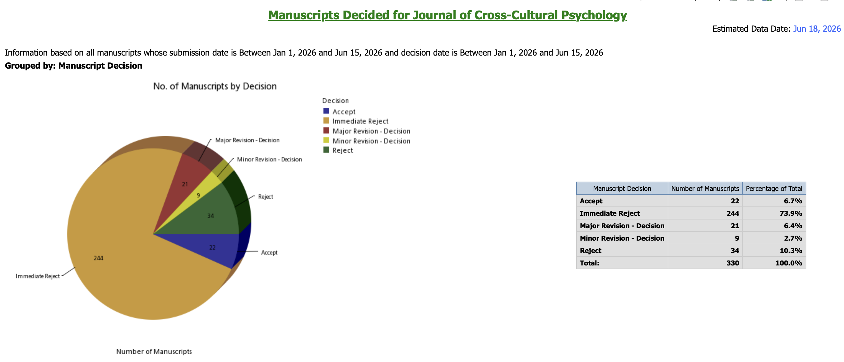

In recent years, there has been a growing interest in cross-cultural psychology, leading to an influx of submissions from researchers who may not fully understand the JCCP mission, which is to investigate the relationship between culture and behavior. We receive a large number of manuscripts that compare participants from two countries on a variable, with no examination of cultural variables that could be related to the differences found. Additionally, we receive single-culture studies that do not investigate cultural factors. Manuscripts of these types are routinely desk rejected. Furthermore, we do not publish psychometric studies of test construction or validation. Studies that compare scale performance or factor structure among different cultural groups are also not considered by JCCP. These guidelines are clearly presented on our website.

The submission of qualitative studies has been increasing over the past few years, and at times, the quality of these submissions is lacking. Former Associate Editor (AE) Judy Gibbons has created a brief description of the essentials of qualitative research, which is often shared with current AEs.

Turnaround Time

After the initial screening and desk rejection, Antonio and I assign the remaining manuscripts to the AEs. The AEs then either desk reject the manuscripts or send them out for review, and subsequently make recommendations to the EiC for rejection or acceptance after the review process. Our average turnaround time for recommendations has now been shortened to less than one month for immediate rejection. Some manuscripts may take longer, usually due to difficulties with reviewers who, at times, agree to review but then do not follow through. AEs sometimes invite 10-15 reviewers to obtain two reviews, as reviewers have become more difficult to secure since the onset of the pandemic. The SI Guest Editors generally take longer than the AEs in managing submissions, contributing to the extended review times depicted in the graphs below.

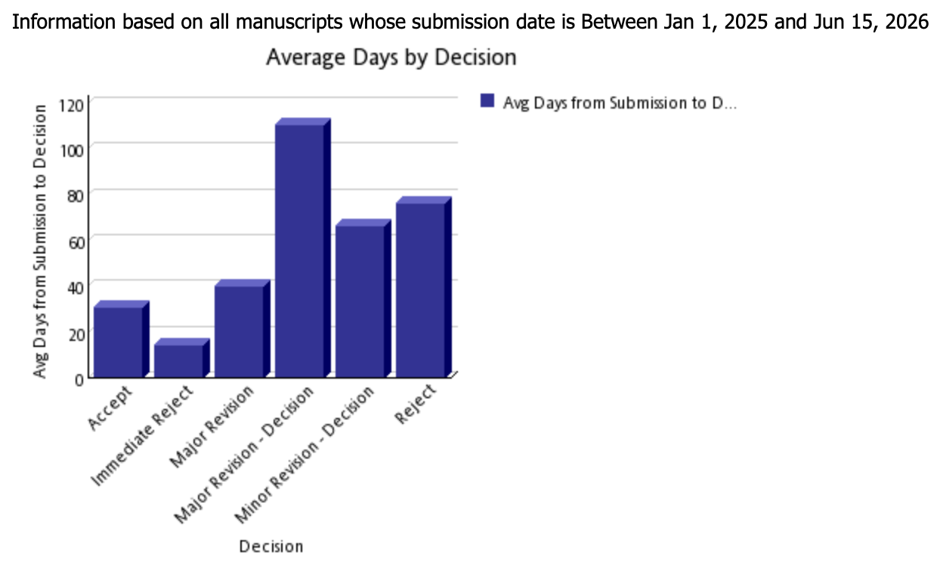
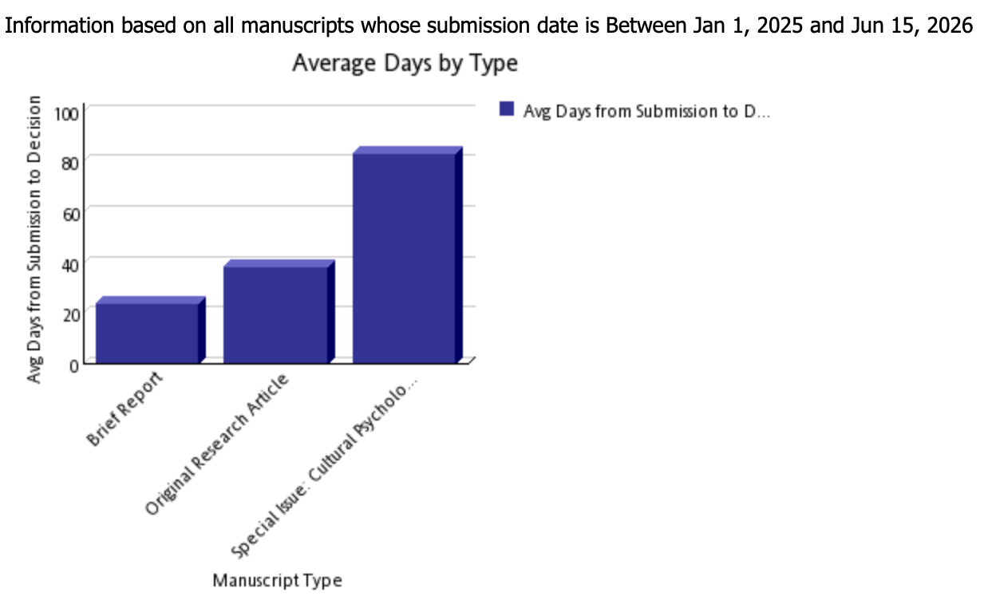

- IMPACT METRICS

Journal Citation Reports

According to the 2026 release of Journal Citation Reports (JCR), JCCP’s impact factor (IF) for 2025 is 3.6, ranking 12th out of 77 in the “Psychology, Social” category, with a 5-year IF of 4.4, ranking 19th out of 77 in the same JCR category. JCCP’s Journal Impact Factor (JIF) percentile was 85.1, placing it in the first quartile (Q1) for the first time. The number of total cites is 8,750.
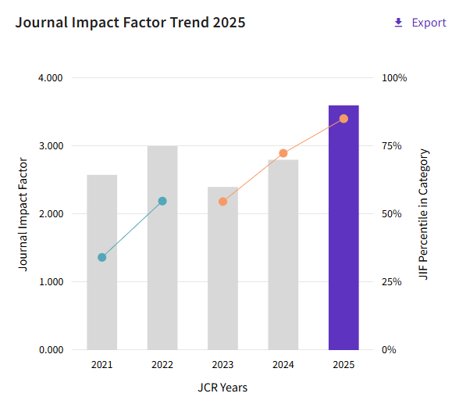

Rank by Journal Impact Factor
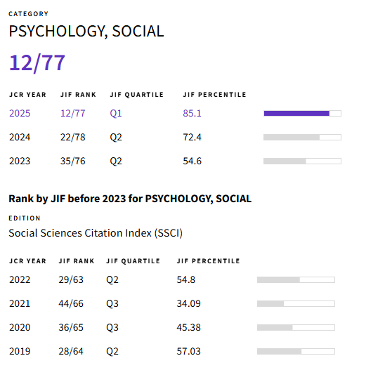
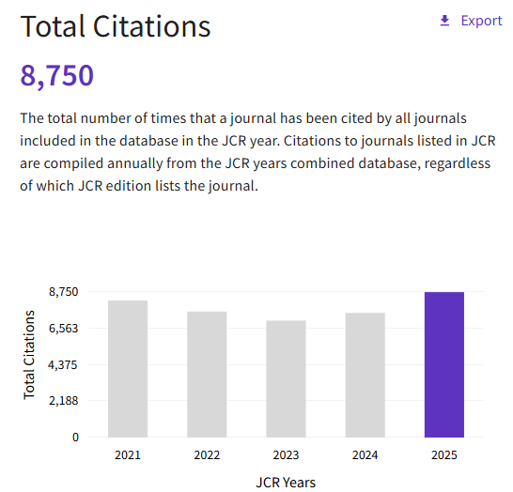

Scopus

CiteScore: 5.6;
Ranking: 34 out of 1434 in Social Sciences - Cultural Studies, Q1; 19 out of 536 in Social Sciences - Anthropology, Q1; 66 out of 315 in Psychology - Social Psychology, Q1
Source-normalized Impact per Paper (SNIP): 1.443
SCImago Journal Rank (SJR): 1.378; ranking: 8 out of 1434 in Cultural Studies, Q1; 9 out of 536 in Anthropology, Q1; 36 out of 315 in Social Psychology, Q1

Notably, JCCP’s 2025 CiteScore increased from 3.9 in 2022, to 4.6 in 2023, 5.3 in 2024, and 5.6 in 2025, placing it in the 97th percentile (top 3%) in Social Sciences – Cultural Studies, Q1.
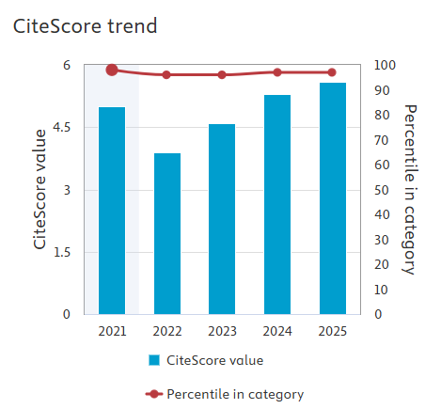
Open Access

Sage Gold Open Access provides the opportunity for authors to have their papers freely available but there must be payment of the Article Processing Charge (APC). This is usually paid by the author or the author’s institution. Corresponding authors may request a waiver of the APC fee after acceptance of the manuscript. Requests are assessed on a case-by-case basis and priority for partial or full waivers are given to authors who reside in the countries described by the Research4Life program. Waiver requests are assessed and granted by SAGE, not the Editor or editorial board, to ensure editorial independence.

A small number of JCCP papers are Gold Open Access (published in journals listed on the Directory of Open Access Journals (DOAJ) or with a Creative Commons (CC) license). Subscription and Free to Read Citable articles include Public Access articles located on the publisher’s site. JCCP Open Access articles have a good citation rate.

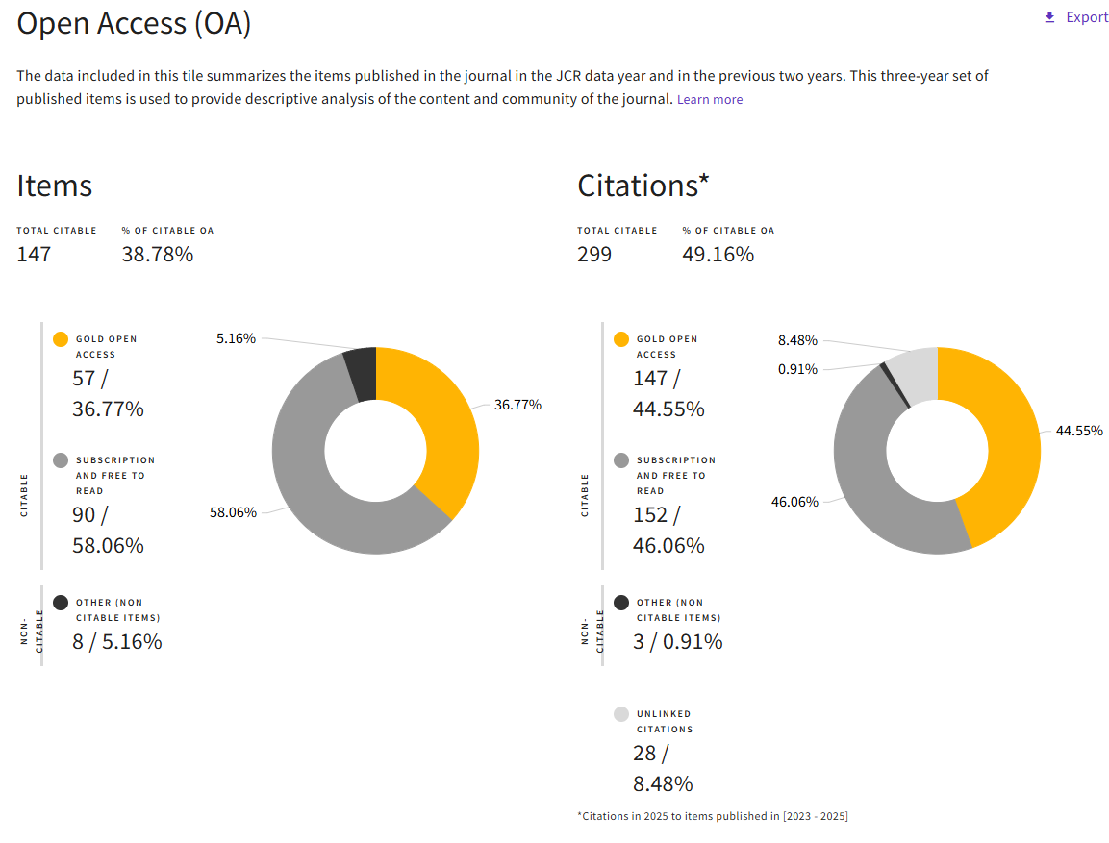

- EDITORIAL HIGHLIGHTS

Editorial Support

Editorial Changes and Assistance. Danielle Bath began as our Sage Editor in August 2015, and had been on maternity leave since January 2024. She has been very supportive of JCCP. During her absence, Cassandra Garcia served as the temporary Publishing Editor of JCCP until March 2025 and was very responsive to our requests. Danielle Bath has since resumed her role.

Technical Support. Sage Editorial Assistant Asha Askoolam, Associate Editor Chloe Howard, and Peer Review Systems Assistant Arti Rawat have been assisting us when we encounter some technical problems. While we have no control over these issues, most are resolved in a reasonable amount of time, and our Editorial Assistant Janice Jennings is adept at tracking down solutions.

Production. During the reporting period, we worked with Ekta Aggarwal of Sage India on JCCP production. The production process has proceeded smoothly. Following the handover, Production Editor Glaline Anna Lincila began managing production tasks on November 19, 2025, while Ekta remained on as the Sage Content Manager, overseeing production services at the journal level to ensure quality and timeliness. Both of them have been very responsive and have processed manuscripts for publication promptly.

Marketing. In 2018, Chris Hardin became our Sage marketing manager. We have not been active in this area, but we have promoted JCCP at conferences and through social media. The total number of submissions and citations has been increasing, reflecting the journal’s growing impact.

Committee on Publication Ethics (COPE). Since March 2016, Sage has provided JCCP with membership in the Committee on Publication Ethics (COPE). COPE has become the industry standard for providing advice on all aspects of publication ethic, particularly in handling cases of research and publication misconduct. Being a COPE member signifies to authors and reviewers that JCCP upholds the highest ethical publication standards. COPE expects all members to adhere to the standard Code of Conduct for Journal Editors, and following the Best Practices is strongly recommended. These guidelines have been shared with the Associate Editors and were particularly helpful when dealing with the paper retraction process.
(http://publicationethics.org/files/Code_of_conduct_for_journal_editors_Mar11.pdf)

Sage has also provided JCCP with access to iThenticate Crossref Similarity Check to evaluate manuscripts for plagiarism. The AEs are encouraged to review manuscripts in Crossref if they or reviewers raise questions.

Editorial Assistant. We are immensely grateful for the competence and conscientiousness of Janice Jennings, our Editorial Assistant. She has adeptly handled numerous challenges with Manuscript Central, contentious authors, and reviewers who do not follow directions, as well as the minutiae of editorial work.

Editorial Board Updates

In general, JCCP has a total of nine AEs. I have been attempting to balance the workload while considering their areas of expertise. Outgoing AEs, including Takeshi Hamamura, Vaishali Raval, and Yanjun Guan have continued to manage the manuscripts assigned to them until completion. Brien Ashdown continued to process some papers after stepping down, but he has been unable to do so recently since he became Editor-in-Chief of International Perspectives in Psychology.

Outgoing Associate Editors:
Brien Ashdown, Carlos Albizu University, USA
Vaishali Raval, Miami University, USA
Yanjun Guan, Nottingham University Business School, China

Continuing Associate Editors:
Nicolas Geeraert, University of Essex, UK
Diana Hanke-Boer, University of Koblenz, Germany
Keiko Ishii, Nagoya University, Japan
Sunita Stewart, University of Texas Southwestern, USA
Ching (Catherine) Wan, Nanyang Technological University, Singapore

New Associate Editors:
Theodore Bartholomew, Scripps College, USA (January – June 2026)
Kuba Krys, The Polish Academy of Sciences, Poland
Ayu Okvitawanli, Universitas Sebelas Maret, Indonesia

New Co-Editors:
Antonio Terracciano, Florida State University, USA
Theodore Bartholomew, Scripps College, USA

I would like to take this opportunity to express my sincere appreciation for Debbie’s strong dedication and efficient service. Debbie continues to work with me on the running orders and new issues in the production process. Her continued efforts in ensuring the quality have set a high standard for our publication.

I am fortunate to work alongside a team of exceptional Associate Editors who bring a wealth of expertise and knowledge to JCCP. Their commitment to upholding the highest standards of academic rigor and their dedication to advancing scholarly research are truly commendable. They often manage a large number (10+) of manuscripts with no complaint. In fact, the AEs who had stepped down from serving as Associate Editors willingly agreed to manage revisions of manuscripts that were submitted long after they had stepped down.

We have updated and increased the number of Consulting Editors (CE), which is usually based on the number of reviews non-CE members have completed in the previous year or two. New CEs must be willing to commit to reviewing six manuscripts during the coming year (most of our current CEs are below that number). AEs have been provided with reviewer data and have nominated new CEs. Suitable candidates were invited to join the Editorial Board.

New Consulting Editors:
Vassilis Saroglou, University of Louvain, Belgium
Michael Minkov, Varna University of Management, Bulgaria
Theodore Bartholomew, Scripps College, USA (2025)
Huajian Cai, University of Oklahoma, USA
Alexander English, Wenzhou-Kean University, China
Ping Hu, The Renmin University of China, China
Liman Li, The Education University of Hong Kong, China
Jacky Ng, The Hong Kong Polytechnic University, China
Ding-Yu Jiang , National Taiwan University, Taiwan
Kuang-Hui Yeh, Institute of Ethnology, Academia Sinica, Taiwan
Kosuke Takemura, Shiga University, Japan

We are grateful for IACCP’s ongoing financial support for JCCP Editors. We hope that IACCP will maintain the honorarium at the same amount for each of the AEs. Recognizing their valuable work is crucial.

- CHALLENGES AND DIRECTIONS

Contract Renewal and Discontinuation of Print Version

JCCP’s ten-year contract with Sage concluded at the end of 2024. Preparations for renewal negotiations began in January 2024. IACCP Past President William Gabrenya, Secretary General Wolfgang Friedlmeier, President Zeynep Aycan, and I engaged in discussions and negotiations with Sage. A new contract was signed, with continued editorial support for JCCP.

JCCP switched to a digital-only format and discontinued the print version as of January 2025. The key advantages of moving to a paperless, online journal include significant cost savings for IACCP, greater environmental responsibility, enhanced features, space savings, improved accessibility, easier access to updates, and the ability to read while traveling.

Application for Inclusion of JCCP in the JCR Category "Cultural Studies"

On May 12, 2024, I submitted a proposal to Sage for including JCCP in the JCR category "Cultural Studies." In addition to its current listing in the "Psychology, Social" category, we believe that JCCP 's interdisciplinary focus and its significant contributions to the study of culture and behavior warrant its inclusion in the "Cultural Studies" category as in the Scopus and SJR rankings. Sage submitted our application to Clarivate for the category addition in May 2024. Unfortunately, our request was rejected by Clarivate on June 18, 2025. The exact feedback we received was “Cultural Studies has not been deemed relevant enough to be added at this time. Journal studies effects of culture on education and, citation data does not support adding the journal to this category.”

New Governance Structure

With the conclusion of my term as EiC, the new editorial leadership team comprises two Co-Editors: Antonio Terracciano and Theodore Bartholomew. Together, they will guide JCCP into a new phase as an even more inclusive space for scholars conducting high-quality research using quantitative, qualitative, and mixed methodologies from around the world. In the shared leadership structure, Antonio primarily oversees manuscripts employing quantitative methodologies (since March 1, 2026), while Ted primarily oversees those using qualitative and mixed methods (since June 15, 2026). This new structure reflects JCCP’s commitment to greater inclusiveness across diverse methodological traditions, epistemologies, and ontological perspectives.

Conclusion

JCCP’s broad scope and international reach have helped solidify its role at the forefront of cross-cultural psychology. In 2025, the journal received a record high of over 800 submissions from authors based in more than 60 countries. This global representation reflects not only the vitality of our field, but also the journal’s role as a key platform for scholarly dialogue across diverse cultural, geographical, and methodological contexts. The overall rejection rate has been over 90% in 2025-2026. Although impact factors declined broadly following the surge in COVID-related research and citations in 2020 and 2021, JCCP’s 2-year impact factor increased from 2.4 in 2023 to 2.8 in 2024 and 3.6 in 2025, ranking 12th out of 77 in the competitive “Psychology, Social” category, and entering the first quartile (Q1) in the JCR for the first time in the Journal’s history. Its CiteScore has increased from 4.6 in 2023 to 5.3 in 2024 and 5.6 in 2025, placing it in the 97th percentile (top 3%) in Social Sciences – Cultural Studies and in Q1 across all Scopus and SJR rankings. Turnaround times vary across manuscript types, with most submissions receiving a first decision within one month. The Associate Editors are a strong group and consistently produce excellent work. We are delighted to welcome the new Editorial Board members and extend our gratitude to those who are rotating off the Board. The Consulting Editors and reviewers continue to make valuable contributions to the Journal with their thoughtful reviews.

While I have completed my term as Editor-in-Chief, I would like to express my heartfelt gratitude to the JCCP editorial team, authors, reviewers, and readers; the IACCP Executive Committee and its broader community; and the Sage team, all of whom have provided tremendous support over the years. It is their collective efforts that have made this work and these achievements possible. I believe that the Journal of Cross-Cultural Psychology will remain the premier outlet for research on culture and psychology under the leadership of its two new Co-Editors.

