The next generation of IACCP: What is new?

Zeynep Aycan, President (2004-2026)
Published in IACCP Bulletin – May Issue, 2026
Presidential Column: From Vision to Change
When I wrote my first Presidential address in December 2024, I invited our community to imagine an IACCP that is impactful, inspirational, and inclusive. At the time, this was a shared aspiration. Today, as my term comes to an end in July, I return to that vision with a different perspective, one shaped by experience, by collective effort, and by a series of deliberate decisions that, in many cases, marked firsts in the history of IACCP.
Reflecting on these two years, it has also become clear that something essential was missing from the original formulation. To be impactful, inspirational, and inclusive, an association must also be institutional and build the structures, systems, and discipline that allow change to endure. For this reason, I now see our journey as guided by four “I”s: Impactful, Inspirational, Inclusive - and Institutional.
The underlying theme of this presidency has been change; not incremental adjustment, but purposeful transformation. Many of the steps we took were introduced for the first time, often requiring us to rethink long-standing assumptions about how IACCP operates and what it can become. This was not the work of a single individual. It was the result of the collective effort of an Executive Committee willing to take responsibility, of committees that worked with dedication, and of members who engaged with openness and trust.
Impactful: Taking our work beyond ourselves
One of our priorities was to ensure that IACCP engages more actively with the world around it.
For the first time, we organized a joint conference in Brisbane (2025) with another international association (IAIR) as a step toward building sustained interorganizational collaboration. We also established institutional partnerships and agreements with organizations such as The Culture Factor and APA Psi Chi, extending IACCP’s reach beyond its own outreach.
Our collaboration with the International Union of Psychological Sciences (IUPsyS) is particularly significant in demonstrating the importance of joint effort in responding to international conflicts worldwide. We recently shared with our members IUPsyS formal statement “Statement on War and the Responsibilities of Psychological Science” https://www.iupsys.net/iupsys-statement-on-war-and-responsibilities-of-psychological-science/. We will participate in the Presidential Roundtable on “Psychology’s Role in an Uncertain World: Strategic Leadership for a Sustainable World” at the International Congress of Applied Psychology (Florence, Italy) following our Leuven Congress. This session will bring together leaders across the field to discuss how psychology can contribute to sustainable futures. We are delighted that Ava Thompson, Secretary-General of IUPsyS will join us in Leuven to participate in the roundtable on institutional responsibilities, chaired by Saba Safdar.
It is worth noting that we created, again for the first time, structured spaces within our conferences to engage with global crises and institutional responsibility. Started in 2023 (Appendix 1), these sessions, organized and chaired by IACCP presidents (current and future), invited open, honest, and at times difficult dialogue on the role of psychologists in an increasingly polarized world. They were guided by a principle that emerged from our collective discussions in the session I led in the Bali Congress: “Do not take sides. Take action with science as our guiding torch.” We also developed principles in handling requests for institutional responsiveness to international conflicts (Appendix 2). These initiatives reflect a shift from viewing IACCP primarily as a platform for scholarship to positioning it as a community that engages with real-world challenges, guided by our science.
Inspirational: Building a future through people
Inspiration requires investment in ideas, and more importantly, in people. For the first time, we organized a fundraising event, with the intention of making it a recurring initiative (Appendix 3). This was a strategic step toward supporting scholarships, training programs, and opportunities for all, but especially early-career scholars. We also introduced a structured mentorship scheme under EDUCATE, creating new pathways for guidance, development, and intergenerational learning (https://www.iaccp.org/the-e-d-u-c-a-t-e-initiative). These initiatives signal an important shift from a community that gathers periodically to one that actively cultivates and supports its members.
At the same time, many of our keynote and invited sessions over the past two years have been deeply inspirational and critical, encouraging us to reflect critically on the role of our scholarly community in enhancing the world around us. Talks such as Patricia Dudgeon’s “Social & Emotional Wellbeing: Indigenous Mental Health & Wellbeing,” Heidi Keller’s “Decolonizing Psychology as a Scientific and Ethical Necessity,” and Kevin Durrheim’s “The Culture of Racism in Psychological Science” challenged us to rethink the ethical, societal, and cultural responsibilities of psychological science. Similarly, presentations such as Gulnaz Anjum’s “Vulnerable and Marginalized Communities from the Global South” and Halina Grzymała-Moszczyńska’s “Methodological Research Challenges on Refugee Trauma” reminded us that cross-cultural psychology is not only about understanding differences but also about responding thoughtfully and responsibly to human suffering, inequality, displacement, and marginalization.
Inclusive: Broadening what - and who - counts
Inclusivity requires us to question who is included and what forms of knowledge are recognized. For the first time, we introduced a co-editor model for the Journal of Cross-Cultural Psychology, explicitly recognizing the value of both quantitative and qualitative/mixed-method approaches (see the proposal to explain the rationale, Appendix 4). This was a deliberate move to address longstanding methodological imbalances and to strengthen epistemic inclusivity in our flagship journal.
We also renewed the global membership survey after 17 years to ensure that our strategic direction is informed by the voices of our members, across regions and career stages. We will share the results at the Leuven Congress and publish them in the next issue of the Bulletin. These efforts reflect a broader commitment to intentional and structured inclusion.
Institutional: Creating what can last
If the first three “I”s define our aspirations, the fourth - institutional - defines our capacity to sustain them. In the past two years, we undertook several relatively bold steps for the first time in IACCP’s history:
- A comprehensive strategic planning process will start at the Leuven Congress, grounded in broad consultation and designed to guide IACCP’s long-term trajectory (see the initial proposal Appendix 5 – an updated roadmap for the strategic planning process is forthcoming).
- The development of job descriptions for Executive Committee roles, strengthening clarity and accountability.
- The introduction of financial planning discipline, including forward budgeting and approval by EC.
- We also took important steps toward environmental responsibility, including the transition of JCCP to a fully digital format and more sustainable conference practices (Appendix 6).
- The difficult but necessary decision to cancel the 2027 regional conference to prioritize strategic focus and sustainability (Appendix 7). Whether regional conferences will be permanently canceled is a discussion we will hold as part of the strategic planning.
- The development of reviewer guidelines in the Leuven Congress addresses both scientific rigor and ethical responsibility (https://iaccp2026.com/wp-content/uploads/2026/04/Reviewer-Guidelines_final-1.pdf).
Individually, these may seem like operational decisions. Collectively, they represent a shift from an association that functions to one that is intentionally designed to endure and evolve.
Looking back and forward
The world is changing, our field is evolving, and IACCP must continue to adapt to remain relevant and impactful. Change involves uncertainty, trade-offs, and, at times, discomfort. But it also creates the conditions for growth. To sustain this growth, strategic planning would be a useful tool to lay the roadmap ahead. I warmly invite you to join this process and continue this dialogue at the Leuven Congress.
I am deeply grateful to the Executive Committee, to our committees, and to all members who contributed to this journey. These achievements are collective, and the direction we have set belongs to all of us. As I step down, I will do so with confidence that IACCP is stronger because of the foundations laid by the ‘first generation leadership’ and the continued efforts of the next generation to preserve and build on them.
The four “I”s (impactful, inspirational, inclusive, and institutional) are not endpoints. They are commitments that will continue to guide IACCP into the future. When a community is willing and courageous enough to reflect critically on itself, it gains the power to evolve, grow, and shape its own destiny and the future of the field it serves.

Appendix 1
Institutional and Individual Neutrality in a Polarized World: Is it possible and desirable?
Open Forum organized by Zeynep Aycan
August 9, 2024, IACCP Bali Congress

Abstract of the Forum
This roundtable is an open call to the conference attendees to participate in a constructive dialog on the responsibilities of concerned scholars and practitioners.

Universities and professional/scholarly organizations are scrutinized for their responses (or lack thereof) to increasing conflicts and calamities in a complex world. This roundtable is an open call to the conference attendees to participate in a constructive dialog on the responsibilities of concerned scholars and practitioners witnessing poor human conditions in many parts of the world. What are the best ways to react individually and institutionally? What are the roles and responsibilities of Psychologists? How do we critically evaluate IACCP's various approaches in the past? What should be the road ahead? Considering the charged nature of the topics, participants are invited to engage in a productive and constructive dialog.

Participants
The forum hosted 14 participants. The meeting notes (i.e., this document) are shared by all participants.
Structure of the Forum
The forum had two parts: the backdrop (20 minutes) and the discussion (55 minutes).
Part 1. Backdrop
Zeynep provided the context within which the discussion on institutional response and neutrality took place (refer to the slides below). The backdrop highlighted several key points, including: (1) the broad scope of current human and environmental crises, (2) reactions from a sample of psychological associations to one of the crises, (3) the emphasis these reactions placed on the role of psychologists, (4) responses from a sample of U.S. universities to one of the crises, and (5) the use of the Kalven principle—which advocates for institutional neutrality to protect freedom of speech—in discussions about the institutional response and neutrality of the sampled U.S. universities.
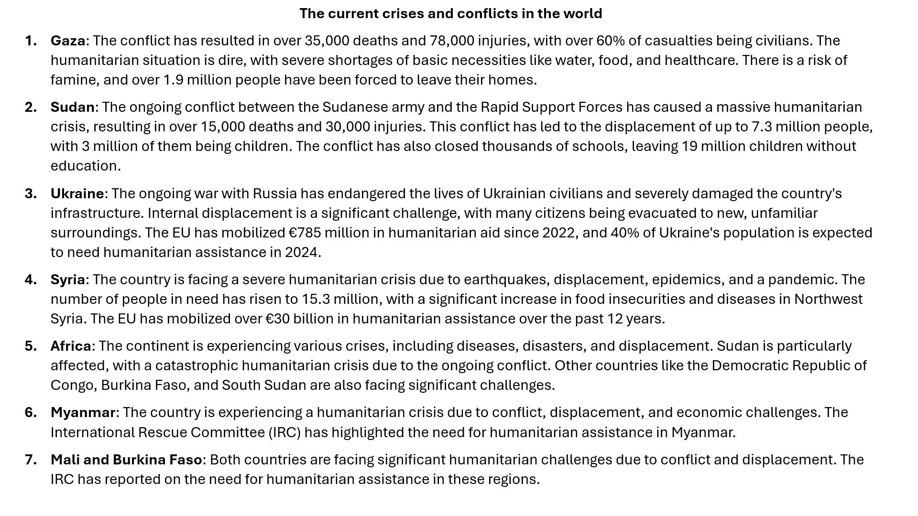

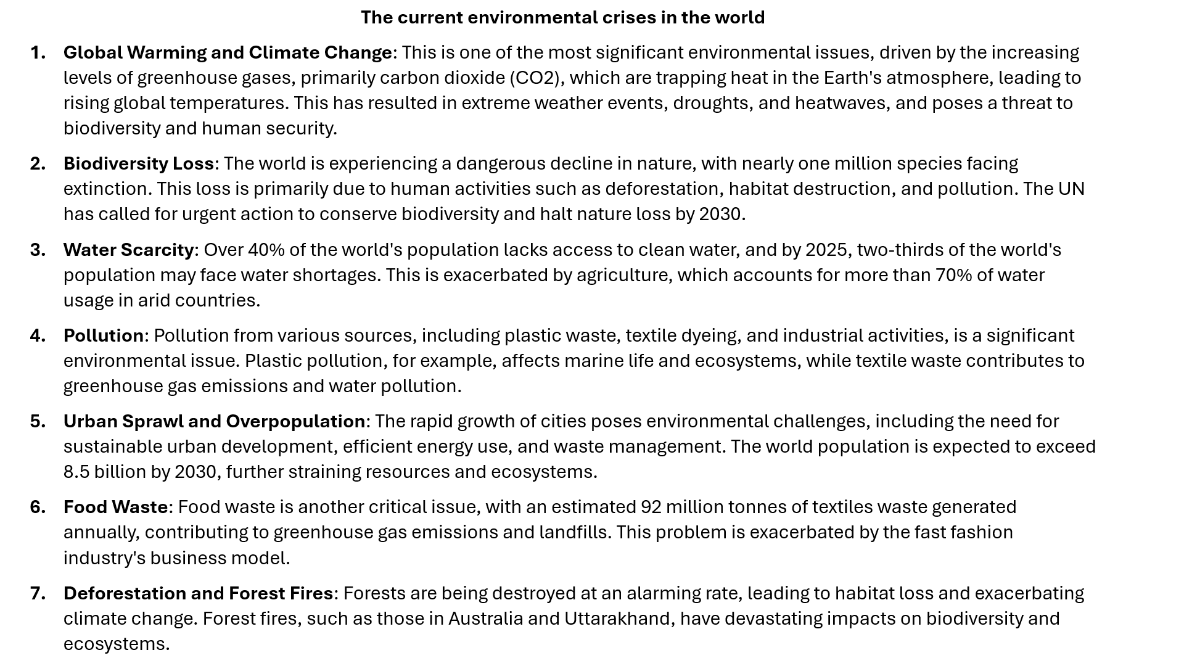

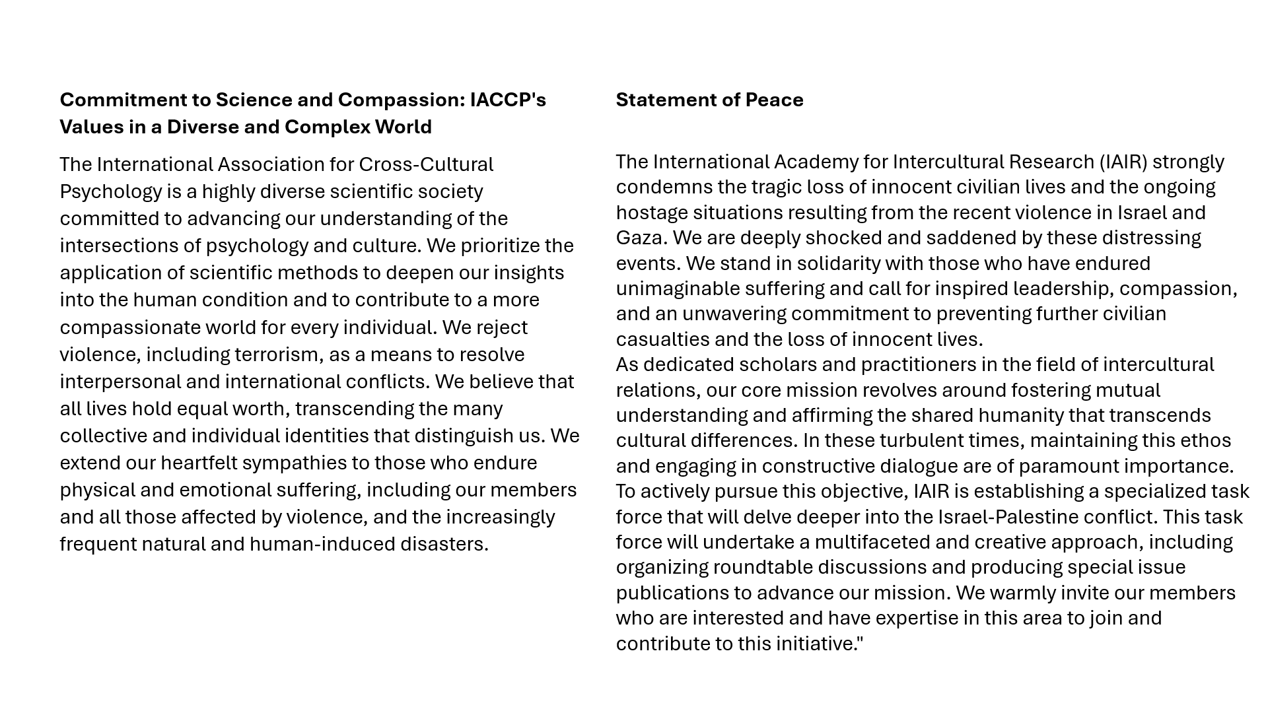
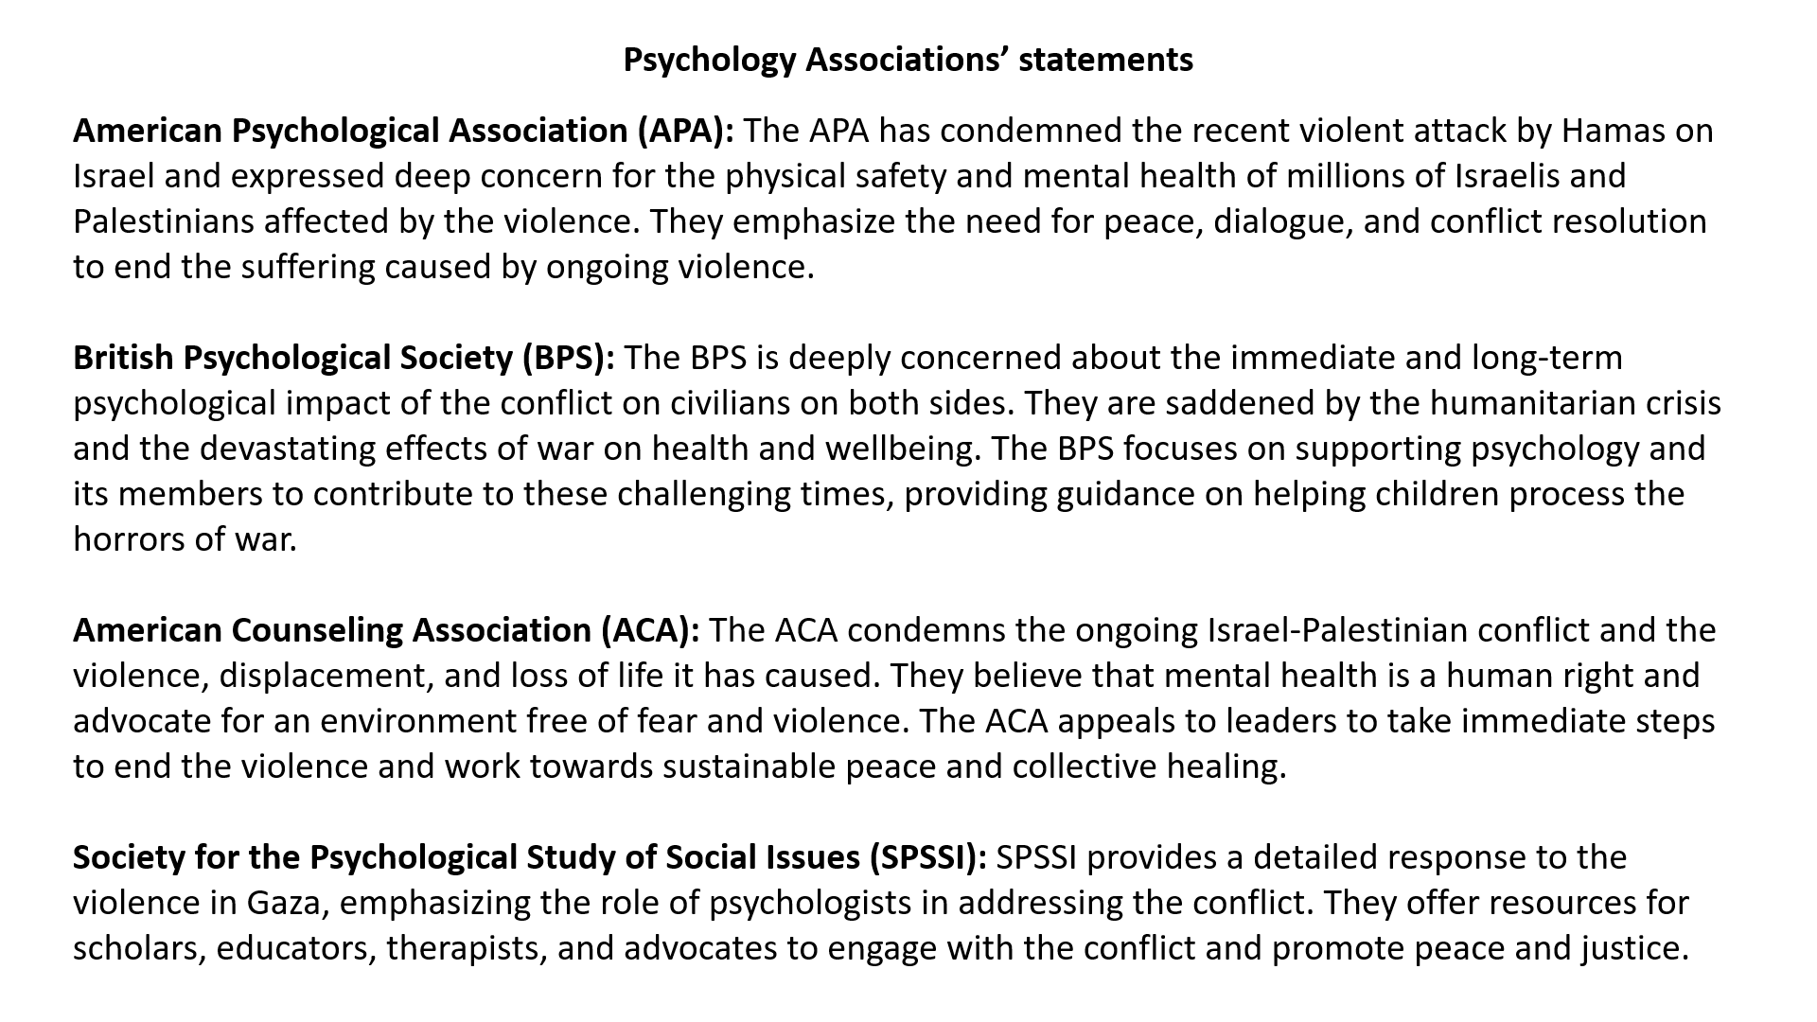

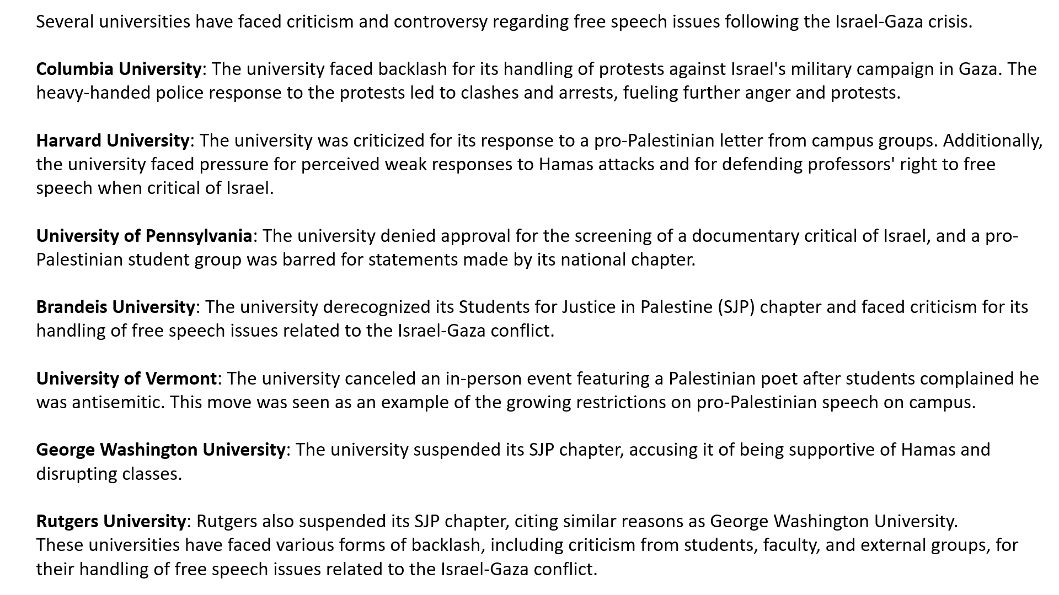

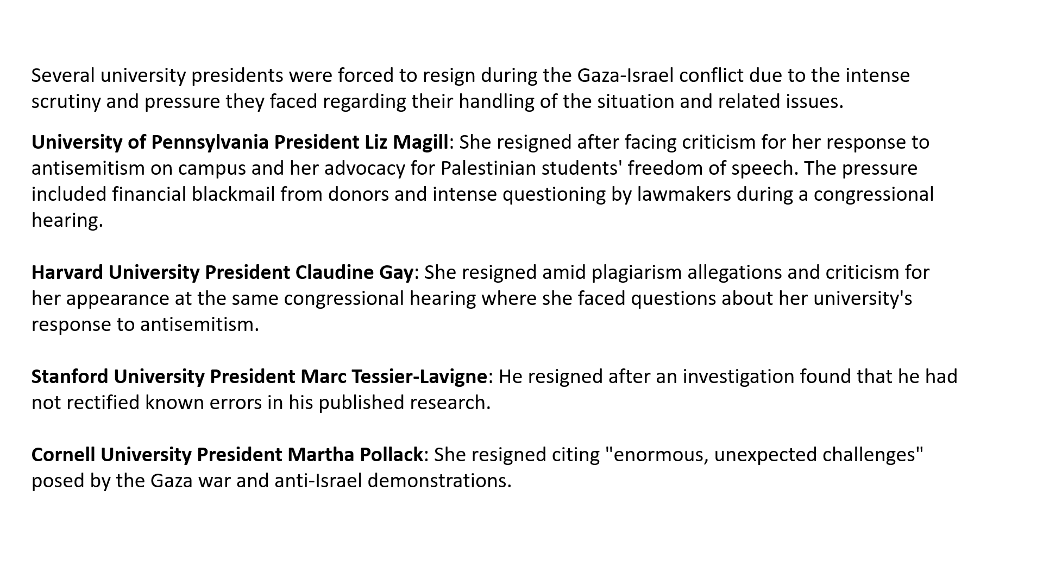
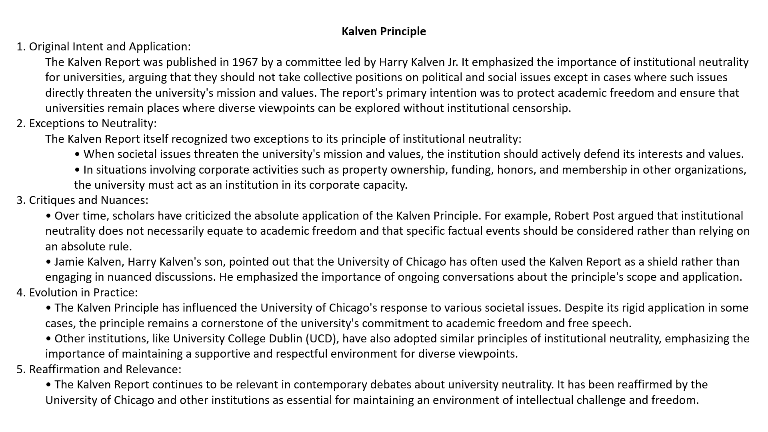

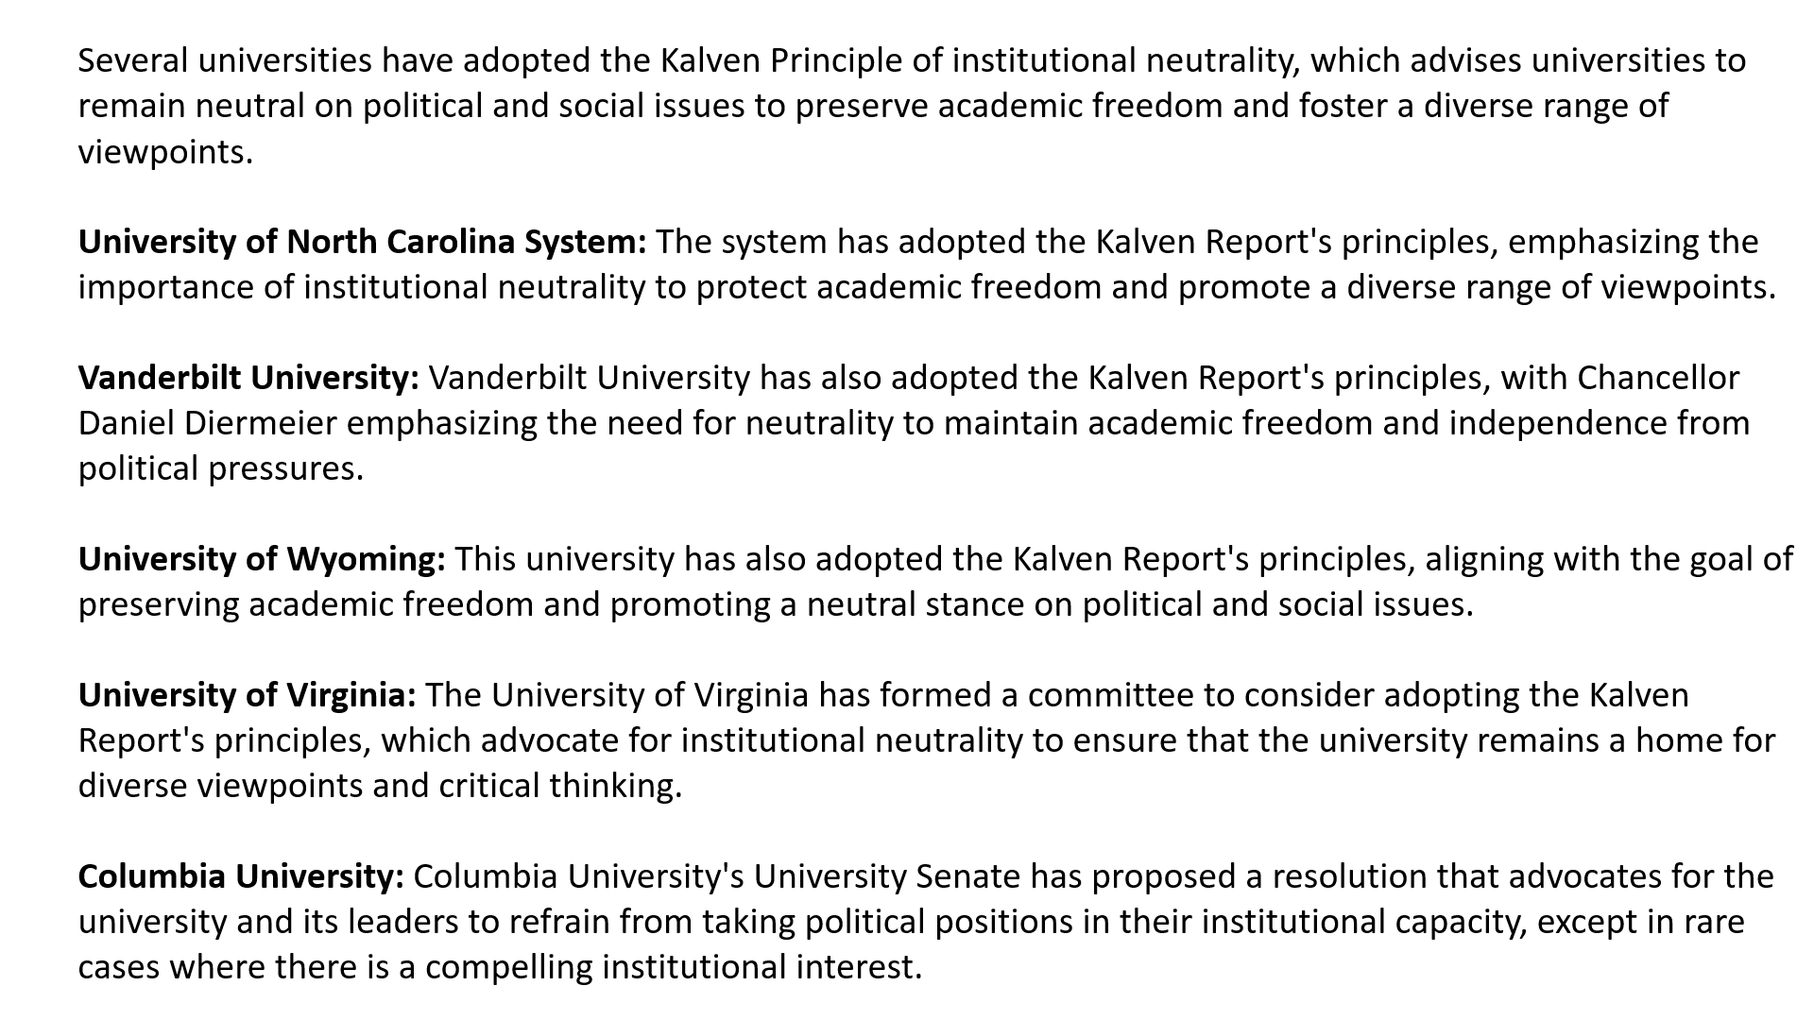
Part 2. Discussions & Recommendations
Participants were encouraged to contribute freely and openly to the forum discussions. Due to the sensitivity of the topics, it was suggested that no recording would be made; therefore, the session’s automatic recording was stopped. Zeynep took notes to summarize the key points.

The main points raised by the participants led to several recommendations for IACCP:

- In cases of international conflict, adopt the principle of “Do not take sides. Take action based on science as the guiding light.” Participants acknowledged that taking sides or condemning one party in an international conflict is neither feasible nor desirable.
  - The facts surrounding the conflict may be unclear or subject to rapid change.
  - Understanding the facts requires expert opinions, such as those from political scientists and historians.
  - Taking sides could alienate some IACCP members and hinder freedom of speech.

- Not taking sides does not mean inaction. Several actions were recommended:
  - Encourage members from the affected parties to engage in dialogue during congresses or conferences (e.g., through symposia or open forums). The primary aim of these dialogues would be to give a voice to those who need to express their opinions and feelings.
  - Invite scholars from various disciplines (e.g., political science, sociology, international relations, history) to attend IACCP conferences or congresses to offer perspectives on intercultural conflicts and human rights issues.
  - Organize workshops at conferences or congresses to develop skills in conflict resolution and intercultural communication.
  - Provide resources (e.g., tools, websites, training programs) to help our members assist victims of international conflicts.
  - Offer resources (e.g., tools, websites, training programs) to help our members educate their students on human rights, intercultural sensitivity, and interpersonal conflict management.
  - Promote hybrid conferences whenever possible to be more inclusive of those who cannot attend due to constraints such as international conflicts, financial limitations, or other reasons.
  - Review IACCP policies and practices (both tacit and explicit) to enhance inclusivity among members.

Appendix 2
Principles for Handling Requests for IACCP Public Statements
on Political or Humanitarian Crises
Proposal developed by Zeynep Aycan
October 2025
As a global scientific community committed to advancing understanding across cultures, the International Association for Cross-Cultural Psychology (IACCP) recognizes that our members may, at times, call upon the Association to take a public stance in response to major geopolitical, humanitarian, or social crises. These moments test not only our shared values but also our ability to uphold scholarly integrity, inclusivity, and compassion.
To guide our deliberations and decisions in such situations, the following principles will apply:
- Respect and dignity for all requests
All member requests will be received with openness, seriousness, and respect.
Each petition reflects a deep moral concern and engagement with global issues - values we encourage in our members. Regardless of whether a formal statement is ultimately issued, every request will be acknowledged and treated as a sincere expression of care for human welfare.
2. Timely and transparent process
IACCP will aim to review and discuss such requests promptly, recognizing that delays may amplify distress among members.
The process and reasoning behind any decision - whether to issue, revise, or refrain from issuing a public statement - will be communicated transparently to maintain trust and accountability.
3. Respect for diversity of views
Given IACCP’s global and multicultural membership, opinions will inevitably vary.
Discussions should be conducted in an atmosphere of mutual respect, where differing perspectives - including silence, neutrality, advocacy, and dissent - can coexist without fear of judgment or exclusion. Any personal attacks or signs of mobbing will not be tolerated.
4. Commitment to scientific and ethical Integrity
IACCP’s voice as a scientific organization must remain rooted in evidence-based understanding and ethical responsibility.
Any public statement should reflect our mission: to promote cross-cultural empathy, human welfare, and peace - not to align with any political position or actor.
5. Consistency and fairness
The Association will apply consistent criteria across all similar cases.
Decisions will not be influenced by geographic, political, or cultural proximity to specific events.
This consistency protects both the credibility and inclusivity of the Association.
6. Avoiding harm and division
In deliberating on whether to issue a statement, IACCP will consider the potential consequences for its members, especially those directly affected by the conflict.
We will avoid actions (or wordings) that risk stigmatizing, alienating, or endangering any group of members based on nationality, ethnicity, or political context.
7. Exploring alternative forms of collective expression
Even when IACCP decides not to issue a political statement, it may facilitate other constructive ways for members to express care and solidarity - through art, dialogue, scholarship, or humanitarian initiatives - that align with our values of compassion and scientific inquiry.

Appendix 3
Presidential Address – Fundraising Event
May 2025
Dear colleagues, friends, and fellow members of the IACCP community,
Good [morning/afternoon/evening]. On behalf of the Executive Committee, I would like to extend a very warm welcome to our first-ever fundraising event for the International Association for Cross-Cultural Psychology. It is such a joy to see you gathered from different corners of the world, representing different disciplines, perspectives, and experiences, yet united by our shared passion for cross-cultural psychology.
As I stand before you today, I feel a mixture of pride, hope, and deep gratitude. Pride for what this association has stood for over the decades. Hope for what we can still achieve together. And gratitude-for your presence, your support, and your belief in the power of our discipline.
We are living through a time of extraordinary complexity and uncertainty. Conflicts (-armed and ideological) -continue to fracture societies. Polarization is on the rise. Questions about the future-of our planet, our democracies, our ways of living together- raise serious concerns for us all.. In such a world, it is easy to feel isolated and powerless.
But this is precisely the kind of world where cross-cultural psychology becomes not only relevant-but essential.
Our field equips us to understand difference, to promote dialogue, to foster empathy across boundaries. We study the psychological consequences of globalization, migration, colonial legacies, environmental injustice, and systemic inequities. We ask how human beings think, feel, and act -not just in general, but in context. And we do so not to divide, but to connect.
Cross-cultural psychology promises to offer a roadmap for coexistence. It helps us challenge ethnocentrism, resist simplistic narratives, and build more inclusive theories and societies. This is the science the world needs right now. And this is the community that has been advancing it for over fifty years.
But even a mission as important as ours cannot be sustained without support. That brings me to the second reason why we are here today: fundraising.
This event is not just symbolic- it is strategic. It is about ensuring that IACCP can continue to do what it does best: cultivate, empower, and elevate the next generation of cross-cultural psychologists.
We have ambitious programs and dreams:
- Scholarships and travel grants for young scholars from underrepresented regions.
- Summer schools and training programs to build capacity.
- Research awards and seed funding for ideas that will shape the future of our discipline.
But dreams, as we know, need resources. And this is where you come in.
Every donation no matter how modest - goes directly toward strengthening the future of our field. It is an investment not just in IACCP, but in ideas that matter, in voices that need to be heard, and in solutions that transcend borders.
These are difficult times. Many of us are navigating challenges: personal, professional, even existential. But that is all the more reason to come together.
And that brings me to the third and final point: this event is also about community.
We need spaces like this, not just to raise funds, but to raise each other’s spirits. To laugh, to share stories, to feel a little less alone. The IACCP has always been more than a scholarly association; it’s a community, a family, a global village.
So let us enjoy this event. Let us remind ourselves that joy, connection, and purpose are still possible - even amidst uncertainty.
Thank you for being here.
Special thanks to Šárka Dobiášová and Hanka Sochančaková, who designed the technical aspects of the event. Thank you to Tamas, Wolfgang, and Emma who will provide a big help to run the activities. Thank you Dr. Ayse Burcin Baskurt for agreeing to run the workshop on the Wheel of Life.
Donation is easy. You don’t need to be a current member to support IACCP. The donation link will be open during the event in the next hour, and we will send reminders of the donation link several times.
At the end of the hour, we will report the total amount raised today.
Let’s leave this event not just with lighter hearts, but with a deeper commitment to each other, to our field, and to a world that sorely needs understanding and hope.

Appendix 4
Co-Editors-in-Chief Model for the Journal of Cross-Cultural Psychology
Proposal developed by Zeynep Aycan
March 2026
The Journal of Cross-Cultural Psychology publishes research spanning experimental, survey-based, ethnographic, interpretive, and reflexive traditions. As the field increasingly values methodological pluralism, appointing co-editors-in-chief with complementary methodological expertise - one primarily quantitative, the other qualitative/interpretive - offers a strategically coherent governance model.
Advantages
1. Methodological credibility and fairness
A dual-editor structure ensures that submissions are evaluated by an editor who deeply understands the epistemological and methodological assumptions underpinning the work.
- Quantitative papers benefit from expertise in measurement equivalence, multilevel modelling, and cross-cultural comparability.
- Qualitative and interpretive papers benefit from informed judgement about rigor, reflexivity, positionality, and interpretive validity.

This reduces the risk of methodological bias, a known challenge in cross-cultural psychology.
2. Broader intellectual positioning of the journal
Co-editorship signals that the journal explicitly values multiple ways of knowing, strengthening its identity as a genuinely cross-cultural outlet rather than one dominated by Western positivist traditions.
Comparable journals using co-editor models to manage breadth include:
- Organization Studies – co-editors reflect diverse theoretical and methodological traditions.
- British Journal of Management – dual editors to balance epistemic diversity.
- Counselling Psychology Quarterly – co-editors supporting qualitative and pluralist approaches.

3. Improved review quality and reviewer matching
Each editor can curate and mobilise method-appropriate reviewer pools, improving:
- Review depth
- Developmental feedback
- Author experience, especially for scholars working outside dominant paradigms

This is particularly important for Global South scholars using context-sensitive or non-positivist approaches.
4. Leadership workload sharing and sustainability
Top journals face increasing submission volumes and complexity. Co-editorship:
- Reduces burnout
- Improves turnaround times
- Allows strategic focus (e.g., special issues, methodological statements, DEI initiatives)

Disadvantages and Risks
1. Risk of methodological siloing
A clear quantitative/qualitative division may unintentionally:
- Reinforce methodological boundaries
- Discourage genuinely integrative or mixed-methods work

This can be mitigated through joint handling of mixed-methods submissions and shared editorial statements.
2. Decision inconsistency
If editorial philosophies diverge too strongly, authors may perceive:
- Uneven standards
- Conflicting signals about “fit” or quality

This risk is manageable through:
- Regular calibration meetings
- Shared acceptance criteria
- Joint editorials clarifying standards of rigor across methods

3. Slower consensus on strategic issues
Co-leadership can slow decisions on:
- Desk-rejection thresholds
- Controversial submissions
- Policy changes

Clear division of operational responsibility, alongside shared strategic oversight, helps avoid bottlenecks.
Overall Conclusion and Recommendation
For the Journal of Cross-Cultural Psychology, a co-editor model split between quantitative and qualitative/reflexive expertise offers strong net benefits:
- Enhances epistemic inclusivity and legitimacy
- Improves review quality and author trust
- Aligns with the journal’s cross-cultural mission

The disadvantages are real but manageable, and experience from journals such as Organization Studies and Counselling Psychology Quarterly suggests that clear governance norms and regular coordination are key to success.
This model is well-suited to the journal’s intellectual scope and would position it as a methodologically pluralist leader in cross-cultural psychology.
Appendix 5
Charting the Future of Cross-Cultural Psychology:
IACCP Strategy Workshop 2027
Proposal developed by Zeynep Aycan
June 10, 2025

Purpose of the Workshop:
To collaboratively develop a strategic roadmap that will guide IACCP’s vision, priorities, and actions for the next 10-15 years. This workshop will unite diverse stakeholders to assess IACCP’s current position, clarify its core identity and mission in a rapidly evolving world, and co-create strategies for advancing its scientific, societal, and institutional impact. The topics will revolve around 3Is of IACCP’s future: Impactful, Inspirational, Inclusive.
Objectives:
- Reflect on IACCP’s Legacy and Strengths
  - What has made IACCP impactful and distinctive over the decades?
- Reaffirm or Refine the Association’s Mission, Vision, and Values
  - Is our mission still fit for purpose? What do we stand for in today’s global landscape?
- Identify Strategic Priorities
  - Membership growth and diversity
  - Scientific leadership and innovation
  - Societal relevance and public engagement
  - Capacity-building for early-career researchers
  - Digital transformation and communication
  - Institutional partnerships and funding models
- Develop an Action-Oriented Strategic Framework
  - With timelines, responsible leads, and key performance indicators
- Strengthen Ownership and Cohesion
  - Ensure all participants feel empowered and committed to enacting the strategy.

Hybrid approach: Combining larger consultation with the Delphi method
Combining a high-impact in-person strategy workshop with a broader, consultative process inspired by the Delphi method will ensure legitimacy, inclusivity, and wisdom across generations and geographies in IACCP.
Benefits of This Hybrid Approach:
- Democratic: Gives voice to global and generational diversity
- Evidence-informed: Strategy grounded in real data from the field
- Inclusive but focused: Small group for synthesis; large group for input and endorsement
- Legitimizing: Boosts trust, transparency, and momentum for implementation
Here is how IACCP Strategic Planning Process (2026–2027) using a hybrid Delphi + Workshop model may look like:
Overall Structure: Three-Phase Process
Phase 1: Strategic Listening & Delphi Round 1
Objective: Gather broad, diverse input from the IACCP community on priorities, trends, and visions for the future.
- Launch an online Delphi-style consultation in 2–3 rounds using online survey tools (e.g., Qualtrics, Google Forms, or DelphiManager).
- Invite:
  - All IACCP members (including students, regional chapter leaders)
  - Past award winners and EC members
  - Key external partners
- Questions may include:
  - What do you see as the most pressing challenges facing cross-cultural psychology?
  - What should IACCP prioritize to stay relevant and impactful?
  - How can IACCP support young scholars and global equity?
  - What does a successful IACCP look like in 2035?
- Launch an online membership survey in addition to the above.
Output:
- Synthesized report identifying emerging themes, points of consensus, and divergence across the community.

Phase 2: Strategy Workshop (In-Person, 25–30 Key Stakeholders)
Objective: Deep dive into the synthesized themes and co-develop the strategic roadmap.
Activities:
- Use the Delphi results to frame discussions, scenario planning, and strategic labs.
- Workshop participants will:
  - Validate and prioritize community-identified themes
  - Translate them into strategic goals and concrete initiatives
  - Develop a draft strategic vision for IACCP 2028–2035
Format: 1-day facilitated retreat following the Leuven conference
Output: Draft strategic framework and action plan
Phase 3: Delphi Round 2 (Validation + Refinement)
Objective: Circulate the draft strategy to the wider community for validation, feedback, and refinement.
Activities:
- Share key strategy proposals (mission, vision, priorities, initiatives) with broader IACCP members via survey and/or webinar.
- Ask:
  - Do you agree with these priorities?
  - What’s missing?
  - What role would you like to play in implementation?
Output:
- Final adjustments to ensure commitment.
- Community ownership of the strategic direction.
Ongoing Engagement Mechanisms
- Publish the final strategy on the IACCP website
- Share periodic progress updates (e.g., via Bulletin or webinars)
- Offer roles for interested members in implementation task forces or working groups

Appendix 6
Enjoy JCCP as a Paperless Digital Journal!
We are pleased to announce that we are planning to make our flagship publication, the Journal of Cross-Cultural Psychology (JCCP), available exclusively in digital format for our members.
The Journal is just a click away (see below):

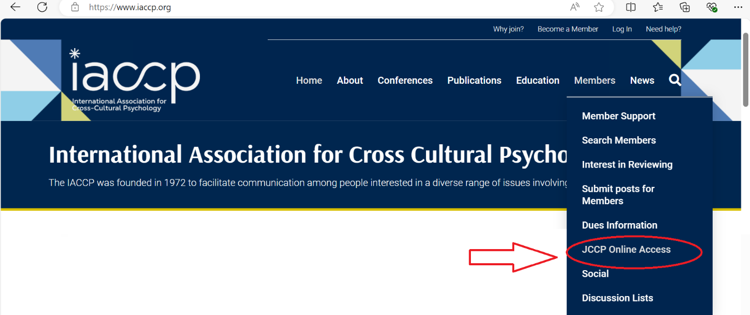
This reflects an increasing trend in the publishing world and among scientific associations like IACCP to promote environmental and financial sustainability.
Prestigious journals from APA, APS, and BPS now provide digital-only copies (e.g., Psychological Methods, Journal of Experimental Psychology: General, Journal of Applied Psychology, Developmental Psychology, Psychological Review, Psychological Science, and the 11 journals of the British Psychological Society).
Below are some key advantages of moving to a paperless, online journal:
- Significant savings for IACCP: Under our current contract negotiations with Sage Inc. (the publisher of JCCP), the cost of providing a printed version of the journal is quoted at $40 per member. Continuing to offer printed copies would place a strain on our already limited budget.
- Environmental responsibility: Going paperless is a step toward a more environmentally sustainable practice for IACCP. More about the climate responsibility of scholarly publishing in this article.
- Enhanced features: The online format offers benefits that print cannot, such as EarlyView papers, virtual special issues, supplementary content, hyperlinked references, and more.
- Space-saving: Printed journals not only take time to arrive but also occupy significant space in our libraries—not to mention the dust they collect. With the online version, members can still print selected articles, annotate them, and store them in their personal files.
- Improved accessibility: The digital format provides better accessibility for visually impaired readers through zoom functionality and easy navigation.
- Stay updated: Readers can register for email alerts for the table of contents, ensuring they stay up-to-date with newly published issues.
- Access when you travel: Readers can access the Journal via their smartphones when they travel for conferences, work, or pleasure.
We recognize that some members prefer printed copies of JCCP, and it may be disappointing to discontinue this option. However, this is a financially and environmentally responsible decision that will help secure our future. We trust our esteemed members to understand and appreciate the wider implications of this decision and support us.
Appendix 7
Biannual Conference Organization
Proposal developed by Zeynep Aycan
February 2025

IACCP has the tradition of organizing conferences every year: Regional Conference in odd years and Congresses in even years. I would like to propose biannual IACCP conferences for the following reasons. The bold sections highlight the gist of the idea in each point.

- The high inflation rate in many parts of the world make conferences expensive events to organize. As a result, organizing committees shy away from hiring PCOs (professional conference organizers) which financially burdens IACCP. Given the current financial bottleneck IACCP is in, organizing conference annually involves risks to our financial sustainability.
- Organizing conferences without a PCO puts an incredible burden on the officers of IACCP, who cannot do much else to advance the Association and the field other than dealing with conference-related issues. As a case in point, the memorandum of understanding (MoU) is now 17 single-space pages that involves all the details required to be attended by the organizers and IACCP officers.
- Given the financial situation in the world, it is unfair to expect our members to attend increasingly expensive conferences we run every year. When there is a conference every year, it is difficult to resist the temptation to skip it, especially for younger scholars who are vulnerable to ‘fear of missing out’ (FOMO).
- Many (if not all) international associations comparable in size to IACCP run their conferences bi-annually. I added a benchmark list at the end of this document. The giants like ICP and ICAP run every four years.
- Our regional conferences have grown in size over the years and started to simulate Congresses. This defies the purpose of attracting regional members and enlarging our membership bases.
- Organizing conferences every year in different parts of the world increasingly involves taking risks due to socio-political (e.g., terrorism, war, visa problems), economic, and natural disasters.
- Inviting people to attend conferences every year and traveling long distances by plane is environmentally irresponsible.

- IAIR - biannual
- AASP - biannual
- ECP - European Congress of Psychology - biannual
- ISSBD - International Society for the Study of Behavioral Development - biannual
- WCBCT - World Congress of Behavioral and Cognitive Therapies - biannual
- ICON - International Conference on Cognitive Neuroscience - biannual
- ICP - International Congress of Psychology - every 4 years
- ICAP - International Conference on Applied Psychology - every 4 years

