THIRD Sunday after Pentecost



June 14, 2026
8 & 10 o’clock in the morning

Saint Barnabas Episcopal Church
91 Main Street • Falmouth, Massachusetts
www.stbfalmouth.org
The Holy Eucharist – Rite I
8 o’clock in the morning

The Entrance Rite
The Acclamation BCP 323
The Gloria BCP 324
The Collect of the Day Page 5
The Readings
The First Reading Page 5
The Psalm Page 5
The Second Reading Page 6
The Gospel Page 7
The Sermon The Rev. David M. Rider
The Nicene Creed BCP 326
The Prayers of the People BCP 328
The Peace Welcome & Announcements Page 9
Blessing of Birthdays and Anniversaries Page 9

THE HOLY COMMUNION

The Offertory
The Great Thanksgiving
Eucharistic Prayer II BCP 340
Proper Preface BCP 345
The Lord’s Prayer BCP 336
The Breaking of the Bread BCP 337
The Invitation and Communion BCP 338
The Post Communion Prayer BCP 339
The Blessing and Dismissal Page 13-14

The Bible texts of the Old Testament, Epistle and Gospel lessons are from the New Revised Standard Version Bible, copyright 1989 by the Division of Christian Education of the National Council of the Church of Christ in the USA, and used by permission. The Collects, Psalms and Canticles are from the Book of Common Prayer, 1979, The Saint Helena Psalter, 2004, and the Episcopal Diocese of Washington. Permission to Podcast/Stream the music in this video obtained from ONE LICENSE (#A-715981)

THE HOLY EUCHARIST RITE II
10 o’clock in the morning

Silence is requested as we prayerfully prepare for worship.

Prelude The Peace G. F. Handel

Opening Hymn The God of Abraham praise Hymnal #401

The Opening Acclamation

Presider: Blessed be God: Father, Son, and Holy Spirit.
People: And blessed be God’s kingdom, now and for ever.

The Collect for Purity

All: Almighty God, to you all hearts are open, all desires known, and from you no secrets are hid: Cleanse the thoughts of our hearts by the inspiration of your Holy Spirit, that we may perfectly love you, and worthily magnify your holy Name; through Christ our Savior. Amen.

Glory to God #S-280

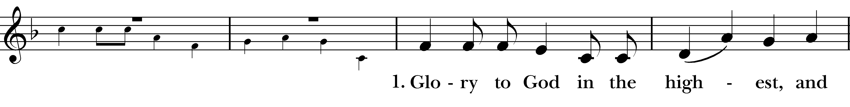
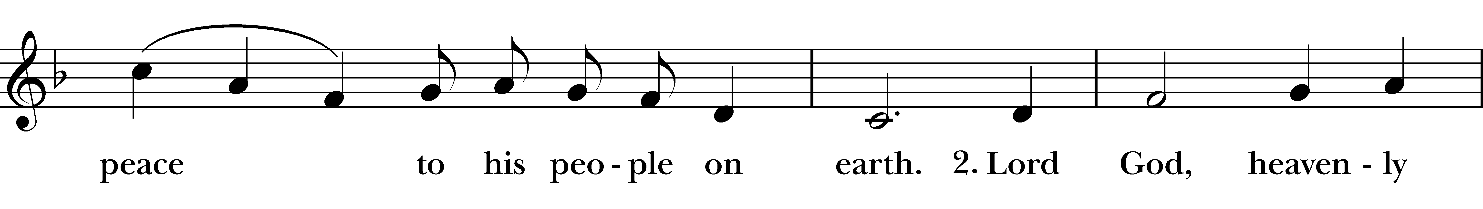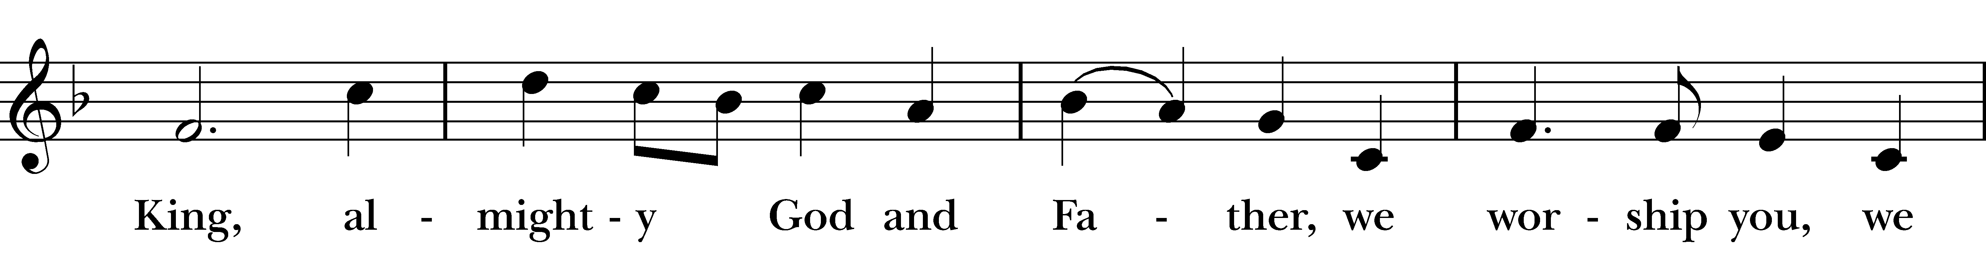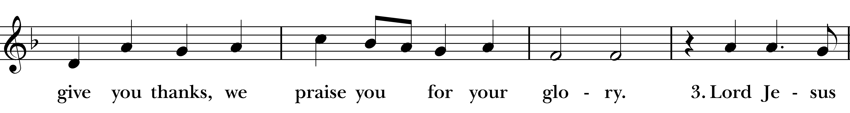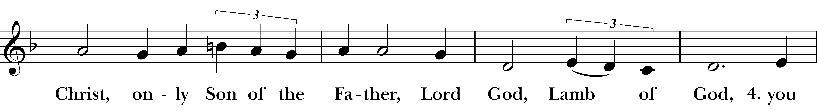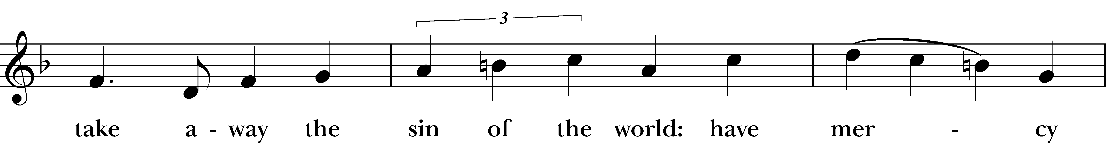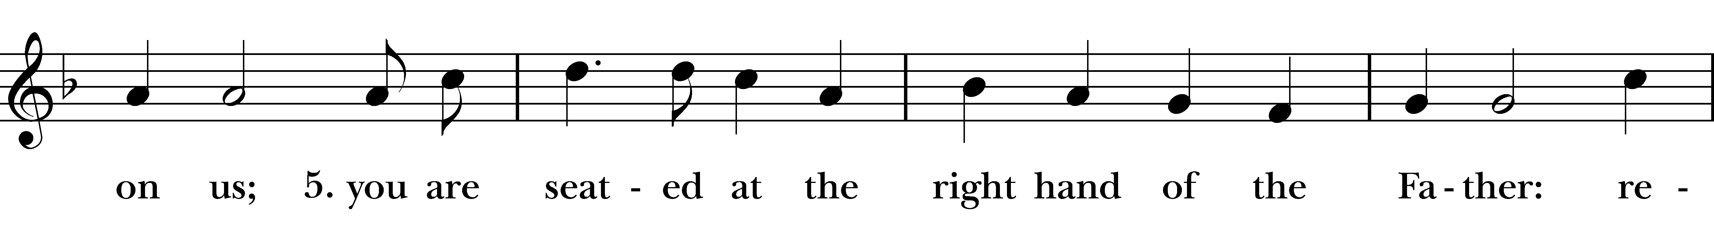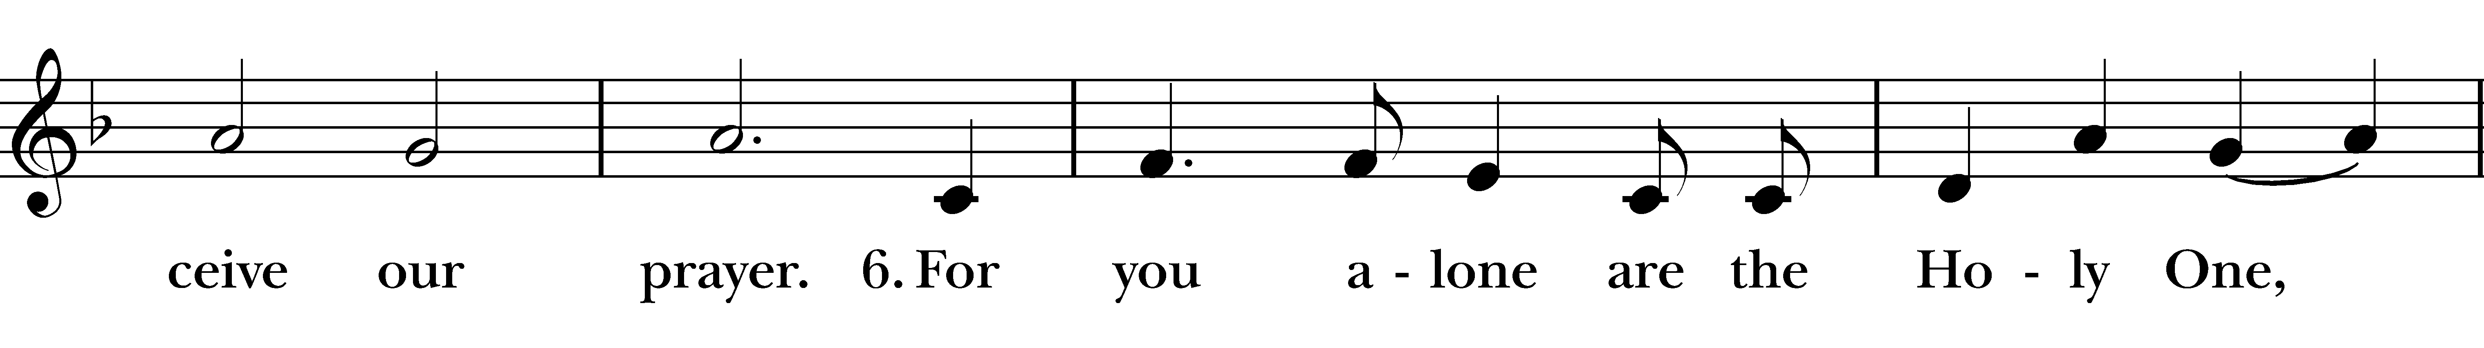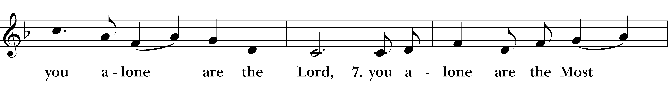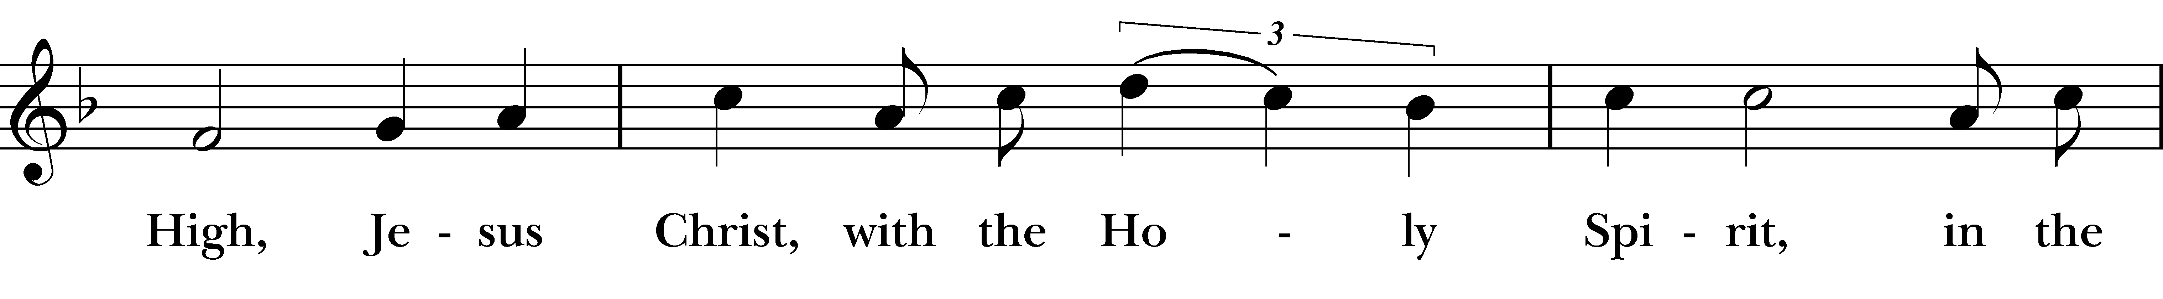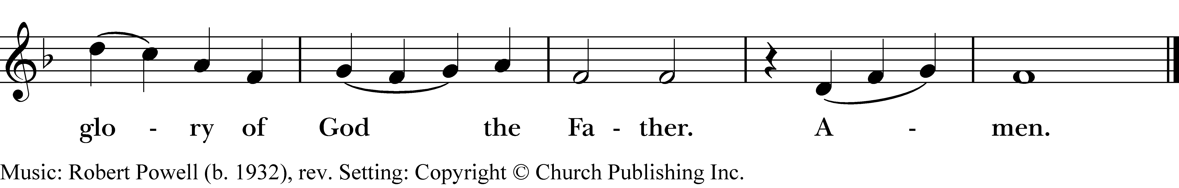
Reprinted under One-License A-715981

The Collect of the Day

Presider: God is with you.
People: And also with you.

Presider: Let us pray.
All: Keep, O Lord, your household the Church in your steadfast faith and love, that through your grace we may proclaim your truth with boldness, and minister your justice with compassion; for the sake of our Savior Jesus Christ, who lives and reigns with you and the Holy Spirit, one God, now and for ever. Amen.

THE LITURGY OF THE WORD

The Readings
Please be seated.

A Reading from Exodus 19:2-81

The Israelites had journeyed from Rephidim, entered the wilderness of Sinai, and camped in the wilderness; Israel camped there in front of the mountain. Then Moses went up to God; the Lord called to him from the mountain, saying, “Thus you shall say to the house of Jacob, and tell the Israelites: You have seen what I did to the Egyptians, and how I bore you on eagles’ wings and brought you to myself. Now therefore, if you obey my voice and keep my covenant, you shall be my treasured possession out of all the peoples. Indeed, the whole earth is mine, but you shall be for me a priestly kingdom and a holy nation. These are the words that you shall speak to the Israelites.”
So Moses came, summoned the elders of the people, and set before them all these words that the Lord had commanded him. The people all answered as one: “Everything that the Lord has spoken we will do.”

Reader: Hear what the Spirit is saying to God’s people.

People: Thanks be to God.

Psalm 100 Please read responsively

1 May all lands be joyful before you, O God, *
serve with gladness and come before your presence with a song.
2 For we know that you are God; *
you yourself have made us, and we are yours; we are your people and the sheep of your pasture.
3 We shall enter your gates with thanksgiving, go into your courts with praise, *
give thanks to you and call upon your Name.
4 For you are good; your mercy is everlasting; *
and your faithfulness endures from age to age.

A Reading from the letter to the Romans 5:1-8

Since we are justified by faith, we have peace with God through our Lord Jesus Christ, through whom we have obtained access to this grace in which we stand; and we boast in our hope of sharing the glory of God. And not only that, but we also boast in our sufferings, knowing that suffering produces endurance, and endurance produces character, and character produces hope, and hope does not disappoint us, because God's love has been poured into our hearts through the Holy Spirit that has been given to us. For while we were still weak, at the right time Christ died for the ungodly. Indeed, rarely will anyone die for a righteous person-- though perhaps for a good person someone might actually dare to die. But God proves his love for us in that while we still were sinners Christ died for us.

Reader: Hear what the Spirit is saying to God’s people.

People: Thanks be to God.

The Gospel Hymn Diverse in culture, nation, race
Reprinted under One-License A-715981
The Gospel

Deacon: The Holy Gospel of our Savior Jesus Christ according to

Matthew 9:35-10:8
All: Glory to you, Lord Christ.

Jesus went about all the cities and villages, teaching in their synagogues, and proclaiming the good news of the kingdom, and curing every disease and every sickness. When he saw the crowds, he had compassion for them, because they were harassed and helpless, like sheep without a shepherd. Then he said to his disciples, “The harvest is plentiful, but the laborers are few; therefore ask the Lord of the harvest to send out laborers into his harvest.”
Then Jesus summoned his twelve disciples and gave them authority over unclean spirits, to cast them out, and to cure every disease and every sickness. These are the names of the twelve apostles: first, Simon, also known as Peter, and his brother Andrew; James son of Zebedee, and his brother John; Philip and Bartholomew; Thomas and Matthew the tax collector; James son of Alphaeus, and Thaddaeus; Simon the Cananaean, and Judas Iscariot, the one who betrayed him.
These twelve Jesus sent out with the following instructions: “Go nowhere among the Gentiles, and enter no town of the Samaritans, but go rather to the lost sheep of the house of Israel. As you go, proclaim the good news, ‘The kingdom of heaven has come near.’ Cure the sick, raise the dead, cleanse the lepers, cast out demons. You received without payment; give without payment.

Deacon: The Gospel of our Savior.
People: Praise to you, O Christ

The Sermon The Rev. David Rider

The Nicene Creed
All: We believe in one God, the Father, the Almighty, maker of heaven and earth, of all that is, seen and unseen. We believe in one Lord, Jesus Christ, the only Son of God, eternally begotten of the Father, God from God, Light from Light, true God from true God, begotten, not made, of one Being with the Father; through him all things were made. For us and for our salvation he came down from heaven, was incarnate of the Holy Spirit and the Virgin Mary and became truly human. For our sake he was crucified under Pontius Pilate; he suffered death and was buried. On the third day he rose again in accordance with the Scriptures; he ascended into heaven and is seated at the right hand of the Father. He will come again in glory to judge the living and the dead, and his kingdom will have no end. We believe in the Holy Spirit, the Lord, the giver of life, who proceeds from the Father, who with the Father and the Son is worshiped and glorified, who has spoken through the prophets. We believe in one holy catholic and apostolic Church. We acknowledge one baptism for the forgiveness of sins. We look for the resurrection of the dead, and the life of the world to come. Amen.

Prayers of the People
Presider: In peace, we pray to you, O God.

Leader: For all people in their daily life and work;
People: For our families, friends, and neighbors, and for those who are alone.

Leader: For this community, the nation, and the world;
People: For all who work for justice, freedom, and peace.

Leader: For the just and proper use of your creation;
People: For the victims of hunger, fear, injustice, and oppression.

Leader: For all who are in danger, sorrow, or any kind of trouble;
People: For those who minister to the sick, the friendless, and the
needy.

Leader: For the peace and unity of the Church of God;
People: For all who proclaim the Gospel, and all who seek the Truth.

Leader: For Sean and Julia, our bishops, David and Perry, our priests, and for all bishops and other ministers;
People: For all who serve God in God’s Church.

Leader: For the special needs and concerns of this congregation.
Silence
The People may add their own petitions
Hear us, Lord;
People: For your mercy is great.

Leader: We thank you, Lord, for all the blessings of this life.
Silence
The People may add their own thanksgivings
We will exalt you, O God our King;
People: And praise your Name for ever and ever.

Leader: We pray for all who have died, that they may have a place in your eternal kingdom.
Silence
The People may add their own petitions
Lord, let your loving-kindness be upon them;
People: Who put their trust in you.

Leader: We pray to you also for the forgiveness of our sins.
Silence may be kept.

All: Have mercy upon us, most merciful God; in your compassion forgive us our sins, known and unknown, things done and left undone; and so uphold us by your Spirit that we may live and serve you in newness of life, to the honor and glory of your Name; through Jesus Christ our Savior. Amen.

The Absolution

Presider: Almighty God have mercy on you, forgive you all your sins through our Savior Jesus Christ, strengthen you in all goodness, and by the power of the Holy Spirit keep you in eternal life. Amen.
The Peace

Presider: May the peace and love of Christ be always with you.
People: And also with you.

Welcome, Announcements
Blessing of Birthdays & Anniversaries

All: O God, our times are in your hand: Look with favor, we pray, on your servants as they begin another year. Grant that they may grow in wisdom and grace, and strengthen their trust in your goodness all the days of their lives; through Jesus Christ our Savior. Amen.
THE HOLY COMMUNION

The Offertory Sentence

The Presentation Hymn All people that on earth do dwell Hymn #377
The Great Thanksgiving Enriching Our Worship #2

Presider: The Lord be with you.
People: And also with you.
Presider: Lift up your hearts.
People: We lift them to the Lord.
Presider: Let us give thanks to the Lord our God.
People: It is right to give our thanks and praise.
Presider: We praise you and we bless you, holy and gracious God, source of life abundant. From before time you made ready the creation. Your Spirit moved over the deep and brought all things into being: sun, moon, and stars; earth, winds, and waters; and every living thing. You made us in your image, and taught us to walk in your ways. But we rebelled against you, and wandered far away; and yet, as a mother cares for her children, you would not forget us. Time and again you called us to live in the fullness of your love. And so this day we join with Saints and Angels in the chorus of praise that rings through eternity, lifting our voices to magnify you as we sing (say):

Holy , holy, holy Lord WLP #858
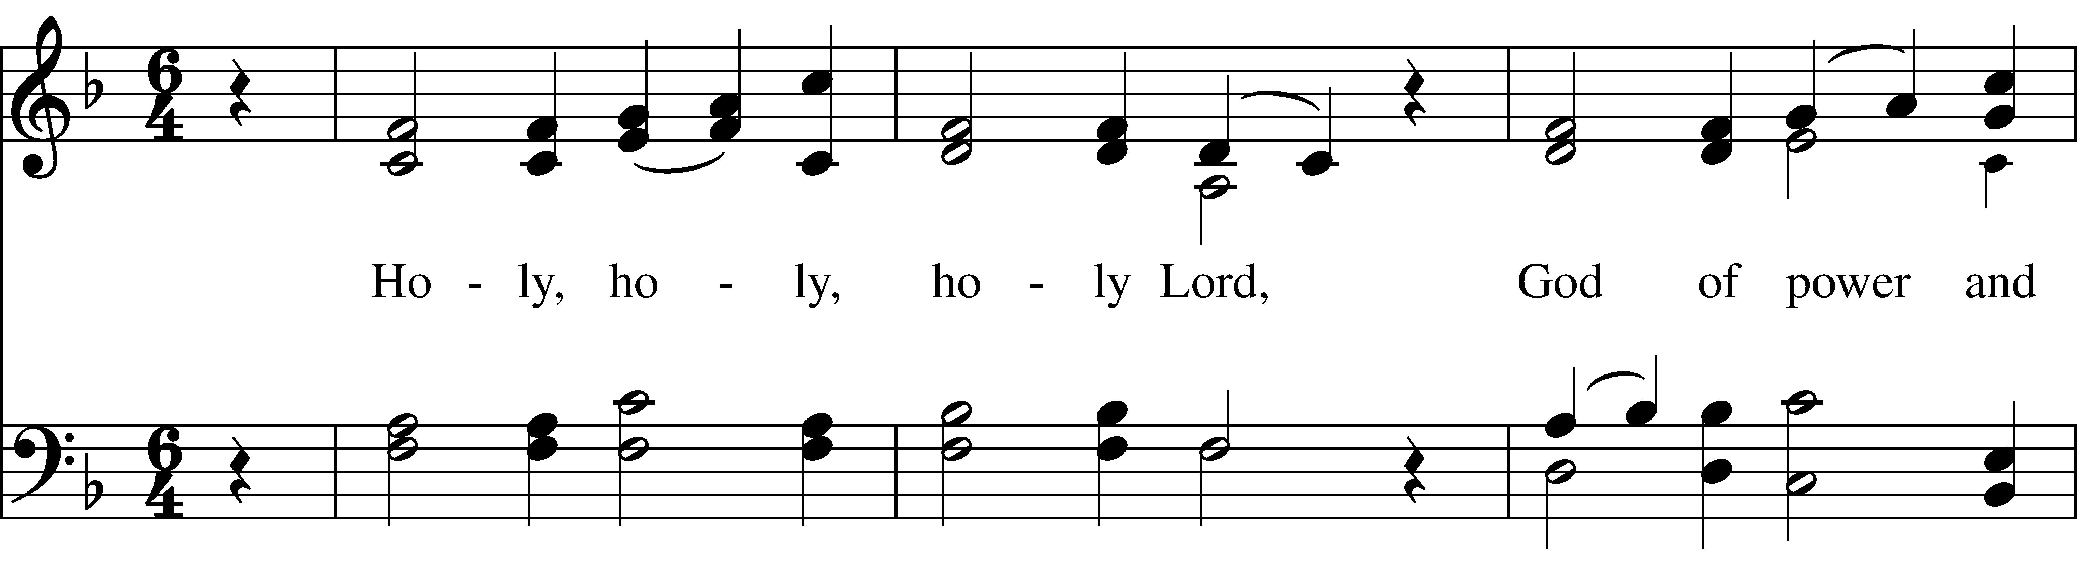
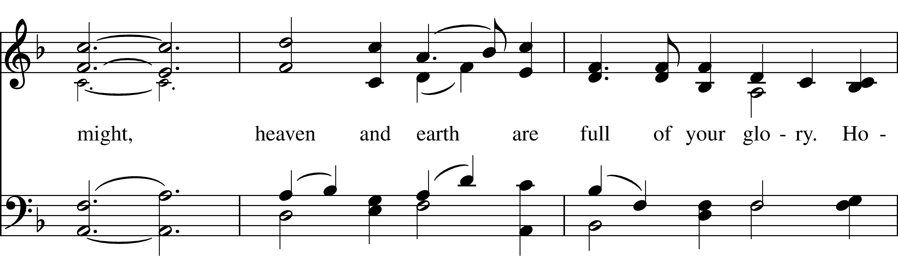
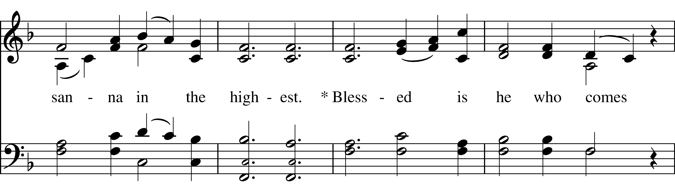
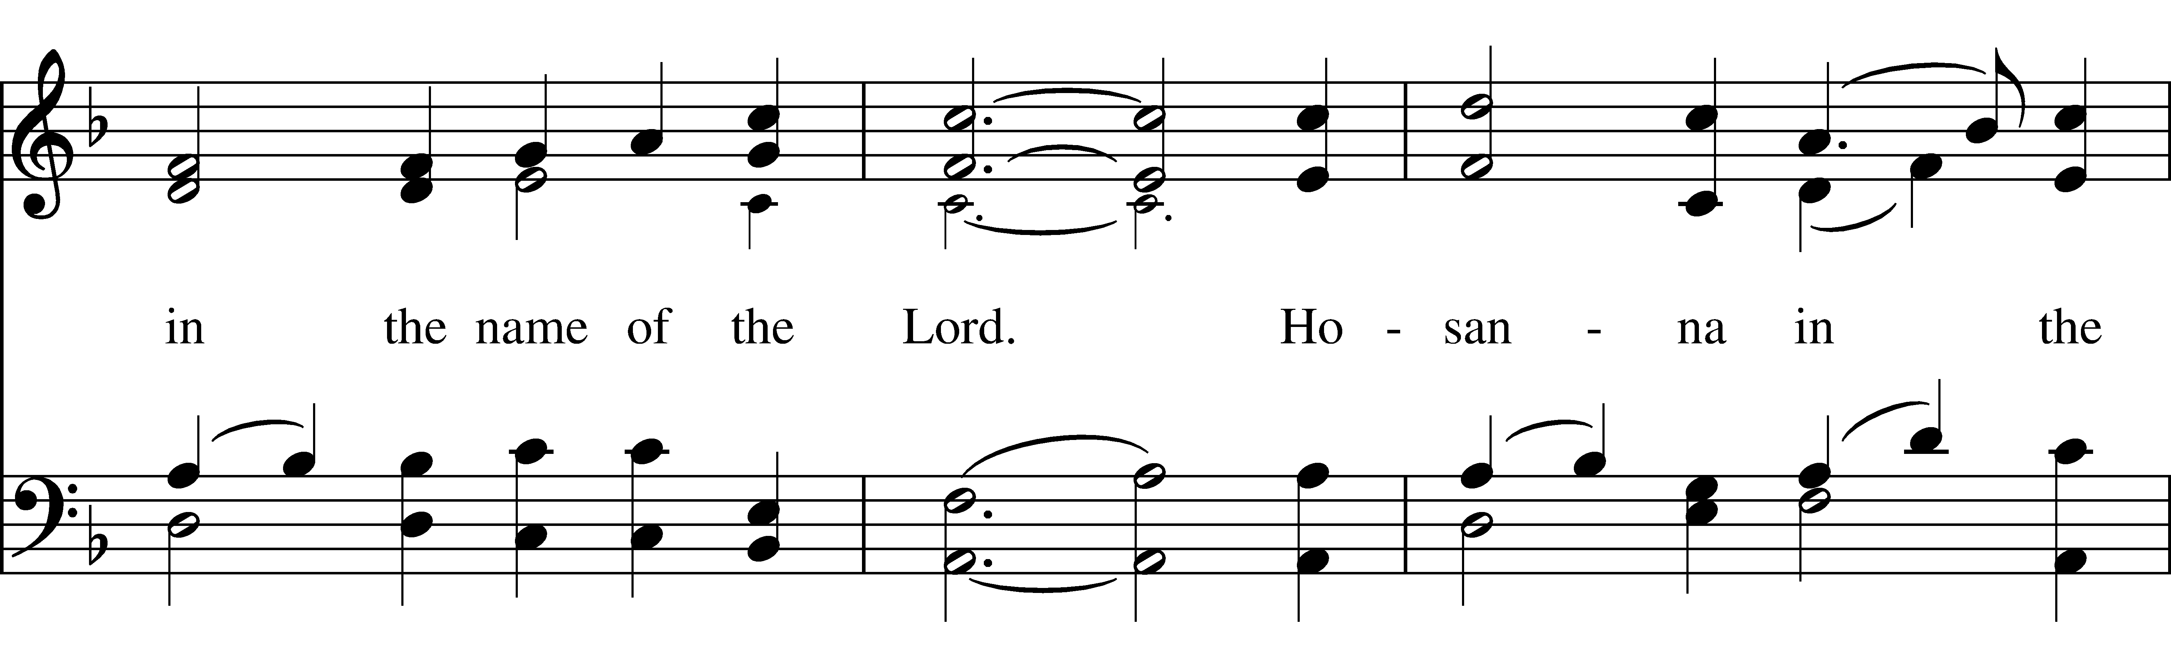
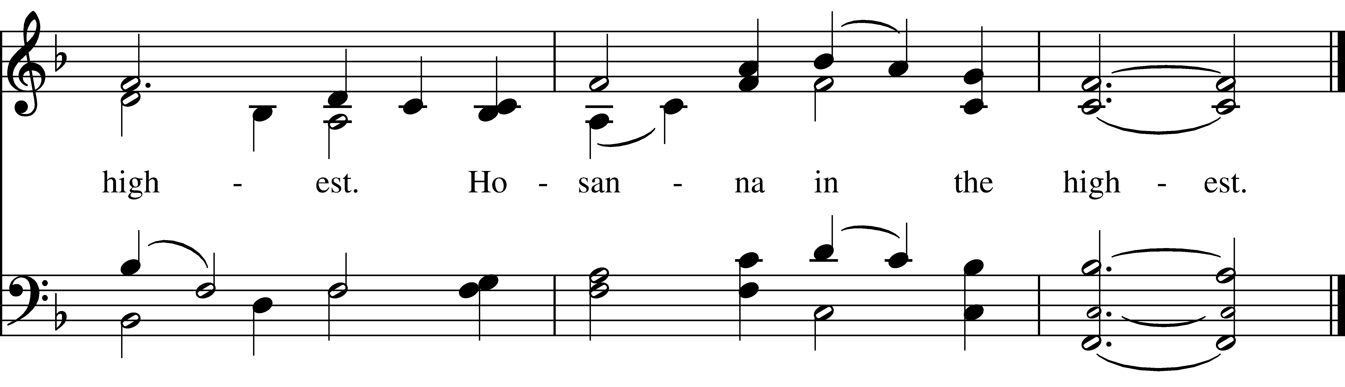
Reprinted under One-License A-715981

Presider: Glory and honor and praise to you, holy and living God. To deliver us from the power of sin and death and to reveal the riches of your grace, you looked with favor upon Mary, your willing servant, that she might conceive and bear a son, Jesus the holy child of God. Living among us, Jesus loved us. He broke bread with outcasts and sinners, healed the sick, and proclaimed good news to the poor. He yearned to draw all the world to himself yet we were heedless of his call to walk in love. Then, the time came for him to complete upon the cross the sacrifice of his life, and to be glorified by you.
On the night before he died for us, Jesus was at table with his friends. He took bread, gave thanks to you, broke it, and gave it to them, and said: “Take, eat: This is my Body, which is given for you. Do this for the remembrance of me.” As supper was ending, Jesus took the cup of wine. Again, he gave thanks to you, gave it to them, and said: “Drink this, all of you: This is my Blood of the new Covenant, which is poured out for you and for all for the forgiveness of sins. Whenever you drink it, do this for the remembrance of me.” Now gathered at your table, O God of all creation, and remembering Christ, crucified and risen, who was and is and is to come, we offer to you our gifts of bread and wine, and ourselves, a living sacrifice. Pour out your Spirit upon these gifts that they may be the Body and Blood of Christ. Breathe your Spirit over the whole earth and make us your new creation, the Body of Christ given for the world you have made. In the fullness of time bring us, with [___________ and] all your saints, from every tribe and language and people and nation, to feast at the banquet prepared from the foundation of the world. Through Christ and with Christ and in Christ, in the unity of the Holy Spirit, to you be honor, glory, and praise, for ever and ever. AMEN.

As our Savior Christ has taught us, we now pray;
The Lord’s Prayer
All: Our Father in heaven, hallowed be your Name, your kingdom come, your will be done, on earth as in heaven. Give us today our daily bread.
Forgive us our sins as we forgive those who sin against us. Save us from the time of trial, and deliver us from evil. For the kingdom, the power,
and the glory are yours, now and forever. Amen.

The Breaking of the Bread
Presider: Alleluia. Christ our Passover is sacrificed for us.
People: Therefore let us keep the feast. Alleluia.

The Invitation and Communion

Presider: The Gifts of God for the People of God. Take them in remembrance that Christ died for you and be thankful.
You will be invited to come forward for Communion or a blessing. All are welcome to receive. Please alert an usher if you would like to receive at your seat. You may decline either the consecrated bread or wine by placing a hand over your heart. Receive the bread (a wafer) in the palm of your hand. Intinction is not permitted. Gluten-free wafers are available upon request at the Altar.

Communion Music:

Canon in D Johann Pachelbel
Praise the Lord, rise up rejoicing Hymnal #334
Please join in singing.
The Post Communion Prayer
Presider: Let us pray.
All: Almighty and ever living God, we thank you for feeding us with the spiritual food of the most precious Body and Blood of your Son our Savior Jesus Christ; and for assuring us in these holy mysteries that we are living members of the Body of Christ, and heirs of your eternal kingdom. And now, O God, send us out to do the work you have given us to do, to love and serve you as faithful witnesses of Christ our Savior. To him, to you, and to the Holy Spirit, be honor and glory, now and forever. Amen.

The Blessing

Presider: The peace of God, which passes all understanding, keep your hearts and minds in the knowledge and love of God, and of his Son Jesus Christ our Lord; and the blessing of God Almighty, the Father, the Son, and the Holy Ghost, be amongst you, and remain with you always. Amen.

The Closing Hymn How great Thou art LEVAS #60
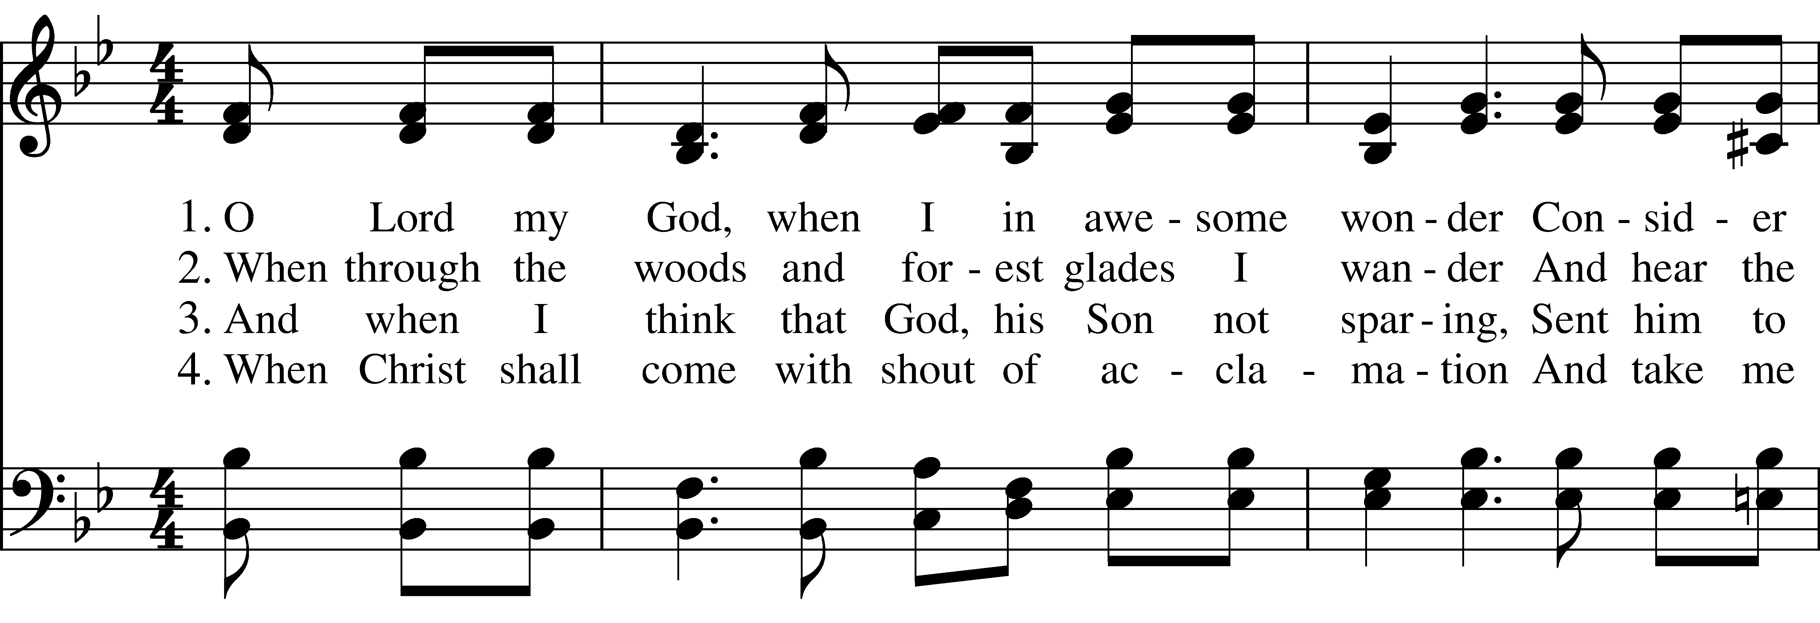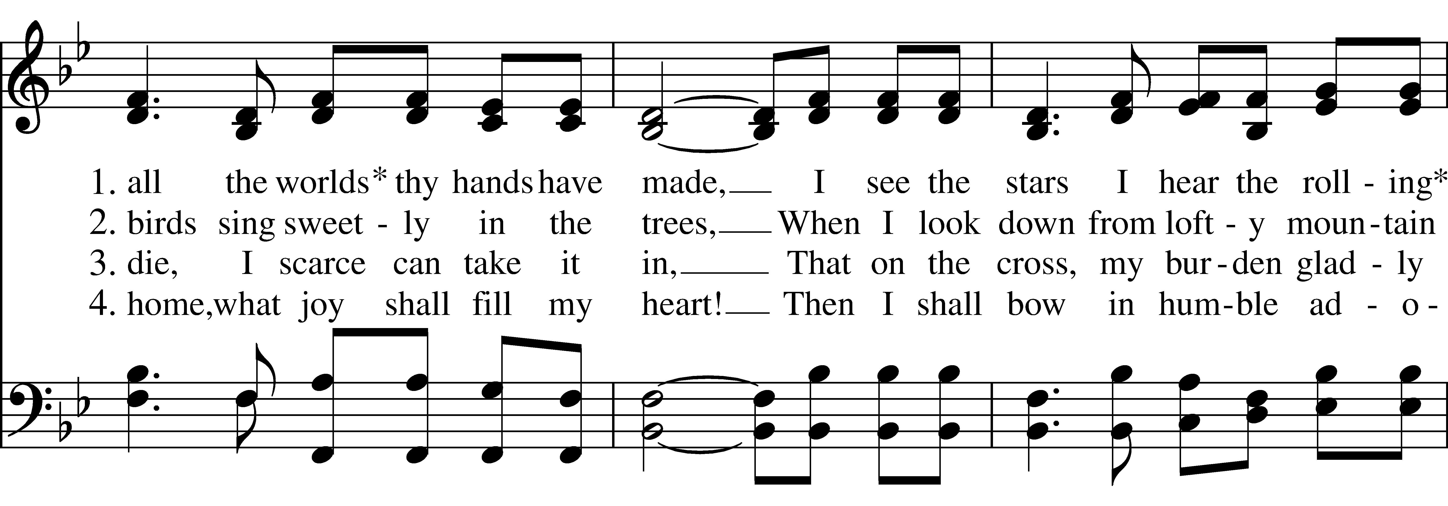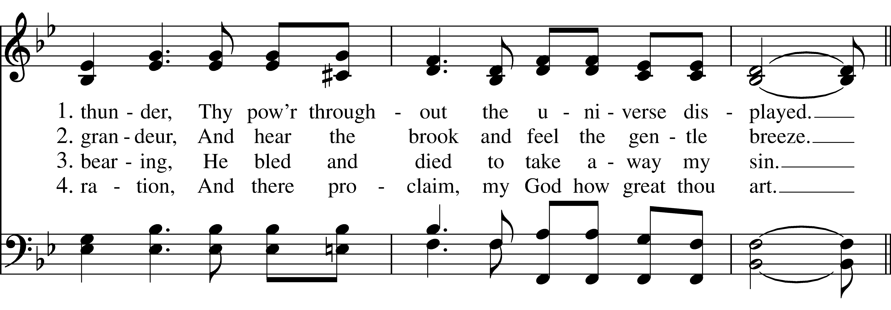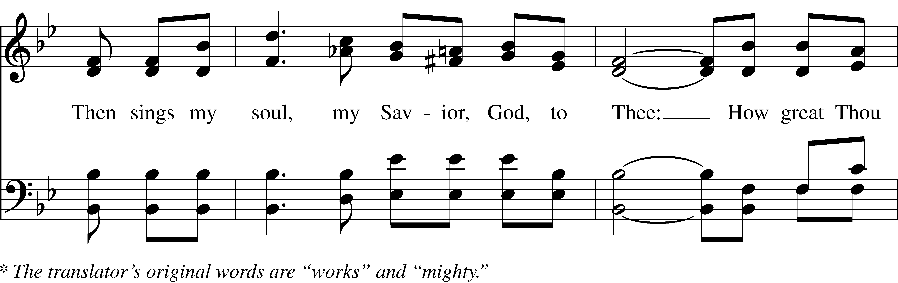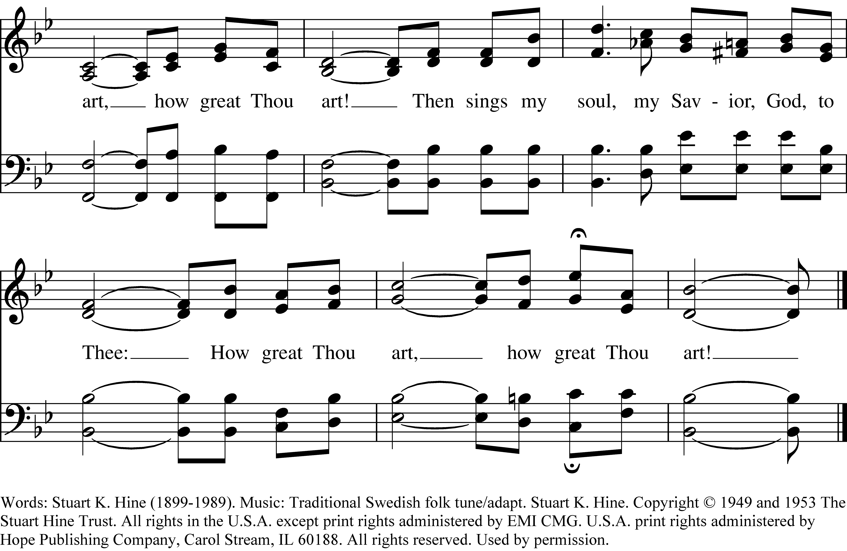
The Dismissal

Deacon: Let us go forth in the name of Christ.
People: Thanks be to God. Alleluia! Alleluia!

The Postlude The Rejoicing G. F. Handel

The worship has ended – our service begins!
THANK YOU TO TODAY’S SERVERS
Presider/Preacher: The Rev. David M. Rider;
Music Director/Organist: Deborah Gemma;
8AM Service: Altar Guild: Merrily Crowley; Lay Eucharistic Minister: Molly Kelleher; Lector: Rhaenel Stone; Usher: Ronald Landry; Vestry Person of the Day:
10AM Service: Acolyte: Noah Schmidt; Altar Guild: Anita Sadek-Lappen; Flower Guild: Marianne Monacci, Anne Wood; Lay Eucharistic Minister: Ken McGrail; Lectors: Helen Malina, Linda Jeffries-Summers; Social Hour: Linda Jeffries-Summers; Usher: Grace Leva; Vestry Person of the Day: ; Virtual Worship: Dalton Webb

PRAYER LIST
Names appear on the published Prayer List for up to six weeks. Confidential prayer requests or for extended periods will be forwarded to the Prayer Chain. Contact the office or use the website to request a name be added.
PARISHIONERS:
FRIENDS OF OUR PARISH:
THOSE GRIEVING:
The friends and family of John Schroth
SERVING IN THE ARMED FORCES:
Christopher Chicoine, Andrew Leitao, Tyler Jeck, Tom Worthington
SAINT BARNABAS’S MINISTRIES:
Property Ministry, Labyrinth
DIOCESAN & LOCAL CYCLE OF PRAYER:
Churches of the Merrimack Valley Deanery; Grace Church, Lawrence; Esperanza Academy, Lawrence; St. Anne’s Church, Lowell;
Congregations: Lectors, Worship Leaders, Eucharistic Ministers & Visitors
In Falmouth: Waquoit Congregational Church, Falmouth Garden Club, 300 Committee

OUR DIOCESE AND PARISH
The Rt. Rev. Julia E. Whitworth, Bishop Diocesan
The Rev. David M. Rider, Interim Priest
The Rev. Everett (Perry) Perine, Associate Priest
Elaine Bruno, Finance Administrator
Deborah Gemma, Director of Music/Organist
David Hinds, Assistant Sexton

Kate Kristenson, Warden
Phoebe Office, Warden
Lucy Young, Clerk
Karl Loos, Treasurer
Grace Leva, Assistant Treasurer

Vestry Members:
Neill Bogan
Ted Gale
Stephen Handy
Richard Jackmauh
Karl Loos
Ken McGrail
Kirstin Meyer-Kaiser
Louise Prussack
Lucy Young

Deanery Delegates:
Beth Bullock-McGrail, Irene Ledwith
Diocesan Delegates:
Claudine Kos, Anne Wood

