Meeting Attendance (Board): Check if present

Dilyn Radcliffe (President) ☒
Corey Valencia (Vice President) ☒
Cory Palmer (Treasurer) ☐
Ronald Neumeyer (Secretary) ☒
Corey McDonald (Director of Concessions) ☒

Meeting Attendance (League Members): List of League Members in attendance.
ERIN LUONGO | DAN MCGOVERN | JASON KENNELLY
MATT MARSULO | JACI MASCO | LOU MASCO
GEORGE LUCY | RALPH DICESARE | DAVE AUGUSTINE
MARRY TAYLOR | EMILY CATTO | DONNIE BYWATERS
JANET HESS | CASEY YOKUM | CHRIS HAWKINS
MATT DEYELL | SAMUEL WASHBAUGH | KEN PATRICK
JUSTIN TRUNZO | BONNIE SAFFELL | NICK BERESH
ERIC SAFFELL | EUGENE HALL | SEAN LOHRER
RYAN BEM | JAY LITZENBURGER | LAURA LITZENBURGER
JOSH FOX | CHRIS DUDLEY
The meeting was called to order at 6:00 PM: on Sunday, February 15, 2026

1/11 Previous Meeting Minutes Approved by:
Motion: ERIN
Second: JANET
Motion Carried: ALL IN FAVOR

President's Report:

Enrollment as of 2/13/2026
- Shetland
  - 25 (2 Teams)
- Pinto
  - 39 (4 Teams)
- Mustang
  - 35 (3 Teams)
- Bronco
  - 44 (4 Teams)
  - *WYATT LEVERS (BURGETTSTOWN CLEAR WITH GR-50)
- Pony
  - 23 (2 Teams)
Night of the Races
$11,700 Was brought in via ticket sales and during the event
The profit after all expenses was $630.00. Attendance at the event played a major role. 260 Tickets were sold, only 150 attended. We will discuss better timing and a different partnership with other leagues going forward.
-PICTURES DATE POSSIBLY 4/12/26
-SEASON POSSIBLE START DATE 4/20/26
-FENCING COMPANY, LOOKED AT EACH FIELD. QUOTE FOR REDOING/CLOSING IN BRONCO AND MUSTANG FIELD $9,305.00. SUPPLY OUR OWN MATERIAL AND BE LABOR ONLY. ($4485.00)
MOTION: JACI M
SECOND: CHRIS D
MOTION PASSED: ALL IN FAVOR

Vice President's Report:
- SHETLAND , INTERNAL PLAY

Treasurer’s Report:

OUT OF TOWN DURING MEETING
Checking-- $34,193.74
Savings— $31,176.25
Upcoming Expenses: Field materials, Slush Puppie Contract and Supplies, Uniforms and Hats

Secretary Report:
Looking at the information for a Water Buffalo and related material to give us a more permanent solution to our Water issue

Director Of Concessions Report:
- The Icee contract is underway, Concession Guidelines/Rules ETC
- IF USING HS FIELD, HAVE OBLIGATION FOR RUNNING CONCESSION DOWN AT FIELD

Old Business:
- The batting cage net was delivered to the school, and they are ready for us to pick up the net and install.
- Were still in the process of getting the final people and items needed to get “Kickers” welded on the poles, so they do not bow in, allowing the net to be strung
- PONY FIELD, CONSTRUCTION BEING DONE. LEAGUE TO BE ABLE TO PLAY THERE

New Business: NEW NET NEEDS PICKED UP FOR BATTING CAGES

Discussion Items:

Planned Discussion-
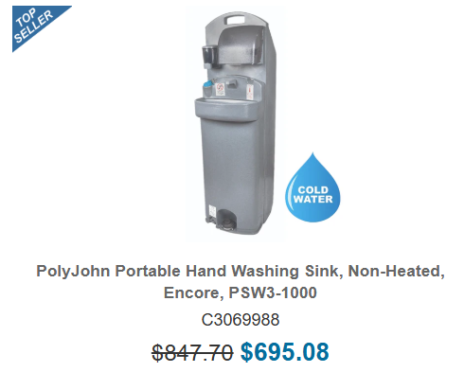
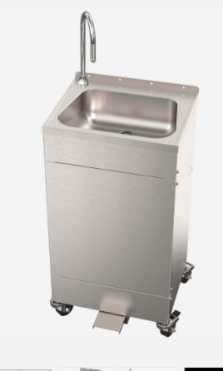
Temp Water Solution Ideas—Emails out to companies for pricing and other deals.
Pony Field usage
- Varsity will be using the Washington Wild Things Field for games
  - CH AD will allow us to use the field for our other divisions' games and Practices
  - They are removing the drain in center field. The work will require a temp fence to be required for all usage until the repair is completed
    - I would like to keep Shetland through Bronco games on our fields and to keep concessions going.

Member Discussion-
Head Coach Votes, Possible digital format of voting, Members in good standing only (non-anonymous voting)

Adjournment
MOTION: G. LUCY SECOND: E. MCDONALD ALL IN FAVOR
END OF MEETING 6:58 PM
Click or tap to enter a date.

