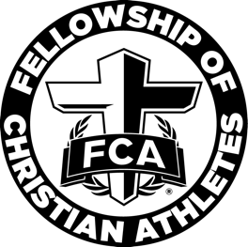

West Atlanta FCA Elementary - Sponsorship

(Name of school) Elementary School is excited to offer an FCA Elementary huddle this school year. Students will meet monthly to learn about Biblical concepts and how to apply these concepts to their lives.

We are seeking community sponsors to help with the cost of activities and breakfast for the students. Your contribution of $(amount) will help us provide a nutritious breakfast for our students and help with the cost of activities associated with the monthly huddle.

In return, we would like to show our support of your organization by listing your organization’s name on the back of a (Name of school) Elementary School FCA t-shirt. We will sell these t-shirts to students and parents. We will wear the FCA t-shirt for our monthly huddles and for other community events hosted by FCA.

To meet our printer deadline, all sponsorships are due by (date). Checks should be made payable to (Name of school) Elementary School. We are happy to pick up the check from your organization, or you can mail the check to:

(Name of school) Elementary School FCA
Attn: (Huddle Leader Name)
(School address)
(School city), GA (School zip)

If you have any questions, please contact our (Name of school) Elementary School FCA Huddle Leader, (Huddle Leader Name), at (Huddle Leader phone number) or (Huddle Leader email address).

Thank you for your support of (Name of school) Elementary School FCA!

Organization Name: _____________________________________________________________

** You can email your logo to (Huddle Leader email address).

Organization name as you would like it to appear on the FCA t-shirt:

______________________________________________________________________________

Contact Name: _________________________________________________________________

Contact Phone Number: __________________________________________________________

Contact Email Address: ___________________________________________________________

