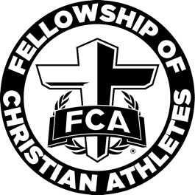

West Atlanta FCA Elementary
Parent Emails

Parent emails can be sent each month. You can send parents the information about the lesson, memory verse, and provide home resources.

Registered Students Email

Dear Parents,

Our Douglas County FCA Elementary campus huddle at (name of school) Elementary School for (month) will be (date). We will start promptly at (time). Drop off will be at (location).

The character word of the month for (month) is (topic). We will learn about (topic) and how (topic) was used in the Bible to further God’s Kingdom.

We would love for your child to invite a friend to our FCA campus huddle. Please remember all students must register to attend. Students may register on the Douglas County FCA Elementary page on our website at https://www.westatlantafca.org/registration

We look forward to seeing your child at the West Atlanta FCA Elementary campus huddle at (name of school) Elementary School on (date)!

