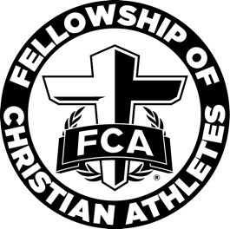

West Atlanta FCA Elementary
Campus Huddle Suggested Itinerary

Depending on your time constraints, this suggested template and time frame may be changed to fit the needs of your school.

7:00-7:05 – Check-in
Please have a checklist of all registered students available. Students must register before they can attend.

7:05-7:20 – Large group, worship, game, student presentation of posters/PowerPoint slides
We have lesson plans, PowerPoint slides, activity options, etc. available on the West Metro FCA Elementary resources page on our website at https://www.westatlantafca.org/resources.

7:20-7:30 – Speaker
This could be a coach, student, children’s pastor, student pastor, church staff, or anyone you feel would do a good job. We have some contacts of speakers on the West Metro FCA Elementary resources page on our website at www.westatlantafca.org/resources.

7:30 – Dismissal
Depending on what your administration allows, you could have the speaker, a student (who was asked beforehand), or West Metro FCA staff pray. You could have the students do prayer requests on index cards as they leave. Many schools like to dismiss to music, some prefer to hand breakfast out as the students leave.

