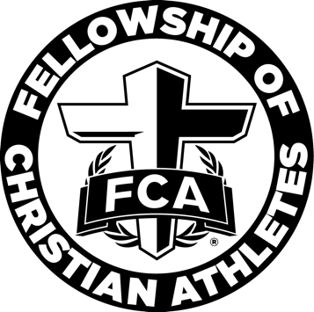

West Atlanta FCA Elementary
Character Words

Love Joy

Peace Patience

Goodness Kindness

Faithfulness Gentleness

Self-Control

