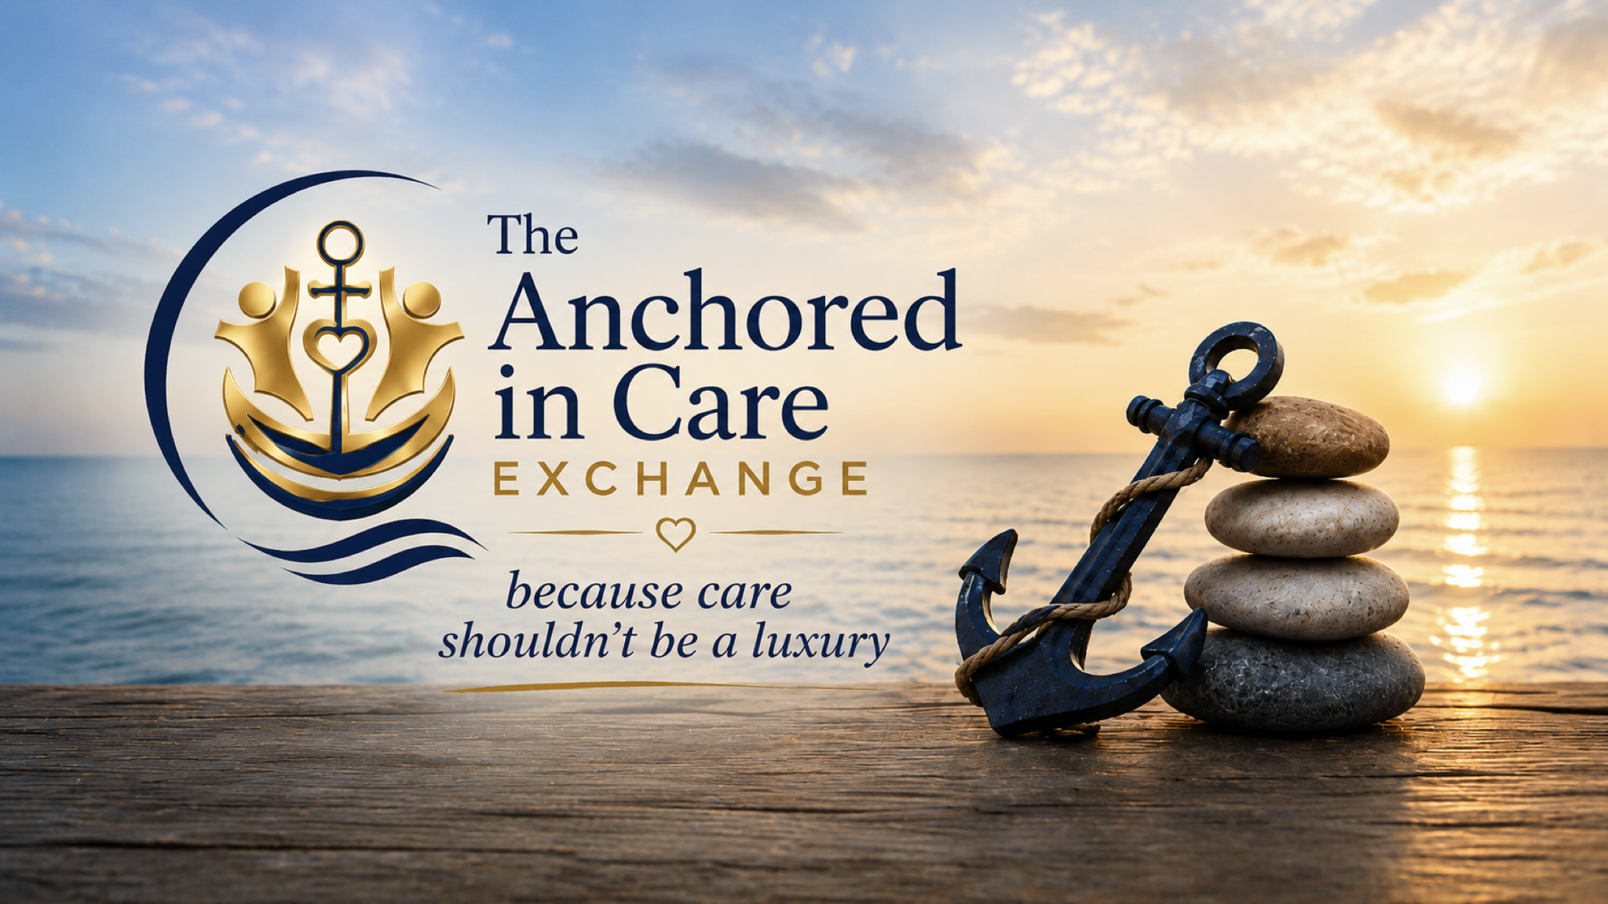

Care Exchange Academy™

Learning to Serve. Leading with Compassion.
Because Care Shouldn't Be a Luxury.

About the Academy
The Care Exchange Academy™ is the official volunteer education and certification program of The Anchored in Care Exchange. The Academy prepares compassionate individuals to safely and confidently support caregivers, older adults, and individuals with disabilities through structured education, hands on learning, mentorship, and continuing professional development.
Our mission is to equip every volunteer with the knowledge, skills, and confidence needed to provide compassionate, person centered care while maintaining the highest standards of professionalism, dignity, and respect.
Whether someone has years of caregiving experience or is beginning their journey after caring for a loved one, the Academy provides the education and support needed to serve with excellence.

Certification Pathways
Every volunteer begins by completing Volunteer Orientation and Core Academy Training.
After orientation, volunteers choose one or more certification pathways.

Certified Community Companion Specialist (CCCS)
Provides:
• Companionship
• Caregiver respite
• Wellness visits
• Friendly check in calls
• Grocery assistance
• Meal companionship
• Transportation accompaniment
• Community outings
• Wellness walks
• Social engagement
• Reading and recreational activities
• Emotional support
This role does not include personal care.

Certified Community Personal Care Specialist (CCPCS)
Provides all Community Companion services plus:
• Bathing assistance
• Grooming
• Dressing
• Toileting
• Continence care
• Mobility assistance
• Safe transfers
• Wheelchair assistance (if needed)
• Gait belt assistance (if needed)
• Support for individuals with neurological diseases or disorders
• Support for individuals with developmental disabilities
This role remains non medical.
Volunteers never administer medications or provide skilled nursing care.

Certified Comprehensive Care Support Specialist (CCCSS)
This certification recognizes volunteers who have successfully completed both the Community Companion Specialist and Community Personal Care Specialist certification programs.
Rather than representing a higher level of certification, Comprehensive Care Support Specialists are qualified to serve in either role depending upon the needs of the caregiver and care recipient.

Leadership Development
Leadership is earned through service, continued education, mentoring, and demonstrated excellence.

Senior Certified Care Exchange Specialist
Volunteers who consistently demonstrate professionalism, reliability, and compassion while completing substantial volunteer service hours and continuing education may be invited to become Senior Specialists.
Senior Specialists serve as mentors for newly certified volunteers and help strengthen the Academy through leadership and encouragement.

Lead Certified Care Exchange Specialist
Lead Specialists assist Volunteer Coordinators with onboarding, mentoring, quality assurance, volunteer coaching, and Academy workshops.
They serve as experienced leaders within the volunteer community while continuing direct service.

Community Care Support Manager
Community Care Support Managers are experienced volunteer leaders who oversee volunteer teams, assist with training, coordinate field support, mentor Lead Specialists, and help maintain the quality and integrity of the Community Care Exchange Program.

Continuing Care Education (CCE)
Learning does not end with certification.
Every certified volunteer completes annual Continuing Care Education requirements to maintain certification and remain current on best practices.
Continuing Care Education topics include:
• Dementia and Alzheimer's disease
• Neurological diseases and disorders
• Developmental disabilities
• CPR and First Aid renewal
• Elder abuse recognition
• Mandated reporting
• Safe body mechanics
• Gait belt techniques
• Fall prevention
• Communication skills
• Cultural competency
• Trauma informed care
• Grief and bereavement
• Mental health awareness
• Caregiver burnout
• Ethics and professional boundaries
• Emergency preparedness
• Person centered care

Volunteer Resource Portal
The Care Exchange Academy will eventually provide a secure online learning portal where volunteers can:
• Download the Volunteer Handbook
• Complete online orientation
• Watch training videos
• Register for workshops
• Access Continuing Care Education
• Download certificates
• Review Academy policies
• Submit volunteer hours
• Complete visit notes
• Access caregiver resources
• Connect with Volunteer Coordinators
• Receive Academy announcements

Recognition
We believe service deserves recognition.
The Care Exchange Academy celebrates volunteer milestones through certificates, leadership appointments, continuing education achievements, annual appreciation events, and service awards recognizing dedication to caregivers and care recipients.

Our Commitment
The Care Exchange Academy exists for one purpose.
To prepare extraordinary volunteers who provide extraordinary care.
Every lesson, every certification, and every hour of service strengthens not only one caregiver or one family, but an entire community.
Because when compassionate people are equipped with knowledge, communities become stronger, caregivers feel supported, and care recipients experience the dignity, respect, and human connection they deserve.

